Figure S1: ¹H NMR spectra of αLA, PαLA, mPEG, MP, and PαLA-MP in DMSO-d₆.

Figure S2: UV–Vis spectra of αLA and PαLA in DMSO.
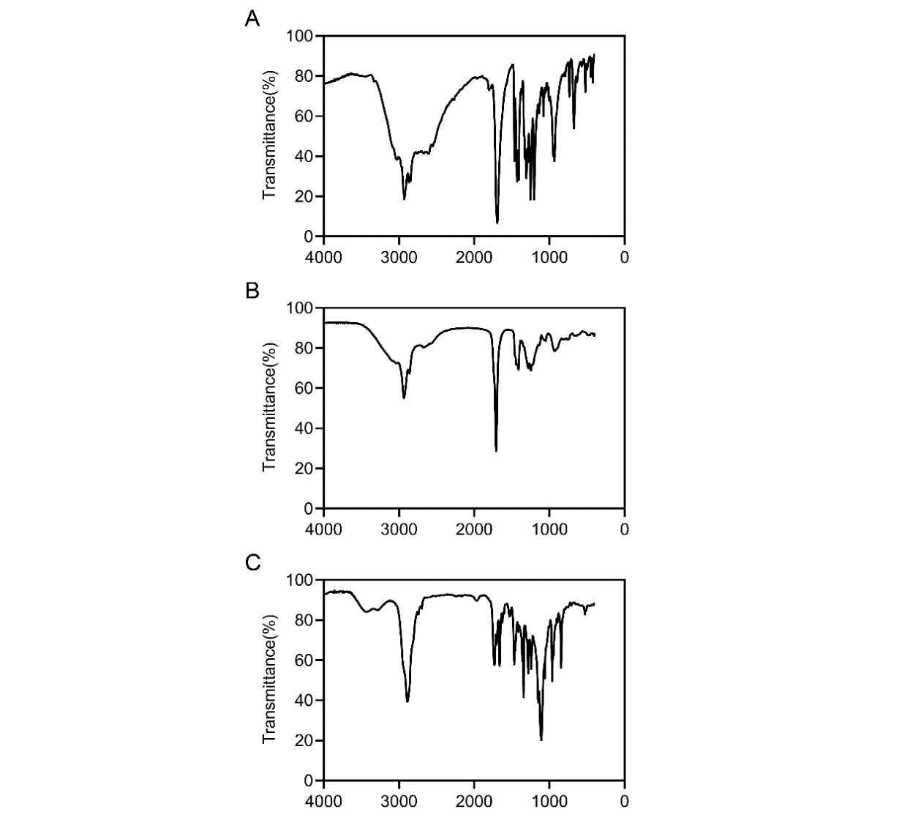
Figure S3: FT-IR spectra of αLA (A), PαLA (B), and PαLA-MP (C).
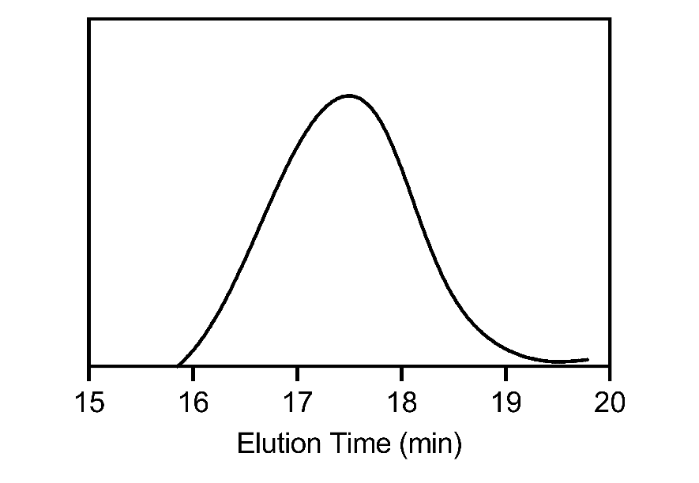
Figure S4: GPC analysis of PαLA-MP using DMF as the eluent.

Figure S5: (A) DLS measurement of PαLA-MP NPs. (B) TEM image of PαLA-MP NPs. Higher magnification TEM images are presented on the right (4×). Scale bars are 200 and 50 μm, respectively.
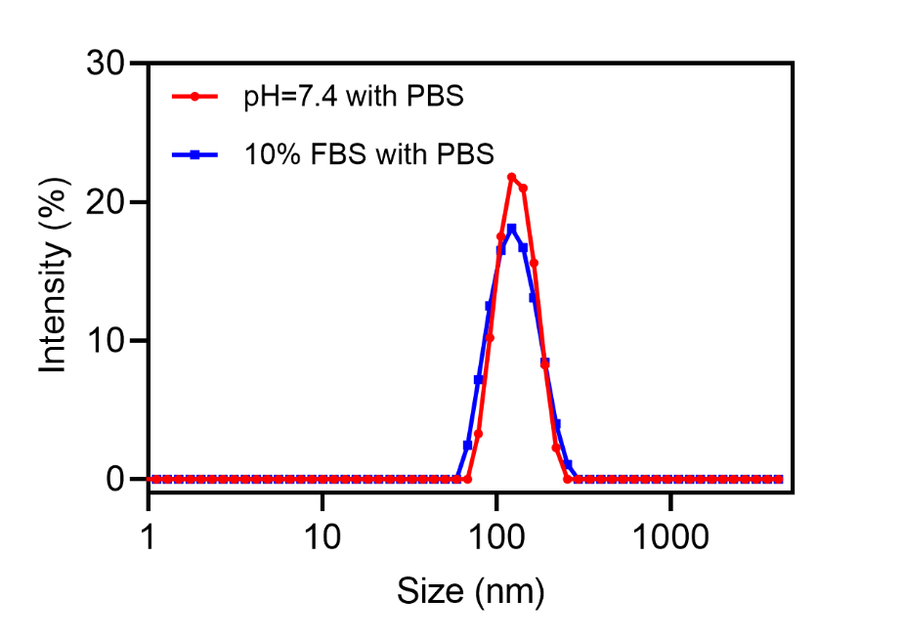
Figure S6: Stability of MC-PαLA-MP NPs in different media.

Figure S7: ESI-MS results of MP in the solution released after 48 h.

Figure S8: (A) DLS measurement of Cy5-PαLA-MP NPs. (B) TEM image of Cy5-PαLA-MP NPs. Higher magnification TEM images are presented on the right (4×). Scale bars are 200 and 50 μm, respectively. (C) Fluorescence of Cy5-PαLA-MP NPs. (D) UV–Vis spectra of PαLA-MP NPs and Cy5-PαLA-MP NPs.

FigureS9: (A) Biodistribution of Cy5-PαLA-MP NPs in rat models of TSCI. (B) Average signals were counted in the major organs after an intravenous injection with Cy5-PαLA-MP NPs.

Figure S10: H&E and Masson staining results of bladders at 2× (left) and 20× (right) magnifications. Scale bars are 500 and 50 μm, respectively.
Figure S11: (A) H&E staining of injured spinal cord displayed at 2× (left) and 20× (right) magnifications. Scale bars are 500 and 50 μm, respectively. (B) Immunofluorescence staining images of GFAP (red) and NF200 (green) in the injured spinal cord shown at 2× (left) and 10× (right) magnifications. Scale bars are 500 and 100 μm, respectively. Arrows indicated the pathological characteristics.

Figure S12: LFB staining of injured spinal cord displayed at 2× (left) and 20× (right) magnifications. Myelinated areas are stained blue, whereas demyelinated areas are unstained. The scale bars are 500 μm (left panels) and 50 μm (right panels).

Figure S13: Immunofluorescence staining images of GFAP (red) and Iba1 (green) in the injured spinal cord shown at 2× (left) and 10× (right) magnifications. Scale bars are 500 and 100 μm, respectively. Arrows indicated the pathological characteristics.

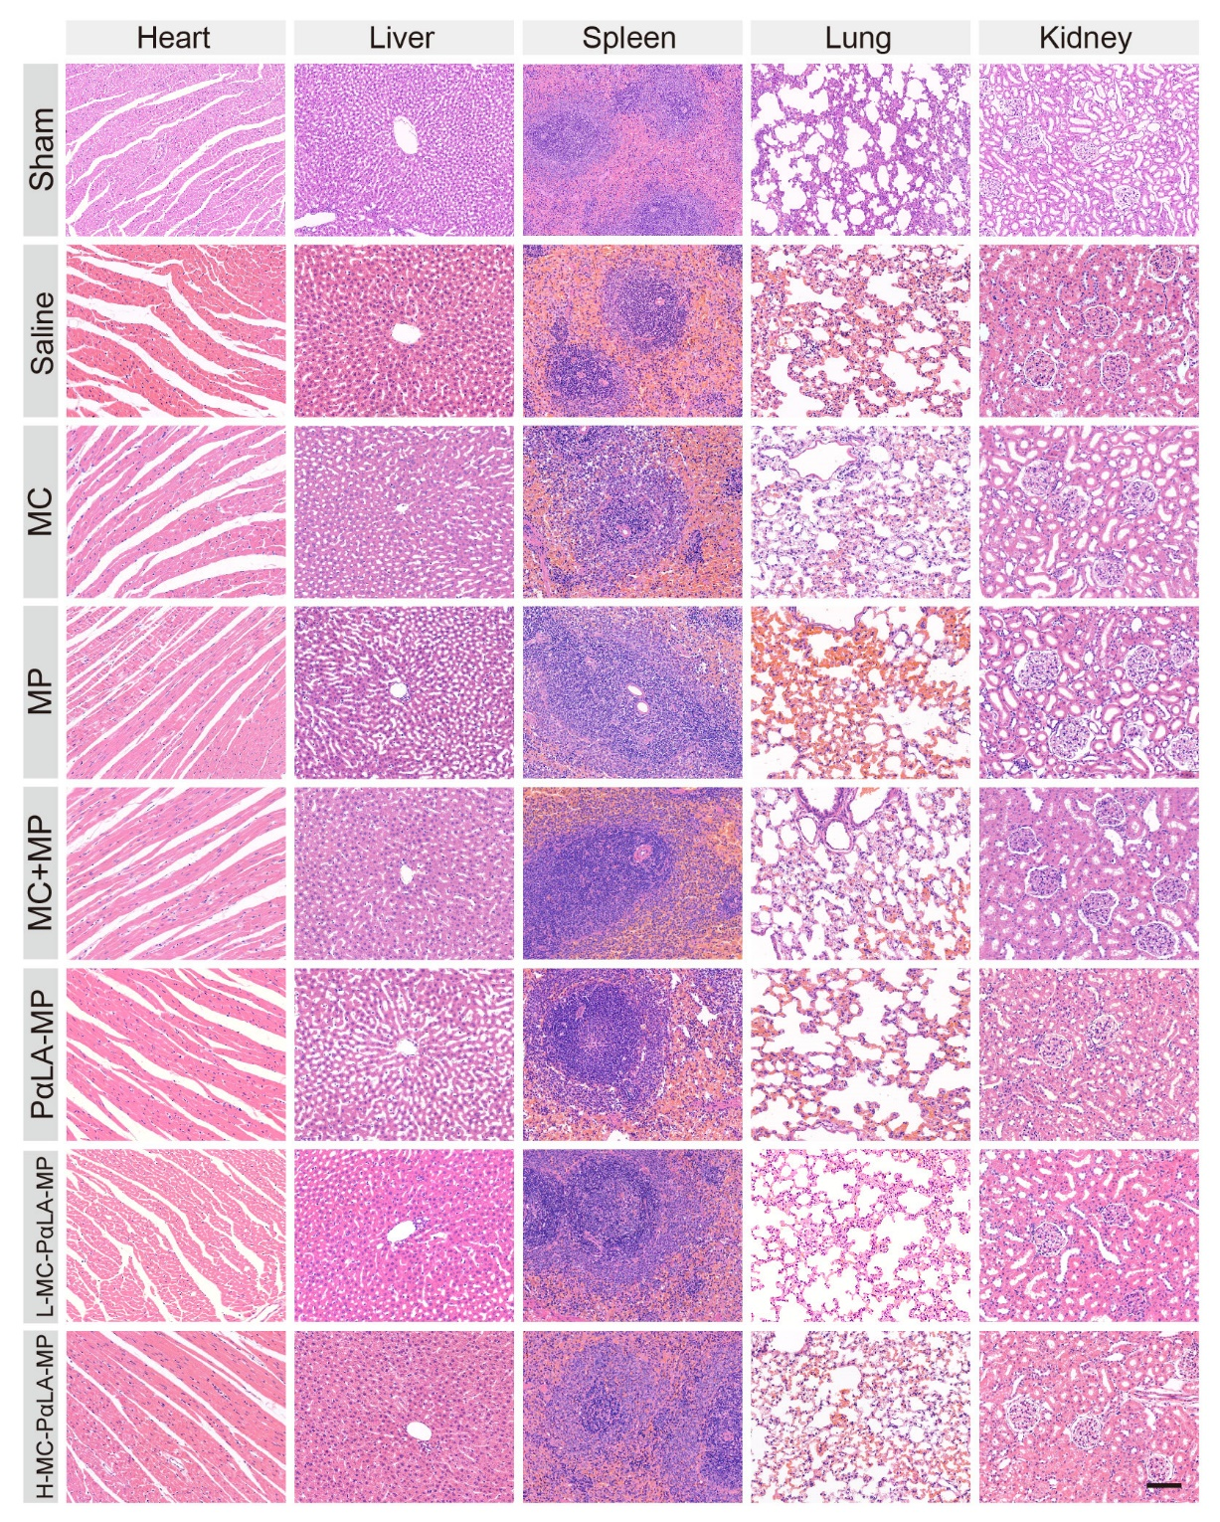
Figure S14: H&E staining of the major organs from rat models of TSCI at the end of treatment. Scale bar = 100 μm.

