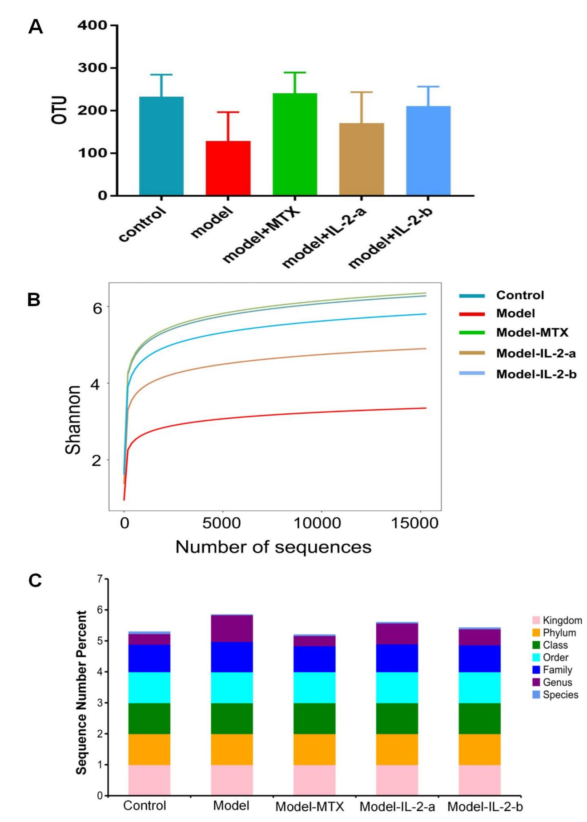

Supplementary Figure 1 A-C

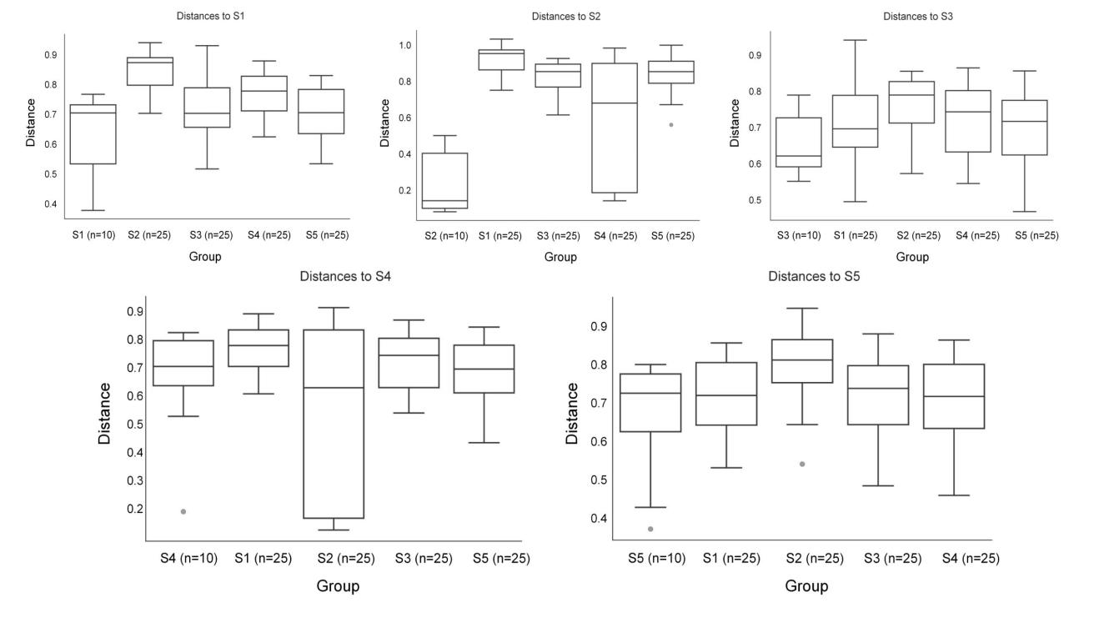

Supplementary Figure 2

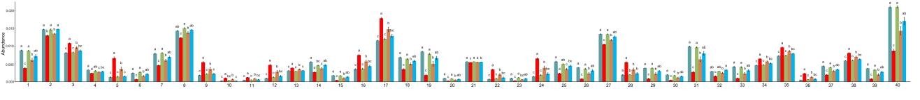

Supplementary Figure 3

Supplementary Figure 1

Species composition analysis

(A)OTUs of each group; the number of OTUs was lower in the model group than in the other groups; the numbers of OTUs were significantly higher in the IL-2-a and IL-2-b groups than in the model group.

(B)Shannon rarefaction curve; the amount of sequencing data was sufficient to reflect most of the microbial species in the sample.

(C)Observations of OTUs at each classification level in the sample.

Supplementary Figure 2

Permanova analysis based on Bray-Curtis distances.

S1: Control, S2: Model, S3: Model + MTX, S4: Model + IL-2-a, S5: Model + IL-2-b.

There were significant differences in microbiota composition between the model and control groups, but there were no obvious differences among the MTX, IL-2-a, IL-2-b, and control groups.

Supplementary Figure 3
Metabolism
In each channel, different colors are used to represent groups. Similar letters above two groups indicate a non-significant difference; different letters indicate a significant difference.

