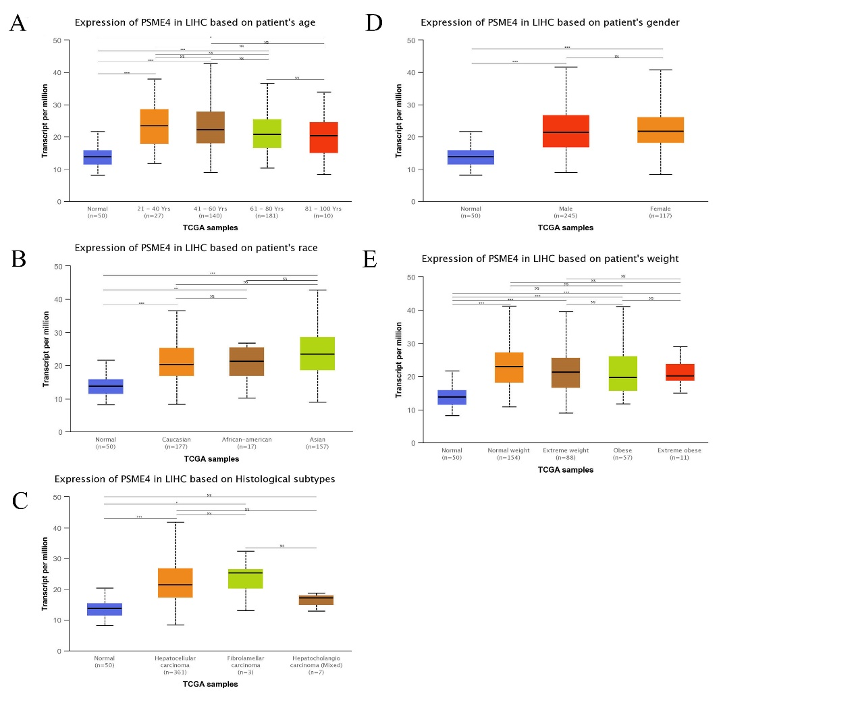
Supplement Figure 1：The expression of PSME4 with different ages(A), races(B), histological types(C), genders(D) or weights(E) in TCGA database. ns p≥0.5,*p< 0.05, **p<0.01, ***p<0.001.

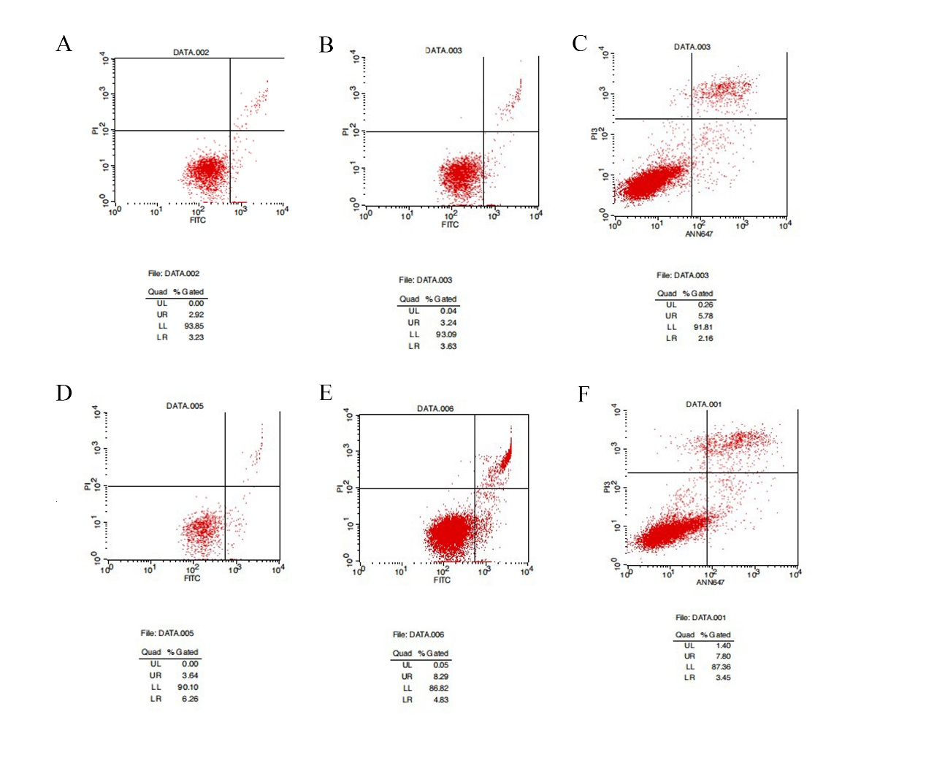
Supplement Figure 2: Repeat apoptosis experiments in triplicate by flow cytometry between the control group (A, B, C) and PSME4-siRNA group (D, E, F).

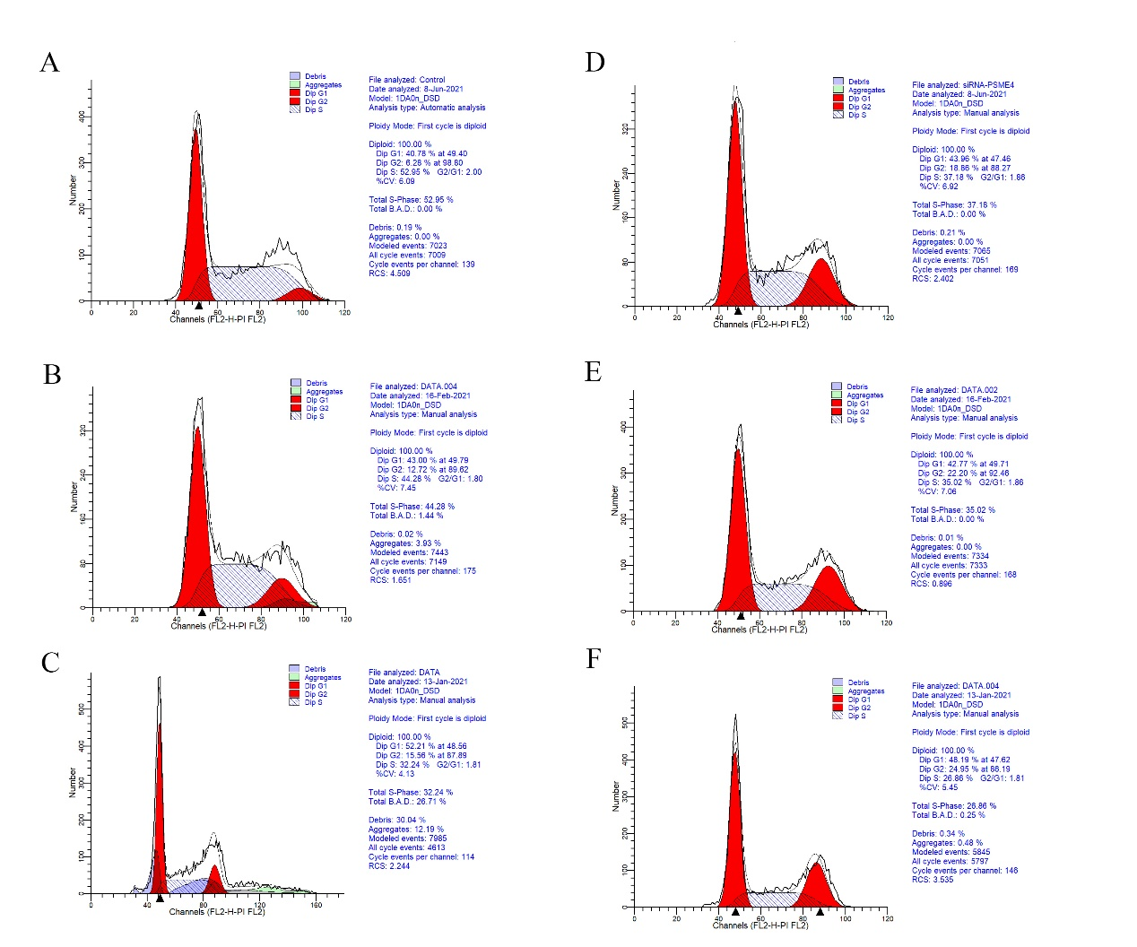
Supplement Figure 3: Repeat cell cycle experiments in triplicate by flow cytometry between the control group (A, B, C) and PSME4-siRNA group (D, E, F).

