Supplementary materials
Supplementary Table 1. The demographic, clinical, and routine laboratory data for patients on the same day of serum sample collection.
Variable ª | Sepsis (n=36) | Non-sepsis (n=43) | P-value ^{b}
Demographics
Age | 63.1 ± 15.7 | 59.6 ± 14.6 | 0.014
Sex M, F | 16 (44%), 20 (56%) | 21 (49%), 22 (51%) | 0.653
BMI | 29.8 ± 9.7 | 29.4 ± 5.9 | 0.354
Routine laboratory data
Hemoglobin (g/dL) | 9.1 ± 2.3 | 10.7 ± 2.0 | 0.219
Packed cell volume (%) | 29.2 ± 7.3 | 33.0 ± 6.4 | 0.852
WBC count × 10⁹/L | 14.1 ± 7.6 | 11.0 ± 5.2 | 0.748
Neutrophils (N) × 10⁹/L | 8.4 ± 1.0 | 8.02 ± 0.9 | 0.337
Lymphocytes (L) × 10⁹/L | 10.5 ± 1.0 | 1.23 ± 0.9 | 0.993
N/L ratio | 15.1 ± 19.7 | 10.1 ± 7.9 | 0.545
Platelets × 10⁹/L | 209.9 ± 137.8 | 258.6 ± 128.2 | 0.495
Sodium (mmol/L) | 138.6 ± 7.0 | 140.0 ± 5.4 | 0.892
Potassium (mmol/L) | 4.4 ± 0.8 | 4.1 ± 0.6 | 0.305
Chloride (mmol/L) | 102.2 ± 10.9 | 104.5 ± 9.1 | 0.520
Creatinine (mg/dl) | 2.4 ± 2.2 | 1.0 ± 0.8 | 0.114
RBS (mg/dl) | 206.5 ± 147.3 | 145.2 ± 61.1 | 0.204
Vital signs
Heart rate | 95.5 ± 24.9 | 86.6 ± 20.5 | 0.265
Temperature | 37.1 ± 1.1 | 36.2 ± 3.4 | 0.170
Respiratory rate | 20.3 ± 5.0 | 25.4 ± 23.5 | 0.922
Systolic BP | 115.2 ± 27.2 | 127.6 ± 20.5 | 0.554
Diastolic BP | 65.9 ± 16.5 | 74.6 ± 13.5 | 0.438
MAP | 79.9 ± 18.1 | 87.7 ± 18.7 | 0.590
SOFA score
Total SOFA | 8.3 ± 4.8 | 3.1 ± 3.5 | <0.001
Respiratory SOFA | 2.1 ± 1.3 | 1.1 ± 1.2 | 0.020
Coagulation SOFA | 0.7 ± 1.1 | 0.3 ± 0.7 | 0.281
Hepatic SOFA | 1.0 ± 1.1 | 0.4 ± 0.7 | 0.008
Cardiovascular SOFA | 2.2 ± 1.9 | 0.5 ± 1.3 | 0.001
CNS SOFA | 0.9 ± 1.4 | 0.5 ± 1.2 | 0.227
Renal SOFA | 1.5 ± 1.4 | 0.3 ± 0.7 | 0.002
Service unit |  |  | 0.253
Surgical ICU | 33 (47.8%) | 36 (52.2%) | 0.332
Medical ICU | 0 (0%) | 3 (100%) | 0.246
Anaesthesia ICU | 2 (50%) | 2 (50%) | 1.000
Shared between the three ICUs | 1 (33.3%) | 2 (66.7%) | 1.000
Source of admission
- Emergency | 13 (36.1%) | 23 (63.9%) | 0.174
- Hospital wards | 12 (70.6%) | 5 (29.4%) | 0.028
- Operations room | 8 (40%) | 12 (60%) | 0.612
- Dialysis unit | 2 (100%) | 0 (0%) | 0.204
- Other | 1 (25%) | 3 (75%) | 0.621
Reason(s) for admission ^{c}
- Post operation | 10 (45.5%) | 12 (54.5%) | 1.000
- Bowel Obstruction | 3 (33.3%) | 6 (66.7%) | 0.498
- Due to sepsis | 25 (100%) | 0 (0%) | <0.001
- Lower limb ischemia | 2 (100%) | 0 (0%) | 0.204
- Renal disease | 10 (43.5%) | 13 (56.5%) | 1.000
others | 28 (46.7%) | 32 (53.3%) | 0.796
Comorbidities
Number of comorbidities | 1.8 ± 1.4 | 1.5± 1.1 | 0.267
None | 7 (50%) | 7 (50%)
1-3 | 25 (42.4%) | 34 (57.6%)
≥4 | 4 (66.7%) | 2 (33.3%)
Types:
CVD | 5 (83.3%) | 1 (16.7%) | 0.087
Dementia | 0 (0%) | 3 (100%) | 0.246
Liver diseases | 0 | 0 | -
Peptic ulcer | 0 | 0 | -
CTD | 0 | 0 | -
Cancer | 11 (64.7%) | 6 (35.3%) | 0.100
Renal diseases | 14 (48.3%) | 15 (51.7%) | 0.816
IHD | 6 (46.2%) | 7 (53.8%) | 1.000
Heart failure | 13 (44.8%) | 16 (55.2%) | 1.000
Diabetes | 20 (48.8%) | 21 (51.2%) | 0.653
COPD | 3 (60%) | 2 (40%) | 0.655
Hypertension | 26 (52%) | 24 (48%) | 0.163
ICU LOS in days | 11.8 ± 10.7 | 9.3 ± 9.2 | 0.198
Hospital LOS in days | 15.9 ± 10.5 | 17.2± 18.7 | 0.097
ª All results are presented as count and percent (n (%)) for categorical variables and (mean ± SD) for continuous variables. Measurement units: Age; years, BMI; kg/m², Heart rate; beat/minute, Temperature; ℃, Respiratory rate; breaths/minute, Systolic/Diastolic/MAP BP; mmHg. RBS; random blood sugar, MAP; Mean arterial pressure. CVD; Cerebrovascular diseases, CTD; connective tissue disease, IHD; Ischemic heart disease, COPD; Chronic obstructive pulmonary disease. LOS; length of stay. ^{b} Fisher’s exact test was used to determine statistical significance. ^{c} More than one reason for admission was reported for each patient as designated by the attending clinician.

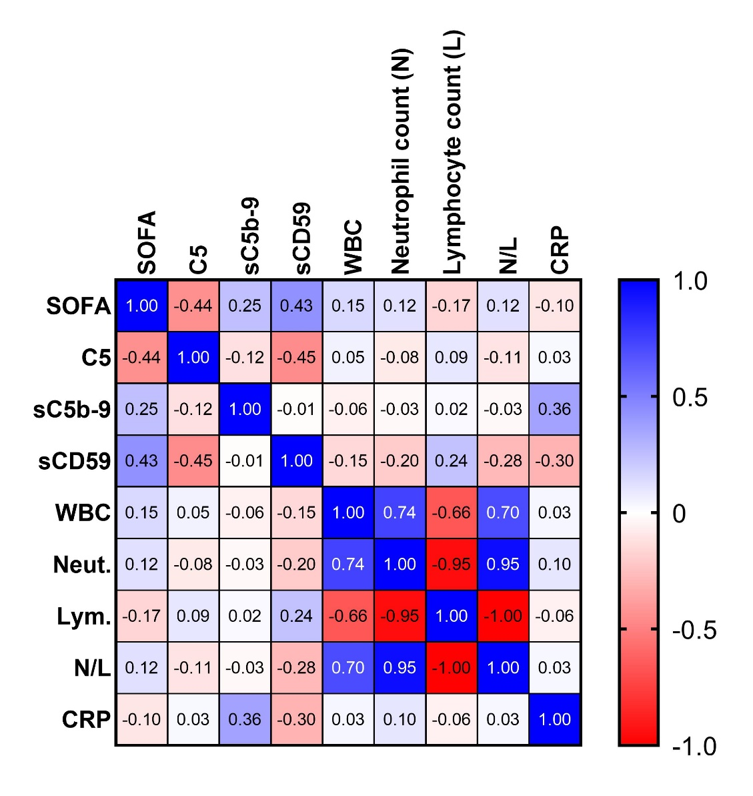
Supplementary Figure 1. Correlation matrix of terminal pathway activation parameters, systemic markers of inflammation, and SOFA score. Spearman’s correlation coefficient (r_{s}) was used to assess the correlation of each column with each other column and a correlation matrix was generated. The values inside the squares represent r_{s}.

