Supporting Information

Highly Optimized Iron oxide embedded poly(lactic acid) nanocomposites for effective magnetic hyperthermia and biosecurity
Chiseon Ryu¹, Hwangjae Lee¹ Hohyeon Kim², Seong Hwang¹, Yaser Hadadian^{2,3}, Ayeskanta Mohanty⁴, In-Kyu Park⁴, Beongki Cho¹, Jungwon Yoon^{2,3,*}, Jae Young Lee^{1,*}

¹ School of Materials Science and Engineering, Gwangju Institute of Science and Technology, Gwangju 61005, Republic of Korea.
² School of Integrated Technology, Gwangju Institute of Science and Technology, Gwangju 61005, Republic of Korea.
³ Research Center for Nanorobotics in Brain, Gwangju Institute of Science and Technology, Gwangju 61005, Republic of Korea.
⁴ Department of Biomedical Sciences, Chonnam National University Medical School, Hwasun-gun, Jeollanam-do, Republic of Korea

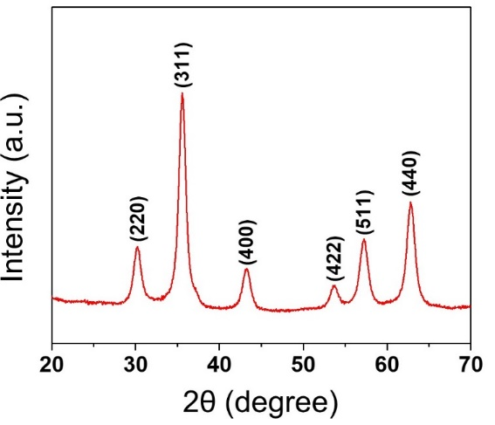
Figure S1. X-ray diffraction (XRD) patterns of oleic acid coated Fe₃O₄ nanoparticles.

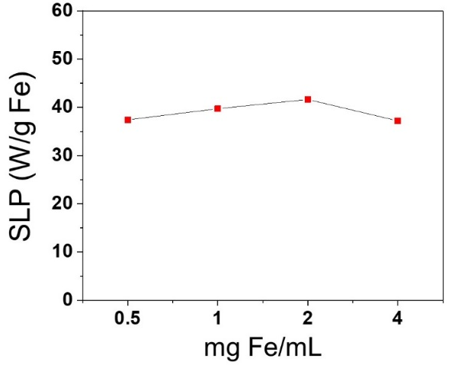
Figure S2. SLP value of IONPs dependent on concentration.

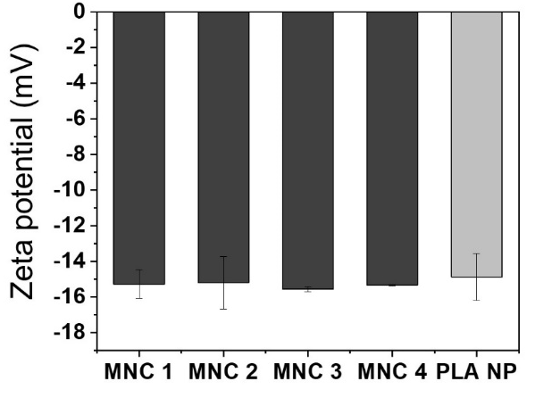
Figure S3. Zeta potential of MNCs and PLA NP (synthesized without IONPs).

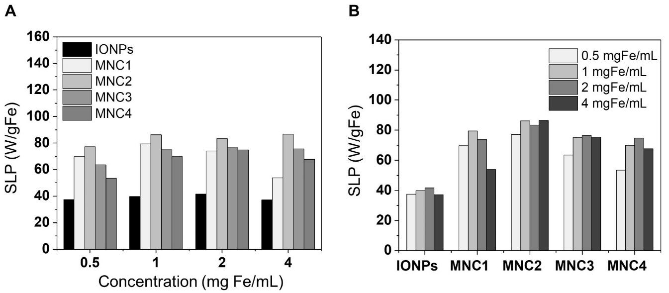
Figure S4. Heating efficiency of IONPs and MNCs. (A) SLP values of the IONPs and MNCs at their different concentrations in 1-octanol. (B) SLP values of various nanoparticle at different concentrations in 1-octanol.

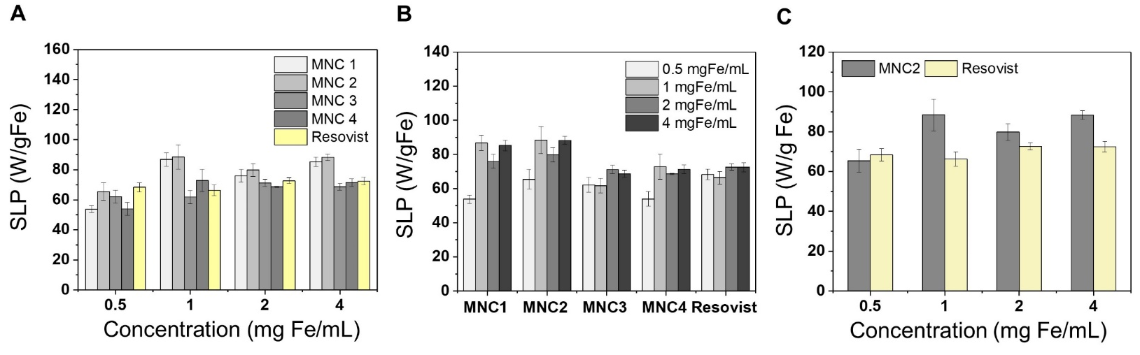
Figure S5. Heating efficiency of MNCs and Resovist. (A) SLP values of the MNCs and Resovist at their different concentrations in DIW. (B) SLP values of various nanoparticle at their different concentrations in DIW. (C) SLP values of MNC 2 and Resovist at different concentrations in DIW.

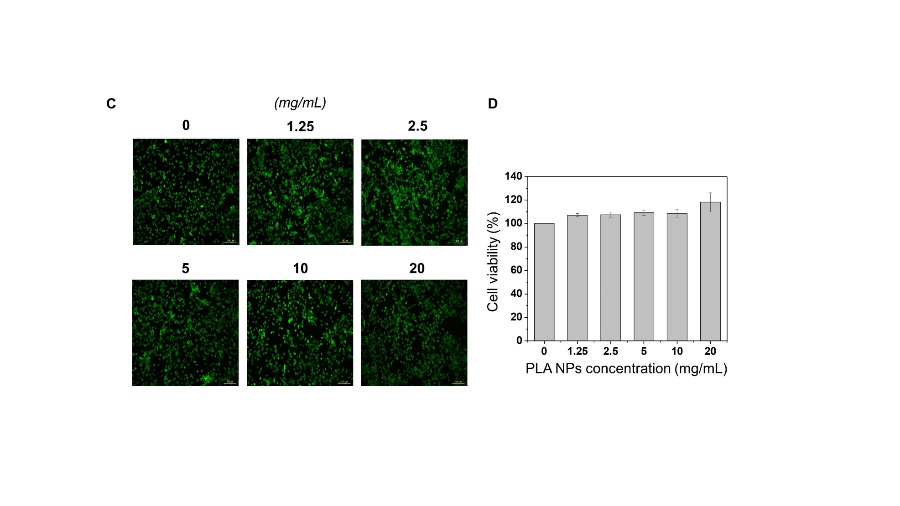
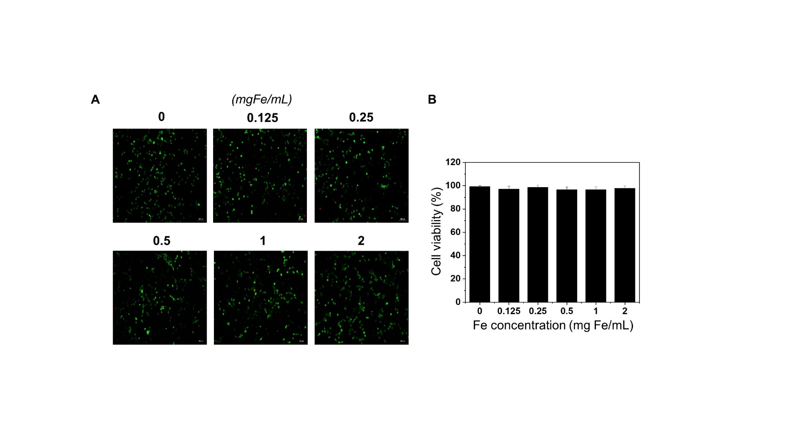
Figure S6. Cytocompatibility tests of the IONPs and PLA NPs with NIH-3T3 cells. (A) Fluorescence micrographs of the cells after the incubation with IONPs at different concentrations for 1 day. The green and red cells in the images indicate live and dead cells, respectively. Scale bars are 100 μm. (B) viability of the cells cultured with IONPs after incubation for 1 day. (C) Fluorescence micrographs of the cells after the incubation with PLA NPs at different concentrations for 1 day. (D) viability of the cells cultured with PLA NPs after incubation for 1 day.

