Supplementary data
Table S1 Distribution of ceftazidime/avibactam MIC values for Enterobacterales strains, specifying ESBL-positive, MDR and CRE strains
Organism | MIC frequency distribution - absolute
Organism | 0.015 | 0.03 | 0.06 | 0.12 | 0.25 | 0.5 | 1 | 2 | 4 | 8 | 16 | 32 | 64 | 128 | 256
Enterobacterales (n=1523) | 52 | 123 | 313 | 425 | 283 | 178 | 89 | 36 | 6 | 1 | 0 | 0 | 1 | 0 | 16
Enterobacterales MDR (n=674) | 6 | 12 | 60 | 118 | 174 | 160 | 84 | 36 | 6 | 1 | 0 | 0 | 1 | 0 | 16
Enterobacterales ESBL (n=434) |  | 3 | 23 | 65 | 134 | 115 | 53 | 20 | 4 | 1 | 0 | 0 | 1 | 0 | 15
Enterobacterales CRE (n=23) |  |  |  | 1 | 0 | 1 | 2 | 5 | 1 | 1 | 0 | 0 | 0 | 0 | 12
Table S2 Antimicrobial susceptibility (Enterobacterales) to ceftazidime/avibactam stratified by age
Organism | 0-18 |  | >18 |  | 61+
Organism | n | % S | n | % S | n | % S
Enterobacterales (n=1523) | 529 | 99.2 | 999 | 98.7 | 669 | 99.0
Enterobacterales MDR (n=674) | 194 | 97.9 | 480 | 97.3 | 332 | 97.9
Enterobacterales ESBL (n=434) | 124 | 96.8 | 310 | 96.1 | 211 | 96.7
Enterobacterales CRE (n=23) | 4 | 50.0 | 19 | 47.4 | 13 | 61.5
Figure S1 Antimicrobial susceptibility (Enterobacterales) to ceftazidime/avibactam stratified by age
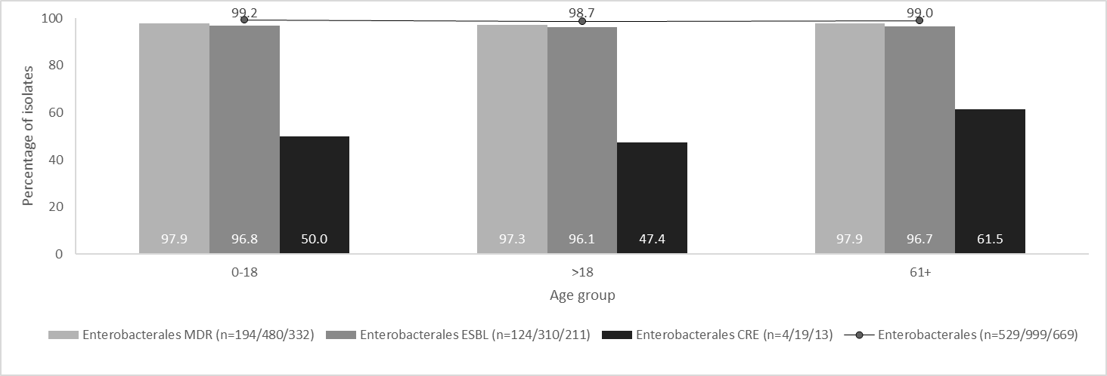
Table S3 Distribution of ceftazidime/avibactam MIC values for the P. aeruginosa strains (specifying MDR, DTR and CR strains)
Organism | MIC frequency distribution - absolute
Organism | 0.25 | 0.5 | 1 | 2 | 4 | 8 | 16 | 32 | 64 | 128 | 256
P. aeruginosa (n=523) | 2 | 10 | 105 | 202 | 96 | 52 | 22 | 13 | 6 | 7 | 8
P. aeruginosa MDR (n=164) |  | 1 | 3 | 15 | 40 | 49 | 22 | 13 | 6 | 7 | 8
P. aeruginosa DTR (n=96) |  |  | 2 | 4 | 16 | 26 | 18 | 9 | 6 | 7 | 8
P. aeruginosa CR (n=93) |  |  |  | 2 | 22 | 27 | 16 | 7 | 5 | 6 | 8
Table S4 Antimicrobial susceptibility (P. aeruginosa) to ceftazidime/avibactam stratified by age
Organism | 0-18 |  | >18 |  | 61+
Organism | n | % S | n | % S | n | % S
P. aeruginosa (n=523) | 194 | 93.3 | 327 | 86.9 | 196 | 87.8
P. aeruginosa MDR (n=164) | 40 | 67.5 | 124 | 65.3 | 72 | 66.7
P. aeruginosa DTR (n=96) | 20 | 50.0 | 76 | 50.0 | 42 | 50.0
P. aeruginosa CR (n=93) | 26 | 69.2 | 67 | 49.3 | 36 | 47.2

