Supplements
Supplement 1 The cerebrospinal fluid samples were classified into four grades according to the degree of blood contamination.
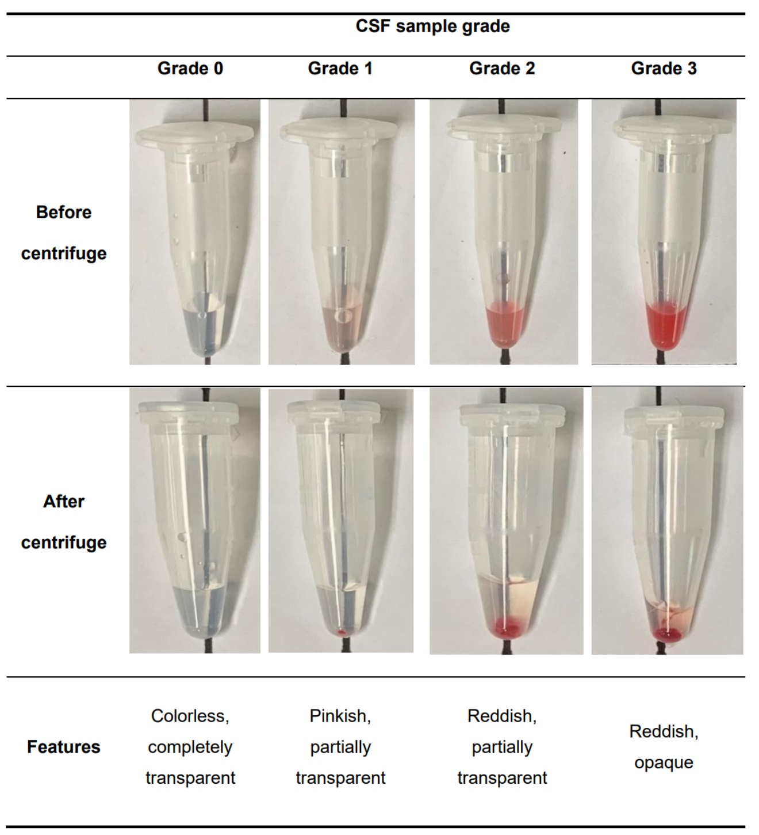
CSF, cerebrospinal fluid

Supplement 2 Association between the degree of blood contamination and brain-derived neurotrophic factor level in group C
 | Degree of blood contamination |  |  |  | P-value
 | Grade 0 | Grade 1 | Grade 2 | Grade 3 | P-value
Samples, n (%) | 73 (47.7) | 39 (25.5) | 26 (17.0) | 15 (9.8) | -
Sampling day, n (%) |  |  |  |  | 0.708
POD 1 | 22 (30.1) | 16 (41.0) | 9 (34.6) | 3 (20.0)
POD 7 | 27 (37.0) | 13 (33.3) | 7 (26.9) | 7 (46.7)
POD 14 | 24 (32.9) | 10 (25.6) | 10 (38.5) | 5 (33.3)
Weight (g), mean (SEM) | 255.7 (4.0) | 242.8 (5.8) | 247.0 (8.0) | 242.9 (8.8) | 0.247
BDNF (pg/mL), mean (SEM) | 8.6 (0.7) | 10.5 (1.0) | 13.1 (1.3)* | 20.1 (3.0)* | <0.001
The cerebrospinal fluid samples were classified into four grades according to the degree of blood contamination: grade 0, colorless and completely transparent; grade 1, pinkish and partially transparent; grade 2, reddish and partially transparent; grade 3, reddish and opaque. The BDNF levels in grades 2 and 3 CSF samples were higher than those in grade 0 samples. The Conover test was performed for posthoc multiple comparisons. Also, the Jonckheere-Terpstra trend test revealed significantly higher BDNF levels with higher contamination grades (P < 0.001), and there was a moderate correlation between the BDNF level and the degree of blood contamination (Spearman’s correlation coefficient 0.397, P < 0.001). POD, postoperative day; SEM, standard error of the mean; BDNF, brain-derived neurotrophic factor. *P < 0.05 compared to grade 0. Bold text; statistically significant data.

