Supplementary files

Supplementary Figure S1. Results of GO Annotation and KEGG pathway analysis. (A) cellular component (GO), (B) biological process(GO), (C) molecular function(GO), (D) KEGG pathway analysis

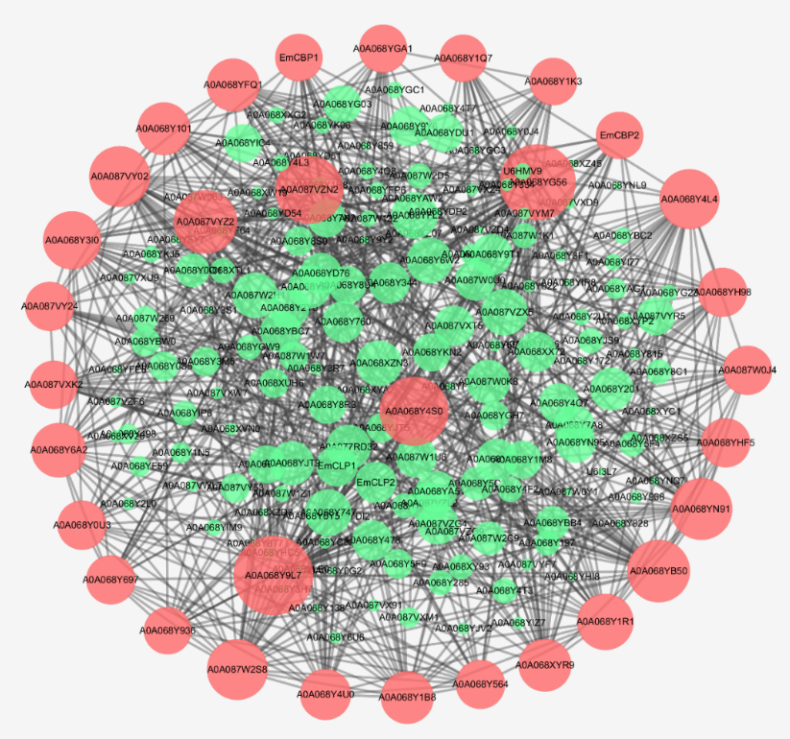
Supplementary Figure S2. Protein-protein interaction network of Em-ESP. Each circle represents an ESP, and the size of the circle represents the number of interactions with other ESP. The larger the circle, the more the interaction; the red circle represents the core protein, and the green one represents the non-core protein.

Supplementary Table S1. Annotation of Em-ESP family (Top 20)
IPR Family | Annotation | Number
IPR036880 | Pancreatic trypsin inhibitor Kunitz domain superfamily | 18
IPR013783 | Immunoglobulin-like fold | 14
IPR008860 | Taeniidae antigen | 9
IPR017853 | Glycoside hydrolase superfamily | 9
IPR038765 | Papain-like cysteine peptidase superfamily | 9
IPR009057 | Homeobox-like domain superfamily | 8
IPR036179 | Immunoglobulin-like domain superfamily | 8
IPR029058 | Alpha/Beta hydrolase fold | 6
IPR013780 | Glycosyl hydrolase, all-beta | 5
IPR035940 | CAP superfamily | 5
IPR036869 | Chaperone J-domain superfamily | 5
IPR036236 | Zinc finger C2H2 superfamily | 5
IPR009003 | Peptidase S1, PA clan | 5
IPR009030 | Growth factor receptor cysteine-rich domain superfamily | 4
IPR036055 | LDL receptor-like superfamily | 4
IPR001283 | Cysteine-rich secretory protein-related | 4
IPR013126 | Heat shock protein 70 family | 4
IPR029047 | Heat shock protein 70kD, peptide-binding domain superfamily | 4
IPR029044 | Nucleotide-diphospho-sugar transferases | 4
IPR036116 | Fibronectin type III superfamily | 4

Supplementary Table S2. Annotation of Em-ESP domain (Top 20)
IPR Domain | Annotation | Number
IPR002223 | Pancreatic trypsin inhibitor Kunitz domain | 18
IPR000668 | Peptidase C1A, papain C-terminal | 9
IPR039417 | Papain-like cysteine endopeptidase | 7
IPR007110 | Immunoglobulin-like domain | 6
IPR013087 | Zinc finger C2H2-type | 6
IPR000742 | EGF-like domain | 6
IPR001356 | Homeobox domain | 6
IPR013201 | Cathepsin propeptide inhibitor domain (I29) | 6
IPR001254 | Serine proteases, trypsin domain | 5
IPR001623 | DnaJ domain | 5
IPR017452 | GPCR, rhodopsin-like, 7TM | 4
IPR000504 | RNA recognition motif domain | 4
IPR008598 | Drought induced 19 protein type, zinc-binding domain | 4
IPR014044 | CAP domain | 4
IPR020479 | Homeobox domain, metazoa | 3
IPR001881 | EGF-like calcium-binding domain | 3
IPR003961 | Fibronectin type III | 3
IPR005123 | Oxoglutarate/iron-dependent dioxygenase | 3
IPR002048 | EF-hand domain | 3
IPR002049 | Laminin EGF domain | 3

Supplementary Table S3. Annotation of Em-ESP functional site (Top 20)
IPR Site | Annotation | Number
IPR020901 | Proteinase inhibitor I2, Kunitz, conserved site | 16
IPR000169 | Cysteine peptidase, cysteine active site | 9
IPR025661 | Cysteine peptidase, asparagine active site | 9
IPR025660 | Cysteine peptidase, histidine active site | 9
IPR013032 | EGF-like, conserved site | 7
IPR017970 | Homeobox, conserved site | 4
IPR018097 | EGF-like calcium-binding, conserved site | 4
IPR018244 | Allergen V5/Tpx-1-related, conserved site | 4
IPR018253 | DnaJ domain, conserved site | 3
IPR020392 | Pancreatic hormone-like, conserved site | 3
IPR018114 | Serine proteases, trypsin family, histidine active site | 3
IPR000047 | Helix-turn-helix motif | 3
IPR018247 | EF-Hand 1, calcium-binding site | 3
IPR023415 | Low-density lipoprotein (LDL) receptor class A, conserved site | 2
IPR017948 | Transforming growth factor beta, conserved site | 2
IPR018161 | Wnt protein, conserved site | 2
IPR016130 | Protein-tyrosine phosphatase, active site | 2
IPR020892 | Cyclophilin-type peptidyl-prolyl cis-trans isomerase, conserved site | 2
IPR017937 | Thioredoxin, conserved site | 1
IPR018297 | Adenylyl cyclase class-4/guanylyl cyclase, conserved site | 1

Supplementary Table S4. Em-ESP amino acid composition
Amino acid | Amount | proportion
Ala (A) | 46 | 6.7%
Arg (R) | 37 | 5.4%
Asn (N) | 26 | 3.8%
Asp (D) | 29 | 4.3%
Cys (C) | 45 | 6.6%
Gln (Q) | 22 | 3.2%
Glu (E) | 39 | 5.7%
Gly (G) | 58 | 8.5%
His (H) | 17 | 2.5%
Ile (I) | 33 | 4.8%
Leu (L) | 36 | 5.3%
Lys (K) | 35 | 5.1%
Met (M) | 6 | 0.9%
Phe (F) | 22 | 3.2%
Pro (P) | 48 | 7.0%
Ser (S) | 57 | 8.4%
Thr (T) | 46 | 6.7%
Trp (W) | 14 | 2.1%
Tyr (Y) | 24 | 3.5%
Val (V) | 42 | 6.2%
Pyl (O) | 0 | 0.0%
Sec (U) | 0 | 0.0%

Supplementary Table S5. Antigen epitopes of Em-ESP
No. | Start site | Sequence | Termination site
1 | 4 | SSGCLSFIFLACTAADPVEH | 23
2 | 56 | AAEILCEA | 63
3 | 70 | EFAECPKR | 77
4 | 79 | CRANVDCWVAYGKPQQCVCDPHFCGLVCLPVGSRCSP | 115
5 | 121 | NGYILLRD | 128
6 | 131 | VGATVDYTCDAGFTV | 145
7 | 149 | RKRHCLAT | 156
8 | 161 | GPEPVCT | 167
9 | 170 | TDHCFSPPYIQNA | 182
10 | 222 | YSTIVCVGN | 230
11 | 235 | KKLDCHRVSCPE | 246
12 | 264 | QGTAVQFCND | 273
13 | 275 | YTIHCPG | 281
14 | 290 | SSKSCSRVCQA | 300
15 | 307 | KSAKCIAVTCPKL | 319
16 | 327 | ISGYQTKVNGVVAFEC | 342
17 | 352 | SFRKCQL | 358
18 | 365 | EPAQCQVRDCGSP | 377
19 | 380 | ISNAVVKFSS | 389
20 | 393 | GSKAYFSCEA | 402
21 | 404 | TKSSVSTLELICG | 416
22 | 423 | SWLPFPYPACYKHCSVPDIVSANISL | 448
23 | 459 | IVAEATLLEHGVTIAVCCHSGFSLSKG | 485
24 | 504 | WSHEVECQPAQCTT | 517
25 | 522 | IPNALARFYGLHHGSVVRYQCFPG | 545
26 | 568 | NTWPLAHDRYSVRCEY | 583
27 | 589 | ELPACVQVRCSRPPVPEGVEIYLVG | 613
28 | 621 | DSKQILPTHGAIVEYSCLKD | 640
29 | 648 | KYTFCID | 654
30 | 661 | ETPICTKITHDIIPPSWL | 678

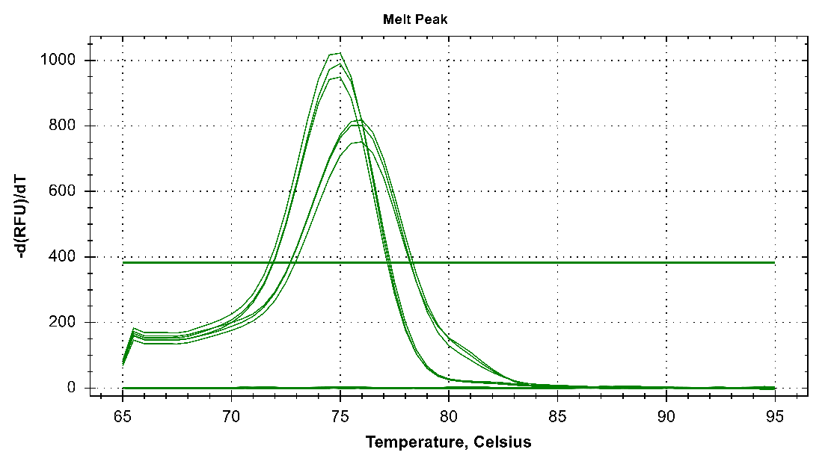
Supplementary Figure S3. EmuJ_000439500 mRNA expression in E.m lesion of mice.

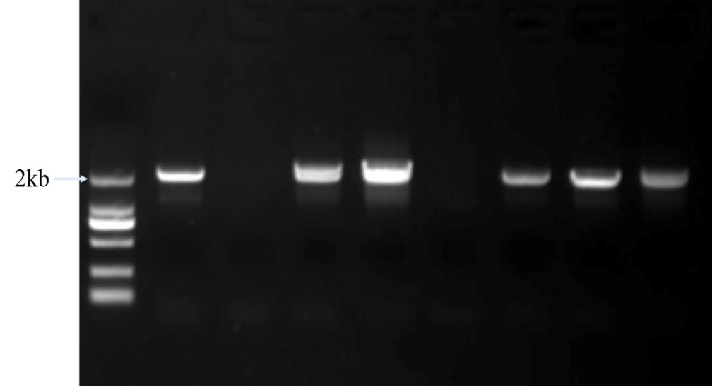
Supplementary Figure S4. Verification of pPICZαA recombinant vector

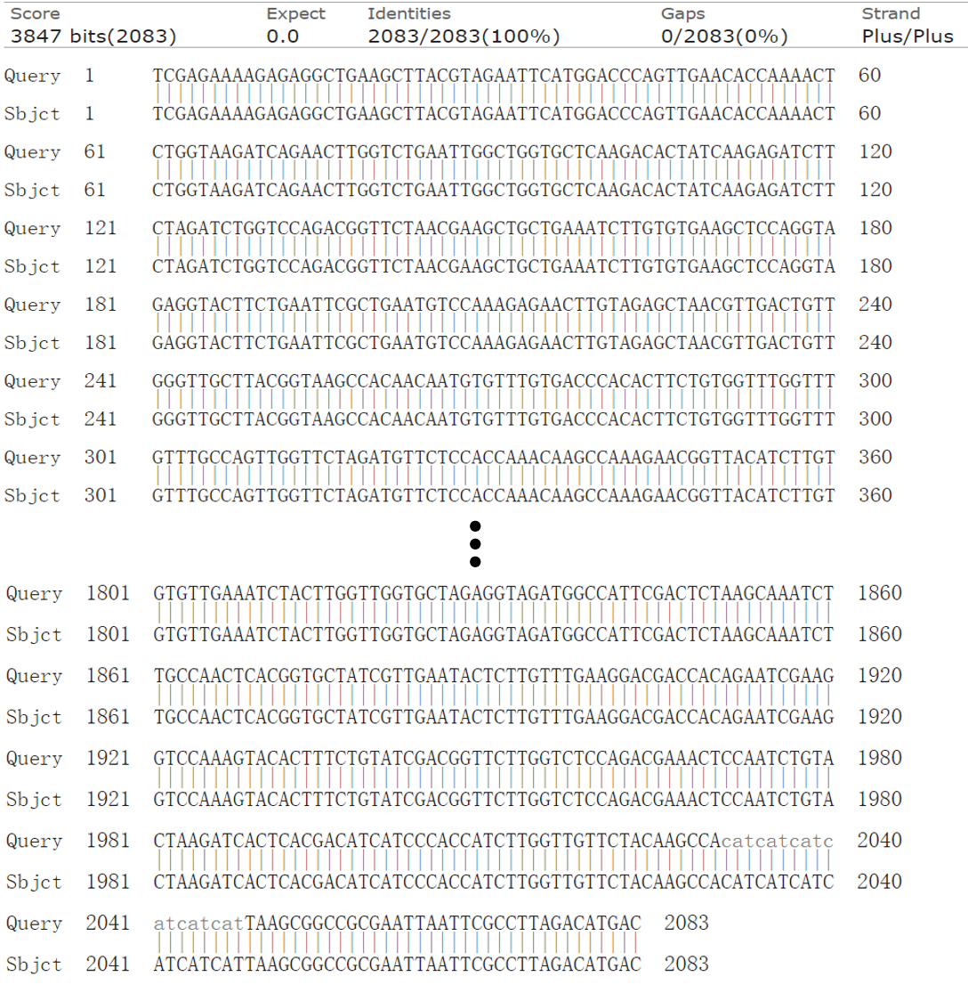
Supplementary Figure S5. Sequencing results pPICZαA recombinant vector sequence and target sequence

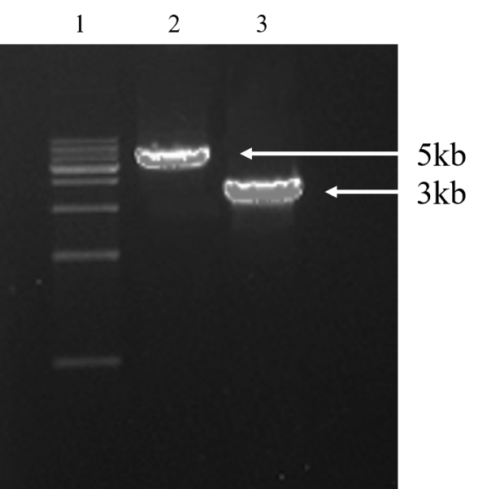
Supplementary Figure S6. Linearization of pPICZαA recombinant vector and empty vector. Lane 1: 1kb DNA Ladder Marker; Lane 2: pPICZαA recombinant vector; Lane 3: Empty pPICZαA

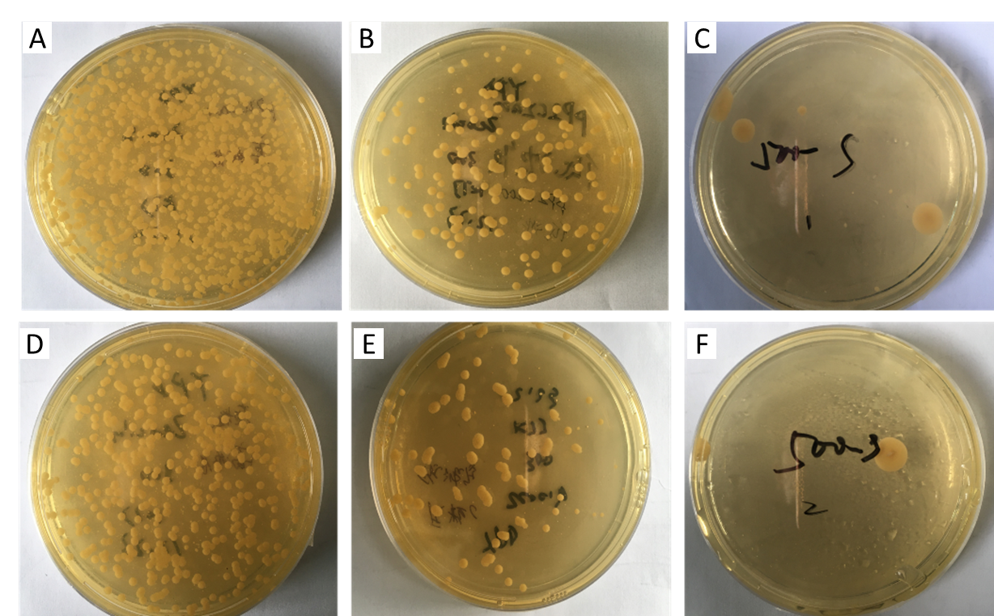
Supplementary Figure S7. (A B C) Growth of yeast transferred with pPICZαA recombinant vector at 100 ug / ml, 300 ug / ml and 500 ug / ml bleomycin concentration; (D E F) growth of yeast transferred with empty vector at 100 ug / ml, 300 ug / ml and 500 ug / ml bleomycin concentration.

