Supplementary Material for
iRGD tumor-penetrating peptide-modified nano-delivery system based on a marine sulfated polysaccharide for enhanced anti-tumor efficiency against breast cancer
Bowei Chen^{a,1}, Xiaohong Liu^{a,1}, Yunan Liª, Tianhe Shanª, Liya Baiª, Chunyu Li^{b,*}, Yinsong Wang^{a,*}
ª School of Pharmacy, Tianjin Key Laboratory on Technologies Enabling Development of Clinical Therapeutics and Diagnostics (Theranostics), Tianjin Medical University, Tianjin 300070, China
^{b} Department of Integrated Traditional Chinese and Western Medicine, International Medical School, Tianjin Medical University, Tianjin 300070, China
Corresponding Authors
*E-mail: wangyinsong@tmu.edu.cn (Yinsong Wang)
*E-mail: lichunyu@tmu.edu.cn (Chunyu Li)
ORCID
Yinsong Wang: 0000-0002-1403-2113
Chunyu Li: 0000-0001-8266-588X
¹ B. Chen and X. Liu contributed equally to this work.

Fig. S1. The ¹H-NMR spectra of ssPBAE.

Fig. S2. (a) The morphology of PSS@PBAE@JQ1/ORI nanoparticles observed by the TEM. (b) The size distribution of PSS@PBAE@JQ1/ORI nanoparticles detected by the dynamic laser scattering method.

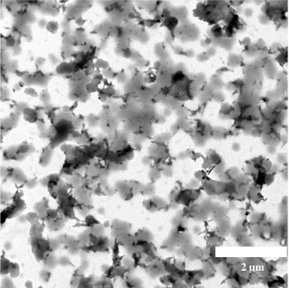
Fig. S3. The morphology of iRGD-PSS@PBAE@JQ1/ORI nanoparticles after 24 h incubation in DTT (10 mM) solution observed by the TEM.
Fig. S4. The cytotoxicities of PSS@ssPBAE and iRGD-PSS@ssPBAE in 4T1 cells after 48-hour treatments at different ssPBAE concentrations.

