Supplementary Tables
Supplementary Table 1 RNA quantification and quality assurance as measured using NanoDrop ND-1000
Sample ID | OD260/280 Ratio | OD260/230 Ratio | Conc. (ng/μl) | Volume | Quantity (ng) | QC Purity Pass or Fail
26 | 2.00 | 2.22 | 777.84 | 10 | 7778.40 | pass
28 | 1.99 | 2.23 | 573.80 | 10 | 57380 | pass
29 | 1.91 | 2.08 | 444.08 | 10 | 4440.80 | pass
231 | 1.99 | 2.20 | 1013.15 | 10 | 10131.50 | pass
232 | 1.97 | 2.16 | 699.57 | 10 | 6995.70 | pass
182 | 1.99 | 2.09 | 835.21 | 10 | 8352.10 | pass
218 | 1.98 | 2.19 | 501.07 | 10 | 5010.70 | pass
221 | 1.91 | 2.29 | 432.26 | 10 | 4322.60 | pass
252 | 1.89 | 2.31 | 474.93 | 10 | 4749.30 | pass
32 | 1.90 | 2.11 | 420.48 | 10 | 4204.80 | pass
Note: Pure RNA is indicated by an OD A260/A280 ratio of between 1.8 and 2.1. The OD 260/A230 ratio should be greater than 1.8. Samples 26, 28, 29, 231, and 232 were from healthy control individuals, and 182, 218, 221, 252, and 32 were from those with CSU.
Abbreviations: OD, optical density; Conc, concentration; QC, quality control.
Supplementary Table 2 Signaling pathways associated with differentially expressed downregulated mRNAs
Pathway | Fisher p | Count | Genes
Salmonella infection - Homo sapiens (human) | 0.002581652 | 4 | CCL3L3//CCL4//IL1A//WASL
Tight junction - Homo sapiens (human) | 0.005483352 | 5 | MPP4//NEDD4//OCLN//PRKAG3//WASL
Cytokine–cytokine receptor interaction - Homo sapiens (human) | 0.01348469 | 6 | BMPR1B//CCL3L3//CCL4//IL1A//IL22//INHBA
TGFβ signaling pathway - Homo sapiens (human) | 0.01872014 | 3 | BMPR1B//FST//INHBA
Abbreviations: TGFβ, transforming growth factor β.

Supplementary Table 3 The top 5 up- and downregulated lncRNAs co-expressed with VEFG signaling pathway
lncRNA Seqname | Up-/downregulated | mRNA Seqname | mRNA GeneSymbol | PCC | p
NR_002730 | up | NM_005417 | SRC | 0.99347 | 7.89E-09
ENST00000570060 | up | NM_005026 | PIK3CD | 0.987211 | 1.15E-07
T331129 | up | NM_004322 | BAD | 0.986628 | 1.38E-07
T109873 | up | NM_024420 | PLA2G4A | 0.968633 | 4.08E-06
NR_001459 | up | NM_000944 | PPP3CA | 0.94822 | 2.95E-05
T084828 | down | NM_005417 | SRC | -0.98488 | 2.25E-07
ENST00000540547 | down | NM_004322 | BAD | -0.97139 | 2.83E-06
T091075 | down | NM_024420 | PLA2G4A | -0.97133 | 2.86E-06
TCONS_00000953 | down | NM_005026 | PIK3CD | -0.9657 | 5.81E-06
T239728 | down | NM_000944 | PPP3CA | -0.95547 | 1.63E-05
Note: A Pearson correlation analyses was used.
Abbreviations: PCC, Pearson Correlation Coefficient.

Supplementary Table 4 lncRNA primer sequence for polymerase chain reaction
lncRNA | Primer Squence(5’-3’)
ENST417930 | F： ACGCGGTTCTCGTCAAAGTT
 | R： GCAGTGCCCTGGATTCGTATA
ENST562459 | F： GGCTGACACTTGAGGATTGCT
 | R： CCGGCCTCTTACAGTCTGAGAA
ENST587970 | F： TATTCCCTGTTGCTAAGCCG
 | R： GGCTTGGGACATTTCACTCT
his-1_RNA_dna | F： TCTGCCAGTTTGAGCACATT
 | R： TGGAGGCTACCCAAGCTATT
T224062 | F： CCAGCACCGCTGTTATAGTT
 | R： CCTCCTTGACAGTCCCCTTA
T264761 | F： GCATCCTTAGCTGTGGAACA
 | R： ATGCTTGCCAGTGCTCTATC
T280622 | F： AAGTCAAAGGGCAAGATTGGG
 | R： CACACCTAAACACACAAAGGAA
β-actin | F： GCATGGGTCAGAAGGATTCCT
 | R： TCGTCCCAGTTGGTGACGAT

Supplementary Table 5 Expression levels of seven lncRNAs in CSU and Control group
lncRNA | CSU Group | Control Group | Z | p
ENST00000417930 | 0.507 (0.028–3.909) | 1.043 (0.487–1.840) | –3.463 | 0.001*
ENST00000562459 | 0.814 (0.039–9.906) | 0.302 (0.012–2.498) | –2.127 | 0.033*
ENST00000587970 | 1.701 (0.224–29.378) | 0.637 (0.046–13.907) | –2.424 | 0.015*
his-1_RNA_dna | 0.600 (0.067–8.417) | 0.436 (0.055–2.466) | –2.022 | 0.043*
T224062 | 0.616 (0.087–9.966) | 1.000 (0.247–17.967) | –1.614 | 0.106
T264761 | 3.992 (0.061–27.864) | 2.458 (0.481–11.366) | –2.177 | 0.029*
T280622 | 0.376 (0.013–5.612) | 0.124 (0.027–1.682) | –2.035 | 0.042*
Note: CSU group was n = 53 and Control group was n = 20. Data are shown as median (range). A Mann-Whitney U test was used to compare groups. * Represents p < 0.05 in the CSU vs the Control group.

Supplementary Table 6 The concentration of inflammatory mediators in serum in the CSU and Control group (ng/mL)
Mediator | CSU Group | Control Group | Z | p
Hs-CRP | 502.600 (243.991–14050.492) | 354.470 (234.503–4002.281) | –1.028 | 0.304
LTB4 | 1.480 (1.003–3.795) | 1.382 (1.050–2.089) | –1.297 | 0.195
PGD2 | 10.346 (0.690–38.572) | 8.336 (1.676–24.516) | –0.867 | 0.386
MCT | 8.490 (1.013–23.476) | 7.881 (4.732–12.246) | –0.744 | 0.457
D-dimer | 83.075 (19.902–237.727) | 55.989 (39.752–115.929) | –2.003 | 0.045*
HIS | 0.126 (0.017–0.577) | 0.064 (0.020–0.525) | –2.087 | 0.037*
Note: CSU group was n=56 and Control group was n=13. Data are shown as median (range). A Mann-Whitney U test was used to compare groups. * Represents p < 0.05 in the CSU vs the Control group.
Abbreviations: hs-CRP, high sensitivity C-reactive protein; LTB4, leukotriene B4; PGD2, prostaglandin D2; MCT, mast cell tryptase; HIS, histamine.

Supplementary Table 7 Correlations between lncRNAs levels and clinical characteristics and inflammatory mediators
 |  | lncRNA
 | Spearman Analysis | ENST00000417930 | ENST00000562459 | ENST00000587970 | his-1_RNA_dna | T264761 | T280622
Age | r | –0.012 | 0.121 | –0.162 | –0.047 | -0.045 | -0.140
 | p | 0.935 | 0.387 | 0.245 | 0.736 | 0.747 | 0.316
Duration | r | 0.122 | –0.059 | -0.007 | 0.115 | 0.069 | -0.241
 | p | 0.384 | 0.675 | 0.962 | 0.410 | 0.623 | 0.082
Frequencies | r | 0.007 | –0.187 | –0.188 | 0.303 | 0.083 | -0.136
 | p | 0.959 | 0.181 | 0.178 | 0.027* | 0.556 | 0.333
Shortest duration time | r | 0.221 | 0.059 | 0.203 | –0.109 | -0.057 | 0.036
 | p | 0.112 | 0.675 | 0.146 | 0.439 | 0.684 | 0.798
Longest duration time | r | 0.136 | 0.008 | 0.148 | –0.244 | 0.065 | -0.039
 | p | 0.331 | 0.953 | 0.291 | 0.079 | 0.644 | 0.782
Minimum wheal diameter | r | 0.132 | 0.024 | 0.143 | 0.025 | –0.191 | –0.002
 | p | 0.348 | 0.865 | 0.307 | 0.857 | 0.170 | 0.990
Maximum wheal diameter | r | –0.276 | –0.079 | 0.001 | –0.291 | –0.352 | –0.271
 | p | 0.045* | 0.574 | 0.995 | 0.034* | 0.010* | 0.049*
Urticaria activity score 7 | r | –0.033 | 0.044 | –0.066 | 0.122 | 0.054 | –0.094
 | p | 0.813 | 0.753 | 0.637 | 0.386 | 0.703 | 0.504
D-dimer | r | 0.027 | 0.000 | –0.003 | 0.140 | –0.259 | 0.119
 | p | 0.853 | 0.999 | 0.981 | 0.328 | 0.066 | 0.406
Histamine | r | 0.074 | 0.152 | 0.192 | 0.217 | 0.058 | –0.054
 | p | 0.608 | 0.228 | 0.176 | 0.127 | 0.687 | 0.706
Note: * Represents p<0.05.
Supplementary Table 8 The ROC curves of selected lncRNAs to assess predictive value in CSU risk
lncRNA | AUC | p | Cut-Off Value | Sensitivity (%) | Specificity (%)
ENST00000417930 | 0.236 | 0.001 | - | - | -
ENST00000562459 | 0.662 | 0.033 | 0.116 | 92.50 | 40
ENST00000587970 | 0.685 | 0.015 | 0.665 | 81.13 | 55
his-1_RNA_dna | 0.654 | 0.043 | 0.355 | 83.02 | 45
T264761 | 0.666 | 0.029 | 4.138 | 49.06 | 90
T280622 | 0.655 | 0.042 | 0.178 | 79.25 | 60
Abbreviations: AUC, area under ROC curve.

Supplementary Figures
Supplementary Figure 1 RNA integrity assessment and gDNA contamination test by denaturing agarose gel electrophoresis. The 28S and 18S rRNA bands are clear and intact, with the 28S band twice as intense as the 18S band. Lanes 1, 2, 3, 4, and 5 contained the total RNA of samples 26, 28, 29, 231, and 232, respectively. Lanes 6, 7, 8, 9, and 10 contained the total RNA of samples 182, 218, 221, 252, and 32 respectively.
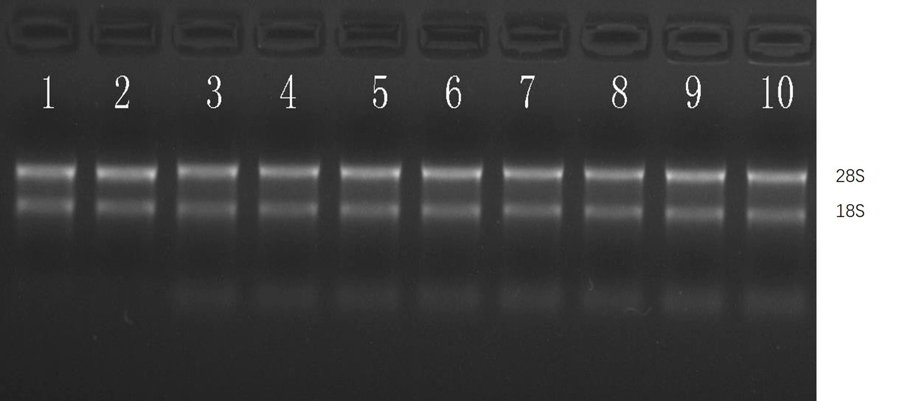

Supplementary Figure 2 KEGG enrichment analysis of upregulated mRNAs, showing the top 10 enrichment scores.
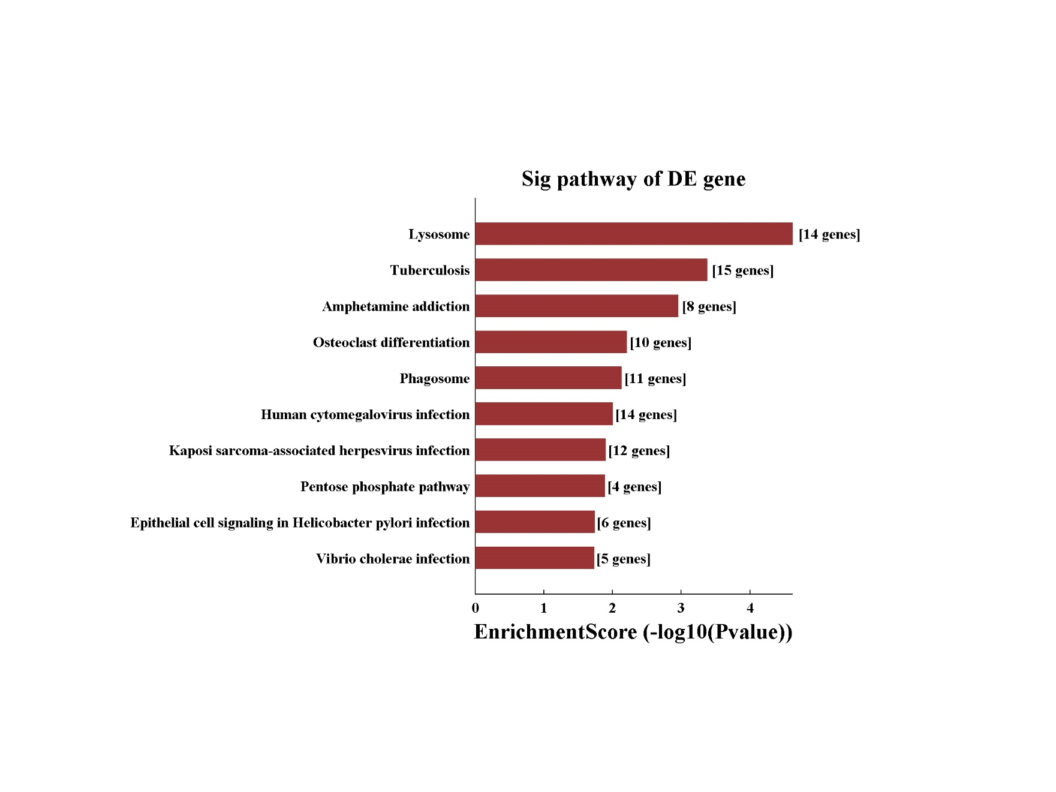

Supplementary Figure 3 KEGG enrichment analyses of downregulated mRNAs.
