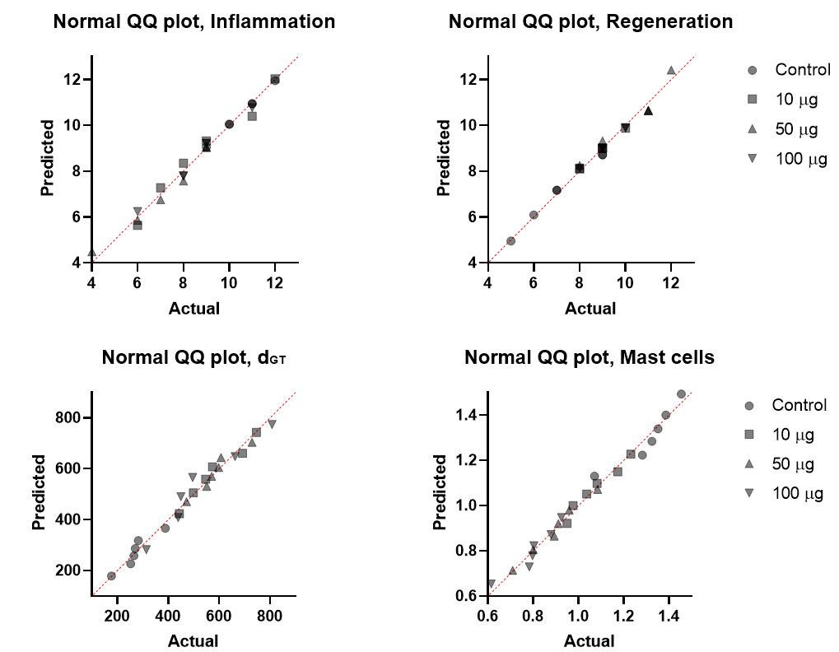

Supplementary Figure 1
1. Normal Q-Q Plots of the intensity of inflammation and regeneration, the thickness of granulation tissue, and the index of functional activity of mast cells (expression of vimentin).
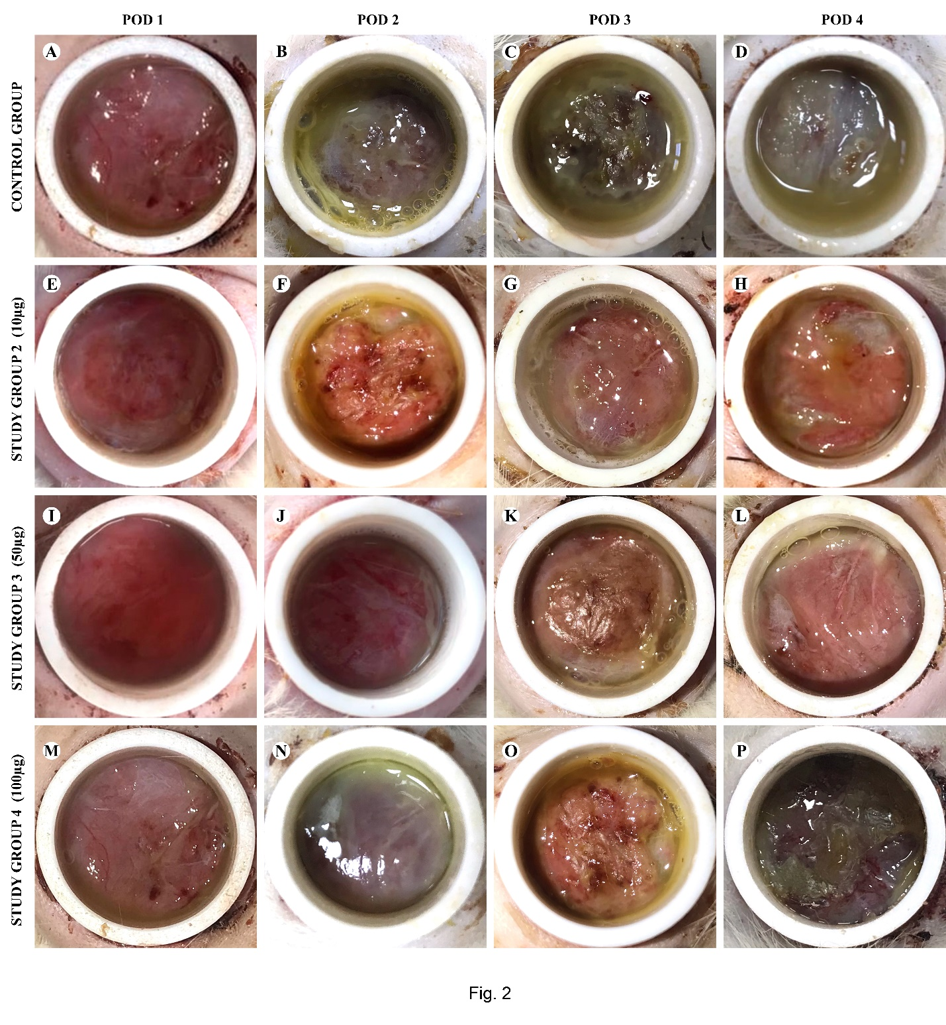

Supplementary Figure 2
2. Gross examination of wound bottoms in animals of the control and experimental groups on post-operative days 1, 2, 3 and 4. A – slight edema in the wound area, В – opaque exudate on the wound bottom, C – dense fibrin layer along the edges of the wound, D – moderate amount of exudate and dense fibrin clot in the wounds, Е – small amount of serous exudate on the wound bottom, F – hyperemia and hemorrhage on the wound bottom, G – moderate serous exudate and hyperemia of wound bottom, H - hyperemia and loose fibrin overlay in the wounds, I – clean and pink wound area, J – moderate hyperemia and edema of the wound area, K – serous exudate along the edges of the wound, L – fibrin along the edges of the wound, М – smooth and shining wound surface, N – serous exudate of the wound bottom, O – hemorrhage and poor serous exudate of the wound area, P – loose fibrin layer covers the wound bottom.

