Figure Legends
Figure S1 Progression-free survival (A) and overall survival (B) of patients treated with EP and EC.
EP, etoposide combined with cisplatin; EC, etoposide combined with carboplatin.
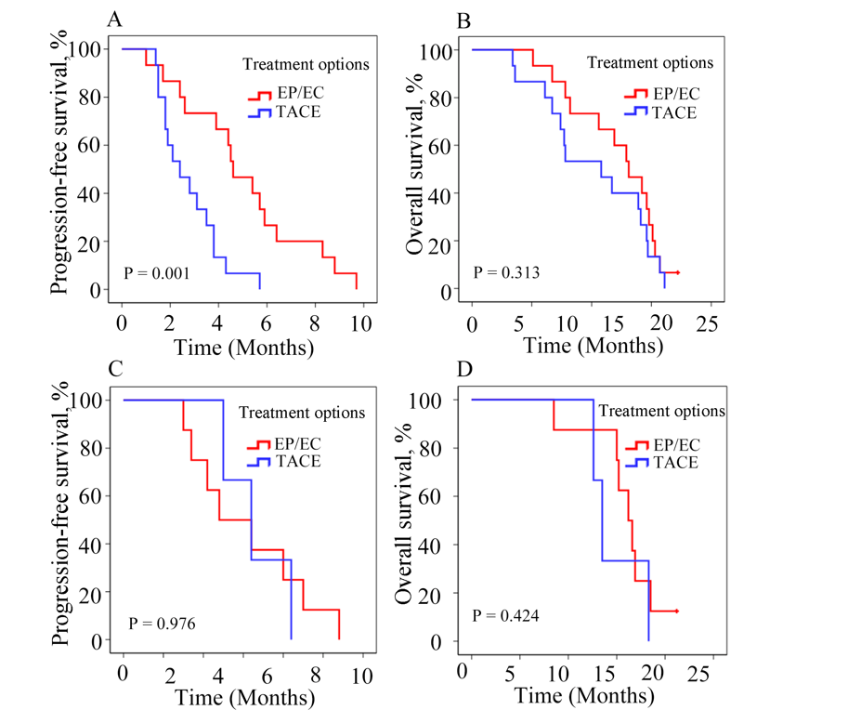
Figure S2 Progression-free survival (A) and overall survival (B) of patients with Ki-67 ≥ 55% who received EP/EC and TACE. Progression-free survival (C) and overall survival (D) of patients with Ki-67 < 55% who received EP/EC and TACE.
EP, etoposide combined with cisplatin; EC, etoposide combined with carboplatin; TACE, transcatheter arterial chemoembolization.

