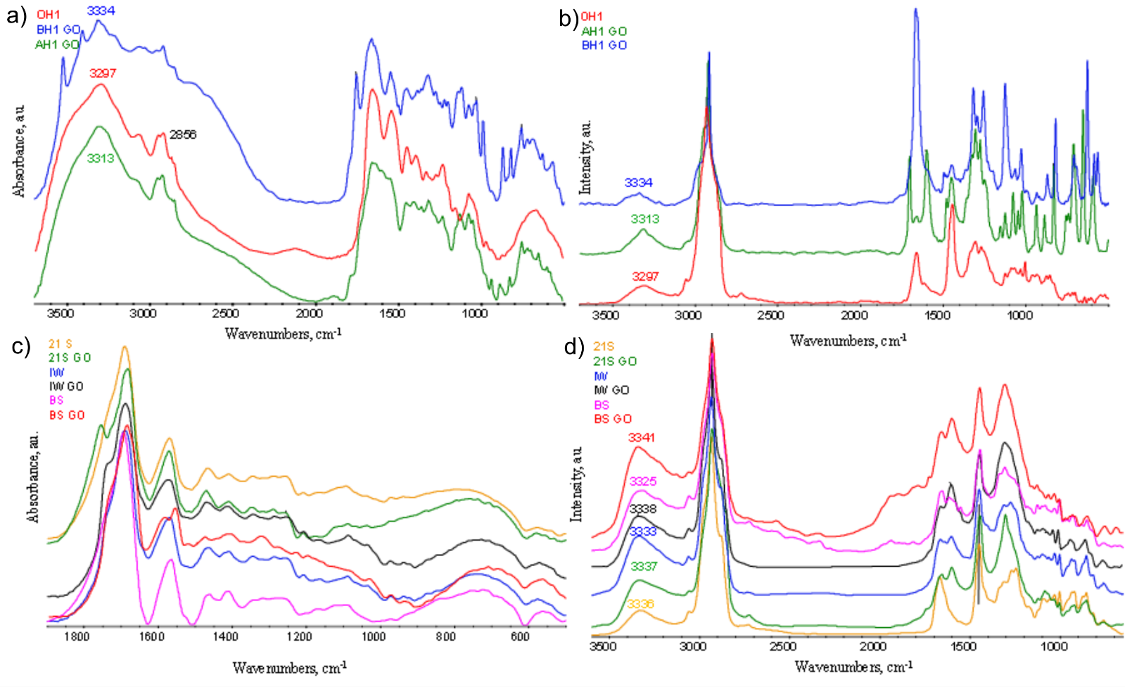
Figure S1 FTIR and FTR spectras: a-d) amniotic samples (BS, IW, OH1, BS GO, IW GO and AH1 SA GO, BH1 AA GO and c,d) fragments of skin (21S i 21S GO).

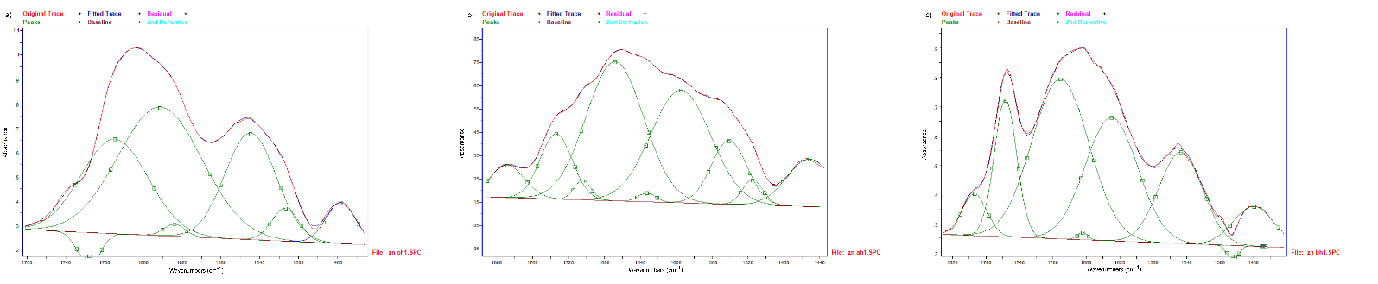
Figure S2. Fragment of FTIR spectra resolved into Gaussian-shaped bands at around 1750–1200 cm⁻¹ attributed to lipid-amide I–III bands of the hypotrophy amniotic samples (a) OH1 and samples in presence of AA or SA (b) AH1 SA, c) BH1 AA).

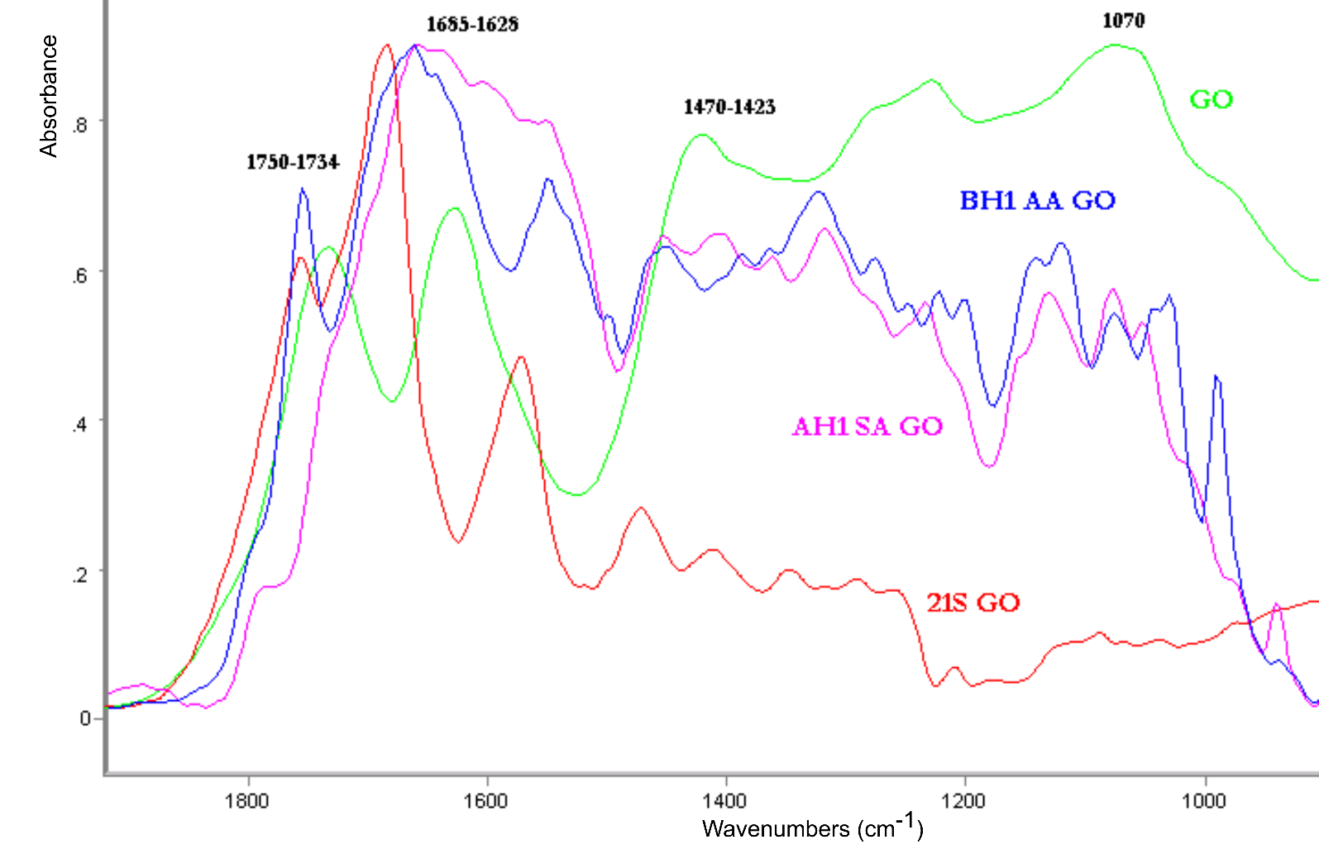
Figure S3. FTIR spectra: GO sample, fragments of skin 21S GO, amniotic samples (AH1 SA GO, BH1 AA GO).

