Appendices:
Appendix 1: The study brochure
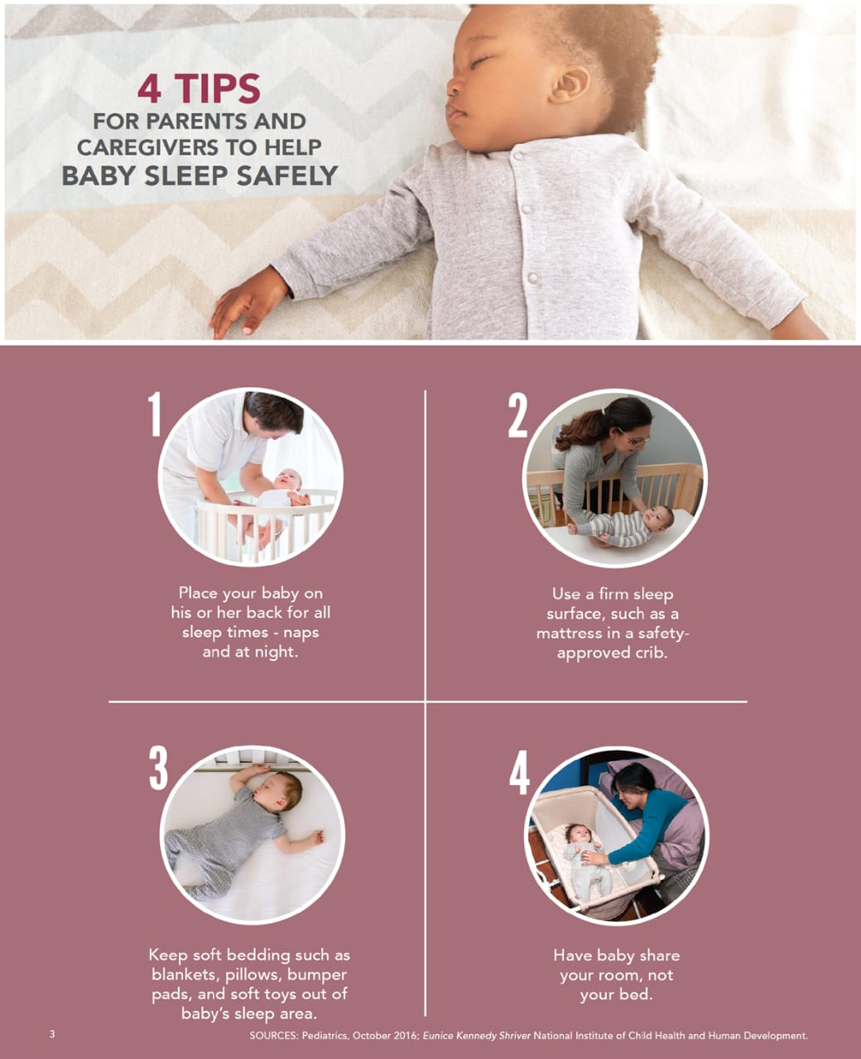
** It was translated to Arabic language for non-English speakers.
١

Appendix 2: The questionnaire tool.

This study is conducted by group of medical students with the supervision of pediatric neonatal consultant. The study aims to assess different domains including attitude, opinions, and knowledge of infant sleep practices. By completing this survey, you voluntary agree to participate in this study and give your consent to use your anonymous data for research purposes only. Your responses will .remain confidential
1.Maternal age:
- Under 20 years
- 20-25
- 26-35
- 36 – 40
- More than 40
- .Number of kids (other than the current newborn)
- 0
- 1
- 2 or more
3.Nationality:
- Saudi
- Non-Saudi (Mention the nationality):
4.Level of Education:
- - Less than high school
- - High school
- - University degree or higher
5.Did a doctor, nurse, or other health care worker talk with you about the safe sleep practices for your baby?
- Yes
- no
6.What is the type of feeding you are providing for your baby?
- Exclusive breast feeding
- Formula feeding
- Combined
7.What is the usual sleeping position for your baby?
- Supine
- Side
- Prone
8.Have you ever been smoker (either antenatally or post-nataly)?
- Yes
- No
9.Is there any one smoker at home ?
- Yes
- No
10.Do you usually sleep with your baby on the same room?
- Yes
- No
11.Does your baby usually sleep with you on the same bed?
- Yes
- No
12.DO you use any of the following in your baby bed?
- Duvet
- Pillow
- Cot bumper
- All
- None

