FigS1. Distribution of proportion of anti-infection programs
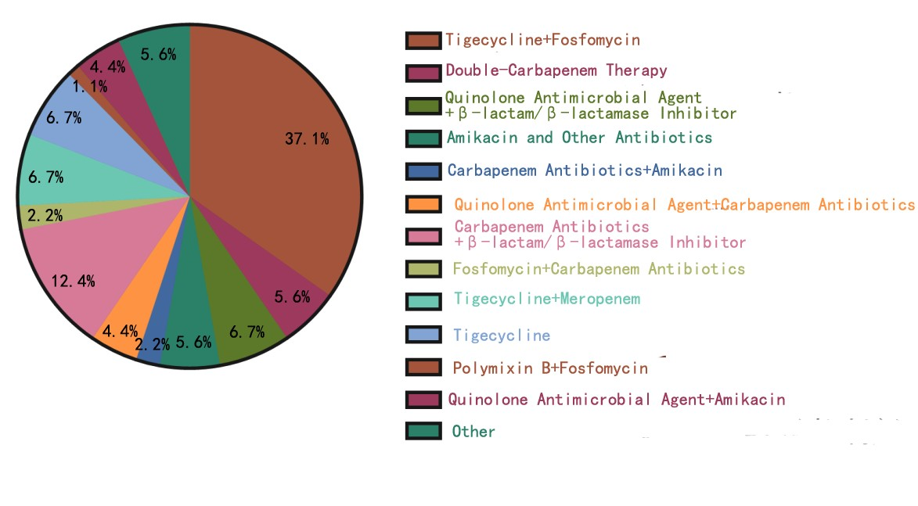
FigS2.Comparison of APACHE II score between survival group and non-survival group

FigS3. Comparison of lactate between survival group and non-survival group
