Supporting information

Associations between total sleep duration and cognitive function among middle-aged and older Chinese: Does midday napping affect on it?

Contents
Table S1. Associations between midday napping and cognitive function among the participants
Table S2. Associations between total sleep duration and cognitive function among the participants without dementia
Table S3. Associations between midday napping and cognitive function in different subgroups stratified by total sleep duration among the participants without dementia
Figure S1. Mean scores of cognitive functions in participants with different total sleep duration stratified by family lifestyles and depressive symptoms.
Figure S2. Association between total sleep duration and cognition function score stratified by current smoking and current drinking.

Table S1. Associations between midday napping and cognitive function among the participants

 | Midday Napping
 | Non-nappers | Short nappers | Moderate nappers | Extended nappers
Model Ⅰ | -1.420 (-1.711, -1.130) *** | Ref | -0.309 (-0.612, -0.007) * | -1.149 (-1.489, -0.808) ***
Model Ⅱ | -0.758 (-0.991, -0.526) *** | Ref | -0.240 (-0.481, 0.002) | -0.736 (-1.009, -0.463) ***
Model Ⅲ | -0.741 (-0.972, -0.510) *** | Ref | -0.243 (-0.483, 0.003) | -0.748 (-1.019, -0.478) ***
Model Ⅰ: Crude model
Model Ⅱ: Adjusted for gender, age, BMI, WC, residential locations, marital status, education level, current smoking, current drinking, social activity
Model Ⅲ: Multivariable model with additional adjusted for self-reported health status, hypertension, diabetes, depressive symptoms based on Model Ⅱ
*P < 0.05, ***P < 0.001.

Table S2. Associations between total sleep duration and cognitive function among the participants without dementia

 | Total sleep duration （hour） |  |  |  |  | P for trend  (5 to 7) | P for trend  (7 to 9)
 | ≤ 5 | 6 | 7 | 8 | ≥9 | P for trend  (5 to 7) | P for trend  (7 to 9)
Model Ⅰ | -2.313 (-2.590, -2.036)*** | -0.391 (-0.695, -0.087)* | Ref | -0.473 (-0.758, -0.187)*** | -1.134 (-1.401, -0.867)*** | <0.001 | <0.001
Model Ⅱ | -1.154 (-1.379, -0.930)*** | -0.333 (-0.576, -0.089)** | Ref | -0.405 (-0.634, -0.177)*** | -0.620 (-0.834, -0.406)*** | <0.001 | <0.001
Model Ⅲ | -0.991 (-1.216, -0.765)*** | -0.295 (-0.537, -0.052)* | Ref | -0.433 (-0.661, -0.206)*** | -0.670 (-0.883, -0.457)*** | <0.001 | <0.001
Model Ⅰ: Crude model
Model Ⅱ: Adjusted for gender, age, BMI, WC, residential locations, marital status, education level, current smoking, current drinking, social activity
Model Ⅲ: multivariable model with additional adjusted for self-reported health status, hypertension, diabetes, depressive symptoms based on Model Ⅱ
*P < 0.05, **P < 0.01, ***P < 0.001.

Table S3. Associations between midday napping and cognitive function in different subgroups stratified by total sleep duration among the participants without dementia †
Total sleep duration  (hour) | Midday napping duration
Total sleep duration  (hour) | Non-nappers | Short nappers | Moderate nappers | Extended nappers
Model Ⅰ
≤5 | -0.860 (-1.481, -0.240) ** |  | -0.764 (-1.515, -0.013) * | -2.082 (-3.343, -0.822) ***
6 | -1.208 (-1.865, -0.550) *** |  | -0.409 (-1.140, 0.321) | -1.932 (-2.969, -0.895) ***
7 | -0.896 (-1.489, -0.303) ** |  | -0.103 (-0.704, 0.498) | -1.781 (-2.575, -0.987) ***
8 | -2.138 (-2.795, -1.481) *** |  | -0.737 (-1.418, -0.057) * | -1.770 (-2.544, -0.995) ***
≥9 | -1.798 (-2.526, -1.071) *** |  | -0.056 (-0.692, 0.580) | -0.496 (-1.143, 0.151)
Model Ⅱ
≤5 | -0.695 (-1.178, -0.213) ** |  | -0.675 (-1.258, -0.092) * | -1.775 (-2.750, -0.800) ***
6 | -0.783 (-1.342, -0.223) ** |  | -0.315 (-0.937, 0.307) | -0.988 (-1.868, -0.108) *
7 | -0.642 (-1.136, -0.148) * |  | -0.016 (-0.518, 0.486) | -0.978 (-1.639, -0.317) **
8 | -0.788 (-1.323, -0.253) ** |  | -0.309 (-0.859, 0.240) | -0.775 (-1.407, -0.143) *
≥9 | -0.665 (-1.255, -0.076) * |  | -0.048 (-0.561, 0.465) | -0.380 (-0.902, 0.142)
Model Ⅲ
≤5 | -0.698 (-1.179, -0.218) ** | Ref | -0.668 (-1.249, -0.087) * | -1.762 (-2.736, -0.789) ***
6 | -0.793 (-1.352, -0.234) ** | Ref | -0.236 (-0.858, 0.387) | -0.904 (-1.783, -0.024) *
7 | -0.723 (-1.214, -0.232) ** | Ref | -0.071 (-0.570, 0.427) | -0.937 (-1.593, -0.282) **
8 | -0.753 (-1.283, -0.222) ** | Ref | -0.243 (-.789, 0.302) | -0.689 (-1.316, -0.062) *
≥9 | -0.674 (-1.260, -0.087) * | Ref | -0.007 (-0.517, 0.503) | -0.329 (-.849, 0.191)
†Model adjusted for gender, age, BMI, WC, residential locations, marital status, education level, current smoking, current drinking, social activity, self-rated health, hypertension, diabetes, depressive symptoms
*P < 0.05, **P < 0.01, ***P < 0.001.

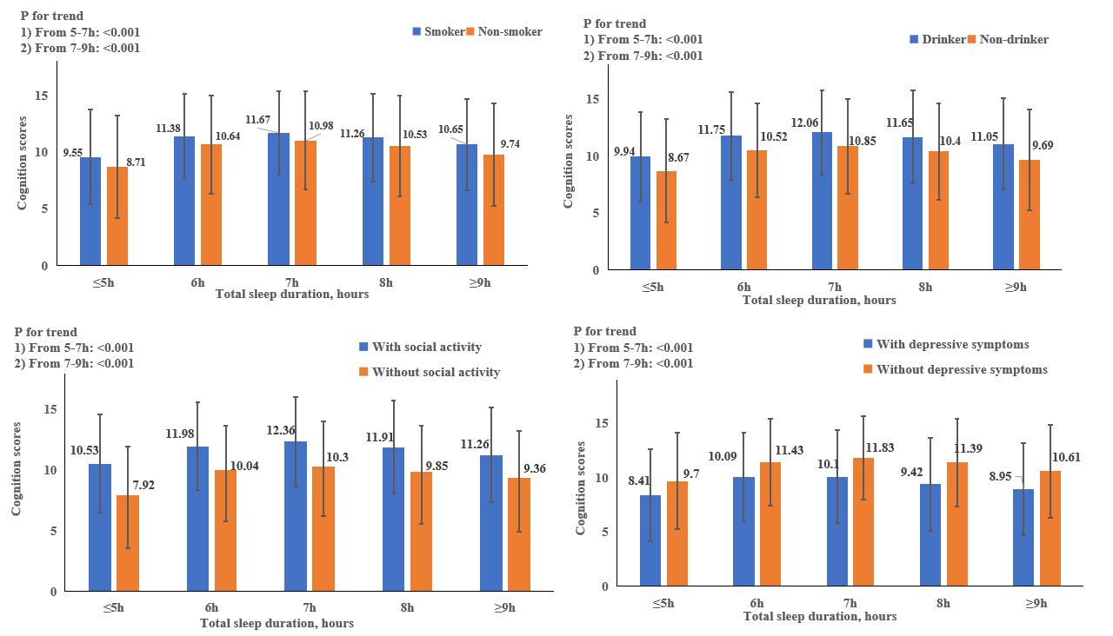
Figure S1. Mean scores of cognitive functions in participants with different total sleep duration stratified by family lifestyles and depressive symptoms.

Figure S2. Association between total sleep duration and cognition function score stratified by current smoking and current drinking.

*P < 0.05, **P < 0.01, ***P < 0.001.

