Supplementary Figure 1 Study flow chart

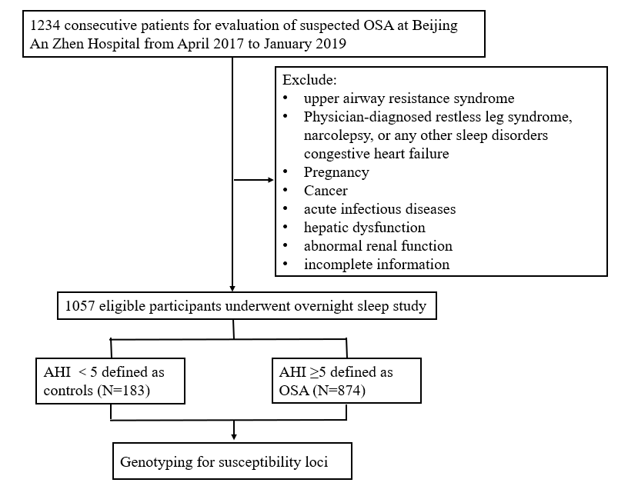

Supplemental table 1 Multivariable logistic regression analysis of SNPs in TNF gene with the risk of OSA

SNP | Genotypes | unadjusted |  | Model 1 |  |  | Model 2
SNP | Genotypes | OR (95%CI) | p-value | OR (95CI) | p-value | OR (95CI) |  | p-value
rs3093661 | GG(n=310) | 1 |  | 1 |  | 1
 | GA (n=30) | 3.682(1.089-12.44) | 0.036* | 4.090(1.089-15.361) | 0.037* | 3.938(1.026-15.109) |  | 0.046*
rs3093662 | AA(n=309) | 1 |  | 1 |  | 1
 | AG(n=31) | 3.836(1.137-12.94) | 0.030* | 4.449 (1.196-16.546) | 0.026* | 4.340 (1.1.43-16.480) |  | 0.031*
rs3093664 | AA(n=309) | 1 |  | 1 |  | 1
 | AG(n=31) | 3.836(1.137-12.94) | 0.030* | 4.449 (1.196-16.546) | 0.026* | 4.340 (1.1.43-16.480) |  | 0.031*
Model 1: adjusted for age, sex, BMI, Smoker and Drinker
Model 2: adjusted for Model 1 + TG, TC, LDL-C, HDL-C and FBG.
*P<0.05.

Supplemental table 2 PCR primer of 9 SNPs

SNP_ID | 2nd-PCRP | 1st-PCRP | UEP_SEQ
rs3093661 | ACGTTGGATGATCAGCG  CACATCTTTCACC | ACGTTGGATGCCAGCC  TTCATCCACTCTC | TCTCTCTCCCTCTCTTG
rs3093664 | ACGTTGGATGCGAGTCC  TTCTCACATTGTC | ACGTTGGATGAGCTCT  GAGGATGTGTCTTG | CATCAGCCGGGCTTCAA
rs1801282 | ACGTTGGATGTGTATCAG  TGAAGGAATCGC | ACGTTGGATGCAAACC  CCTATTCCATGCTG | TGAAGGAATCGCTTTCTG
rs4686803 | ACGTTGGATGTCGGCTTA  CTGCAACCTTTG | ACGTTGGATGATGGTG  GTAGGCACCTGTGG | AACCTTTGCCTCCCAGGTT
rs1063537 | ACGTTGGATGGGTTGAGG  TAGTTGATGGTG | ACGTTGGATGGAGAAT  GCTATTTACTCTG | ACAATAACTCCAGTGATGTT
rs3093662 | ACGTTGGATGTCTTAGCCC  TGAGGTGTCTG | ACGTTGGATGGGAAAGA  GCTGTTGAATGCC | GGTTTTCTCTCTCCATTCATC
rs2241766 | ACGTTGGATGCCTTGAGTC  GTGGTTTCCTG | ACGTTGGATGTGCTGGG  AGCTGTTCTACTG | AGTCGTGGTTTCCTGGTCATG
rs3774262 | ACGTTGGATGATTATGGGA  GCCTCCATGTC | ACGTTGGATGAGAAACC  AATAAGAGCTCCC | TCTGTGGGAGATATAGAAGGA
rs2082940 | ACGTTGGATGACTATCTTTT  TGCTTACAG | ACGTTGGATGGACAAAG  CTTTATATGTGG | TCTTTTTGCTTACAGTTTTAAAT

Supplemental table 3 Hardy-Weinberg equilibrium

SNP | Genotype |  |  | Controls |  |  |  |  |  | Cases
SNP |  | Actual |  |  | Expected |  | χ2 | P | Actual |  | Expected |  |  | χ2 | P
rs1063537 | CC | 109 |  |  |  | 110.96 | 0.71 | 0.70 |  | 465 |  | 469.38 | 0.57 |  | 0.75
 | CT |  | 67 |  |  | 63.07 |  |  |  | 351 |  | 342.24
 | TT |  | 7 |  |  | 8.96 |  |  |  | 58 |  | 62.38
rs2082940 | CC | 108 |  |  |  | 109.41 | 0.35 | 0.84 |  | 461 |  | 465 | 0.47 |  | 0.79
 | CT |  | 67 |  |  | 64.18 |  |  |  | 353 |  | 345.01
 | TT |  | 8 |  |  | 9.41 |  |  |  | 60 |  | 64
rs4686803 | CC | 109 |  |  |  | 110.96 | 0.71 | 0.70 |  | 462 |  | 466.46 | 0.59 |  | 0.75
 | CT |  | 67 |  |  | 63.07 |  |  |  | 353 |  | 3444.09
 | TT |  | 7 |  |  | 8.96 |  |  |  | 59 |  | 63.46
rs2241766 | TT | 109 |  |  |  | 110.96 | 0.71 | 0.70 |  | 458 |  | 462.81 | 0.67 |  | 0.71
 | TG |  | 67 |  |  | 63.07 |  |  |  | 356 |  | 346.38
 | GG |  | 7 |  |  | 8.96 |  |  |  | 60 |  | 64.81
rs3774262 | GG |  | 109 |  |  | 110.96 | 0.71 | 0.70 |  | 462 |  | 467.19 | 0.80 |  | 0.67
 | GA |  | 67 |  |  | 63.07 |  |  |  | 354 |  | 343.63
 | AA |  | 7 |  |  | 8.96 |  |  |  | 58 |  | 63.19
rs3093661 | GG |  | 172 |  |  | 172.17 | 0.18 | 0.92 |  | 798 |  | 798.70 | 0.31 |  | 0.86
 | GA |  | 11 |  |  | 10.67 |  |  |  | 75 |  | 73.61
 | AA |  | 0 |  |  | 0.17 |  |  |  | 1 |  | 1.70
rs3093662 | AA |  | 172 |  |  | 172.17 | 0.18 | 0.92 |  | 795 |  | 795.83 | 0.41 |  | 0.81
 | AG |  | 11 |  |  | 10.67 |  |  |  | 78 |  | 76.34
 | GG |  | 0 |  |  | 0.17 |  |  |  | 1 |  | 1.83
rs3093664 | AA | 172 |  |  |  | 172.17 | 0.18 | 0.92 |  | 796 |  | 796.79 | 0.38 |  | 0.83
 | AG | 11 |  |  |  | 10.67 |  |  |  | 77 |  | 75.43
 | GG | 0 |  |  |  | 0.17 |  |  |  | 1 |  | 1.79
rs1801282 | GG | 153 |  |  |  | 154.23 | 1.46 | 0.48 |  | 776 |  | 774.98 | 0.40 |  | 0.82
 | GC | 30 |  |  |  | 27.54 |  |  |  | 94 |  | 96.05
 | CC | 0 |  |  |  | 1.23 |  |  |  | 4 |  | 2.98

Supplemental table 4 Characteristics of participants

 | Control | Mild OSA | Moderate OSA | Severe OSA | P-value
N | 183 | 272 | 266 | 336
Male (n, %) | 122 (67.03%) | 214 (78.39%) | 231 (86.84%) | 294 (87.50%) | <0.001**
Age (years) | 50.54 ± 14.25 | 54.86 ± 12.16 | 54.08 ± 11.49 | 49.75 ± 12.36 | <0.001**
BMI (kg/m²) | 24.68 ± 3.83 | 26.35 ± 3.77 | 27.53 ± 3.48 | 29.26 ± 3.91 | <0.001**
SBP (mmHg) | 126.95 ± 19.69 | 130.26 ± 18.14 | 131.51 ± 19.65 | 131.79 ± 18.42 | 0.037*
DBP (mmHg) | 78.09 ± 14.37 | 79.36 ± 13.02 | 80.96 ± 14.31 | 83.57 ± 14.39 | <0.001**
HDL-C#(mmol/L) | 1.15 (0.99-1.36) | 1.10 (0.92-1.30) | 1.04 (0.89-1.24) | 1.06 (0.91-1.24) | <0.001**
LDL-C(mmol/L) | 2.71 ± 0.82 | 2.65 ± 0.94 | 2.55 ± 0.97 | 2.88 ± 0.93 | <0.001**
TC (mmol/L) | 4.49 ± 1.13 | 4.48 ± 1.19 | 4.47 ± 1.19 | 4.79 ± 1.17 | 0.001*
TG# (mmol/L) | 1.29 (0.95-1.72) | 1.54 (1.09-2.23) | 1.50 (1.12-2.18) | 1.78 (1.21-2.48) | <0.001**
FPG (mmol/L) | 5.37 ± 1.73 | 8.46 ± 36.19 | 5.77 ± 2.73 | 5.82 ± 2.23 | 0.219
AHI (times/h) | 2.31 ± 1.33 | 9.60 ± 2.72 | 21.72 ± 4.15 | 50.74 ± 16.92 | <0.001**
Drinker (n, %) | 70 (38.46%) | 100 (36.76%) | 106 (39.85%) | 167 (49.70%) | 0.005*
Smoker (n, %) | 69 (37.91%) | 129 (47.25%) | 116 (44.11%) | 153 (45.81%) | 0.233
ESS score# | 6 (3-10) | 6 (3-10) | 7 (4-11) | 9 (5-14) | <0.001**
Berlin Questionnaire  high risk (n, %) | 35 (27.78%) | 103 (38.29%) | 127 (54.04%) | 228 (74.75%) | <0.001**
Values were expressed as mean ± standard deviation, median ± interquartile range or n (%).
#Data were asymmetrically distributed and expressed as median ± interquartile
Differences between groups were analyzed by independent Student t-test, Fisher’s exact test, χ2 test, or Wilcoxon test.
Abbreviations: OSA, Obstructive sleep apnea; BMI, body mass index; SBP, systolic blood pressure; DBP, diastolic blood pressure; FPG, fasting plasma glucose; TG, triglycerides; TC, total cholesterol; LDL-C, low-density lipoprotein cholesterol; HDL-C, high-density lipoprotein cholesterol; AHI, apnea-hypopnea index; ESS, Epworth Sleepiness Scale
*P<0.05, **P<0.001

