Single nuclear RNA sequencing highlights intra-tumoral heterogeneity and tumor microenvironment complexity in testicular embryonic rhabdomyosarcoma

Xuezheng Xu^{1#}, Zhizhong Liu^{2#}, Yi Li³, Liqing Fan^{4,5}, Shuang Wang⁶, Jie Guo⁷, Yanwei Luo^{8*} and Hao Bo^{4,5*}

1. Department of Orthopaedics, Hunan Cancer Hospital and The Affiliated Cancer Hospital of Xiangya School of Medicine, Central South University, Changsha, 410013, China.
2. Department of Urology, Hunan Cancer Hospital and The Affiliated Cancer Hospital of Xiangya School of Medicine, Central South University, Changsha, 410013, China.
3. Department of Obstetrics, the First Hospital of Changsha, Changsha, 410005, China.
4. Clinical Research Center for Reproduction and Genetics in Hunan Province, Reproductive and Genetic Hospital of CITIC-Xiangya, Changsha, 410078, China.
5. NHC Key Laboratory of Human Stem Cell and Reproductive Engineering, Institute of Reproductive and Stem Cell Engineering, Central South University, Changsha, 410078, China.
6. Medical Research Center and Clinical Laboratory, Xiangya Hospital, Central South University, Changsha, 410008, China.
7. National Institution of Drug Clinical Trial, Xiangya Hospital, Central South University, Changsha, 410008, China.
8. Department of Blood Transfusion, the Third Xiangya Hospital of Central South University, Changsha, 410013, China.

# Xuezheng Xu and Zhizhong Liu contributed equally to this work.
*Corresponding author: Yanwei Luo: royalway@csu.edu.cn; Hao Bo: 1172881652@qq.com.

Fig S1 The well-known markers across the cell types identified in testicular ERMS. (A) Violin plots displaying the expression of representative well-known markers across the cell types identified in testicular ERMS. (B) UMAP plot shows expression of specific markers of T cell and B cell. (C) Heatmap of specific markers in each cell type.

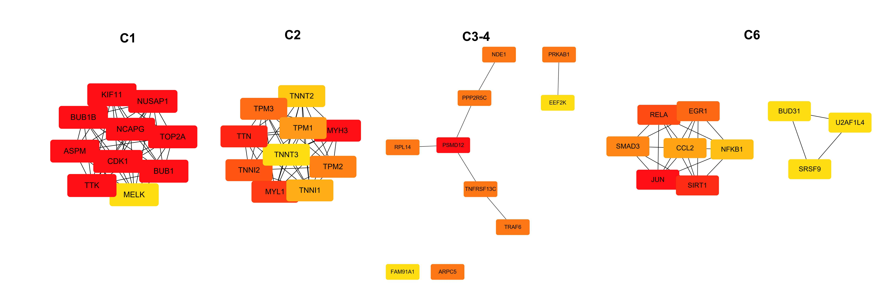
Fig S2 A simplified scheme showing the functional interaction network of the representative marker genes in the 6 subclusters.

Fig S3 (A) Heatmap showing expression levels of DEGs in cancer cells and myoid cells. (B) UMAP plot shows expression of 4 downregulated transcription factors in myoid cells.

Fig S4 (A) SCENIC analysis of 3 subgroups of macrophages. (B) The pathway enrichment of GSEA of the 50 hallmark gene sets in MSigDB database among the 3 subgroups of macrophages.

