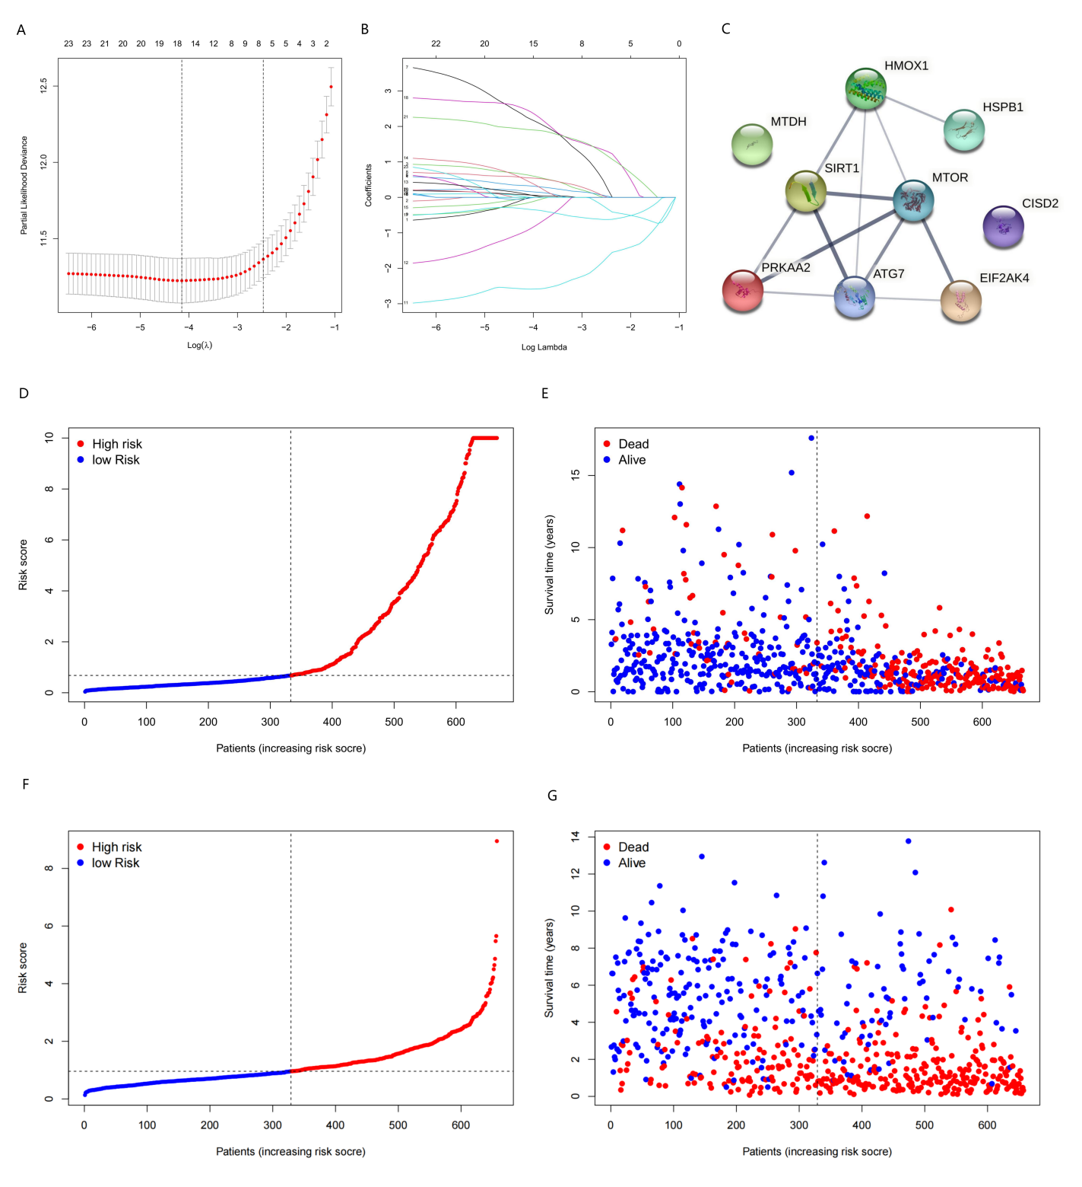
Figure S1
Construction of prognostic gene signature. (A) LASSO coefficient profiles of 23 potential prognostic genes. Each curve corresponds to a gene. (B) Selection of the optimal parameter in LASSO regression with 10-fold cross-validation. (C) The PPI network downloaded from the STRING database indicated the interactions among the nine AD-FRGs. (D) Distribution of risk score in the TCGA cohort. (E) Scatter plot of patients with different survival statuses in the TCGA cohort. (F) Distribution of risk score in the CGGA cohort. (G) Scatter plot of patients with different survival statuses in the CGGA cohort. LASSO, the least absolute shrinkage and selection operator Cox regression model.
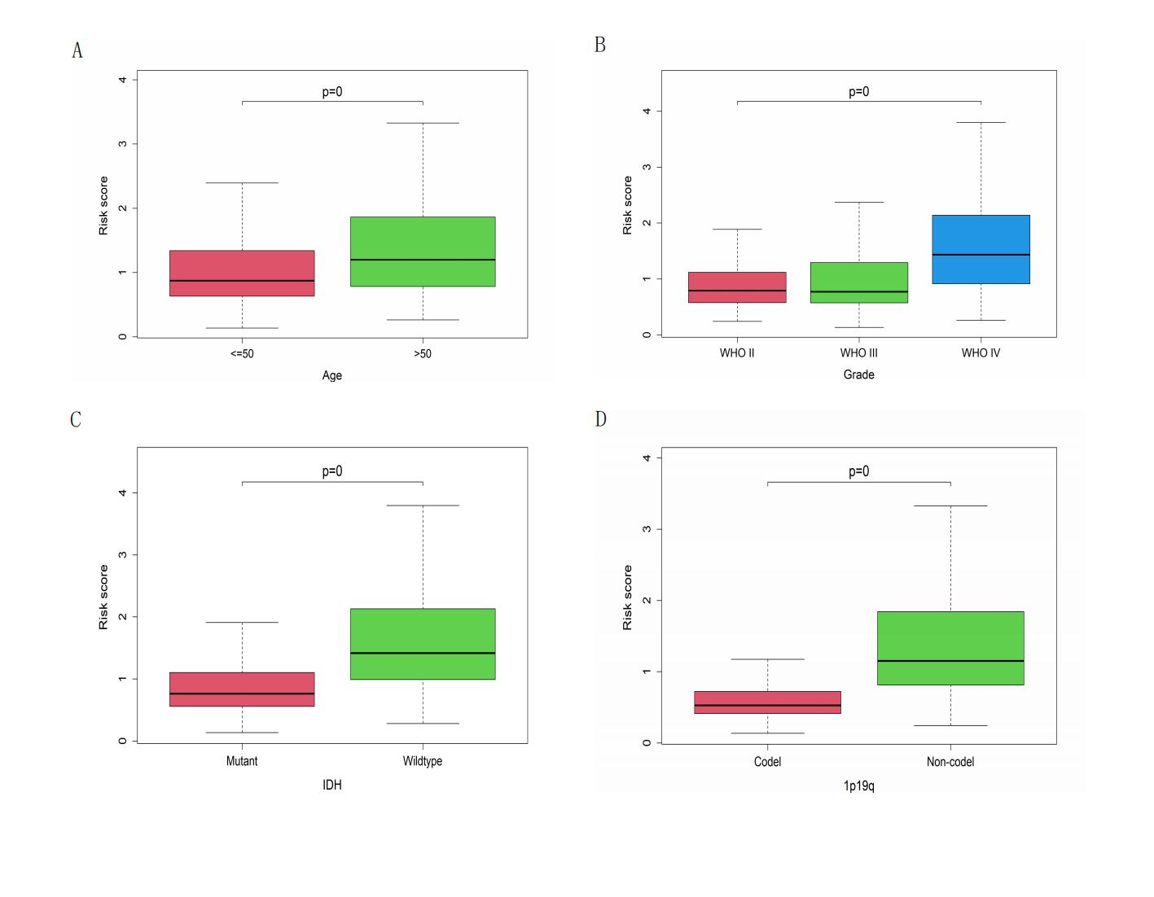

Figure S2
Relationship between nine-gene signature and clinical covariates. The risk score was significantly correlated with age(A), WHO stage(B), IDH status(C) and 1p/19q co-deletion status(D).
IDH, the isocitrate dehydrogenase.

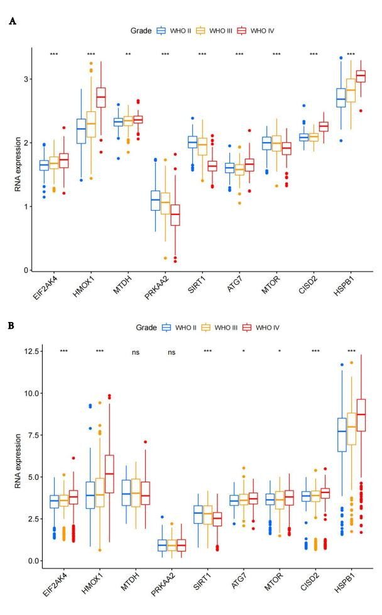
Figure S3
Relationship between gene expression and clinical covariates. The expression of nine genes can effectively distinguish tumor grade in the training cohort(A) and validation cohort(B). *P < 0.05, **P < 0.01, ***P < 0.001.

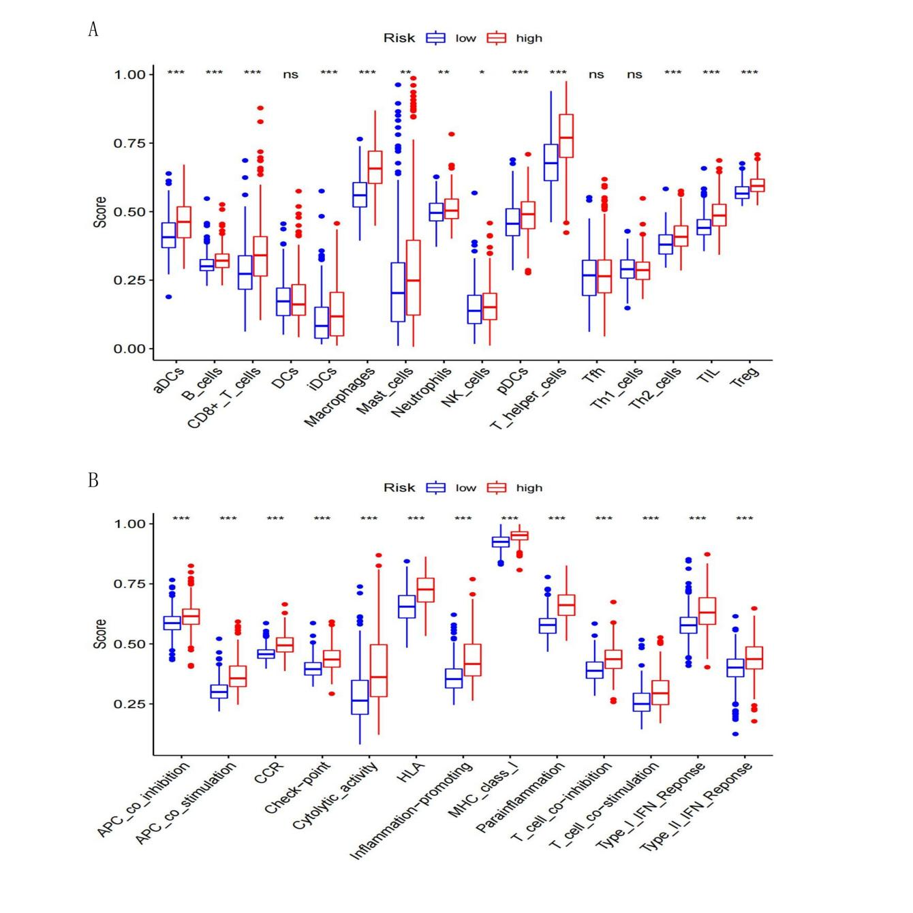

Figure S4
Single sample gene set enrichment analysis. The ssGSEA was used to estimate the 16 immune cell scores(A) and 13 immune-related functions(B) in the CGGA cohort. *P < 0.05, **P < 0.01, ***P < 0.001.

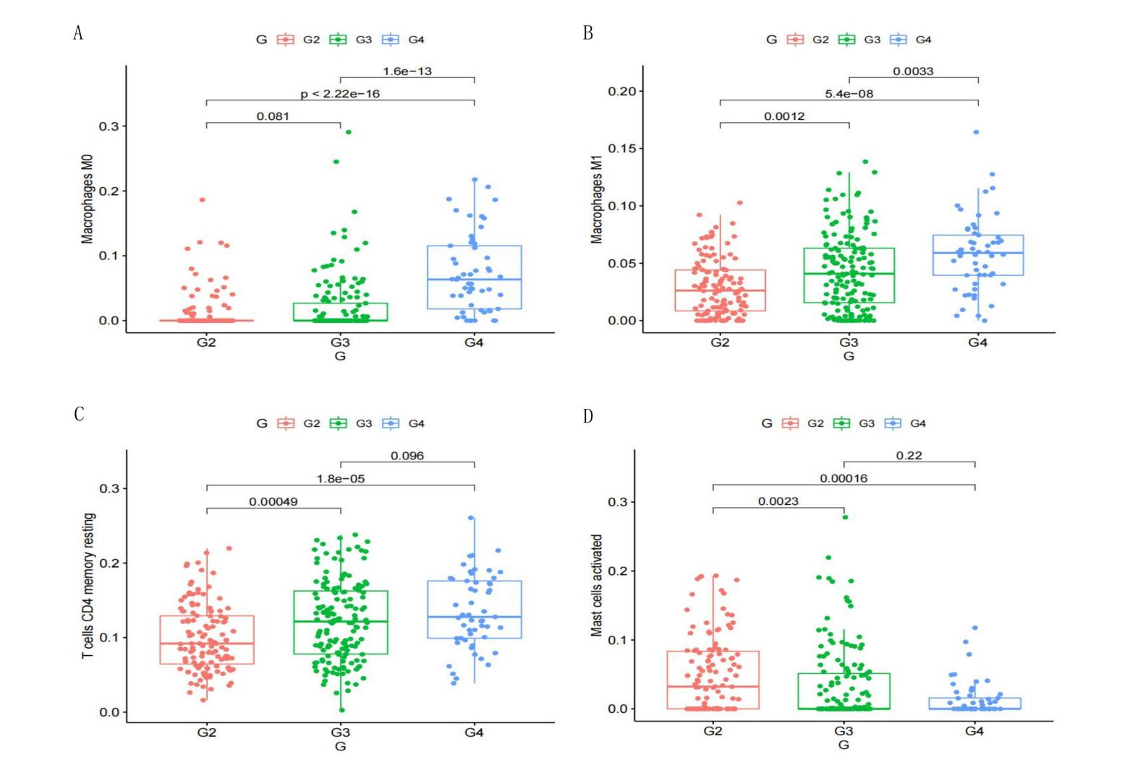
Figure S5
The proportion of macrophage M0(A), macrophage M1(B), T cells CD4 memory resting(C) and mast cells activated(D) was significantly correlated with WHO grade.

