Supporting information
sFigure 1. Comparison of GV content and size among the three different Microcystis strains. A: Transmission electron microscopy sections of Microcystis strains FACHB930, FACHB1326 and FACHB2329. B: In the sections of the three Microcystis cells, the percentage GV area to the total cell area was measured. C: The diameter distribution of the purified GVs from these three strains. D: The length distribution of the purified GVs from these three strains.

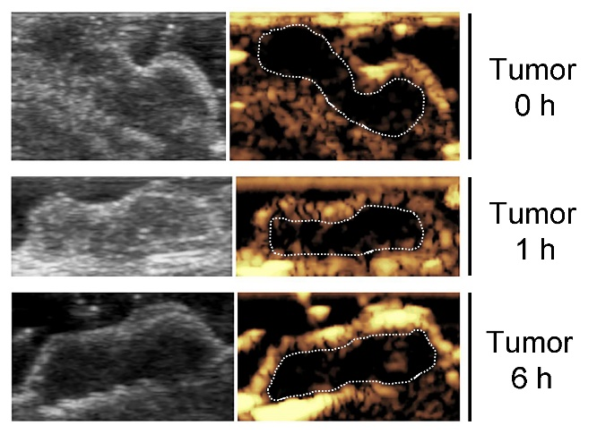
sFigure 2. The contrast signal could barely be detected in the tumor after a short time (0 hour, 1 hour and 6 hours) GV-injection.

B
A
sFigure 3. Blood biochemistry (A) and blood routine examinations (B) of C57 mice after receiving GV injection for 24 hours. The unit of ALT, AST and ALP are U L⁻¹; the units of BUN and CREA are mg dl⁻¹ and μmol L⁻¹, respectively; the units of WBC, Lymph#, Mon#, Gran# and PLT are 10⁹ L⁻¹, the units of Lymph%, Mon%, Gran%, HCT and RDW are %; the units of HGB and MCHC are g L⁻¹; the units of MCV and MPV are fL; the units of RBC and MCH are 10¹² L⁻¹ and pg, respectively. Injection of PBS with same volume was set as control groups.

sFigure 4. Characterization of representative inflammatory factors such as TNF-alpha, IL-1 beta and IL-6 after receiving intravenous injection with GVs for 24 hours. Injection of PBS with same volume was set as control groups.

sFigure 5. The cellular level safety of GVs. HEK293 cells and EJ cells cultured in 96-well plate were incubated with 10 μl GVs (OD500=2) or PBS (control) for 24 hours prior to the detection of cell viability using the CCK-8 assay.

