Supplementary Appendix

Methods
Model Details
Module 1
Let $i=1,...,N$ and denote the index for each patient in the trial, and let $j=1,...,J=5$ denote the scheduled times at which the data were collected over the duration of the study (ie at 4, 16, 28, 40, and 52 weeks). The first module explicitly handled the excess zeros, which were separately modeled with respect to the other HRU values. Specifically, for each subject and time point an indicator variable $d_{ij}$ was created, taking the value 1 if the $i$-th individual was associated with a zero HRU at all time points (denoted with $y_{ij}^{0}$) and 0 if the individual was associated with at least a positive HRU value at some time point (denoted with $y_{ij}^{>=0}$). These indicator variables are then modeled as
$$\begin{matrix}d_{ij} & ∼\text{Bernoulli}(π_{ij}^{d}) \\ \text{logit}(π_{ij}^{d}) & =αX\end{matrix}$$

where $π_{ij}^{d}$ was the individual probability of zero HRU, which was estimated on the logit scale as a function of a set of regression parameters $α$ and covariates $X$. In the base-case scenario, the covariates included in the model were those used in the main IMPACT analyses for primary endpoints: treatment group, gender, exacerbation history (≤1, ≥2 moderate/severe), smoking status, geographical region, and post-bronchodilator percent predicted forced expiratory volume in 1 second (FEV₁).¹ To account for the variability in healthcare systems across $s=1,...,S=6$ geographical regions, random effects intercept terms were included in the model. This allows to ‘borrow strength’ across different clusters and potentially improves the estimates.

Module 2
In the second module, the HRU data for each individual at each time point (denoted with $y_{ij}$) were modeled using a Negative Binomial distribution, based on a generalized linear regression for the rate parameter $λ_{i,j}$ as
$$\begin{matrix}y_{ij} & ∼\text{Negative Binomial}(λ_{ij},r_{j}) \\ \text{log}(λ_{ij}) & =βX\end{matrix}$$
where, $r_{j}$ was an overdispersion parameter. Notice that, by means of the logistic regression in Module 1 for estimating the probability of having excess zeros, $y_{ij}$ was in fact modeled using a mixture approach to account for the potential route from which the data arise (ie ‘pure 0 counts’ vs ‘pure ≥0 counts’). This mixture depended on weights that were estimated in Module 1 above. The generalized linear model in Module 2 also depended on the same set of covariates $X$ included in Module 1, whose impact was captured by a set of regression parameters $β$.

Module 3
In the final module, the missingness mechanism was explicitly specified in terms of a model for the probability of being missing at time $j=2,...,J$. Indeed, since missingness in the trial was monotone and all HRU values were observed at $j=1$, Module 3 was only defined for the successive time points, while at $j=1$ only Module 1 and Module 2 were specified. For each individual and relevant time point a second indicator variable $m_{ij}$ was created, which takes value 1 or 0 according to whether the subject had withdrawn or not from the study at time $j$. The missingness indicator variables were then modeled using logistic regression as
$$\begin{matrix}m_{ij} & ∼\text{Bernoulli}(π_{ij}^{m}) \\ \text{logit}(π_{ij}^{m}) & =γV+δ_{1}y_{ij-1}+δ_{2}y_{ij}\end{matrix}$$
where, $π_{ij}^{m}$ is the individual probability of being missing at time $j$, which was estimated on the logit scale as a function of a set of covariate variables $V$ and the HRU data at time $j-1$ and $j$, respectively, indexed by the regression parameters $γ$, $δ_{1}$, and $δ_{2}$. The set of covariates included in the missingness model $V$ was formed by the same covariates included in Module 1 and Module 2 and an additional set of missingness predictors $Z$, which were identified in the feasibility assessment, ie $V=\left(X,Z\right)$.

The inclusion of $y$ in the model allows for a MNAR mechanism, where the probability of missingness at time $j$ depends on the outcome at the same and previous time, and whose impact was captured by the parameters $δ_{1}$ and $δ_{2}$, respectively. We set both $δ_{1}$ and $δ_{2}$ to 0 to define a MAR mechanism. Different scenarios were considered to assess the sensitivity of the results to different MNAR assumptions about the time dependence structure between the probability of being missing and the unobserved HRU values. The alternative MNAR scenarios assessed are:
- MNAR1: The probability of being missing at $j$ depends on the HRU values at $j$, ie $δ_{1}=0$.
- MNAR2: The probability of being missing at $j$ depends on the HRU values at $j-1$, ie $δ_{2}=0$.
- MNAR3: The probability of being missing at $j$ depends on the HRU values at $j$ and $j-1$.

We set MNAR3 as the base-case scenario as this was considered the most plausible missingness assumption based on the results from the descriptive analysis. Within a Bayesian framework, prior distributions need to be specified for the relevant model parameters in each module. In the base-case scenario, inference was stabilized by assuming relatively small effects for the regression parameters, which could be considered reasonable as all the regression models were on a logit or log scale. Therefore, prior distributions in the form of Normals centered on 0 and with standard deviation of 5 were based on the assumption that the relative risk (RR) or odds ratio (eg for the treatment effect, or for the impact of a given covariate in the probability of missingness) were very unlikely to exceed reasonable values. In Module 3, in the base-case scenario, point priors at 0 are assumed for $δ_{1}=0$ and $δ_{2}=0$, which defines a MAR mechanism. In the alternative missingness scenarios, a series of normal priors with unit variance are specified for these parameters, ie $δ∼N\left(0,1\right)$.

Finally, a sensitivity analysis was conducted to assess the potential impact of the modeling assumptions used in the base-case scenario for each module. Some examples of these checks include: probit link functions for the regression models in Module 1 and Module 3; Poisson distributions for the model of the HRU data in Module 2; and Normal priors centered at 0 with standard deviations of 3 for the regression parameters in all three modules.

The model was implemented and the marginal HRU rates derived at each time $μ_{j}$ through Monte Carlo integration. At each iteration of the posterior distribution, we generated a large number of samples for $y_{ij}$ based on the posterior values for the parameters of the models in the Markov chain Monte Carlo (MCMC) output.² We then approximated the posterior distribution of the marginal HRU rates by taking the expectation over these sampled values at each iteration. Finally, we derived the overall marginal rates $μ$ over the trial period by summing the HRU rates at each time point.

Results
- Baseline characteristics for patients who completed the study and those who withdrew are included in Supplementary Table 4.
- Supplementary Tables 1‒3 and Supplementary Figures 3–8 include the PPPY and 95% credible intervals across all missingness scenarios by type of HRU.
- Across the four missingness scenarios explored, the adjusted PPPY rates for all types of HRU were lower in those patients who received FF/UMEC/VI when compared with treatment with either FF/VI or UMEC/VI under the same missingness assumptions (Table 1, Supplementary Tables 1‒3). This was confirmed in the sensitivity analyses across all assumptions of missingness that were explored (Supplementary Figures 3–8). Under each MNAR scenario, the per patient HRU rates were similar across all groups (Supplementary Figure 9).
- For PPPY total costs over the duration of the trial, the 95% credible intervals under all missingness scenarios do not contain 0, with the results of MNAR3 and MAR being associated with the largest and smallest negative differences in favor of FF/UMEC/VI compared with FF/VI and UMEC/VI (Supplementary Table 5, Supplementary Figure 10). Overall, the results across the MNAR scenarios for the total costs show absolute values that are generally higher than those obtained under MAR, but with relative cost differences that always favor FF/UMEC/VI over both FF/VI and UMEC/VI.
- Mean HRU values were systematically higher at all time points compared for those patients who withdrew compared with those who completed the study (Supplementary Figure 1). In addition, the patients who withdrew from the study were also associated with lower proportion of zeros at each time (Supplementary Figure 2).

Table S1 Mean and 95% credible intervals of the PPPY rates for each type of HRU over the IMPACT trial duration by treatment group under MNAR1. The results for the rate ratios between FF/UMEC/VI and FF/VI or UMEC/VI, and between FF/VI and UMEC/VI, are also reported for each type of HRU.
Adjusted HRU PPPY rates (mean, 95% CrI) | FF/UMEC/VI  (n=4,151) | FF/VI  (n=4,134) | UMEC/VI  (n=2,070)
Hospital (GW) | 1.68 (1.46; 1.97) | 1.80 (1.55; 2.11) | 1.84 (1.58; 2.15)
Rate ratio (GW) -FF/UMEC/VI | – | 0.94 (0.90; 0.97) | 0.92 (0.88; 0.95)
Rate ratio (GW) - FF/VI | – | – | 0.98 (0.95; 1.02)
Hospital (IC) | 0.25 (0.19; 0.33) | 0.33 (0.27; 0.41) | 0.34 (0.27; 0.43)
Rate ratio (IC) - FF/UMEC/VI | – | 0.75 (0.52; 1.06) | 0.74 (0.51; 1.04)
Rate ratio (IC) - FF/VI | – | – | 0.99 (0.71; 1.33)
Home care visit (HV) | 0.07 (0.06; 0.07) | 0.07 (0.07; 0.08) | 0.07 (0.07; 0.08)
Rate ratio (HV) -FF/UMEC/VI | – | 0.94 (0.90; 0.97) | 0.92 (0.89; 0.95)
Rate ratio (HV) - FF/VI | – | – | 0.98 (0.95; 1.02)
Office visit (OV) | 0.96 (0.94; 0.99) | 1.03 (1.01; 1.05) | 1.05 (1.03; 1.08)
Rate ratio (OV) -FF/UMEC/VI | – | 0.93 (0.93; 0.94) | 0.92 (0.91; 0.93)
Rate ratio (OV) - FF/VI | – | – | 0.98 (0.97; 0.99)
Urgent care/outpatient (UC) | 0.32 (0.30; 0.35) | 0.34 (0.32; 0.37) | 0.35 (0.32; 0.38)
Rate ratio (UC) - FF/UMEC/VI | – | 0.94 (0.92; 0.96) | 0.92 (0.90; 0.94)
Rate ratio (UC) - FF/VI | – | – | 0.98 (0.96; 1.00)
Emergency room (ER) | 0.20 (0.19; 0.21) | 0.21 (0.20; 0.22) | 0.22 (0.20; 0.23)
Rate ratio (ER) - FF/UMEC/VI | – | 0.94 (0.92; 0.95) | 0.92 (0.90; 0.94)
Rate ratio (ER) - FF/VI | – | – | 0.98 (0.96; 1.00)
Abbreviations: CrI, credible interval; ER, emergency room; FF, fluticasone furoate; GW, general ward; HRU, healthcare resource utilization; HV, home visit; IC, intensive care; MNAR3, missing not at random scenario 3; OV, office visit; PPPY, per patient per year; UC, urgent care; UMEC, umeclidinium; VI, vilanterol.

Table S2 Mean and 95% credible intervals of the PPPY rates for each type of HRU over the IMPACT trial duration by treatment group under MNAR2. The results for the rate ratios between FF/UMEC/VI and FF/VI or UMEC/VI, and between FF/VI and UMEC/VI, are also reported for each type of HRU.
Adjusted HRU PPPY rates (mean, 95% CrI) | FF/UMEC/VI  (n=4,151) | FF/VI  (n=4,134) | UMEC/VI  (n=2,070)
Hospital (GW) | 1.69 (1.53; 1.89) | 1.81 (1.63; 2.02) | 1.85 (1.66; 2.06)
Rate ratio (GW) -FF/UMEC/VI | – | 0.94 (0.90; 0.97) | 0.92 (0.88; 0.95)
Rate ratio (GW) - FF/VI | – | – | 0.98 (0.95; 1.02)
Hospital (IC) | 0.26 (0.22; 0.32) | 0.28 (0.24; 0.34) | 0.29 (0.25; 0.34)
Rate ratio (IC) - FF/UMEC/VI | – | 0.94 (0.74; 1.19) | 0.92 (0.72; 1.16)
Rate ratio (IC) - FF/VI | – | – | 0.98 (0.77; 1.24)
Home care visit (HV) | 0.07 (0.06; 0.07) | 0.07 (0.07; 0.08) | 0.07 (0.07; 0.08)
Rate ratio (HV) -FF/UMEC/VI | – | 0.94 (0.90; 0.97) | 0.92 (0.89; 0.95)
Rate ratio (HV) - FF/VI | – | – | 0.98 (0.95; 1.02)
Office visit (OV) | 0.97 (0.94; 0.99) | 1.03 (1.01; 1.06) | 1.05 (1.03; 1.08)
Rate ratio (OV) -FF/UMEC/VI | – | 0.93 (0.93; 0.94) | 0.92 (0.91; 0.93)
Rate ratio (OV) - FF/VI | – | – | 0.98 (0.97; 0.99)
Urgent care/outpatient (UC) | 0.32 (0.30; 0.35) | 0.34 (0.32; 0.37) | 0.35 (0.32; 0.38)
Rate ratio (UC) - FF/UMEC/VI | – | 0.94 (0.92; 0.96) | 0.92 (0.90; 0.94)
Rate ratio (UC) - FF/VI | – | – | 0.98 (0.96; 1.00)
Emergency room (ER) | 0.20 (0.19; 0.21) | 0.22 (0.20; 0.23) | 0.22 (0.21; 0.23)
Rate ratio (ER) - FF/UMEC/VI | – | 0.94 (0.92; 0.96) | 0.92 (0.90; 0.94)
Rate ratio (ER) - FF/VI | – | – | 0.98 (0.96; 1.00)
Abbreviations: CrI, credible interval; ER, emergency room; FF, fluticasone furoate; GW, general ward; HRU, healthcare resource utilization; HV, home visit; IC, intensive care; MNAR3, missing not at random scenario 3; OV, office visit; PPPY, per patient per year; UC, urgent care; UMEC, umeclidinium; VI, vilanterol.

Table S3 Mean and 95% credible intervals of the PPPY rates for each type of HRU over the IMPACT trial duration by treatment group under MAR. The results for the rate ratios between FF/UMEC/VI and FF/VI or UMEC/VI, and between FF/VI and UMEC/VI, are also reported for each type of HRU.
Adjusted HRU PPPY rates (mean, 95% CrI) | FF/UMEC/VI  (n=4,151) | FF/VI  (n=4,134) | UMEC/VI  (n=2,070)
Hospital (GW) | 1.58 (1.43; 1.75) | 1.69 (1.52; 1.87) | 1.72 (1.56; 1.92)
Rate ratio (GW) -FF/UMEC/VI | – | 0.94 (0.90; 0.97) | 0.92 (0.88; 0.95)
Rate ratio (GW) - FF/VI | – | – | 0.98 (0.95; 1.02)
Hospital (IC) | 0.21 (0.15; 0.29) | 0.27 (0.21; 0.35) | 0.28 (0.22; 0.37)
Rate ratio (IC) - FF/UMEC/VI | – | 0.78 (0.50; 1.16) | 0.76 (0.49; 1.14)
Rate ratio (IC) - FF/VI | – | – | 0.98 (0.67; 1.42)
Home care visit (HV) | 0.07 (0.06; 0.07) | 0.07 (0.07; 0.08) | 0.07 (0.07; 0.08)
Rate ratio (HV) -FF/UMEC/VI | – | 0.94 (0.90; 0.97) | 0.92 (0.89; 0.95)
Rate ratio (HV) - FF/VI | – | – | 0.98 (0.95; 1.02)
Office visit (OV) | 0.97 (0.95; 0.99) | 1.03 (1.01; 1.06) | 1.05 (1.03; 1.08)
Rate ratio (OV) -FF/UMEC/VI | – | 0.93 (0.93; 0.94) | 0.92 (0.91; 0.93)
Rate ratio (OV) - FF/VI | – | – | 0.98 (0.97; 0.99)
Urgent care/outpatient (UC) | 0.32 (0.30; 0.35) | 0.34 (0.32; 0.37) | 0.35 (0.32; 0.38)
Rate ratio (UC) - FF/UMEC/VI | – | 0.94 (0.92; 0.96) | 0.92 (0.90; 0.94)
Rate ratio (UC) - FF/VI | – | – | 0.98 (0.96; 1.00)
Emergency room (ER) | 0.20 (0.19; 0.21) | 0.21 (0.20; 0.22) | 0.21 (0.20; 0.23)
Rate ratio (ER) - FF/UMEC/VI | – | 0.94 (0.92; 0.95) | 0.92 (0.90; 0.94)
Rate ratio (ER) - FF/VI | – | – | 0.98 (0.96; 1.00)
Abbreviations: CrI, credible interval; ER, emergency room; FF, fluticasone furoate; GW, general ward; HRU, healthcare resource utilization; HV, home visit; IC, intensive care; MNAR3, missing not at random scenario 3; OV, office visit; PPPY, per patient per year; UC, urgent care; UMEC, umeclidinium; VI, vilanterol.

Table S4 Summary statistics of the six baseline characteristics included as predictors of missingness in the model, separately reported for the patients who completed the study and those who withdrew. P values obtained from ANOVA and Chi-Square tests for the differences among those who withdrew from the study across the treatment arms are also reported.
 | Completed study | Withdrawn from study | p value
FEVPPSC, mean | 46.67 | 41.75 | 0.02
FEVPPSC, SD | 14.75 | 14.51
EOSBL, mean | 0.22 | 0.22 | 0.02
EOSBL, SD | 0.24 | 0.20
Race: Asian | 0.17 | 0.12 | 0.03
Race: Black | 0.02 | 0.03
Race: Other | 0.03 | 0.02
Race: White | 0.77 | 0.82
GOLD 1/2 no exacerbation | 0.00 | 0.01 | 0.06
GOLD 1/2 exacerbation | 0.38 | 0.27
GOLD 3/4 no exacerbation | 0.38 | 0.27
GOLD 3/4 exacerbation | 0.33 | 0.42
PRA <2 | 0.60 | 0.63 | 0.01
PRA ≥2 | 0.40 | 0.37
PRE <2 | 0.44 | 0.49 | 0.05
PRE ≥2 | 0.56 | 0.51
Abbreviations: EOSBL, baseline eosinophil; FEVPPSC, post-bronchodilator percent predicted FEV₁; GOLD, GOLD grade history; PRA, number of previous exacerbations treated with antibiotics; PRE, number of COPD-related exacerbations in the previous year; SD, standard deviation
Table S5 Mean and 95% credible intervals of the PPPY total costs over the IMPACT trial duration by treatment group. The results are reported under the three alternative missingness scenarios (MNAR1, MNAR2, and MAR) for the total costs in each arm and for the cost differences between FF/UMEC/VI and FF/VI or UMEC/VI and between FF/VI and UMEC/VI.
Adjusted total costs (mean, 95% CrI) | FF/UMEC/VI  (n=4,151) | FF/VI  (n=4,134) | UMEC/VI  (n=2,070)
Total costs, £ (MNAR1) | 1,152.99  (1,021.37; 1,310) | 1,321.41  (1,184.02; 1,483.39) | 1,348.51  (1,204.6; 1,521.37)
Incremental costs, £ (MNAR1)-FF/UMEC/VI | – | –168.42  (–303.39; –33.79) | –195.52  (–333.24; –58.29)
Incremental costs, £ (MNAR1)-FF/VI | – | – | –27.10  (–173.74; 112.84)
Total costs (MNAR2) | 1,181.6  (1,088.28; 1,289.16) | 1,263.49  (1,163.14; 1,376.43) | 1,289.88  (1,190.7; 1,403.18)
Incremental costs, £ (MNAR2)-FF/UMEC/VI | – | –81.89  (–176.43; –9.35) | –108.28  (–200.37; -16.76)
Incremental costs, £ (MNAR2)-FF/VI | – | – | –26.39  (–119.92; 69.3)
Total costs, £ (MAR) | 1,060.94  (960.9; 1,187.02) | 1,199.18  (1,090.85; 1,326.64) | 1,223.91  (1,109.73; 1,358.71)
Incremental costs, £ (MAR)-FF/UMEC/VI | – | –138.24  (–273.16; –6.17) | –162.97  (–302.9; –27.5)
Incremental costs, £ (MAR)-FF/VI | – | – | –24.73  (–168.35; 114.08)
Abbreviations: CrI, credible interval; FF, fluticasone furoate; MAR, missing at random; MNAR, missing not at random; PPPY, per patient per year; UMEC, umeclidinium; VI, vilanterol; £, GB pounds.

Figure S1 Mean number of days in general ward (A) and intensive care (B), number of home care (C), emergency room (D), office (E), and urgent care (F) visits, over the whole trial duration by treatment group, for those completing IMPACT, and those withdrawing from the study.
A
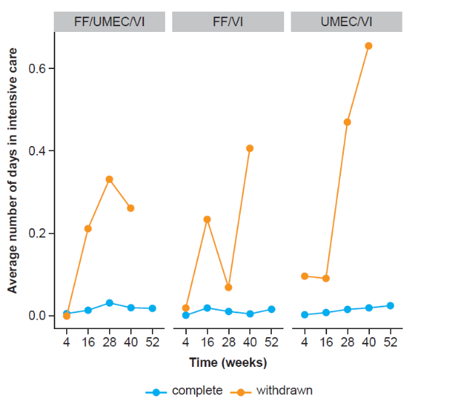
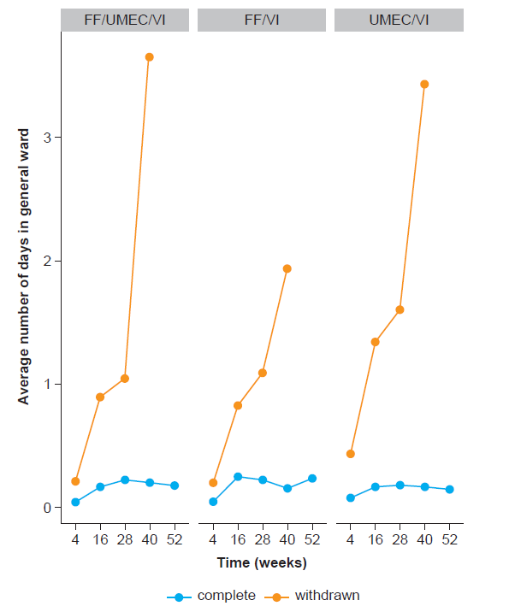
B
C
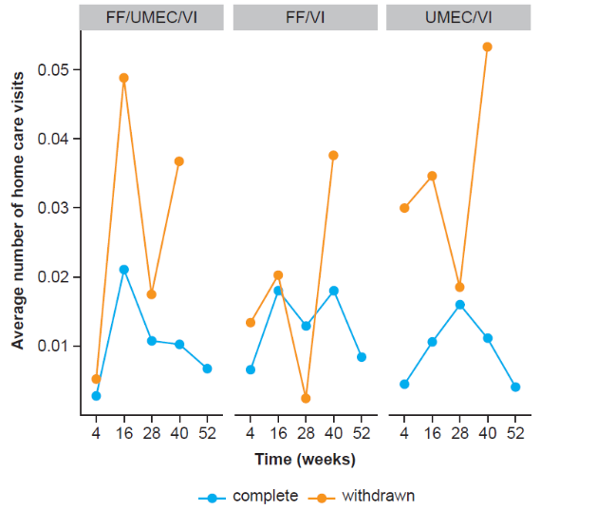
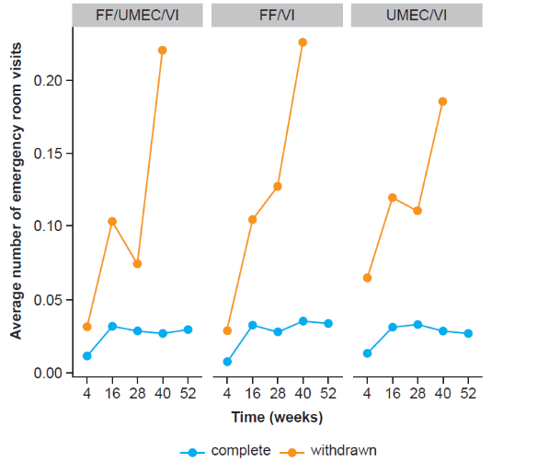
D

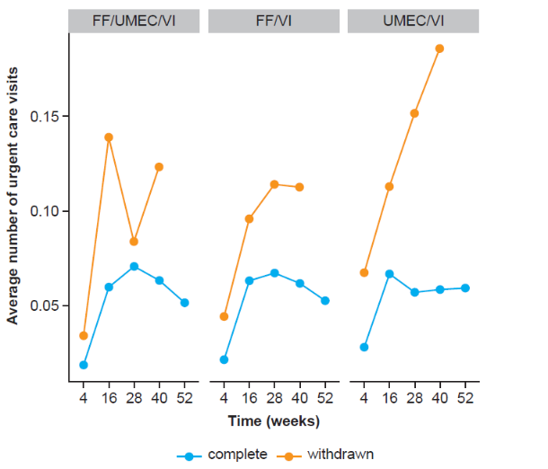
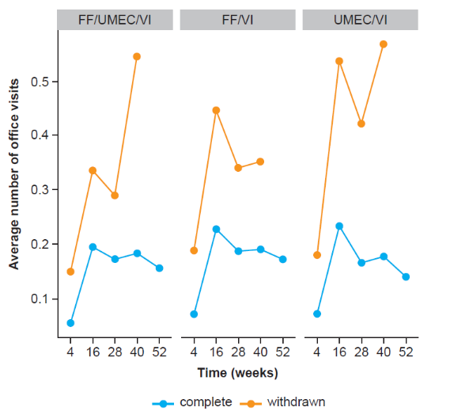
F
E

Abbreviations: FF, fluticasone furoate; UMEC, umeclidinium; VI, vilanterol.

Figure S2 Proportion of zeros for days in general ward (A) and intensive care (B), number of home care visits (C), emergency room visits (D), office visits (E), and urgent care visits (F), over the whole trial duration by treatment group, for those completing IMPACT, and those withdrawing from the study.
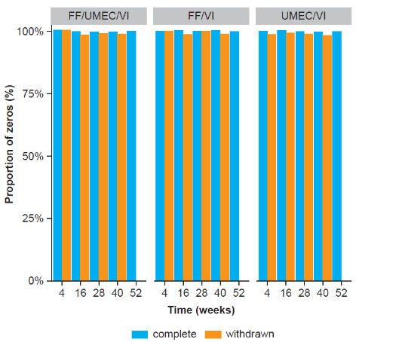
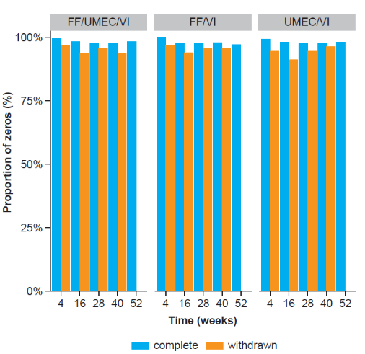
B
A

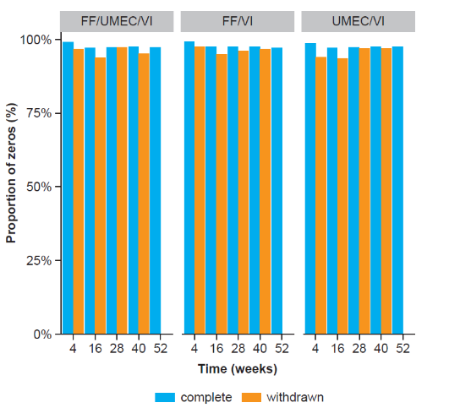
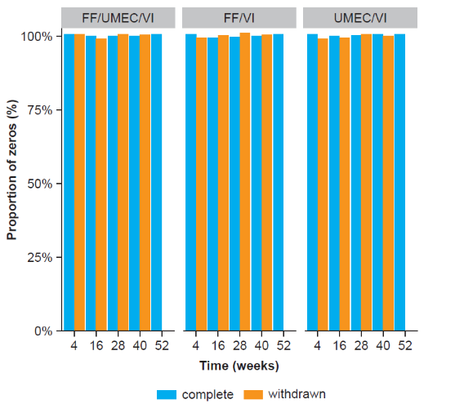
D
C

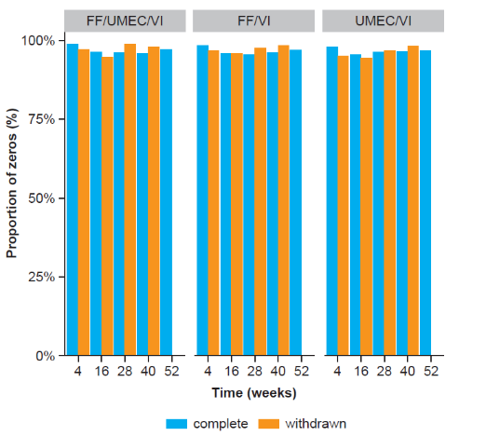
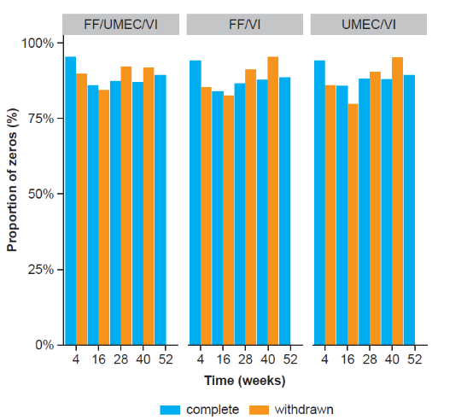
F
E

Abbreviations: FF, fluticasone furoate; UMEC, umeclidinium; VI, vilanterol.
Figure S3 Mean and 95% credible intervals of the PPPY rates for the days in general ward over the IMPACT trial duration by treatment group across four alternative missingness scenarios.
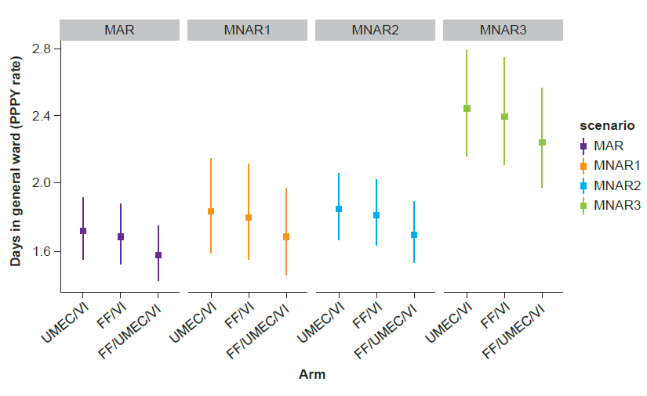
Abbreviations: FF, fluticasone furoate; MAR, missing at random; MNAR, missing not at random; PPPY, per patient per year; UMEC, umeclidinium; VI, vilanterol.

Figure S4 Mean and 95% credible intervals of the PPPY rates for the days in intensive care over the IMPACT trial duration by treatment group across four alternative missingness scenarios.
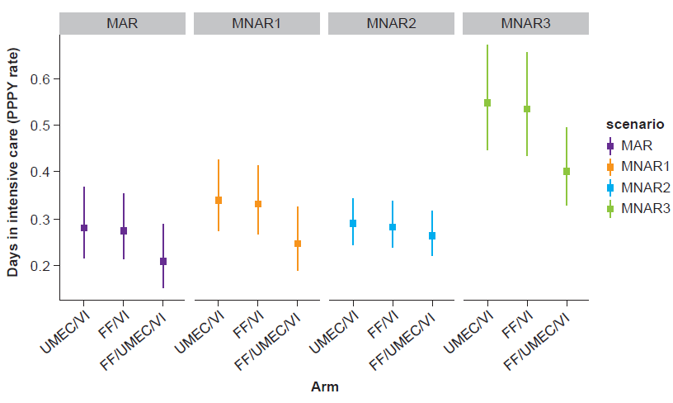
Abbreviations: FF, fluticasone furoate; MAR, missing at random; MNAR, missing not at random; PPPY, per patient per year; UMEC, umeclidinium; VI, vilanterol.

Figure S5 Mean and 95% credible intervals of the PPPY rates for home care visits over the IMPACT trial duration by treatment group across four alternative missingness scenarios.
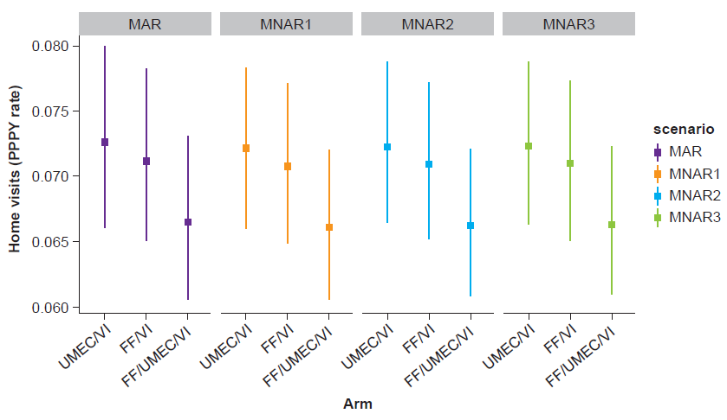
Abbreviations: FF, fluticasone furoate; MAR, missing at random; MNAR, missing not at random; PPPY, per patient per year; UMEC, umeclidinium; VI, vilanterol.

Figure S6 Mean and 95% credible intervals of the PPPY rates for office visits over the IMPACT trial duration by treatment group across four alternative missingness scenarios.

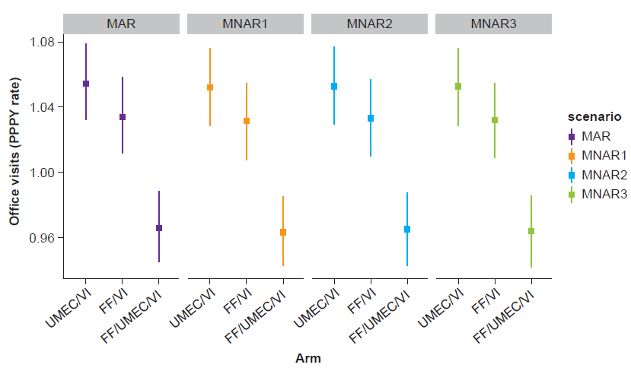
Abbreviations: FF, fluticasone furoate; MAR, missing at random; MNAR, missing not at random; PPPY, per patient per year; UMEC, umeclidinium; VI, vilanterol.

Figure S7 Mean and 95% credible intervals of the PPPY rates for urgent care/outpatient visits over the IMPACT trial duration by treatment group across four alternative missingness scenarios.
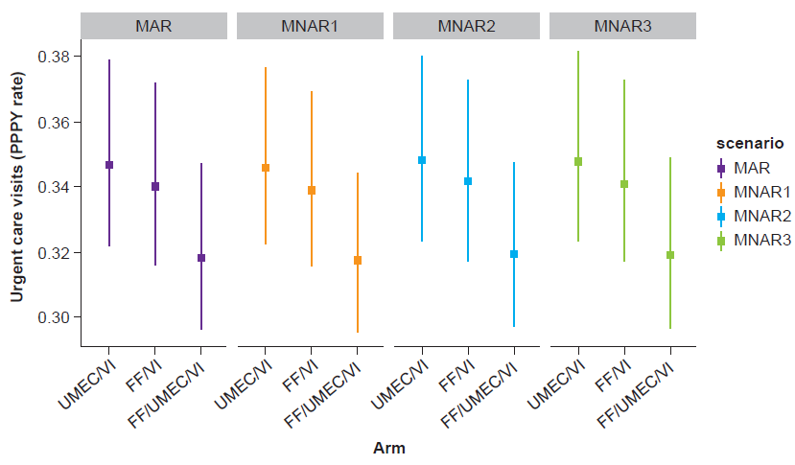
Abbreviations: FF, fluticasone furoate; MAR, missing at random; MNAR, missing not at random; PPPY, per patient per year; UMEC, umeclidinium; VI, vilanterol.

Figure S8 Mean and 95% credible intervals of the PPPY rates for emergency room visits over the IMPACT trial duration by treatment group across four alternative missingness scenarios.
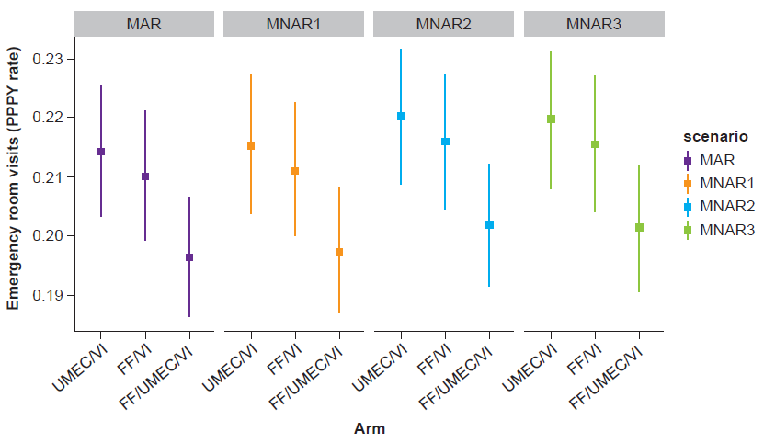
Abbreviations: FF, fluticasone furoate; MAR, missing at random; MNAR, missing not at random; PPPY, per patient per year; UMEC, umeclidinium; VI, vilanterol.

Figure S9 PP rates and associated 95% credible intervals for the number of days in general ward (A) and intensive care (B), number of home care (C), emergency room (D), office (E), and urgent care (F) visits, over the whole trial duration.
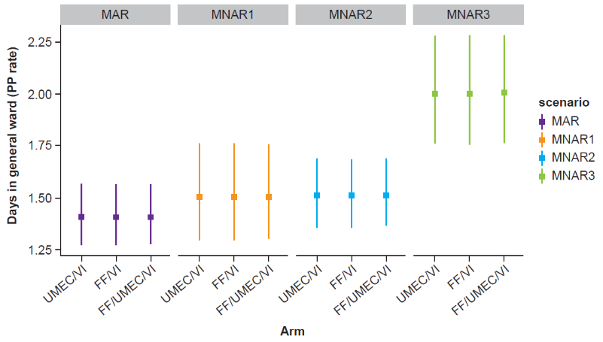
A

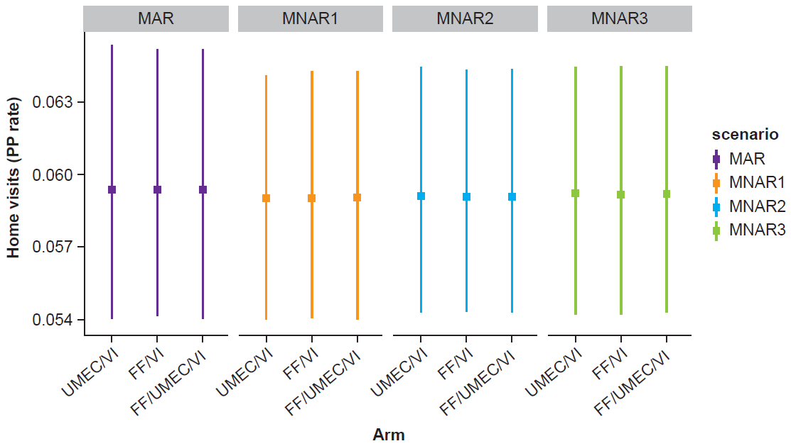
C
B

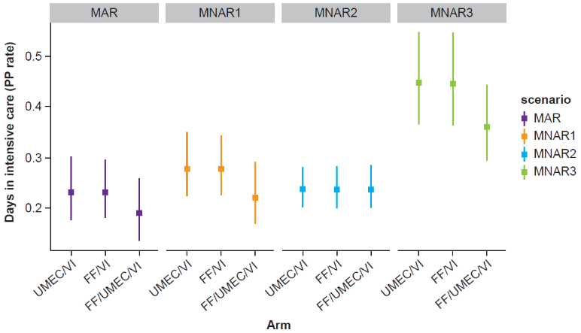

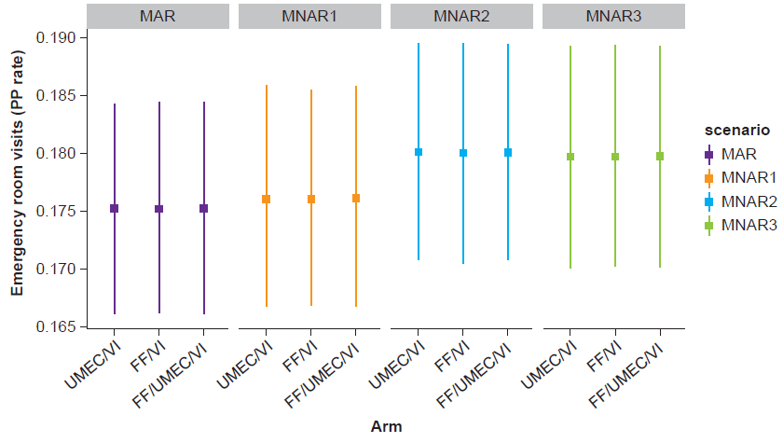
D

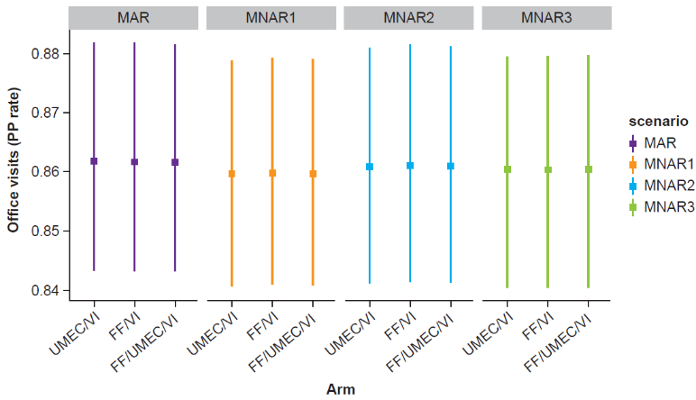
E

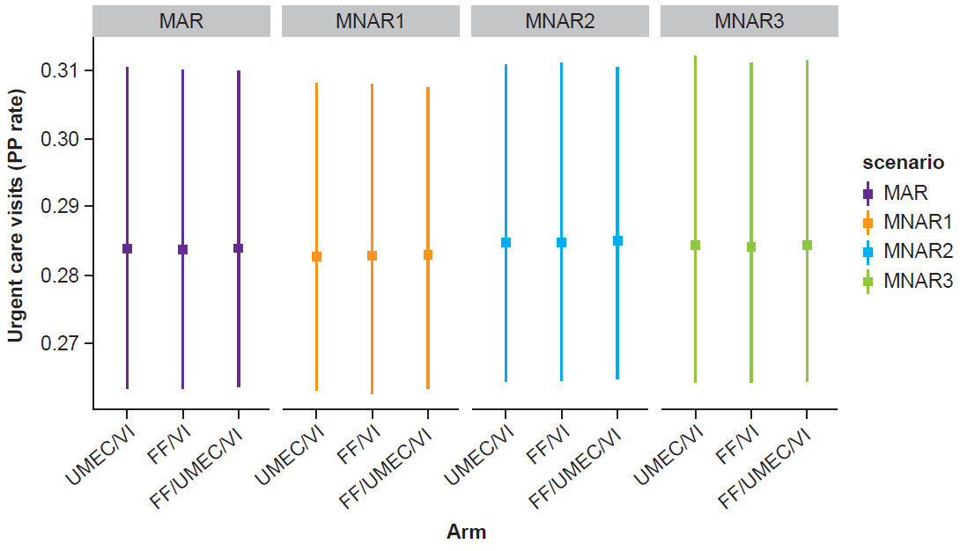
F

Abbreviations: FF, fluticasone furoate; MAR, missing at random; MNAR, missing not at random; PP, per patient; PPPY, per patient per year; UMEC, umeclidinium; VI, vilanterol.
Figure S10 Mean and 95% credible intervals of the total cost in GBP (PPPY) over the IMPACT trial duration by treatment group across four alternative missingness scenarios.
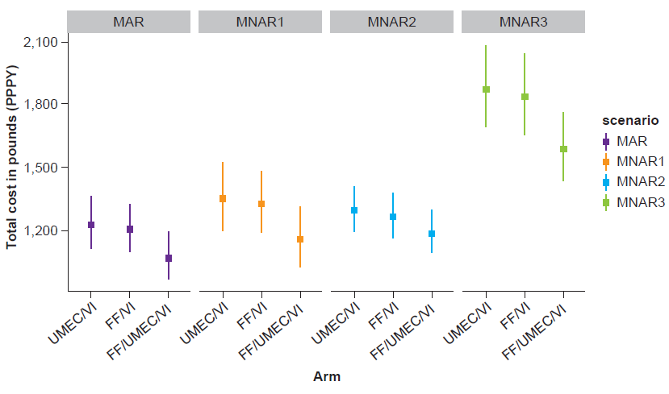
Abbreviations: FF, fluticasone furoate; MAR, missing at random; MNAR, missing not at random; PPPY, per patient per year; UMEC, umeclidinium; VI, vilanterol.

References
1. Lipson DA, Barnhart F, Brealey N, et al. Once-daily single-inhaler triple versus dual therapy in patients with COPD. N Engl J Med. 2018:378(18):1671–1680.
2. Brooks S, Gelman A, Jones G, Meng XL, eds. Handbook of Markov Chain Monte Carlo. New York: CRC Press; 2011.

