Supplementary figures

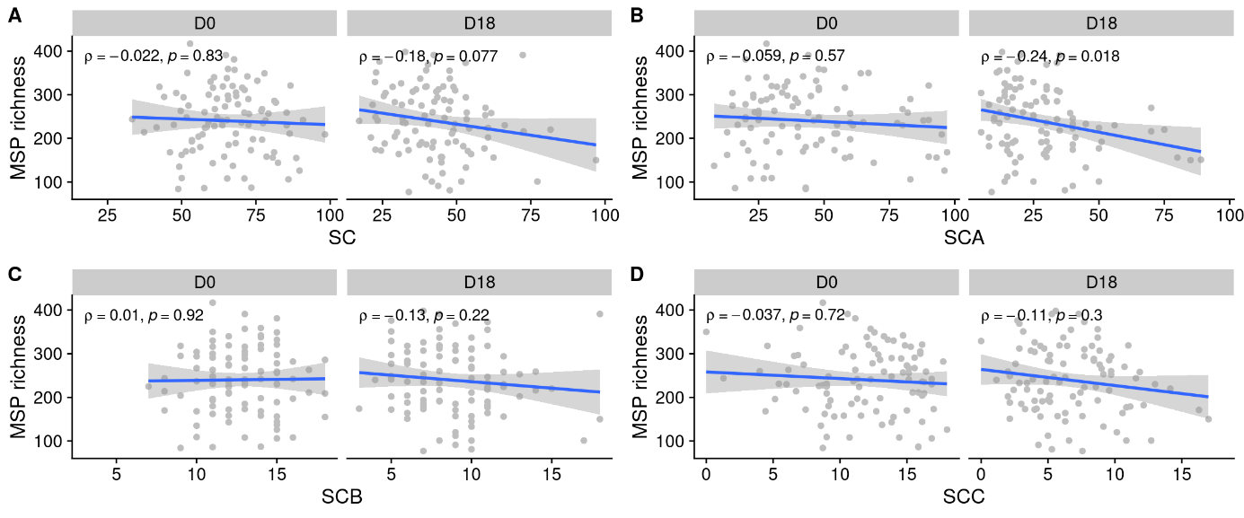
Figure S1: Relations between MSP richness (at D0 or D18) and (A) SCORAD, or subtype of SCORAD: (B) SCORAD A; (C) SCORAD B; (D) SCORAD C.

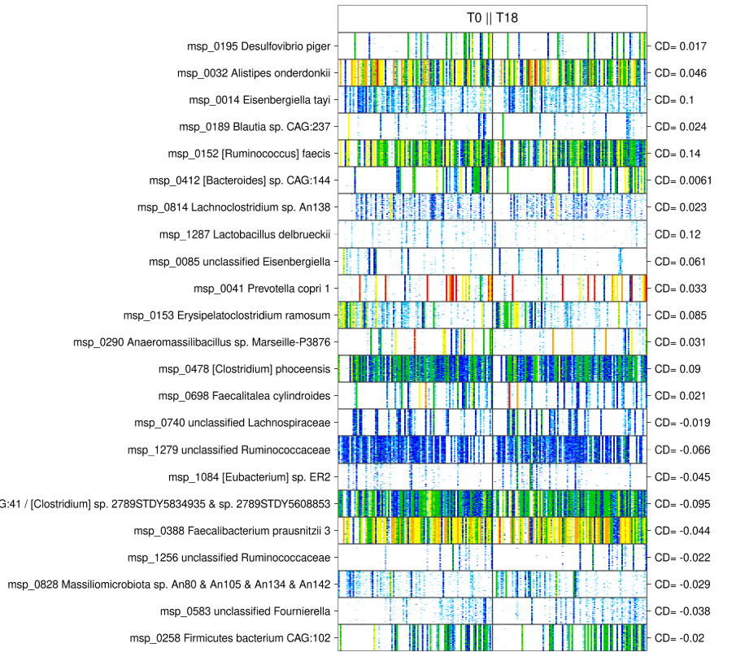
Figure S2: Barcodes of contrasted MSP between D0 and D18. The right side figures give the Cliff’s Delta (Cliff’s Delta positive: enriched at D0; Cliff’s Delta negative : enriched at D18). Individuals are in columns and MGS in rows; each bar indicates the abundance of 50 marker genes of a species in an individual, using a color code (absence: white < light blue < blue < green < yellow < orange < red for relative abundance of 1e-04, each color change corresponding to a 4-fold abundance change).

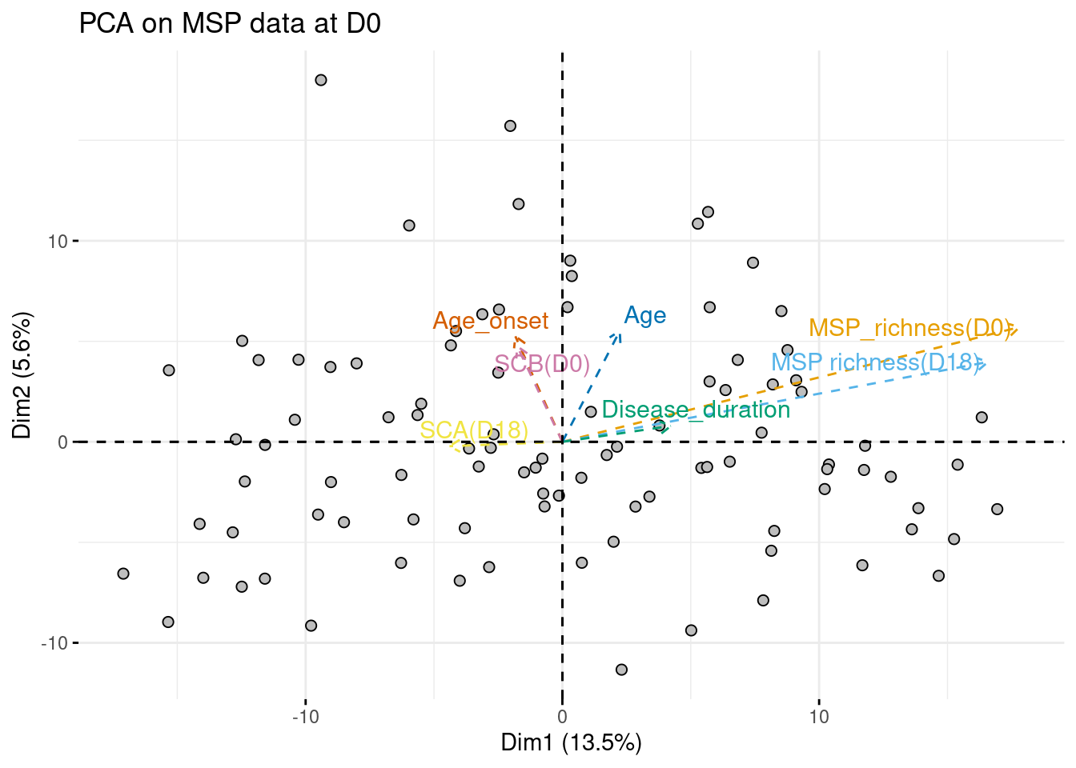
Figure S3: Projection of individuals on the first two components of the PCA performed on baseline abundance of the 554 MGS present in at least 10% of samples. Clinical variables that significantly correlates with the first or second dimension with p-value ≤ 0.05 are displayed as supplementary variables.

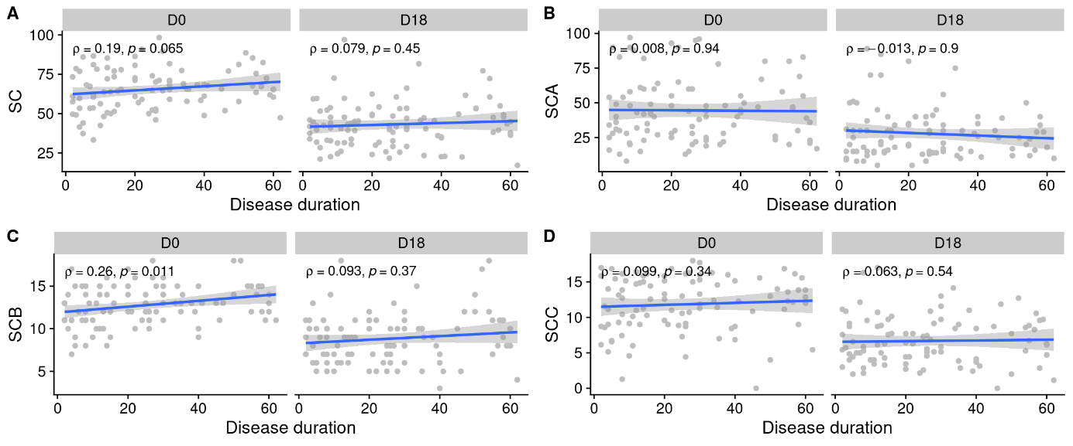
Figure S4: Relation between disease duration and (A) SCORAD, (B) SCORAD A, (C) SCORAD B, (D) SCORAD C (at D0 or D18). Coefficients of Spearman’s correlation along with their associated p-values are displayed.
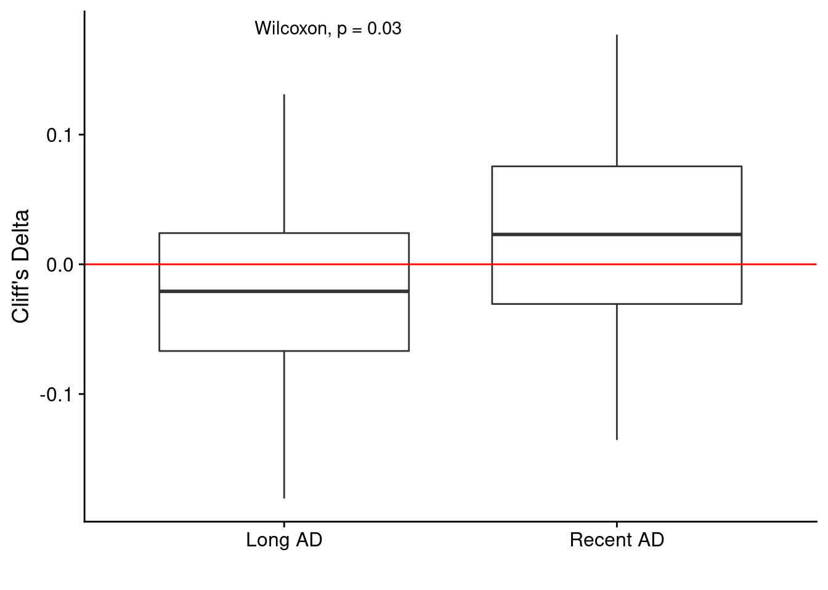
Figure S5: Distribution of effect size, measured as Cliff’s Delta, of the species whose abundance significantly change between D0 and D18 (P ≤ 0.1) in the subgroup of long AD (disease duration ≥ 23 years, n = 48) or in the subgroup of recent AD (disease duration < 23 years, n = 48). The red line highlights the null effect size (Cliff’s Delta = 0). Cliff’s Delta > 0 indicates that a species decreased between D0 and D18; Cliff’s Delta < 0 indicates that a species increased between D0 and D18.

