Supplementary Information
For “Cyclic RGD-decorated liposomal (-)-gossypol (AT-101) with enhanced targeting effect for tumor therapy”

Hao Liu¹
Ruirui Zhang¹
Dan Zhang¹
Chun Zhang¹
Zhuo Zhang¹
Xiujuan Fu¹
Yu Luo¹
Siwei Chen¹
Ailing Wu²
Weiling Zeng³
Kunyan Qu¹
Hao Zhang¹
Sijiao Wang¹
Houyin Shi⁴

¹School of Pharmacy, Southwest Medical University, Luzhou City, Sichuan, People's Republic of China; ²Department of Anesthesiology, The First People’s Hospital of Neijiang, Neijiang, Sichuan, the People's Republic of China; ³Department of Scientific Research, the Affiliated Traditional Chinese Medicine Hospital of Southwest Medical University, Luzhou City, Sichuan, People's Republic of China; ⁴Department of Orthopedics, the Affiliated Traditional Chinese Medicine Hospital of Southwest Medical University, Luzhou City, Sichuan, the People's Republic of China.

Supplementary Figure

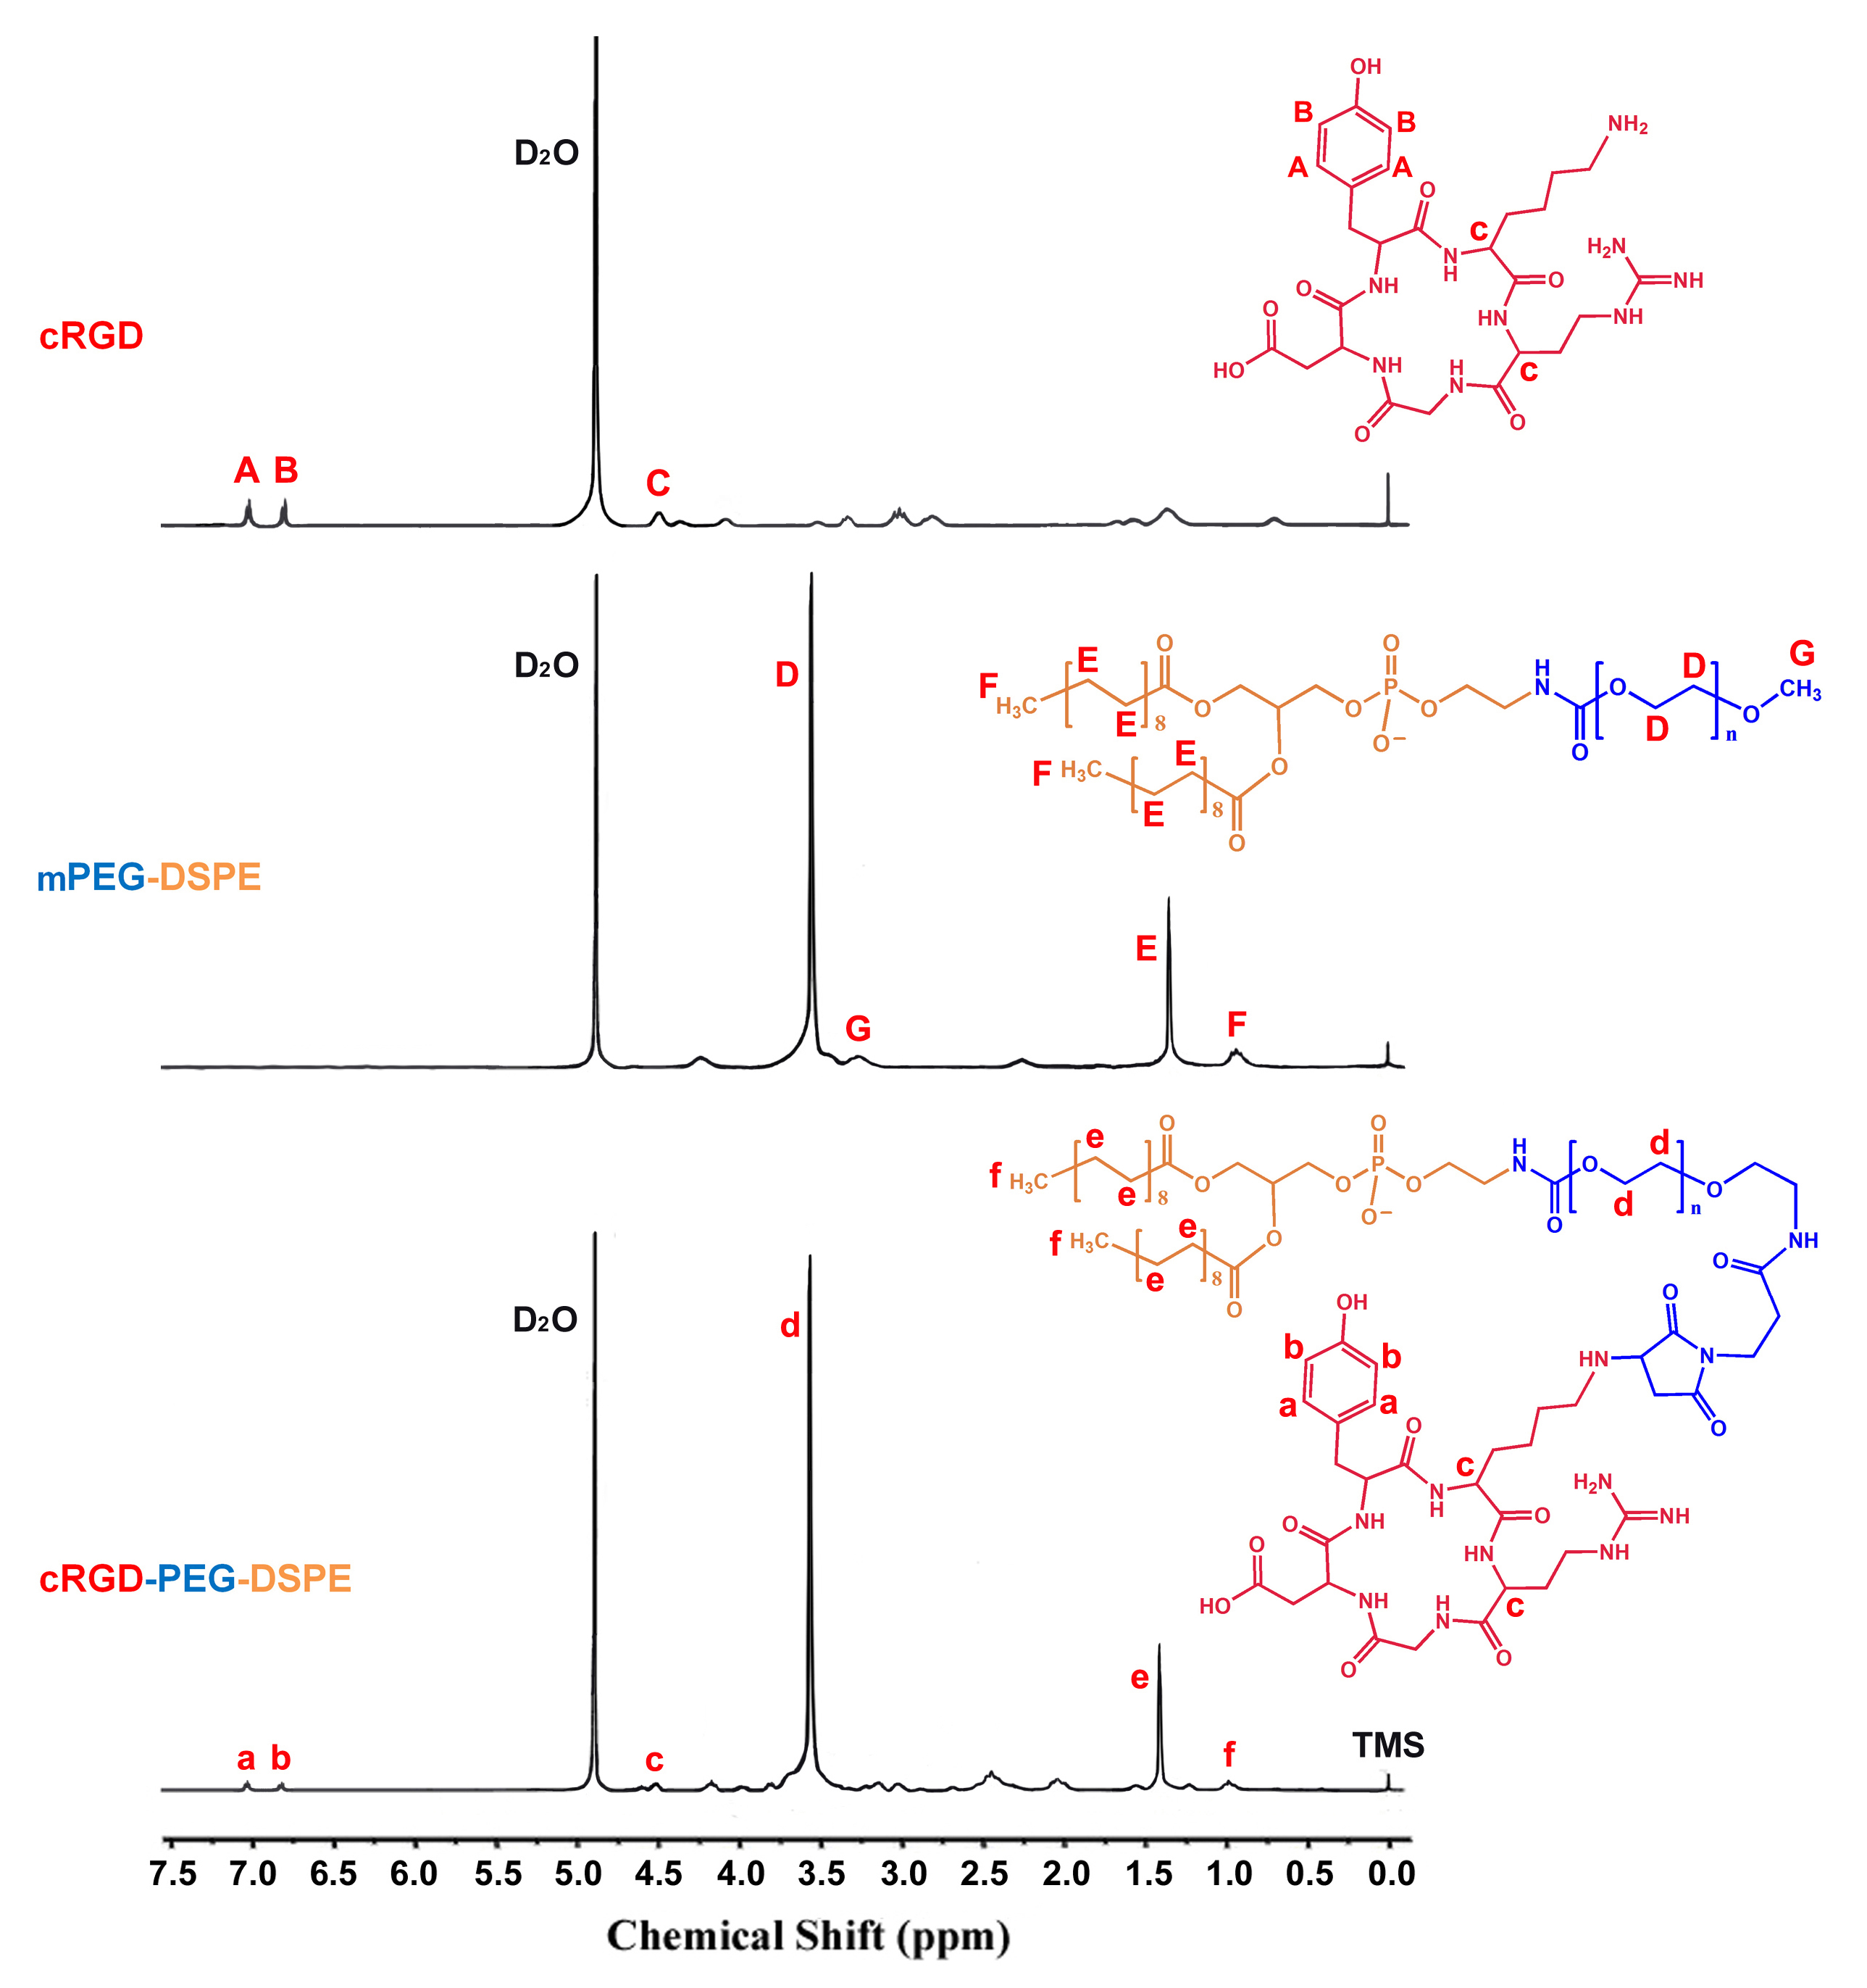

Figure S1 ¹H NMR spectra of cRGD, mPEG-DSPE, and cRGD-PEG-DSPE. Each sample was dissolved in deuterium oxide (D₂O) at the concentration of approximately 10 mg mL⁻¹, with tetramethylsilane (TMS) as the internal standard. The ¹H NMR spectrum was recorded using an Avance III NMR spectrometer (Bruker Co., Germany) operated at 400 MHz. For cRGD, the NMR peaks assigned to the aromatic ring were observed at 7.03 ppm and 6.81 ppm. For mPEG-DSPE, the NMR peaks at 3.56 ppm and 3.27 ppm were attributable to the mPEG chain; and the NMR peaks at 1.37 ppm and 0.95 ppm were attributable to the stearoyl groups of DSPE. The NMR spectrum of cRGD-PEG-DSPE showed the characteristic peaks of both cRGD and mPEG-DSPE.

