Supplementary Figure 1
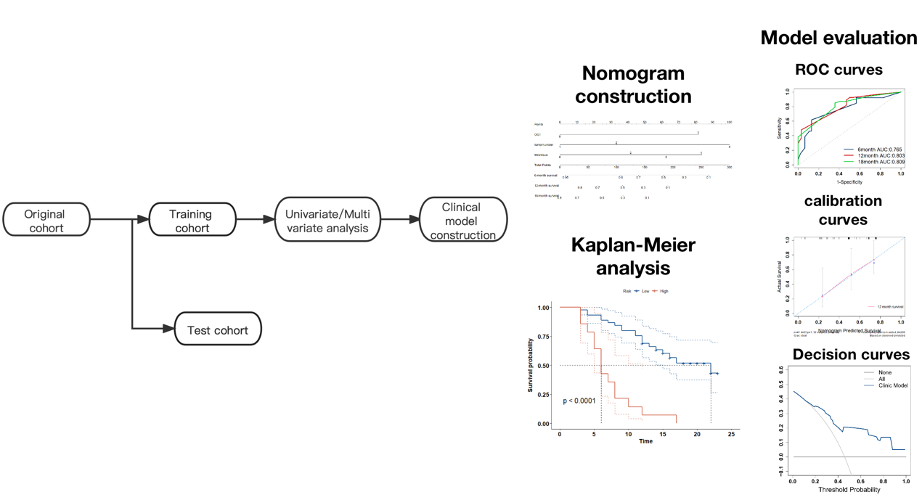

Figure legend
Workflow of the study.

