Supporting information:
Attitudes, barriers, and motivations to sun protection in schools in Reunion Island: a qualitative study
S. Leruste¹, M. Marx¹, C. Ah-Mouck¹, L. Yap-Chim¹, N. Sultan-Bichat², M. Beylot-Barry³, M. Spodenkiewicz^{4,5°}, J. Dumez^{1,5*}, A. Bertolotti^{5,6}
¹ UFR La Réunion, Département universitaire de médecine générale, La Réunion, France
² CH Ouest Réunion, Saint Paul, La Réunion, France
³ CHU de Bordeaux, Service de Dermatologie, INSERM U 1053, Univ. Bordeaux. Bordeaux, France
⁴ CHU Réunion, Pôle de Santé Mentale. UFR Santé Univ. Réunion, Saint Pierre, La Réunion, France
⁵ Inserm CIC1410, CHU Réunion, Saint Pierre, La Réunion, France
⁶ CHU Réunion, Service des Maladies Infectieuses - Dermatologie, Saint Pierre, La Réunion, France
* equal contribution of co-authors

Figure S1. Interview canvas
Canvas:
- Icebreaker questions:
“In practice, what measures do you use to deal with sun exposure?”
“In practice, what sun protection measures do you use?”
“What is your perspective on sun protection in general?”
“What is the place of sun protection in your daily life?”
“What do you think about sun protection?”
- Follow-up questions:
Why? How do you feel about these measures? What are the things that bother you? Can you say more? What do you mean by that? What bothers you the most? What motivates you? Where do you know this from? How do you feel about…? What don’t you understand?

,

Table S1. Verbatim excerpts from interviews with parents, teachers, and children, Reunion Island
Theme |  |  | Population (Number attributed to interviewees in chronological order of participation in the study) | Quotes
Specificities of sun exposure in Reunion Island |  |  | Parent (8) | “Because at the start of the school year in January February, it’s just not possible, the sun is ...”
 |  |  | Teacher (10) | “At the stadium, every year, often during that period we were talking about… when the sun comes back at the end of January beginning of February, kids get first-degree burns on their feet through their shoes.”
Effects of sun exposure on health |  |  | Parents, teachers, children | “Sunburns," "burns," "skin spots," "cancers," "reduced visual acuity," "sun glare," "headaches," "sunstroke," "malaise.”
 |  |  | Teacher (2) | “She had a small spot and the spot turned into something bigger (skin cancer) …”
 |  |  | Parent (13) | “I know that she had two (suspicious nevi) removed from her back already, that she had to do the biopsy anyway.”
 |  |  | Parent (13) | “I have friends who had melanoma and all that...so you feel a little more concerned.”
Importance of sun protection |  |  | Teacher (2) | “It’s essential!”
 |  |  | Child (5,14) | “It’s important to protect yourself.”
Protection habits |  |  | Parent (3) | “We take shelter under the trees.”
 |  |  | Parent (1) | “We don’t expose ourselves during the most dangerous hours.”
 |  |  | Child (8) | “At the beach I wear sunscreen.”
 |  |  | Child (9) | “I don’t put anything at school.”
Protection in function of skin phototype |  |  | Parent (5) | “Since I was little girl because I’m a bit dark skinned... I can’t tan... I don't need sunscreen.”
 |  |  | Parent (10) | “I was with a metropolitan woman who was sensitive to the sun, so it played a role in the education of the kids, I think it plays a role.”
 |  |  | Teacher (3) | “Now I know I’m at risk so... Unfortunately, we’re not all equal on this point.”
Main barriers to sun protection |  |  | Parent (8) | “There is a bit of shade, but not enough.”
 |  |  | Parent (8) | “The bottle of sunscreen isn’t cheap.”
 |  |  | Parent (3) | “It’s also for the marine fauna that I’ll avoid putting too much sunscreen”
 |  |  | Teacher (5) | “At school... The children are in full sun at noon! In full sun! There is no shade! Nothing!”
 |  |  | Teacher (7) | “At the lagoon, I won’t wear sunscreen because it’s not good for the lagoon.”
 |  |  | Teacher (4) | “Oh that’s really inappropriate, I don’t think we’re allowed to touch them either. No, no, it’s very wrong to do that.”
 |  |  | Teacher (6) | “As teachers, we receive no training, we get nothing.”
 |  |  | Child (13) | “Sometimes I forget to put on my cap.”
 |  |  | Child (7) | “It smells weird and it does weird stuff on the skin.”
 |  |  | Child (4) | “It’s too hot when I wear long sleeves.”
Lack of accountability |  |  | Parent (7) | “(Cap) when the prof asks me to.”
 |  |  | Teacher (6) | “At school, I start from the principle that it’s not my direct responsibility.”
 |  |  | Parent (8) | “But we often write little messages in the notebooks: don’t forget the cap, don’t forget the cap.”
 |  |  | Teacher (2) | “We asked to have the courtyard covered, it would have been nice you see...but uh well no, because again, there’s no money so...the kids are constantly exposed.”
 |  |  | Teacher (12) | “There really need to be an authority or I don’t know... We need someone from above who says careful, be careful.”
Feelings of guilt |  |  | Parent (11) | “But then it’s true that no, I don’t think about it for school, I’m not used to it.”
 |  |  | Teacher (2) | “Here it’s violent! That’s for sure! It’s very violent! I became aware of it uh... later. Too late maybe for my children... I regret that a little bit... I was not vigilant enough...”
 |  |  | Teacher (6) | “With the children, I don’t use cream, I could give a good example, it could be a model for them...”
Parental education |  |  | Child (4) | “Mom told us so now I think it’s important.”
 |  |  | Child (5) | “Mom always says that you have to protect your solar capital.”
Lack of sun protection in school |  |  | Child (4) | “Did the teacher ever tell you about the sun? No.”
 |  |  | Child (13) | “Do your teachers and aunties tell you anything to protect you from the sun? No, they don’t.”

Figure S2. Model of data from interviews with teachers
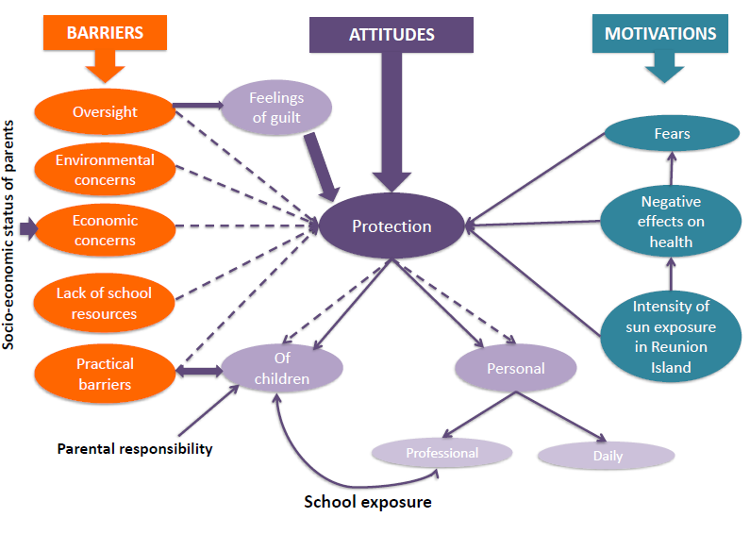
Leads to
Does not lead to
Major interaction

Figure S3. Model of data from interviews with children
Leads to
Does not lead to

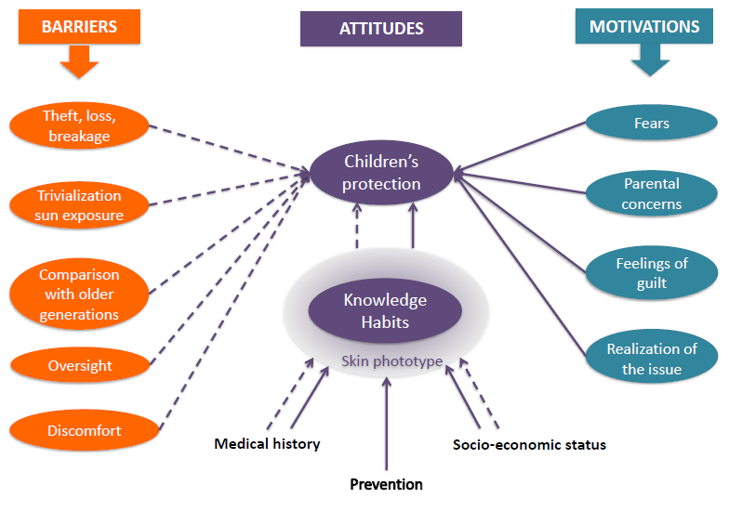
Figure S4. Model of data from interviews with parents
Leads
Does not lead to

