Supplementary figures:
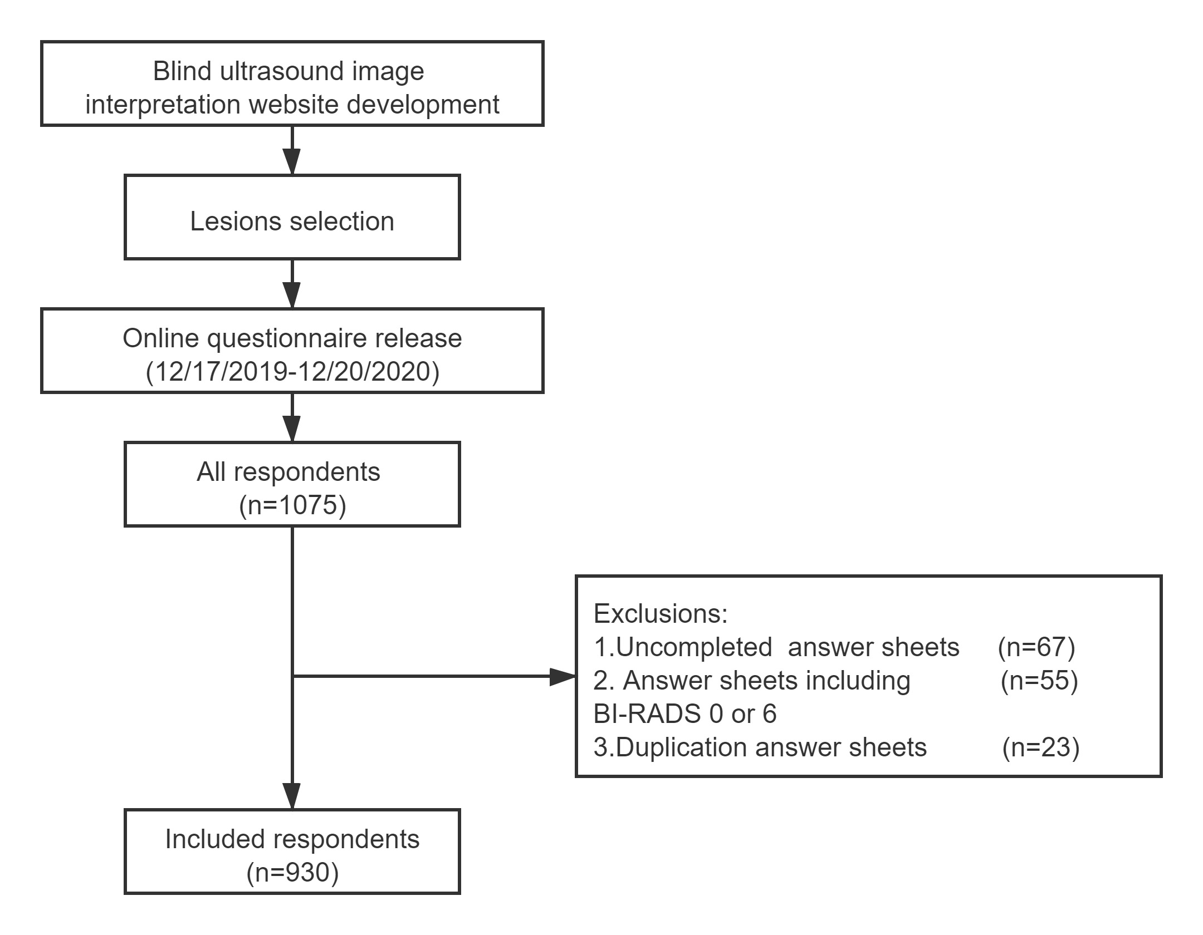
Figure S1：Flow chart of the survey

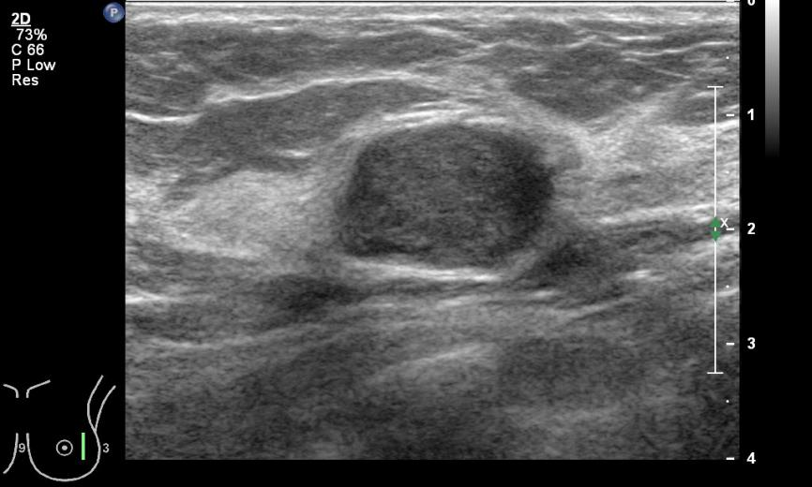
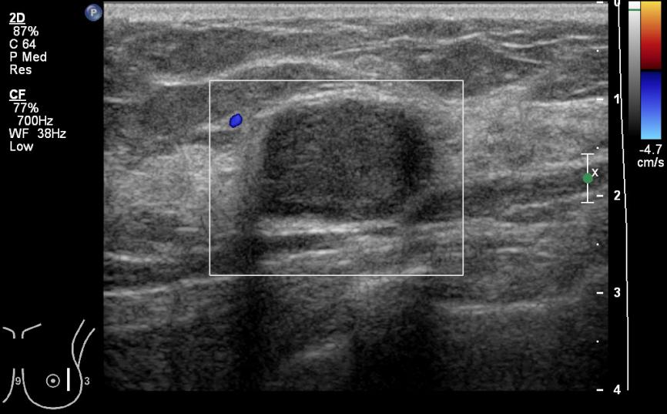
Figure S2：Ultrasound B-mode and Color Doppler Flow images of lesion 1.

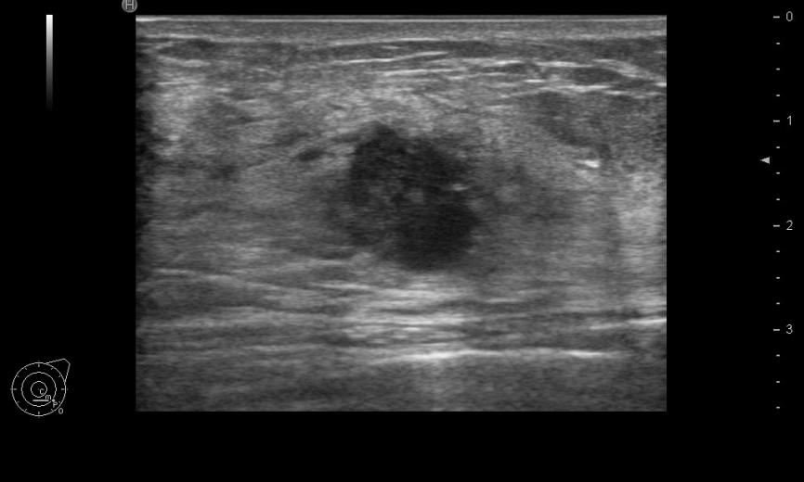
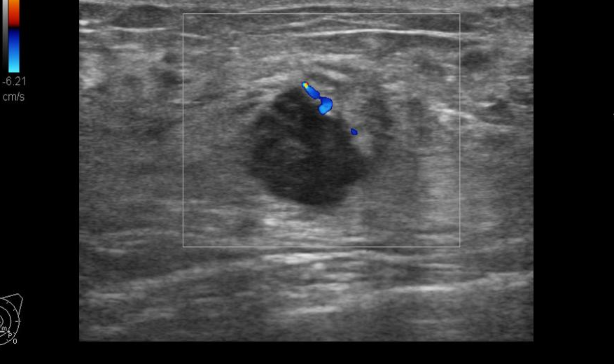
Figure S3：Ultrasound B-mode and Color Doppler Flow images of lesion 2.

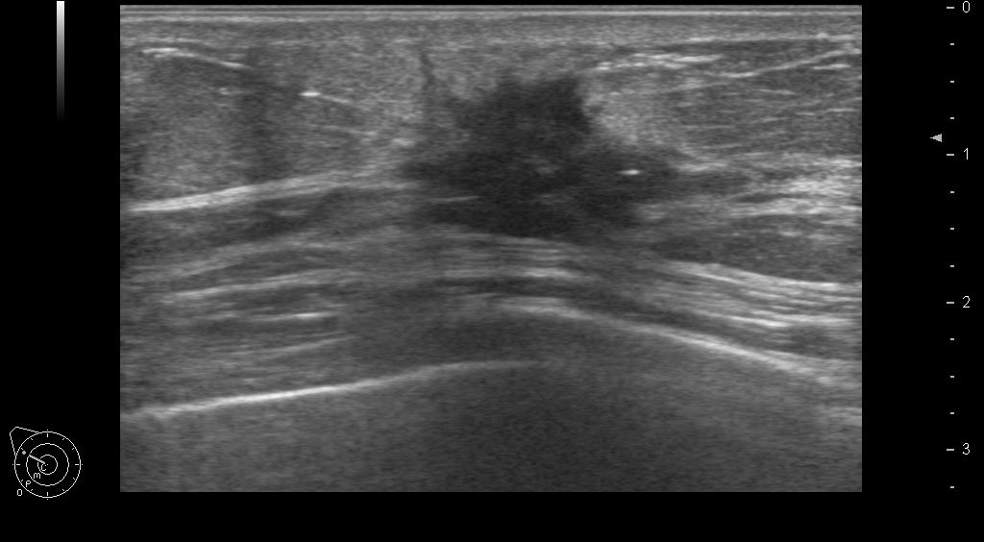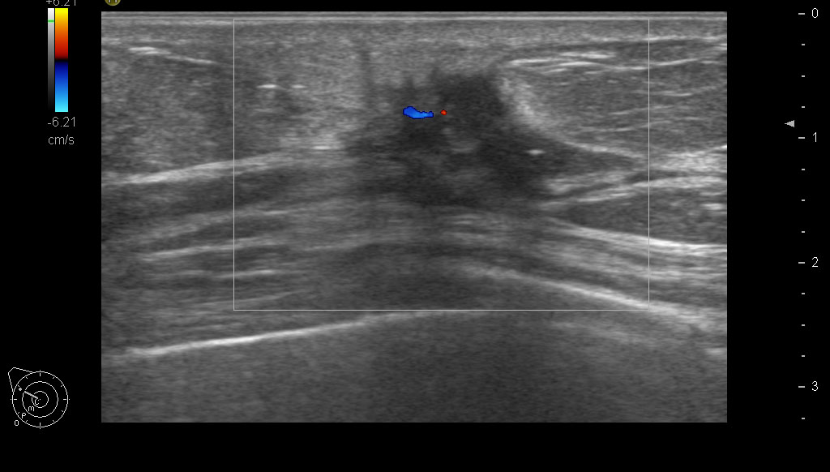
Figure S4：Ultrasound B-mode and Color Doppler Flow images of lesion 3.

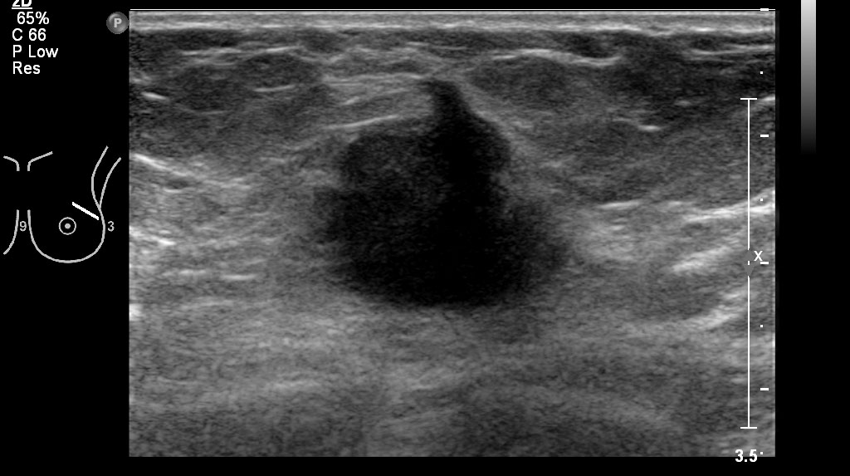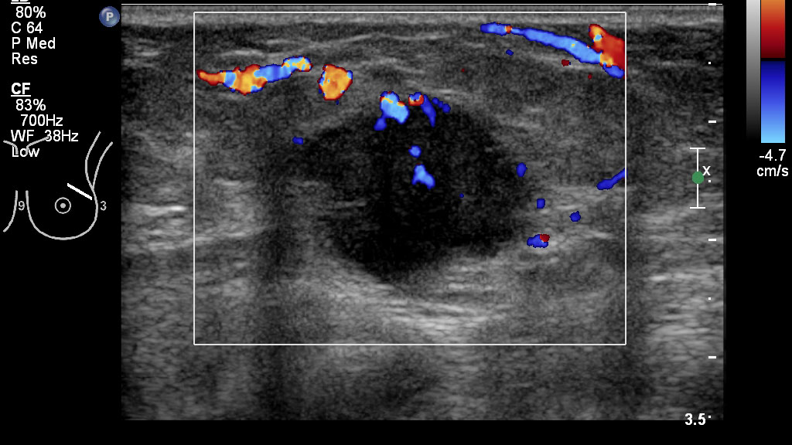
Figure S5：Ultrasound B-mode and Color Doppler Flow images of lesion 4.

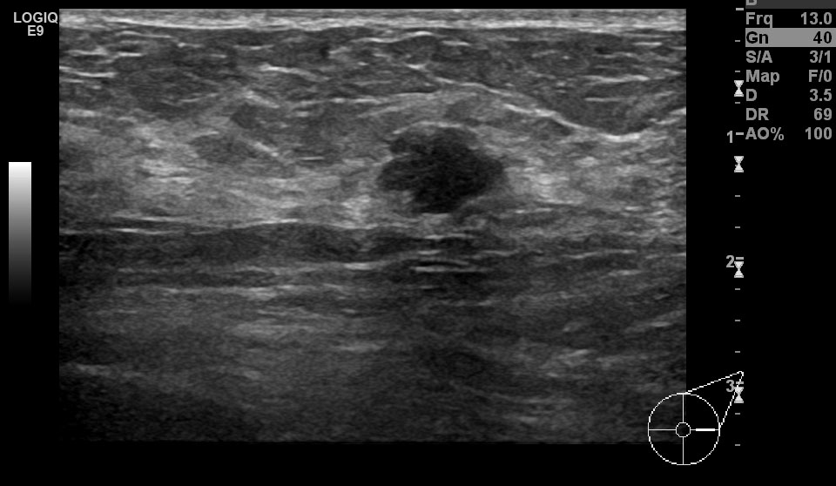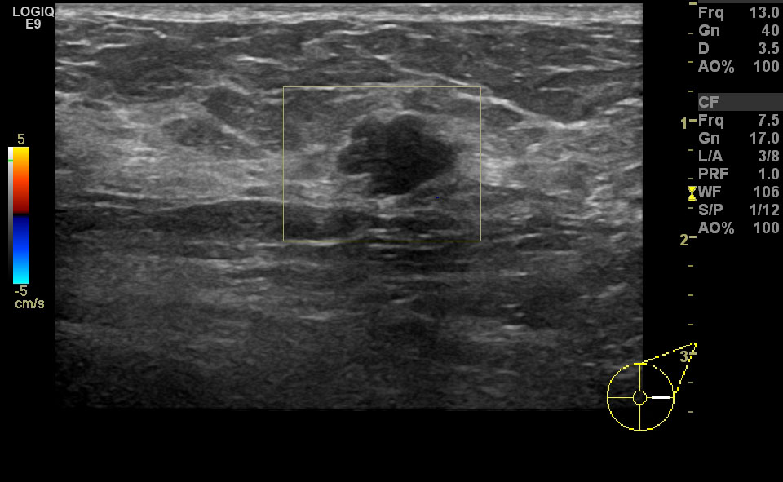
Figure S6：Ultrasound B-mode and Color Doppler Flow images of lesion 5.

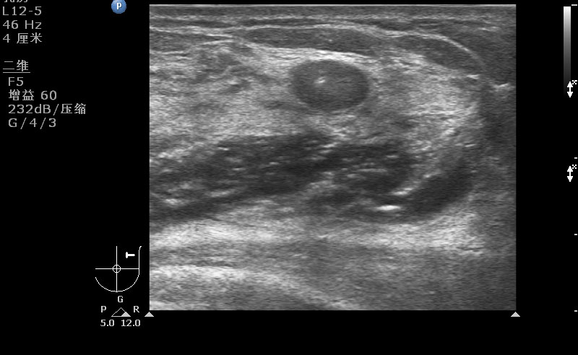
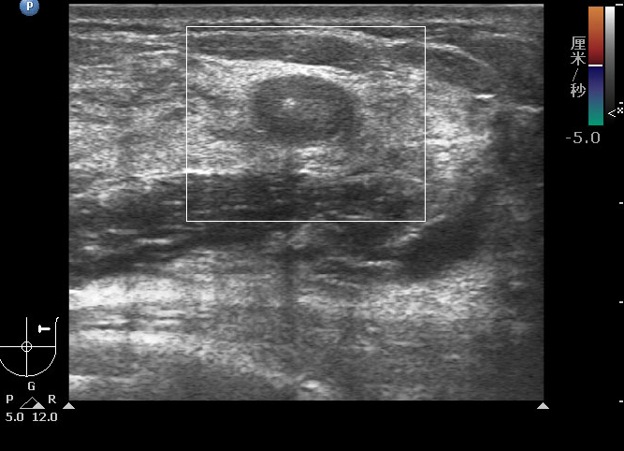

Figure S7：Ultrasound B-mode and Color Doppler Flow images of lesion 6.
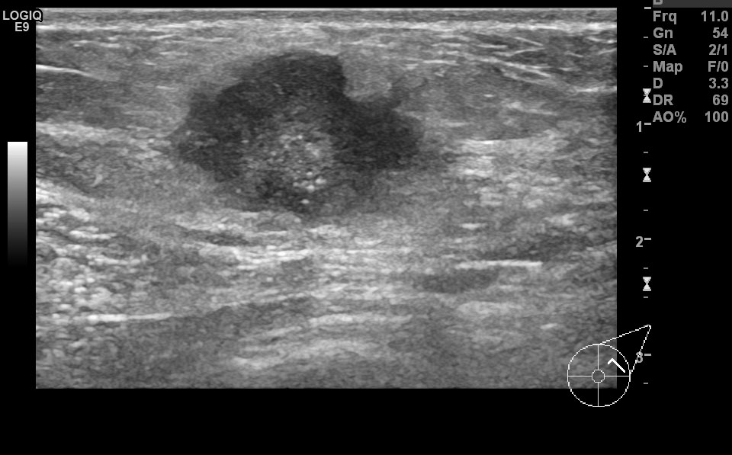

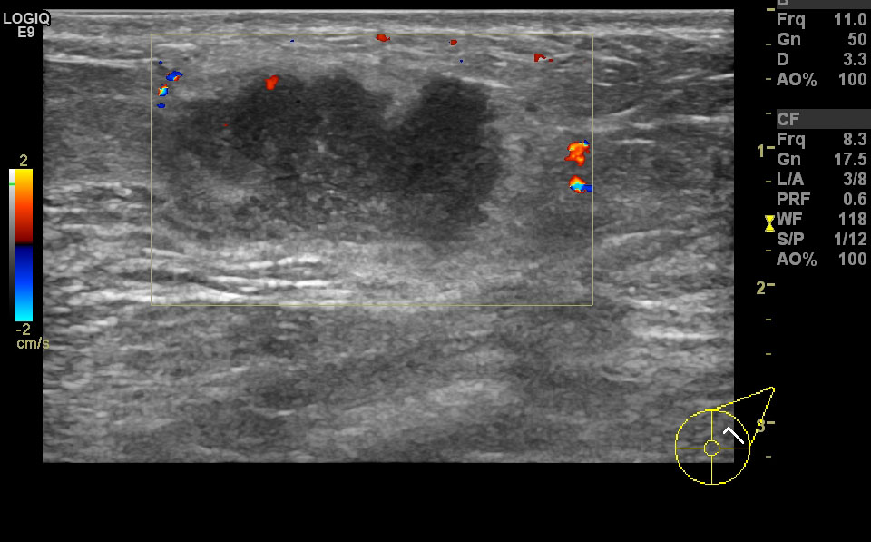

Figure S8：Ultrasound B-mode and Color Doppler Flow images of lesion 7.

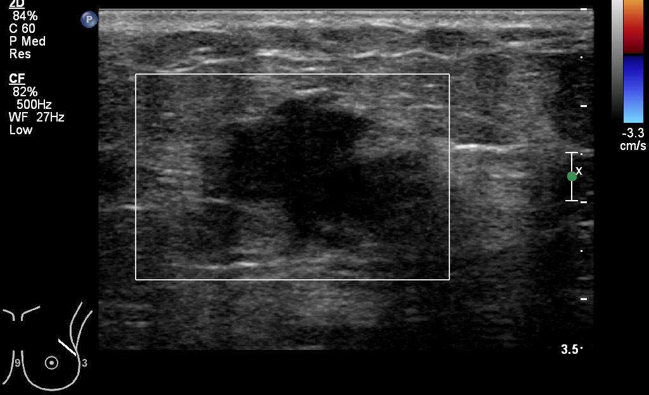
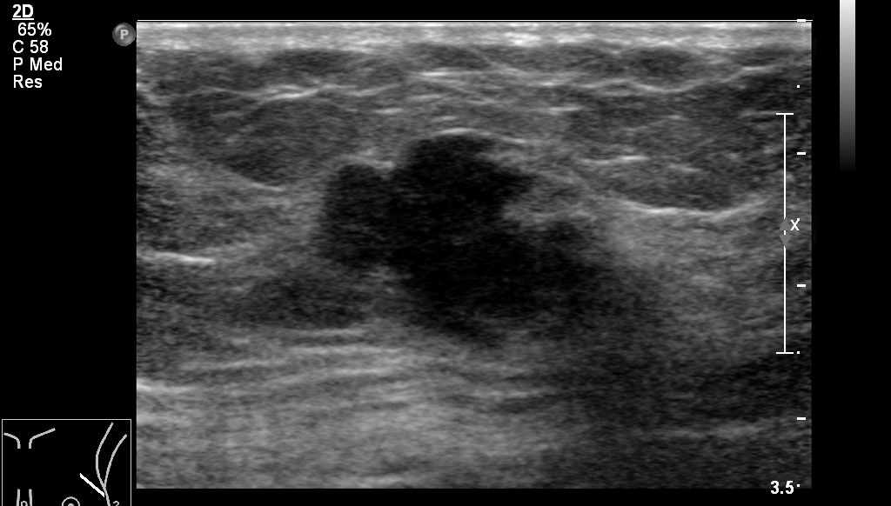

Figure S9：Ultrasound B-mode and Color Doppler Flow images of lesion 8.

Figure S10：Ultrasound B-mode and Color Doppler Flow images of lesion 9.

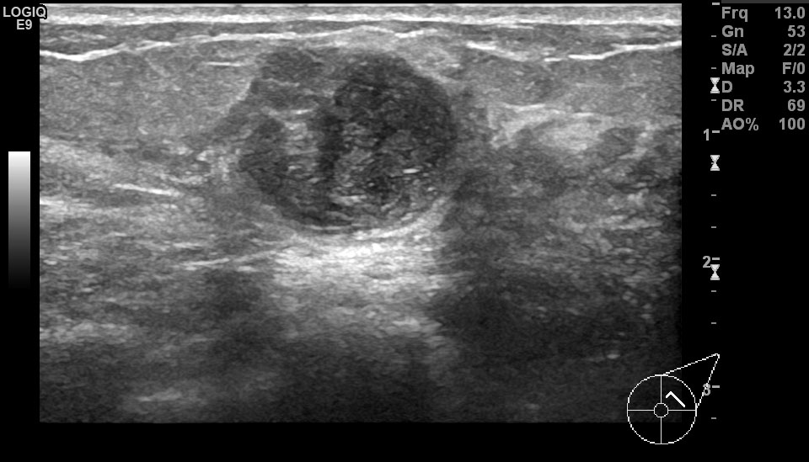
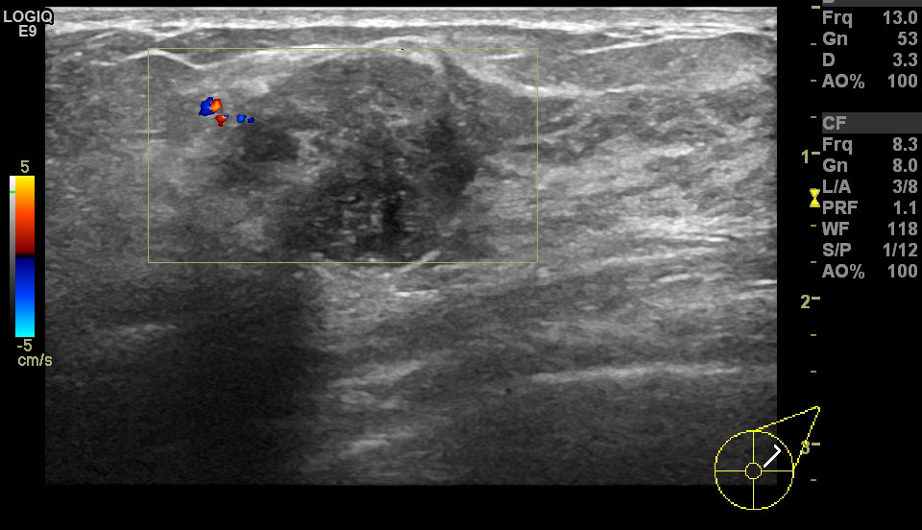

Figure S11：Ultrasound B-mode and Color Doppler Flow images of lesion 10.

