Supplementary materials

Supplementary table 1: Healthcare utilization: Cost prices used (€)
Cost category | Volume | Cost price (€, 2018)ª
Primary care
General practitioner | Visit | 34.00
Physiotherapist | Visit | 34.00
Hospital care
Emergency room | Visit | 269.00
Ambulance | Transport | 536.00
Outpatient medical services | Visit | 91.00
Inpatient hospital care | Day | 495.00
Long-term care
Nursing at home | Hour | 76.00
Personal care at home | Hour | 52.00
Domestic help at home | Hour | 22.50
Daycare | Day | 134.00^{b}
Inpatient care | Day | 168.00^{c}
Informal care | Hour | 14.57
ªDutch standard cost prices were used to value healthcare utilization.⁴¹ All prices were presented in 2018 Euros, and if necessary indexed to the reference year using a consumer price index.
^{b}Cost price for elderly daycare.
^{c}Cost price for inpatient elderly care.
Supplementary table 2: Estimated intervention costs (€)
Cost category | N | Volume | Price/  Volumeª | Costs
 |  |  |  | Subtotal | Total | Per Participant^{b}
Labor costs | 2 | 100 h | 33.97 | – | 6,794 | 51.08
Training costs
Nurse | 23 | 20 h^{c} | 30.95 | 14,237
Nurse assistant | 34 | 20 h^{c} | 22.18 | 15,082
Nurse aide | 8 | 20 h^{c} | 19.76 | 3,162
Domestic worker | 89 | 16 h^{d} | 19.14 | 27,255
Total |  |  |  | – | 59,736 | 449.14
Material costs
Program materials
Program trainer | 2 | 320 prints | 0.25 | 160
Nurse | 23 | 120 prints | 0.25 | 690
Nurse assistant | 34 | 120 prints | 0.25 | 1,020
Nurse aide | 8 | 120 prints | 0.25 | 240
Domestic worker | 89 | 40 prints | 0.25 | 890
Total |  |  |  | – | 3,000 | 22.56
Use of role models | 2 | 5 h | 20.66 | – | 207 | 1.56
Use of professional actors | 3 | 10 h | 168.90 | – | 5,067 | 38.09
Travel costs
Program trainer | 2 | 12.5 h | 33.97 | 849
Nurse | 23 | 1.75 h | 30.95 | 1,246
Nurse assistant | 34 | 1.75 h | 22.18 | 1,320
Nurse aide | 8 | 1.75 h | 19.76 | 277
Domestic worker | 89 | 1.25 h | 19.14 | 2,129
Total |  |  |  | – | 5,821 | 43.77
Accommodation costs | N/A | 50 meetings | 50.00e | – | 2,500 | 18.80
Total intervention costs |  |  |  | – | 83,125 | 625.00
ªGross hourly wages are requested from the healthcare organization.
^{b}Costs only relate to intervention group participants (n = 133).
^{c}Nurse, nurse assistants and nurse aides received 7 meetings, 6 practical assignments, and 20 weekly newsletters, with an average time investment of 9h, 6h, and 5h, respectively.
^{d}Domestic workers received 5 meetings, 4 assignments, and 20 newsletters, with an average time investment of 7h, 4h and 5h, respectively.
^{e}Only a small price was charged for accommodation assuming meetings take place at the care site itself with little or no costs.

Supplementary table 3: Mean (SD) costs (€) of healthcare utilization per participant in the control and intervention group for the within-trial period (12 months) (observed estimates)
Cost category | Control group (n = 99) |  |  |  |  |  | Intervention group (n = 101)
Cost category | Mean | (SD) | Median | Min | Max |  | Mean | (SD) | Median | Min | Max
Intervention costs | 0 | (0) | 0 | 0 | 0 |  | 625 | (0) | 625 | 625 | 625
Healthcare costs | 13,090 | 10,779 | 10,629 | 641 | 31,410 |  | 14,369 | 11,579 | 10,364 | 1,264 | 55,154
Primary care
General practitioner | 257 | (296) | 170 | 0 | 1,870 |  | 305 | (466) | 170 | 0 | 3,638
Physiotherapist | 834 | (1,162) | 68 | 0 | 5,304 |  | 1,002 | (1,221) | 629 | 0 | 5,168
Hospital care
Emergency room | 92 | (237) | 0 | 0 | 1,614 |  | 117 | (233) | 0 | 0 | 1,345
Ambulance | 168 | (388) | 0 | 0 | 2,144 |  | 191 | (483) | 0 | 0 | 3,216
Outpatient hospital care | 278 | (320) | 182 | 0 | 1,456 |  | 425 | (885) | 182 | 0 | 8,281
Inpatient hospital care | 1,370 | (3,821) | 0 | 0 | 23,265 |  | 2,318 | (5,652) | 0 | 0 | 38,115
Long-term care
Nursing at home | 854 | (1,616) | 293 | 0 | 10,527 |  | 1,559 | (3,340) | 208 | 0 | 16,662
Personal care at home | 5,465 | (5,149) | 3,976 | 0 | 28,933 |  | 4,629 | (4,278) | 3,285 | 0 | 21,535
Domestic help at home | 1,488 | (1,597) | 1,350 | 0 | 5,940 |  | 1,780 | (1,672) | 1,575 | 0 | 7,003
Daycare | 1,671 | (4,908) | 0 | 0 | 20,904 |  | 1,449 | (4,414) | 0 | 0 | 20,904
Inpatient care | 630 | (2,453) | 0 | 0 | 15,120 |  | 595 | (2,835) | 0 | 0 | 26,040
Patient and family costs | 4,651 | (5,506) | 2,683 | 0 | 31,410 |  | 4,696 | (6,946) | 1,705 | 0 | 30,621
Total costs | 17,741 | (12,180) | 13,688 | 2189 | 63,953 |  | 19,691 | (14,778) | 14,703 | 1,889 | 67,598
Note. Costs are expressed in 2018 Euros.
Supplementary table 4: Mean (SD) volumes of healthcare utilization per participant in the control and intervention group for the within-trial period (12 months) (observed estimates)
Healthcare category (volume) | Control group (n = 99) |  |  |  |  |  | Intervention group (n = 101)
Healthcare category (volume) | Mean | (SD) | Median | Min | Max |  | Mean | (SD) | Median | Min | Max
Primary care
General practitioner (visit) | 7.6 | (8.7) | 5.0 | 0.0 | 55.0 |  | 9.0 | (13.7) | 5.0 | 0.0 | 107.0
Physiotherapist (visit) | 24.5 | (34.2) | 2.0 | 0.0 | 156.0 |  | 29.5 | (35.9) | 18.5 | 0.0 | 152.0
Hospital care
Emergency room (visit) | 0.3 | (0.9) | 0.0 | 0.0 | 6.0 |  | 0.4 | (0.9) | 0.0 | 0.0 | 5.0
Ambulance (transport) | 0.3 | (0.7) | 0.0 | 0.0 | 4.0 |  | 0.4 | (0.9) | 0.0 | 0.0 | 6.0
Outpatient hospital care (visit) | 3.1 | (3.5) | 2.0 | 0.0 | 16.0 |  | 4.7 | (9.7) | 2.0 | 0.0 | 91.0
Inpatient hospital care (day) | 2.8 | (7.7) | 0.0 | 0.0 | 47.0 |  | 4.7 | (11.4) | 0.0 | 0.0 | 77.0
Long-term care
Nursing at home (hour) | 11.2 | (21.3) | 3.9 | 0.0 | 138.5 |  | 20.5 | (43.9) | 2.7 | 0.0 | 219.2
Personal care at home (hour) | 105.1 | (99.0) | 76.5 | 0.0 | 556.4 |  | 89.0 | (82.3) | 63.2 | 0.0 | 414.1
Domestic help at home (hour) | 66.2 | (71.0) | 60.0 | 0.0 | 264.0 |  | 79.1 | (74.3) | 70.0 | 0.0 | 311.3
Daycare (day) | 12.5 | (36.6) | 0.0 | 0.0 | 156.0 |  | 10.8 | (32.9) | 0.0 | 0.0 | 156.0
Inpatient care (day) | 3.7 | (14.6) | 0.0 | 0.0 | 90.0 |  | 3.5 | (16.9) | 0.0 | 0.0 | 155.0
Informal care (hour) | 319.2 | (377.9) | 184.2 | 0.0 | 2155.8 |  | 322.3 | (476.8) | 117.0 | 0.0 | 2101.7

Sensitivity analysis 1  (ITT – healthcare perspective) | Sensitivity analysis 2  (CC – societal perspective) | Sensitivity analysis 3  (no cost outliers – societal perspective)
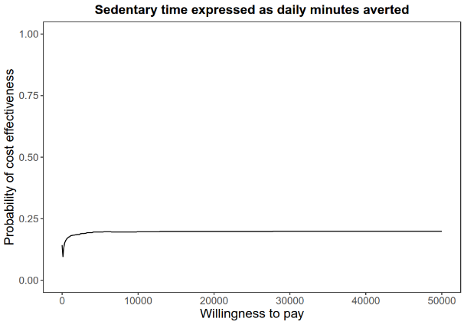 | 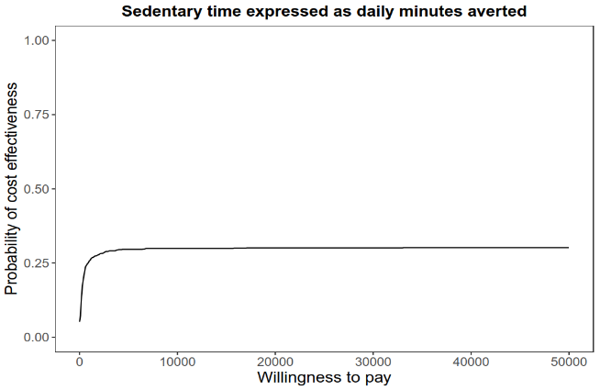 | 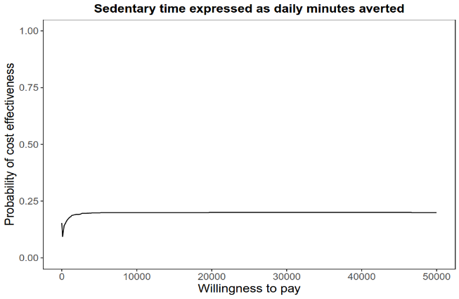
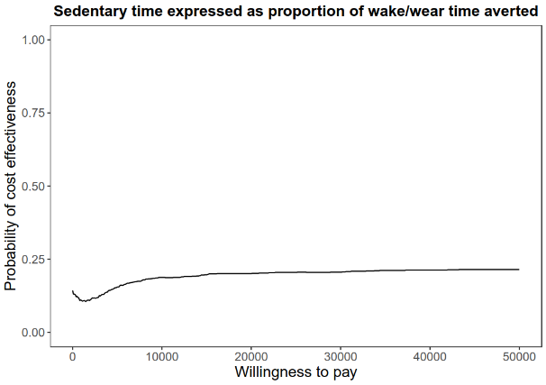 | 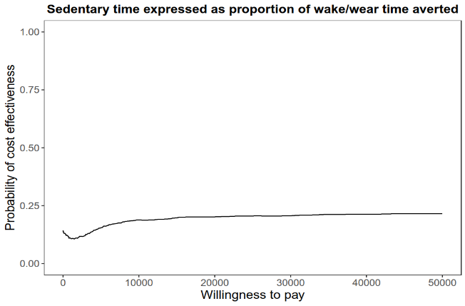 | 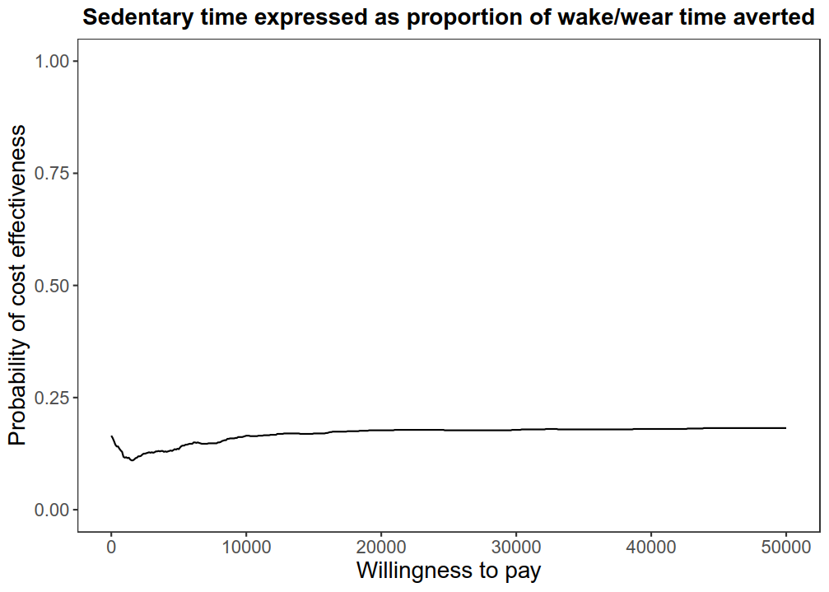
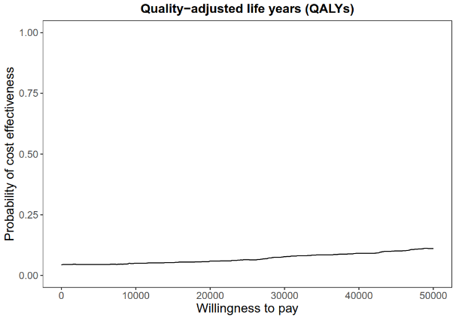 | 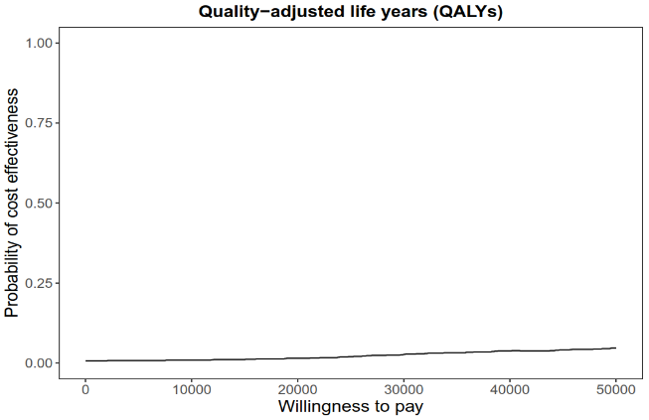 | 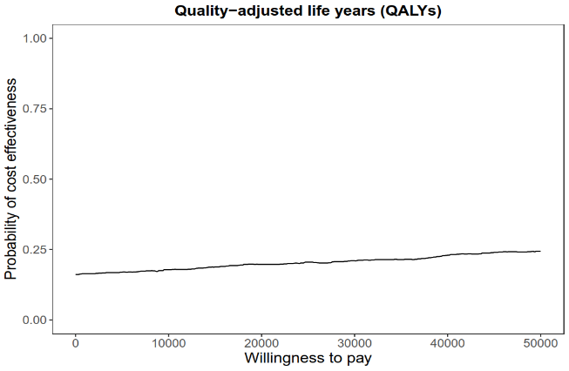
Supplementary figure 1: Cost-effectiveness acceptability curves for total societal costs and sedentary time expressed as daily minutes averted, sedentary time expressed as proportion of wake/wear time averted, and quality-adjusted life years (QALYs), respectively, for sensitivity analyses from the healthcare perspective, complete cases, and participants without extreme cost outliers. ITT, intention-to-treat; CC, complete cases

