Supplementary materials

Dual pH-Responsive and Tumor-targeted Nanoparticle-mediated
Anti-angiogenesis siRNA Delivery for Tumor Treatment

Supplementary methods

- Synthesis of carboxymethyl chitosan modified by histidine cholesteryl ester and EGFR monoclonal antibody (CHCE):
Add 200 mg of cholesterol (Sigma-Aldrich) and 130 mg of t-Butyloxy carbonyl-histidine (Boc-histidine) (Sigma-Aldrich) to 10 mL of dichloromethane (Sinopharm Chemical Reagent Co., Ltd), then add 140 mg of 1, 3-dicyclohexylcarbodiimide (Aladdin) and 2 mg of 4-dimethyl aminopyridine (Aladdin) and react at room temperature. After 15 hours, the white precipitates were filtered off. The solvent was removed under reduced pressure and purified to obtain the Boc-histidine cholesteryl ester intermediate; Dissolve 200 g Boc-histidine cholesteryl ester intermediate in 7 mL of dichloromethane, continue to add 1 mL of trifluoroacetic acid (Aladdin), stir for 1h, then neutralize with 2 mL of 36.6% aqueous ammonia solution (Sinopharm Chemical Reagent Co., Ltd), and reduce. The solvent was evaporated, and the residue was diluted in ethyl acetate, washed with water, dried over magnesium sulfate. The solvent was evaporated under reduced pressure again to obtain a white powdery histidine cholesteryl ester; Dissolve 520 mg the histidine cholesteryl ester in 100 mL tetrahydrofuran to prepare solution A. Dissolve 500 mg carboxymethyl chitosan, 250 mg 1-ethyl-(3-dimethyl aminopropyl) carbodiimide hydrochloride (Aladdin), and 150 mg N-hydroxysuccinimide (Aladdin) in 50 mL 1% acetic acid. Activate the carboxyl group in the solution for 1 hour at room temperature, add solution A with stirring, react at room temperature for 72 h, evaporate tetrahydrofuran (Aladdin) under reduced pressure, add 200 mL of absolute ethanol and stir to accumulate the precipitate, filter, and wash the precipitate with tetrahydrofuran, acetone, and ether in turn to obtain a white powder of Histidine cholesteryl ester modified carboxymethyl chitosan polymer compound (CHC). Dissolve 38 mg of carbodiimide hydrochloride and 23 mg of N-hydroxysuccinimide in 2 mL of a 0.1 mM EGFR monoclonal antibody and activate the carboxyl group for 1 h to obtain activated targeting marker solution. Dissolved 40 mg of CHC in 10 mL of 1% hydrochloric acid solution, then added activated targeting marker solution with stirring and reacted at 4°C for 24 h. Freeze-drying to obtain carboxymethyl chitosan modified by histidine cholesteryl ester and EGFR monoclonal antibody (CHCE).

- Determination of siRNA loading content and encapsulation efficiency
Mixed a certain concentration of CHCE solution and siRNA solution according to different mass ratios (1:1, 2:1, 4:1, 8:1, 16:1, 32:1) at 4°C for 30 min to synthesize the multifunctional CHCE/siRNA nanoparticles. Then 50 µl CHCE/siRNA nanoparticles were transferred to the adsorption column and 12000g centrifuged at 4°C for 5 minutes. The CHCE/siRNA nanoparticles were retained in the adsorption column, and the non-encapsulated free siRNA was in the solution, and then detected the siRNA concentration with a 260-nm spectrophotometer. The encapsulation efficiency and loading content of siRNA were calculated as follows: Loading content =（WT− WF）/WNP× 100% (1)Where WT is the total weight of siRNA fed, WF is the weight of non-encapsulated free siRNA, and WNP is the weight of nanoparticles. Encapsulation efficiency = (WT− WF)/WT× 100% (2). Where WT is the total weight of siRNA fed, and WF is the weight of non-encapsulated free siRNA

- Cellular uptake of CHCE/siRNA NPs
1×10⁵ SK-MEL-28 cells were inoculated with pure siRNA, CHC/siRNA, and CHCE/siRNA (the siRNA were modified with FITC, and the siRNA concentration in each group was 1.6 μg/mL) for 1 h at room temperature. Collecting the cells and the cellular uptake of CHCE/siRNA NPs to cells was detected by laser scanning confocal microscope, fixed with 4% paraformaldehyde for 5 min, then stained with DAPI (Invitrogen) for 10 minutes. The cellular uptake was detected by a laser scanning confocal microscope.

4. Western blot
2x105 SK-MEL-28 cells were cultured with PBS, CHCE/nc-siRNA, siRNA, and CHC/siRNA, CHCE/siRNA, PEI/siRNA (the siRNA concentration in each group was 1.6 μg/mL) for 48h, respectively. Then the cells were collected to extract protein and detected the protein concentration using the BCA kit. The equal amount of protein was separated on SDS-PAGE and transferred to the Hybond-P membrane. The membrane was blocked 1 h at room temperature using 5% skimmed milk powder solution. The membrane with VEGFA protein was incubated with VEGFA antibody (1/2000 dilution) (Jackson ImmunoResearch) overnight at 4℃, and the membrane with GAPDH protein was incubated with GADPH antibody (1/5000 dilution) (Jackson ImmunoResearch) overnight at 4℃. After extensive washing, the membrane with VEGFA protein was incubated with the horseradish peroxidase-conjugated anti-rabbit immunoglobulin in blocking buffer at room temperature for 1 h. The membrane with GAPDH protein was incubated with the horseradish peroxidase-conjugated anti-mouse immunoglobulin in blocking buffer at room temperature for 1 h. The membranes were washed three times with PBS. The bound antibody was detected using the enhanced chemiluminescence (ECL) assay.

5. qPCR
2×105 SK-MEL-28 cells were cultured with PBS, CHCE/nc-siRNA, siRNA, and CHC/siRNA, CHCE/siRNA, PEI/siRNA (the siRNA concentration in each group was 1.6 μg/mL) for 48 h, respectively. Then the cells were collected to extract the total RNA using Trizol and reverse transcribed into cDNA for qPCR. The qPCR master mix was prepared on ice, including 10 pmol of each primer, 3-4 mM of MgCl2, and 1xSYBR Green I solution. 2 ul cDNA was added to 18ul PCR master-mix. The thermal cycling conditions comprised an initial denaturation step at 95℃ for the 30s, 40 cycles at 95℃ for 5 s, and 58℃ for 5 s, and 72℃ for 10s. Each sample was run in duplicate and normalized to the internal control. The VEGFA primers were forward-AGGGCAGAATCATCACGAAGT, reverse-AGGGTCTCGATTGGATGGCA. As it was difficult to assess the precise amount of total RNA added to each reaction (based on absorbance) and its quality, we quantified a housekeeping gene glyceraldehyde-3-phosphate dehydrogenase (GAPDH) as the endogenous RNA control. The primers for the internal control were forward-GAAGGTGAAGGTCGGAGTC, reverse-GAAGATGGTGATGGGATTTC.

6. Immunohistochemistry (IHC) assay
The expression of VEGFA protein was detected by immunohistochemistry. Formalin-fixed paraffin tissue sections were dewaxed with xylene for 5 min each time, then rehydrated with graded ethanol, and then washed with PBS for 3 times (5 min each time). The tissue sections were placed in a preheated 1 mm EDTA buffer (pH 8.0) for antigen repair for 30 min, cooled at room temperature. Then the endogenous peroxidase was inactivated and incubated in the dark at room temperature for 15 min. Then 10% FBS was used for sealing at room temperature for 30 min and the diluted VEGFA antibody (1:200) was incubated overnight at 4℃. The second antibody was incubated at 37℃ for 1 h and then incubated with horseradish peroxidase for 30 minutes. Staining was done on the DAB and visualized using the fluorescence microscope. Upon completion of the staining, the tissue sections were well rinsed in distilled water for 5 min and then counterstained in Hematoxylin solution for 1 min, followed by a running tap water rinse for 3 min and then dehydrated to xylenes and sealed with neutral gum.

Supplementary Figures

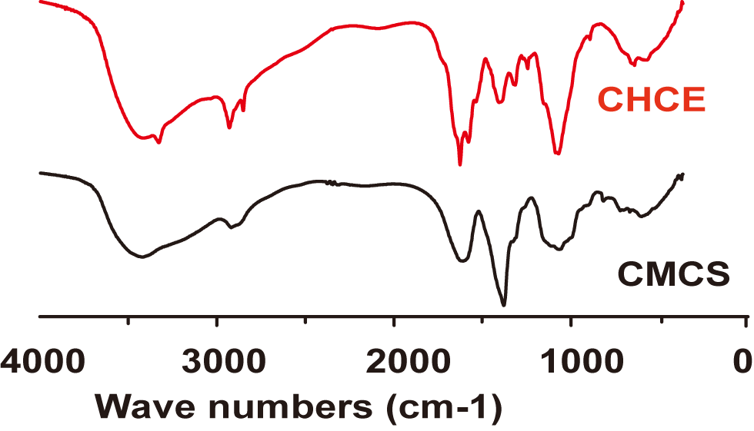

Supplementary Figure 1. Infrared spectra of carboxymethyl chitosan (CMCS) and carboxymethyl chitosan modified by histidine cholesteryl ester and EGFR monoclonal antibody (CHCE).

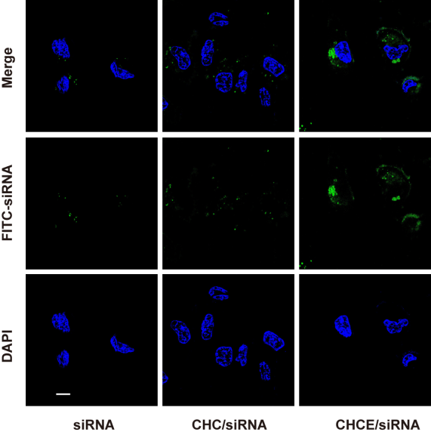
Supplementary Figure 2. A laser scanning confocal microscope detected the cellular uptake of CHCE/siRNA NPs. 1×105 SK-MEL-28 cells were inoculated with pure siRNA, CHC/siRNA, and CHCE/siRNA (the siRNA were modified with FITC, and the siRNA concentration in each group was 1.6 μg/mL). Scale bar, 10 µm.

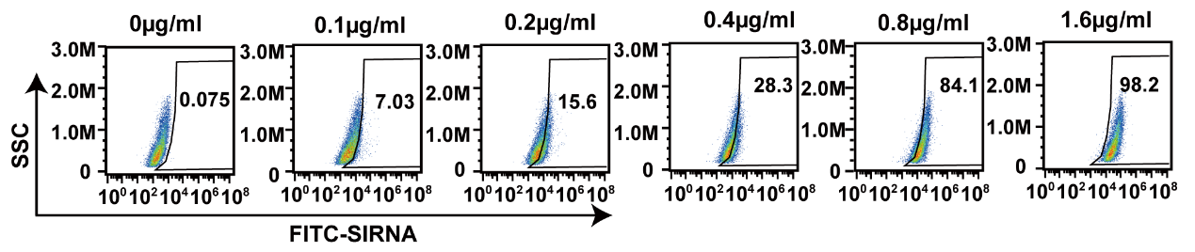
Supplementary Figure 3. Flow cytometry detected the concentration-dependent cellular uptake efficiency of CHCE/siRNA NPs. The SK-MEL-28 cells were cultured with different concentration of CHCE/siRNA NPs (the siRNA were all modified with FITC, the siRNA concentration were 0 μg/mL, 0.1 μg/mL, 0.2μg/mL, 0.4 μg/mL, 0.8 μg/mL, 1.6 μg/mL).

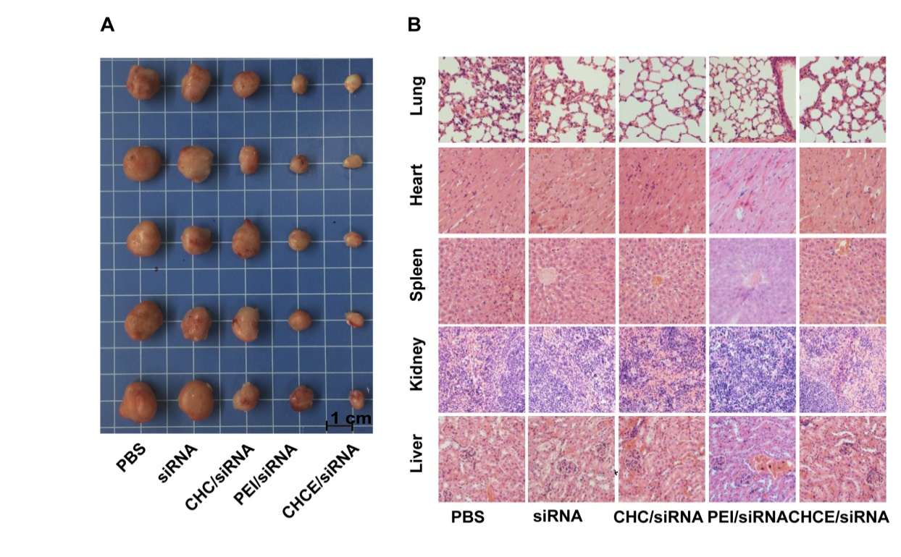
Supplementary Figure 4. The antitumor effect of CHCE/siRNA NPs in tumor-bearing mice. (A) The image of tumors at the end of treatment. (B) Histologic assessments of major organs.

Supplementary Table

Supplementary Table 1. The siRNA encapsulation efficiency and loading content.
CHCE:siRNA | Encapsulation efficiency | loading content
0.5:1 | 7.4% | 14.8%
1:1 | 13.5% | 13.5%
2:1 | 24.6% | 12.3%
4:1 | 46.4% | 11.6%
8:1 | 78.6% | 9.8%
16:1 | 80.5% | 5.03%
32:1 | 79.5% | 2.48%

