Supplementary materials
Table S1 Input parameters in the base-case analysis
Table S2 Pooled prevalence and incidence of PCV among Asian patients with nAMD using random-effect model
Table S3 Budget impact analysis results
Figure S1 Cost-effectiveness plane of IVB combined with vPDT compared to IVB monotherapy
Figure S2 Threshold analysis showing cost of verteporfin for using in combination with intravitreal bevacizumab.
Figure S3 Average budget per year by drug cost and monitoring cost of IVB monotherapy and IVB combined with vPDT.
References

Table S1 Input parameters in the base-case analysis
Parameters | Distribution | Mean | SE | Source
Transitional probabilities
First year: Probability of gaining 15 letters or more (per month) - IVR | beta | 0.0125 | 0.0012 | EVEREST II-year 1 ¹
First year: Probability of gaining 15 letters or more (per month) - IVB | beta | 0.0125 | 0.0012 | Assumed equal to IVR
First year: Probability of gaining 15 letters or more (per month) - IVA | beta | 0.0329 | 0.0033 | PLANET-year 1 ²
First year: Probability of gaining 15 letters or more (per month) - IVR+vPDT | beta | 0.0231 | 0.0023 | EVEREST II-year 1 ¹
First year: Probability of gaining 15 letters or more (per month) - IVB+vPDT | beta | 0.0231 | 0.0023 | Assumed equal to IVR+vPDT
First year: Probability of losing 15 letters or more (per month) - IVR | beta | 0.0044 | 0.0004 | EVEREST II-year 1 ¹
First year: Probability of losing 15 letters or more (per month) - IVB | beta | 0.0044 | 0.0004 | Assumed equal to IVR
First year: Probability of losing 15 letters or more (per month) - IVA | beta | 0.0021 | 0.0002 | PLANET-year 1 ²
First year: Probability of losing 15 letters or more (per month) - IVR+vPDT | beta | 0.0011 | 0.0001 | EVEREST II-year 1 ¹
First year: Probability of losing 15 letters or more (per month) - IVB+vPDT | beta | 0.0011 | 0.0001 | Assumed equal to IVR+vPDT
Probability of hemorrhage† (per month) - IVR | beta | 0.0013 | 0.00013 | Calculated from EVEREST II-year 2 ³ (24 months)
Probability of hemorrhage† (per month) - IVB | beta | 0.0013 | 0.00013 | Assumed equal to IVR
Probability of hemorrhage† (per month) - IVA | beta | 0.0019 | 0.00019 | Calculated from PLANET (2 years)
Probability of hemorrhage† (per month) - IVR+vPDT | beta | 0.0002 | 0.00002 | Calculated from EVEREST II-year 2 ³ (24 months)
Probability of hemorrhage† (per month) - IVB+vPDT | beta | 0.0002 | 0.00002 | Assumed equal to IVR+vPDT
Probability of recovery from hemorrhage (per month) | beta | 0.1100 | 0.0110 | ⁴ and assumed the same probability for all interventions.
Second year: Probability of gaining 15 letters or more (per month) - IVR | beta | 0.0228 | 0.0023 | EVEREST II-year 2 ³
Second year: Probability of gaining 15 letters or more (per month) - IVB | beta | 0.0228 | 0.0023 | Assumed equal to IVR
Second year: Probability of gaining 15 letters or more (per month) - IVA | beta | 0.0329 | 0.0033 | Calculated from PLANET-year 1 ²
Second year: Probability of gaining 15 letters or more (per month) - IVR+vPDT | beta | 0.0302 | 0.0030 | EVEREST II-year 2 ³
Second year: Probability of gaining 15 letters or more (per month) - IVB+vPDT | beta | 0.0302 | 0.0030 | Assumed equal to IVR+vPDT
Second year onwards: Probability of losing 15 letters or more (per month) - IVR | beta | 0.0047 | 0.0005 | EVEREST II-year 2 ³
Second year onwards: Probability of losing 15 letters or more (per month) - IVB | beta | 0.0047 | 0.0005 | Assumed equal to IVR
Second year onwards: Probability of losing 15 letters or more (per month) - IVA | beta | 0.0027 | 0.0003 | Calculated from PLANET-year 1 ²
Second year onwards: Probability of losing 15 letters or more (per month) - IVR+vPDT | beta | 0.0041 | 0.0004 | EVEREST II-year 2 ³
Second year onwards: Probability of losing 15 letters or more (per month) - IVB+vPDT | beta | 0.0041 | 0.0004 | Assumed equal to IVR+vPDT
Third year onwards: Probability of gaining 15 letters or more (per month) - IVR | beta | 0.0074 | 0.0007 | LUMINOUS, 2017 ⁵
Third year onwards: Probability of gaining 15 letters or more (per month) - IVB | beta | 0.0074 | 0.0007 | Assumed equal to IVR
Third year onwards: Probability of gaining 15 letters or more (per month) - IVA | beta | 0.0103 | 0.0010 | Assumed from proportion from LUMINIOUS ⁵ (IVR in nAMD)
Third year onwards: Probability of gaining 15 letters or more (per month) - IVR+vPDT | beta | 0.0095 | 0.0010 | Assumed from proportion from LUMINIOUS ⁵ (IVR in nAMD)
Third year onwards: Probability of gaining 15 letters or more (per month) - IVB+vPDT | beta | 0.0095 | 0.0010 | Assumed from proportion from LUMINIOUS ⁵ (IVR in nAMD)
Treatment-related ocular adverse events
Rate of vitreous hemorrhage (per month) | gamma | 0.000814 | 0.000814 | EVEREST II-year 2 ³ (24 months)
Rate of subretinal hemorrhage (per month) | gamma | 0.000136 | 0.000136 | EVEREST II-year 2 ³ (24 months)³
Proportion of patients with vitreous hemorrhage who receive Par Plana Vitrectomy | gamma | 0.25 | 0.25 | Expert opinion
Rate of cataract (per month) | gamma | 0.000013 | 0.000013 | LUMINOUS, 2017 ⁵
Rate of endophthalmitis (per month) | gamma | 0.000025 | 0.000025 | LUMINOUS, 2017 ⁵
Rate of retinal detachment (per month) | gamma | 0.000013 | 0.000013 | LUMINOUS, 2017 ⁵
Costs
Direct medical cost
Medications and administration
Unit cost of bevacizumab per 1 injection (THB) | gamma | 769.11 | 107.45 | Primary data which a vial of bevacizumab 100 mg/4 ml could be divided into 30 pre-filled syringes.
Unit cost of ranibizumab 10 mg/ml (0.23 ml/vial) for 1 injection (THB) | gamma | 39,175.81 | 1,397.90 | Primary data
Unit cost of aflibercept 2 mg (0.05 ml/vial) for 1 injection (THB) | gamma | 38,803.55 | 1,382.98 | Primary data
Unit cost of verteporfin 15 mg/vial for PDT (THB) | gamma | 37,785.65 | 208.21 | Primary data
Unit cost of PDT, excluding verteporfin (THB per visit) | gamma | 2,060.03 | 206.00 | Primary data
Unit cost of an intravitreal administration and topical antibiotic | gamma | 1,718.82 | 171.88 | Primary data
First year: Frequency of IVR (per year) | gamma | 7.30 | 0.26 | EVEREST II-year 1 ¹
First year: Frequency of IVB (per year) | gamma | 7.30 | 0.26 | Assumed equal to IVR
First year: Frequency of IVA (per year) | gamma | 8.10 | 0.10 | PLANET-year 1 ²
First year: Frequency of IVR in combination therapy (per year) | gamma | 5.20 | 0.19 | EVEREST II-year 1 ¹
First year: Frequency of IVB in combination therapy (per year) | gamma | 5.20 | 0.19 | Assumed equal to IVR
First year: Frequency of vPDT in combination therapy (per year) | gamma | 1.50 | 0.06 | EVEREST II-year 1 ¹
Second year: Frequency of IVR (per year) | gamma | 5.20 | 0.52 | EVEREST II-Year 2 ³
Second year: Frequency of IVB (per year) | gamma | 5.20 | 0.52 | Assumed equal to IVR
Second year: Frequency of IVA (per year) | gamma | 4.60 | 0.46 | PLANET-Year 2 ⁶
Second year: Frequency of IVR in combination (per year) | gamma | 2.90 | 0.29 | EVEREST II-Year 2 ³
Second year: Frequency of IVB in combination therapy (per year) | gamma | 2.90 | 0.29 | Assumed equal to IVR from EVEREST II-year 1 ¹ at month 12
Second year: Frequency of vPDT in combination therapy (per year) | gamma | 0.70 | 0.07 | EVEREST II-Year 2 ³
Third year: Frequency of IVR (per year) | gamma | 3.10 | 0.31 | Estimated from frequencies in year 1 and 2 [Frequency = (-2.1 * year) + 9.4]
Third year: Frequency of IVB (per year) | gamma | 3.10 | 0.31 | Assumed equal to IVR
Third year: Frequency of IVA (per year) | gamma | 1.10 | 0.11 | Estimated from frequencies in year 1 and 2 [Frequency = (-3.5 * year) + 11.6]
Third year: Frequency of IVR in combination therapy (per year) | gamma | 1.55 | 0.16 | Assumed to be a half of the frequency of IVR in the third year
Third year: Frequency of IVB in combination therapy (per year) | gamma | 1.55 | 0.16 | Assumed equal to IVR
Third year: Frequency of vPDT in combination therapy (per year) | gamma | 0.44 | 0.04 | Assumed to be 1/7 of the frequency of IVR in the third year
Cost of ocular examination
Cost of indocyanine green angiography (THB) | gamma | 1,796.28 | 179.63 | Primary data
Unit cost of fundus fluorescein angiography, including contrast (THB) | gamma | 1,130.76 | 113.08 | Primary data
Unit cost of OCT (THB) | gamma | 550.80 | 55.08 | Primary data
First year: Frequency of OCT– IVB | gamma | 7.90 | 0.79 | Assumed that OCT was performed every visit
First year: Frequency of OCT– IVR | gamma | 7.90 | 0.79 | Assumed that OCT was performed every visit
First year: Frequency of OCT – IVA | gamma | 8.00 | 0.80 | Assumed that OCT was performed every visit
First year: Frequency of OCT – IVR+vPDT or IVB+vPDT | gamma | 7.90 | 0.79 | Assumed that OCT was performed every visit
Second year: Frequency of OCT – IVB | gamma | 4.60 | 0.46 | Assumed that OCT was performed every visit
Second year: Frequency of OCT – IVR | gamma | 4.60 | 0.46 | Assumed that OCT was performed every visit
Second year: Frequency of OCT– IVA | gamma | 4.66 | 0.47 | Assumed that OCT was performed every visit
Second year: Frequency of OCT – IVR+vPDT or IVB+vPDT | gamma | 4.60 | 0.46 | Assumed that OCT was performed every visit
Third year: Frequency of OCT – IVB | gamma | 2.00 | 0.20 | Assumed that OCT was performed every visit
Third year: Frequency of OCT – IVR | gamma | 2.00 | 0.20 | Assumed that OCT was performed every visit
Third year: Frequency of OCT - IVA | gamma | 2.00 | 0.20 | Assumed that OCT was performed every visit
Third year: Frequency of OCT – IVR+vPDT or IVB+vPDT | gamma | 2.00 | 0.20 | Assumed that OCT was performed every visit
Unit cost of eye dilation (THB per visit) | gamma | 72.28 | 7.23 | ⁷
Cost of Fundus camera examination for both eyes (THB) | gamma | 194.40 | 19.44 | Primary data
Cost of outpatient service, including cost of VA and IOP measurements (THB per day) | gamma | 305.32 | 30.53 | ⁷
Cost of inpatient service (THB per day) | gamma | 1,310.84 | 131.08 | ⁷
First year: Monitoring visit‡ (visits per year) - IVB | gamma | 7.90 | 0.79 | Assumed equal to IVR
First year: Monitoring visit‡ (visits per year) - IVR | gamma | 7.90 | 0.79 | EVEREST II-year 1 ¹
First year: Monitoring visit‡ (visits per year) – IVA | gamma | 8.00 | 0.80 | PLANET-year 1 ²
First year: Monitoring visit‡ (visits per year) – IVR+vPDT or IVB+vPDT | gamma | 7.90 | 0.79 | EVEREST II-year 1 ¹ and assumed frequency of the visit of IVB group was equal to frequency of the visit of IVR group
Second year: Monitoring visit‡ (visits per year) - IVB | gamma | 4.60 | 0.46 | Assumed equal to IVR
Second year: Monitoring visit‡ (visits per year) - IVR | gamma | 4.60 | 0.46 | EVEREST II-year 1 ¹
Second year: Monitoring visit‡ (visits per year) - IVA | gamma | 4.66 | 0.47 | PLANET-year 1 ²
Second year: Monitoring visit‡ (visits per year) – IVR+vPDT or IVB+vPDT | gamma | 4.60 | 0.46 | EVEREST II-year 2 ³ and assumed frequency of the visit of IVB group was equal to frequency of the visit of IVR group
Third year onwards: Monitoring visit‡ (visits per year) - IVB | gamma | 2.00 | 2.00 | Expert opinion
Third year onwards: Monitoring visit‡ (visits per year) - IVR | gamma | 2.00 | 2.00 | Expert opinion
Third year onwards: Monitoring visit‡ (visits per year) - IVA | gamma | 2.00 | 2.00 | Expert opinion
Third year onwards: Monitoring visit‡ (visits per year) – IVR+vPDT or IVB+vPDT | gamma | 2.00 | 2.00 | Expert opinion
Cost of treatment ‖
Unit cost of Par Plana Vitrectomy in 2018 (THB) | gamma | 19,606.76 | 2,943.17 | Primary data
Treatment cost for cataract in 2010 (THB per episode) | gamma | 14,835.76 | 3,886.59 | Average cost of primary data from tertiary hospitals and a study of Yospaiboon Y, et al. ⁸
Treatment cost for subretinal hemorrhage using Par Plana Vitrectomy and gas (THB per episode) | gamma | 41,615.28 | 4,161.53 | Primary data
Treatment cost for retinal detachment due to intravitreal injection (THB per episode) | gamma | 55,922.93 | 5,592.29 | Primary data¶
Direct non-medical cost
Costs of device, equipment, and home renovation (once; THB) | gamma | 5,097.78 | 2,819.29 | Primary data
Costs of meal, transportation, and hotel and time cost of caregivers (THB per month) | gamma | 4,689.55 | 2,949.65 | Primary data
Utilities
BCVA of ≤25 ETDRS Letters | beta | 0.53 | 0.14 | Primary data
BCVA of 26-40 ETDRS Letters | beta | 0.68 | 0.11 | Primary data
BCVA of 41-55 ETDRS Letters | beta | 0.77 | 0.18 | Primary data
BCVA of 56-70 ETDRS Letters | beta | 0.83 | 0.05 | Primary data
BCVA of 71-85 ETDRS Letters | beta | 0.87 | 0.02 | Primary data
BCVA of 86-100 ETDRS Letters | beta | 0.87 | 0.02 | Assumed: equal to utility of VA 71-85 ETDRS letters
Complication: vitreous hemorrhage or subretinal hemorrhage (VA: CF, HM, PL, NPL) [during and post hemorrhage states) | beta | 0.53 | 0.14 | Assumed: equal to utility of ≤25 ETDRS Letters ETDRS letters
Parameter for budget impact analysis
Proportion of patients with unilateral PCV |  | 75% | % | Expert opinion
Pooled prevalence of patients with PCV among Asian patients with nAMD (patients) |  | 24% | % | Meta-analysis (Table S3)
Average number of patients with nAMD per year |  | 5,280 | patients | Primary data§
Pooled incidence of PCV among Asian patients with nAMD (eye) |  | 18% | % | Meta-analysis (Table S3)
Notes: Italicized-bold text represents the parameter categories and italicized text represents subgroups of the parameter categories. † Hemorrhage includes vitreous hemorrhage and subretinal hemorrhage. ‡ Monitoring visit includes visual acuity measurement and outpatient service. ‖ Treatment cost for vitreous hemorrhage using Par Plana Vitrectomy (THB per episode) was 39,615.28 THB (assumed using 3 days of hospitalization, PPV, dilation, Fundus photography, OCT, medications, IVB, and 4 outpatient follow-up visits and VA measurements). Total cost of cataract treatment per 1 episode was 19,426.64 THB which includes cost of cataract treatment, cost of 2.35 days of hospitalization, and costs of 4 outpatient follow-up visits and VA measurements. Total treatment cost for endophthalmitis per 1 episode was 55,873.99 THB (assumed 10 days of hospitalization, cost of endophthalmitis treatment, and 6 outpatient follow-up visits and VA measurements). ¶ The cost of retinal detachment treatment calculated from 3 days of hospitalization, 4 outpatient visits for follow up, treatment cost, and costs of gas, silicone oil, heavy silicone oil, and medication from tertiary hospitals. § Beneficiaries of Universal Health Coverage Scheme and Civil Servant Medical Benefit Scheme who received intravitreal bevacizumab for treating nAMD derived from databases of the National Health Security Office (2012-2019) and the Comptroller General's Department (2019).
Abbreviations: BCVA, best corrected visual acuity; CF, count finger; ETDRS, the Early Treatment Diabetic Retinopathy Study; HM, hand motion; ICG, Indocyanine green; IOP, intraocular pressure; IVA, intravitreal aflibercept; IVB, intravitreal bevacizumab; IVR, intravitreal ranibizumab; mg, milligram; ml, milliliter; nAMD, neovascular age-related macular degeneration; NPL, no light perception; OCT, optical coherence tomography; OPD, outpatient department; PCV, polypoidal choroidal vasculopathy; PL, light perception; RR, relative risk; SE, standard error; THB, Thai baht; VA, visual acuity; vPDT, verteporfin photodynamic therapy.

Table S2 Pooled prevalence and incidence of PCV among Asian patients with nAMD using random-effect model
Study | Prevalence  (patients) |  | [95% CI] |  | Study | Incidence  (eyes) |  | [95% CI]
Chen SJ (2004); Taiwan† | 0.16 | 0.13 |  | 0.20 | Sho (2003); Japan⁹ | 0.23 | 0.2 |  | 0.27
MarukoI I (2007); Japan¹⁰ | 0.55 | 0.49 |  | 0.49 | Kwok (2002); China¹¹ | 0.11 | 0.07 |  | 0.16
Liu Y (2007); China¹² | 0.25 | 0.18 |  | 0.32
Chen SJ (2008); Taiwan¹³ | 0.11 | 0.01 |  | 0.33
Cheung GCM (2017); Singapore¹⁴ | 0.14 | 0.11 |  | 0.18
Pooled prevalence | 0.24 | 0.1 |  | 0.39 | Pooled incidence | 0.18 | 0.15 |  | 0.21
Heterogeneity chi² = 159.51 (d.f. = 4) p < 0.01  I² (variation in ES attributable to heterogeneity) = 97.49% |  |  |  |  | Test of ES=0: z= 12.23 p < 0.01  I² =0.00%
Note: †Unpublished data mentioned in a study of Chen SJ, et al.¹³.
Abbreviations: CI, confidence interval; d.f., degree of freedom; ES, effect estimate; nAMD, neovascular age-related macular degeneration; PCV, polypoidal choroidal vasculopathy.

Table S3 Budget impact analysis results
Fiscal year | IVB | IVB+vPDT | IVR | IVA | IVR+vPDT | Incremental budget* (million USD)
 | (million USD) | (million USD) | (million USD) | (million USD) | (million USD) | IVB + vPDT | IVR | IVA | IVR + vPDT
The original cost of verteporfin (37,786 THB per vial)
1 | 3 | 8 | 28 | 31 | 26 | 5 | 26 | 28 | 23
2 | 3 | 7 | 33 | 32 | 26 | 4 | 30 | 29 | 23
3 | 3 | 7 | 34 | 27 | 26 | 5 | 31 | 24 | 24
4 | 3 | 8 | 40 | 29 | 30 | 5 | 36 | 26 | 27
5 | 4 | 9 | 45 | 31 | 33 | 6 | 42 | 27 | 30
Total 5 years | 15 | 40 | 180 | 149 | 142 | 25 | 165 | 134 | 126
Average/ year | 3 | 8 | 36 | 30 | 28 | 5 | 33 | 27 | 25
The cost of verteporfin at the Thai willingness to pay threshold (20,889 THB per vial)
1 | 3 | 5 | 28 | 31 | 24 | 3 | 26 | 28 | 21
2 | 3 | 5 | 33 | 32 | 24 | 2 | 30 | 29 | 21
3 | 3 | 5 | 34 | 27 | 24 | 2 | 31 | 24 | 21
4 | 3 | 6 | 40 | 29 | 27 | 3 | 36 | 26 | 24
5 | 4 | 7 | 45 | 31 | 30 | 3 | 42 | 27 | 27
Total 5 years | 15 | 28 | 180 | 149 | 129 | 13 | 165 | 134 | 114
Average/  year | 3 | 6 | 36 | 30 | 26 | 3 | 33 | 27 | 23
Note: IVB monotherapy was reference.
Abbreviations: IVA, intravitreal aflibercept; IVB, intravitreal bevacizumab; IVB+vPDT, intravitreal bevacizumab in combination with verteporfin photodynamic therapy; IVR, intravitreal ranibizumab; IVR+vPDT, intravitreal ranibizumab in combination with verteporfin photodynamic therapy; USD, the United States dollar.

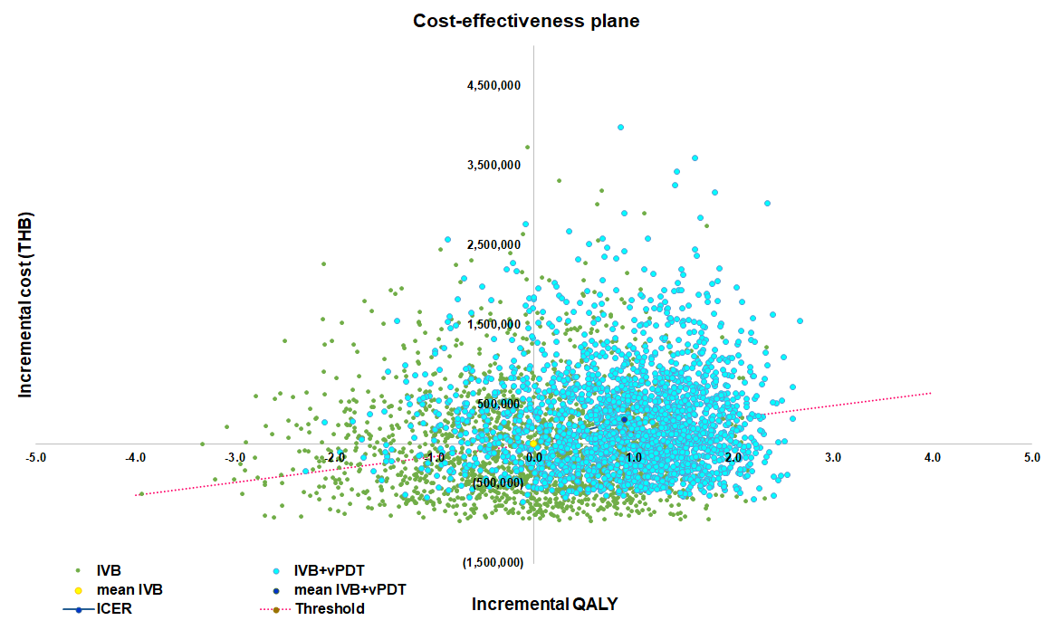
Figure S1 Cost-effectiveness plane of IVB combined with vPDT compared to IVB monotherapy
Abbreviations: IVB, intravitreal bevacizumab; IVB+vPDT, intravitreal bevacizumab in combination with verteporfin photodynamic therapy; ICER, incremental cost-effectiveness ratio; QALY, quality-adjusted life-year; THB, Thai baht.

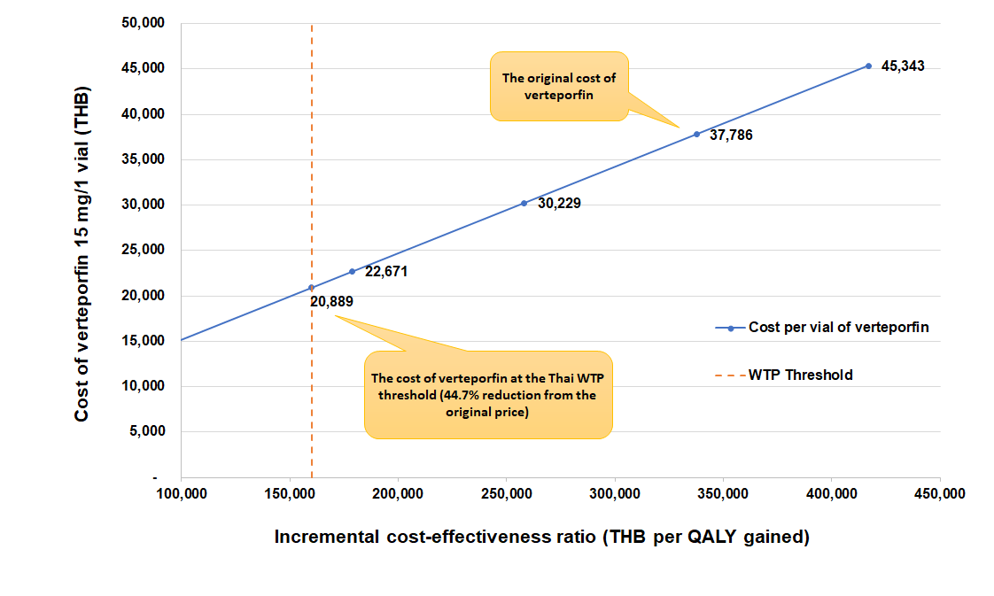
Figure S2 Threshold analysis showing cost of verteporfin for using in combination with intravitreal bevacizumab.
Abbreviations: QALY, quality-adjusted life-year; THB, Thai baht; WTP, willingness to pay.
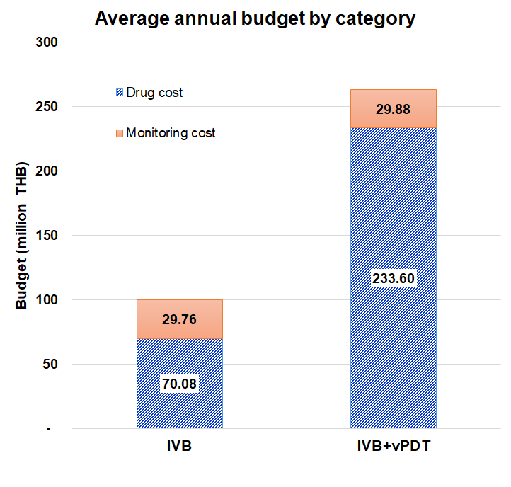
Figure S3 Average budget per year by drug cost and monitoring cost of IVB monotherapy and IVB combined with vPDT.
Abbreviations: IVB, intravitreal bevacizumab; IVB+vPDT, intravitreal bevacizumab in combination with verteporfin photodynamic therapy; THB, Thai baht.

References (Supplementary material)
1. Koh A, Lai TY, Takahashi K, et al. Efficacy and safety of ranibizumab with or without verteporfin photodynamic therapy for polypoidal choroidal vasculopathy: A randomized clinical trial. JAMA ophthalmology. 2017;135(11):1206-1213.
2. Lee WK, Iida T, Ogura Y, et al. Efficacy and safety of intravitreal aflibercept for polypoidal choroidal vasculopathy in the PLANET study: A randomized clinical trial. JAMA ophthalmology. 2018;136(7):786-793.
3. Lim TH, Lai TYY, Takahashi K, et al. Comparison of ranibizumab with or without verteporfin photodynamic therapy for polypoidal choroidal vasculopathy: the EVEREST II randomized clinical trial. JAMA ophthalmology. 2020;138(9):935-942.
4. Salmon HA, Chalk D, Stein K. How lack of information hampers decision making in ophthalmology. British Journal of Healthcare Management. 2017;23(1):28-38.
5. LUMINOUS™: Study to observe the effectiveness and safety of ranibizumab through individualized patient treatment and associated outcomes. Basel: Novartis Pharma AG; 12 April 2017 2017.
6. Wong TY, Ogura Y, Lee WK, et al. Efficacy and safety of intravitreal aflibercept for polypoidal choroidal vasculopathy: two-year results of the aflibercept in polypoidal choroidal vasculopathy study. American Journal of Ophthalmology. 2019;204:80-89.
7. Riewpaiboon A. Standard cost lists for health technology assessment. Bangkok: Tana Press Co., Ltd.; 2011.
8. Yospaiboon Y, Yospaiboon K, Ratanapakorn T, Sinawat S, Sanguansak T, Bhoomibunchoo C. Management of cataract in the Thai population. Journal of the Medical Association of Thailand = Chotmaihet thangphaet. 2012;95 Suppl 7:S177-181.
9. Sho K, Takahashi K, Yamada H, et al. Polypoidal choroidal vasculopathy: incidence, demographic features, and clinical characteristics. Archives of ophthalmology (Chicago, Ill : 1960). 2003;121(10):1392-1396.
10. Maruko I, Iida T, Saito M, Nagayama D, Saito K. Clinical Characteristics of Exudative Age-related Macular Degeneration in Japanese Patients. American Journal of Ophthalmology. 2007;144(1):15-22.e12.
11. Kwok AKH, Lai TYY, Chan CWN, Neoh EL, Lam DSC. Polypoidal choroidal vasculopathy in Chinese patients. The British journal of ophthalmology. 2002;86(8):892-897.
12. Liu Y, Wen F, Huang S, et al. Subtype lesions of neovascular age-related macular degeneration in Chinese patients. Graefe's Archive for Clinical and Experimental Ophthalmology. 2007;245(10):1441-1445.
13. Chen S-J, Cheng C-Y, Peng K-L, et al. Prevalence and Associated Risk Factors of Age-Related Macular Degeneration in an Elderly Chinese Population in Taiwan: The Shihpai Eye Study. Investigative Ophthalmology & Visual Science. 2008;49(7):3126-3133.
14. Cheung CMG, Laude A, Yeo I, et al. Systemic, Ocular and Genetic Risk Factors for Age-related Macular Degeneration and Polypoidal Choroidal Vasculopathy in Singaporeans. Scientific Reports. 2017;7(1):41386.

