Supplementary Table 1. The clinical characteristics of patients in GSE21257 and Target datasets.
Variable | GSE21257 | Target
Gender
Male | 34 | 57
Female | 19 | 40
Primary site
Upper limbs | 8* | 7
Lower limbs | 44 | 85
Trunk | NA | 5
Metastasis status
Non-metastasis | 19 | 43
Metastasis | 34 | 54
Age at diagnosis (mean years)
Non-metastasis | 19.44 | 16.76
Metastasis | 18.30 | 14.41
Survival status
Death | 23 | 38*
Alive | 30 | 58
Survival time
≥5 years | 24 | 29
<5 years | 29 | 67*
*Some patients’ data were not applicable. NA: not applicable; Target: Therapeutically Applicable Research to Generate Effective Treatments.

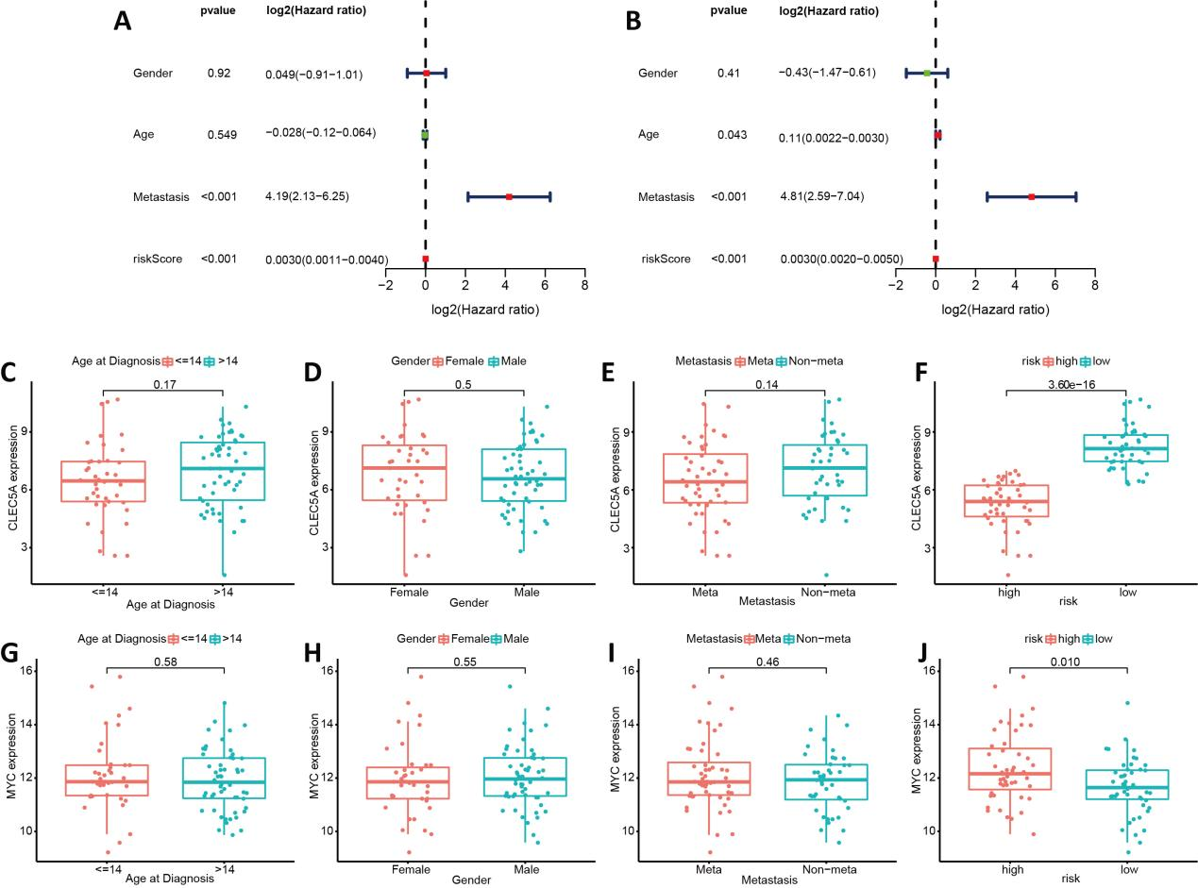

Supplementary Figure 1. Relationships between inflammatory response-associated gene signature and clinical parameters in Target dataset. (A, B). Univariate and multivariate cox regression analyses validated risk score as the independent prognostic factor. (C-F). Boxplots of the relationship between CLEC5A expression and clinical characteristics. (G-J). The correlation between MYC expression and clinical characteristics. CLEC5A: C-type lectin domain family 5 member A; Target: Therapeutically Applicable Research to Generate Effective Treatments.

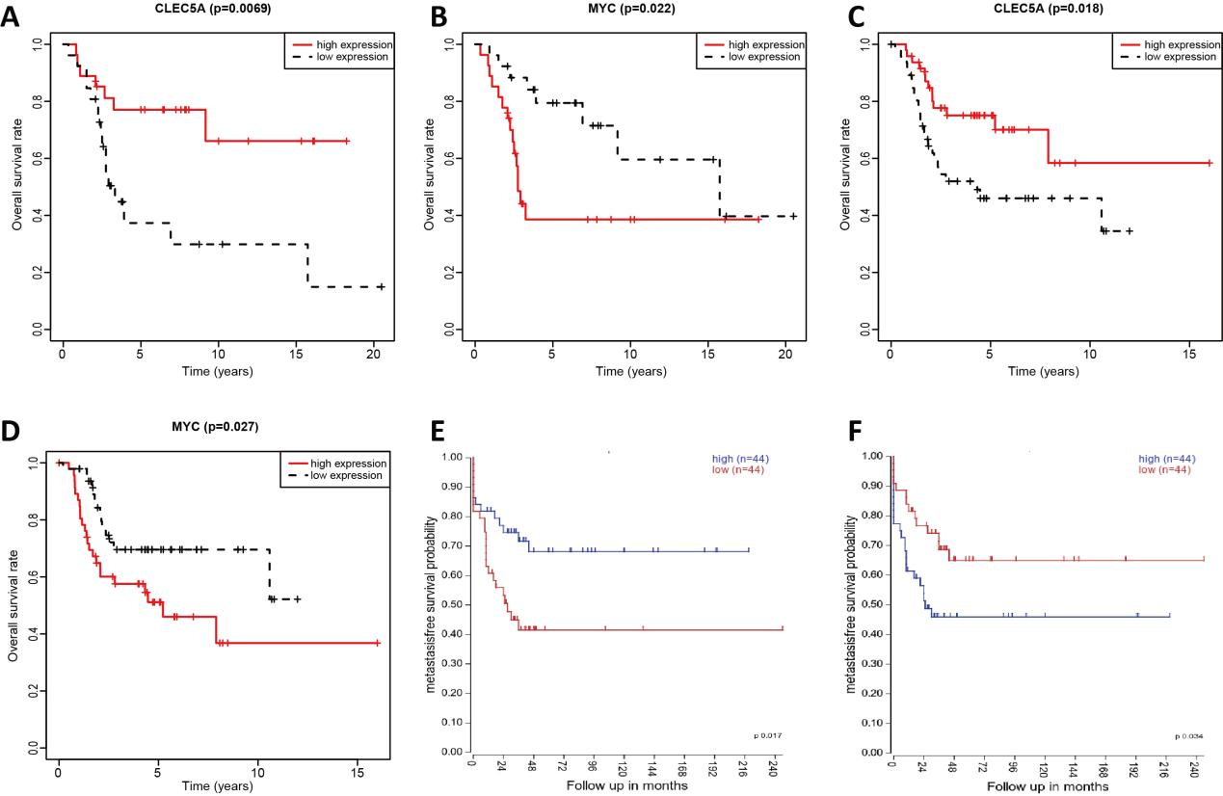

Supplementary Figure 2. The correlations between individual genes in inflammatory response-associated prognostic signature and survival rates. (A, B). Kaplan-Meier survival analyses of CLEC5A and MYC in GSE21257. (C,D).Kaplan-Meier survival plot of CLEC5A and MYC in Target dataset. (E, F).Kaplan-Meier survival analyses of CLEC5A and MYC in online database R2. CLEC5A: C-type lectin domain family 5 member A; Target: Therapeutically Applicable Research to Generate Effective Treatments.

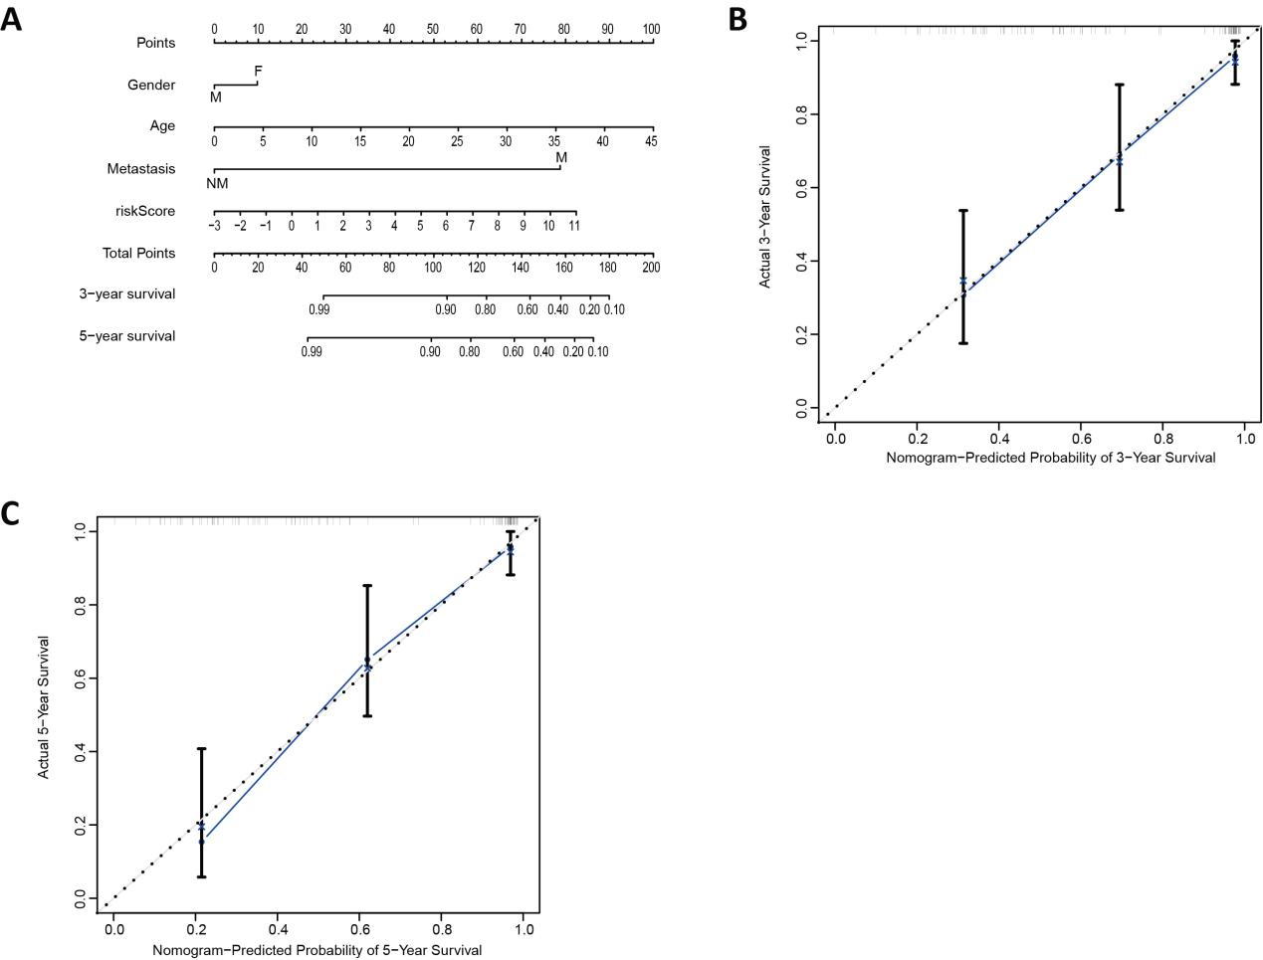
Supplementary Figure 3. Construction of the nomogram in Target dataset. (A) The nomogram predicted the 3- and 5-year survival risk in osteosarcoma patients. (B) The calibration curve of the 3-year survival. (C) The calibration curve of the 5-year survival. Target: Therapeutically Applicable Research to Generate Effective Treatments.

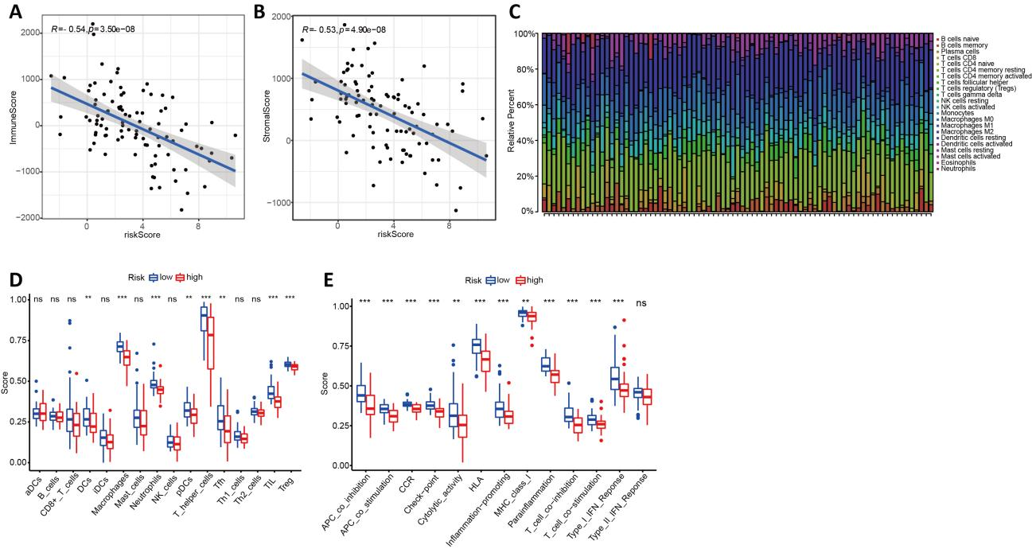

Supplementary Figure 4. The relationships between inflammatory response and immune infiltration in Target dataset. (A) The association between risk score and immune score. (B). The correlation between risk score and stromal score. (C) The infiltrative proportion of 22 immune cells in osteosarcoma with statistically significant. (D) The relationships between risk score and different immune cells. (E) The association between risk score and different immune functions. Target: Therapeutically Applicable Research to Generate Effective Treatments;NS, not significant; aDCs: activated dendritic cells; DCs: dendritic cells; iDCs: immature dendritic cells; NK: natural killer; aDCs: activated dendritic cells; pDCs: plasmacytoid dendritic cells; Tfh: T-follicular helper cells; Th: T helper; TIL: tumor infiltrating lymphocytes; Treg: T regulatory cells; APC: antigen-presenting cells; CCR: cytokine-cytokine receptor interaction; HLA: human leukocyte antigen; MHC: major histocompatibility complex; IFN: interferon; **P < 0.01; ***P < 0.001.

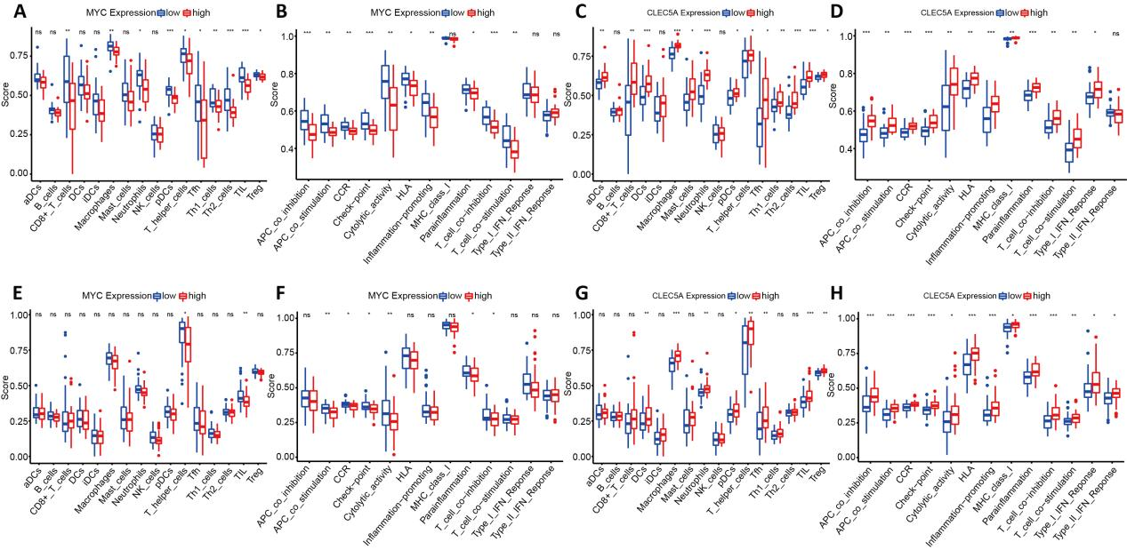

Supplementary Figure 5. The relationships between MYC or CLEC5A expression and different immune cells in GSE21257 (A, C) and Target dataset (E, G). The association between MYC or CLEC5A expression and different immune functions in GSE21257 (B, D) and Target dataset (F, H). Target: Therapeutically Applicable Research to Generate Effective Treatments;NS, not significant; aDCs: activated dendritic cells; DCs: dendritic cells; iDCs: immature dendritic cells; NK: natural killer; aDCs: activated dendritic cells; pDCs: plasmacytoid dendritic cells; Tfh: T-follicular helper cells; Th: T helper; TIL: tumor infiltrating lymphocytes; Treg: T regulatory cells; APC: antigen-presenting cells; CCR: cytokine-cytokine receptor interaction; HLA: human leukocyte antigen; MHC: major histocompatibility complex; IFN: interferon;*P < 0.05; **P < 0.01; ***P < 0.001.

