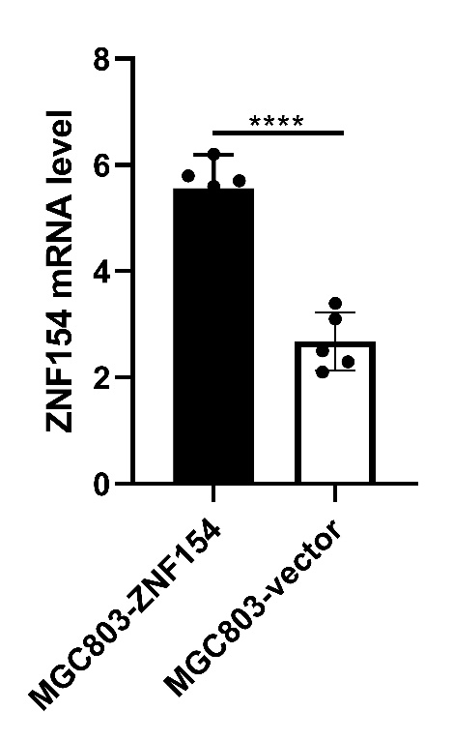
Supplementary Figure 1:ZNF154 mRNA levels of MGC803-ZNF154 and MGC803-vector cells. Data are presented as mean ± SD of triplicate experiments， ****p<0.0001.

