Supplementary Table 1. Univariate and multivariate logistic regression for factors associated with lymph node metastasis.
Covariate | Central lymph node metastasis |  | Lateral lymph node metastasis
Covariate | Univariate  OR (95% CI), p value | Multivariate  OR (95% CI), p value | Univariate  OR (95% CI), p value | Multivariate  OR (95% CI), p value
Sex (female vs male) | 0.577(0.490, 0.678), <0.001 | 0.596(0.481, 0.737), <0.001 | 0.527(0.405, 0.685), <0.001 | 0.502(0.326, 0.773), 0.002
Age (≤50y vs >50y) | 2.346(2.007, 2.741), <0.001 | 2.272(1.868, 2.763), <0.001 | 1.634(1.237, 2.157), 0.001
Comorbidity | 0.789(0.669, 0.930), 0.005 |  | 0.731(0.539, 0.993), 0.045
Hashimoto’s thyroiditis | 1.079(0.854, 1.364), 0.522 |  | 0.780(0.497, 1.226), 0.281
Familial or personal history of cancer | 0.940(0.763, 1.157), 0.557 |  | 0.980(0.679, 1.414), 0.914
Pre-surgical ultrasound information
Tumor size | 1.291(1.201, 1.388), <0.001 | 1.391(1.262, 1.533), <0.001 | 1.560(1.412, 1.723), <0.001 | 1.487(1.237, 1.789), <0.001
TI-RADS score | 1.358(1.253, 1.472), <0.001 | 1.296(1.183, 1.420), <0.001 | 2.042(1.802, 2.316), <0.001 | 1.589(1.338, 1.886), <0.001
Multifocal lesion | 1.011(0.859, 1.190), 0.897 |  | 1.191(0.876, 1.620), 0.264
Admission year | 1.164(1.080, 1.254), <0.001 | 1.214(1.102, 1.338), <0.001 | 1.069(0.937, 1.219), 0.320

Supplementary Table 2. Clinical characteristics of 38 thyroid cancer patients receiving ultrasound examination before and after the COVID-19 pandemic.
Variable | Value
Sex, female (%) | 33(86.8)
Age
Mean (SD) | 44.6(12.4)
Median (IQR) | 46(36, 53)
≤50 years old (%) | 22(57.9)
>50 years old (%) | 16(42.1)
Comorbidities (%) | 11(28.9)
Hashimoto’s thyroiditis (%) | 4(10.5)
Medical history (%)
Familial history of malignancy | 4(10.5)
Personal history of other malignancy | 5(13.2)
Histological types and subtypes (%)
Papillary | 38(100)
PTMC | 28(73.7)
Conventional | 20(52.6)
Follicular variant | 8(21.1)
Postsurgical pathological information
Maximum size (cm, SD) | 0.82(0.56)
Site (%)
Unilateral | 18(47.4)
Bilateral | 20(52.6)
Tumor number (n, SD) | 1.58(0.83)
Peripheral location (%) | 27(71.1)
Extrathyroidal extension (%) | 4(10.5)
Lymph node metastasis (%) | 13(34.2)
CLNM | 13(34.2)
LLNM | 2(5.3)
Delayed time (day) ª
Mean (SD) | 201.3(86.1)
Median (IQR) | 189(133, 259)

ª Delayed time is defined as the time interval between the date of the last pre-COVID-19 thyroid ultrasound examination and the date of pre-surgical ultrasound examination.
Abbreviation: PTMC, papillary thyroid micro carcinoma;CLNM, central lymph node metastasis; LLNM, lateral lymph node metastasis; TI-RADS, thyroid imaging reporting and data system.
Supplementary Table 3. Comparison of ultrasound and pathological data in patients with tumor ≤10mm and >10mm.
Variable | Tumor ≤10mm |  |  | Tumor >10mm
Variable | Pre-lockdown | Post-lockdown | P value | Pre-lockdown | Post-lockdown | P value
Postoperative pathological information
Maximum size (SD) | 0.562(0.23) | 0.59(0.22) | 0.071 | 1.87(0.94) | 1.84(0.97) | 0.751
Tumor number (SD) | 1.52(1.02) | 1.64(1.15) | 0.157 | 1.67(1.15) | 2.02(1.51) | 0.016*
Extrathyroidal extension (%) | 1035(55.7) | 153(66.2) | 0.002** | 844(87.1) | 106(84.8) | 0.474
Lymph node metastasis | 502(27.0) | 74(32.0) | 0.108 | 556(57.4) | 90(72.0) | 0.002**
CLNM (%) | 489(26.3) | 71(30.7) | 0.153 | 544(56.1) | 89(71.2) | 0.001**
LLNM (%) | 62(3.3) | 9(3.9) | 0.658 | 151(15.6) | 31(24.8) | 0.009**
Presurgical ultrasound information
Maximum size (SD) | 1.02(0.80) | 0.97(0.75) | 0.381 | 1.96(1.03) | 2.03(1.25) | 0.515
Multiple lesions (%) | 1238(71.5) | 147(66.5) | 0.126 | 640(71.1) | 84(70.0) | 0.801
Lymph node metastasis (%) | 142(8.4) | 27(12.2) | 0.064 | 195(21.7) | 40(33.1) | 0.005**

* p<0.05
** p<0.01
*** p<0.001

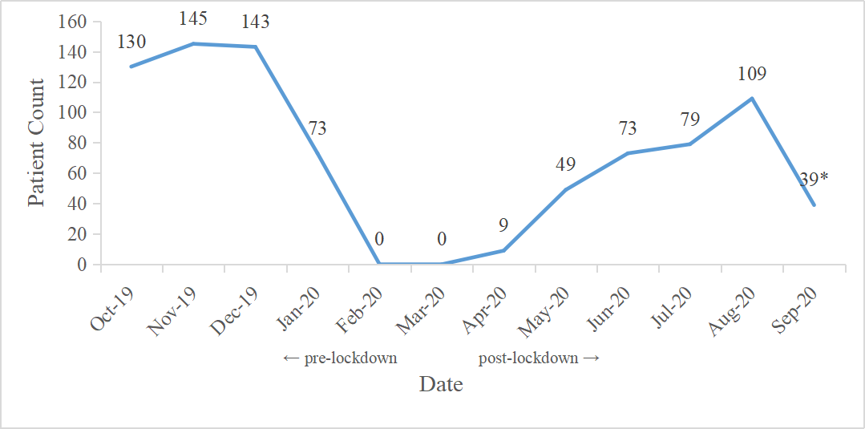
Supplementary Figure 1. In-hospital thyroid cancer patient count before and after the outbreak of COVID-19.
The lockdown of the oncological department was conducted from Jan 23, 2020, the Eve of the Chinese Spring Festival, to April 8, 2020, which lasted 76 days in total. But the social-contact limitation was not relieved then and the residents in Wuhan were still afraid of getting infected.
*The in-hospital thyroid cancer patient count in Sept. 2020 was limited to Sept-15, 2020.
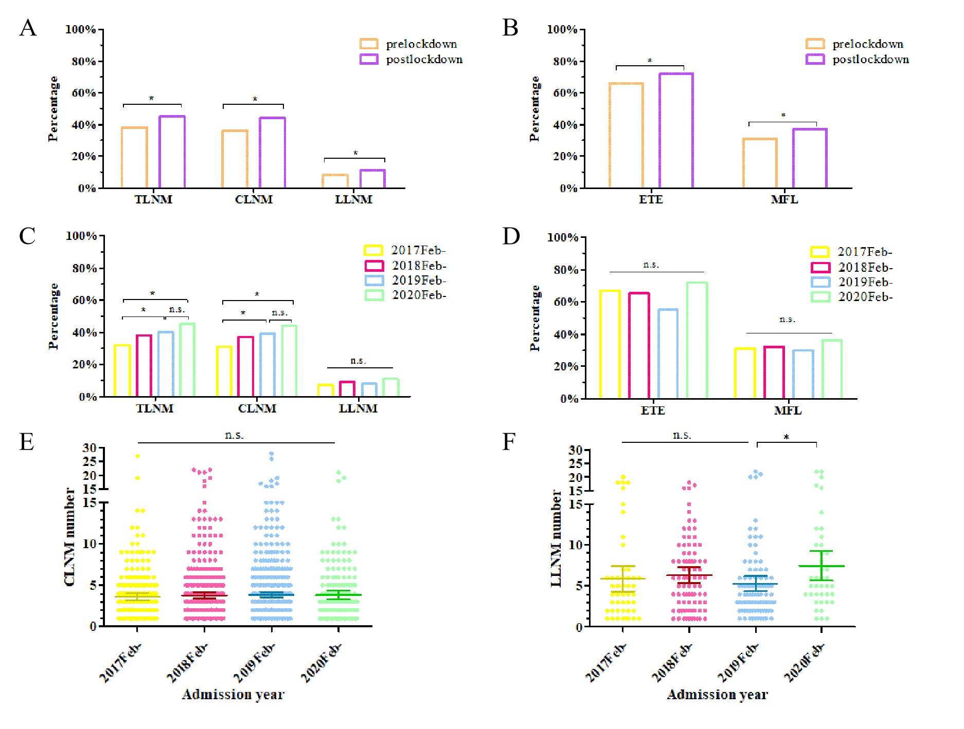
Supplementary Figure 2. The comparison of lymph node metastasis, extrathyroidal extension, multifocal lesions and LNM number.
The means with 95%CI were marked with lines in the 2e&2f. The data for 2020 were collected till Sept. 15, 2020.
* Significant difference
Abbreviation: n.s. not statistically significant; TLNM, total lymph node metastasis; CLNM, lymph node metastasis; LLNM, lateral lymph node metastasis; ETE, extrathyroidal extension; MFL, multifocal lesions.
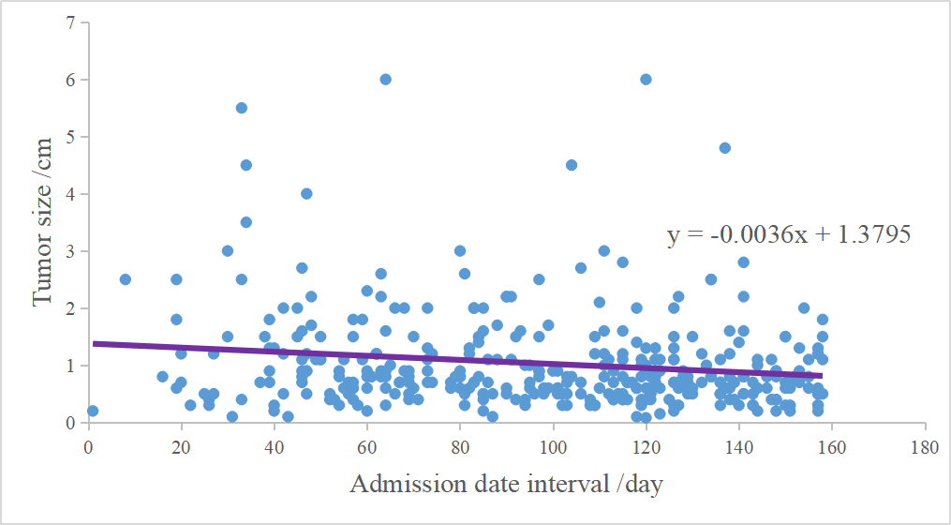
Supplementary Figure 3. The correlation between admission date interval and postoperative pathological tumor size.
A p-value of 0.002 was reached.

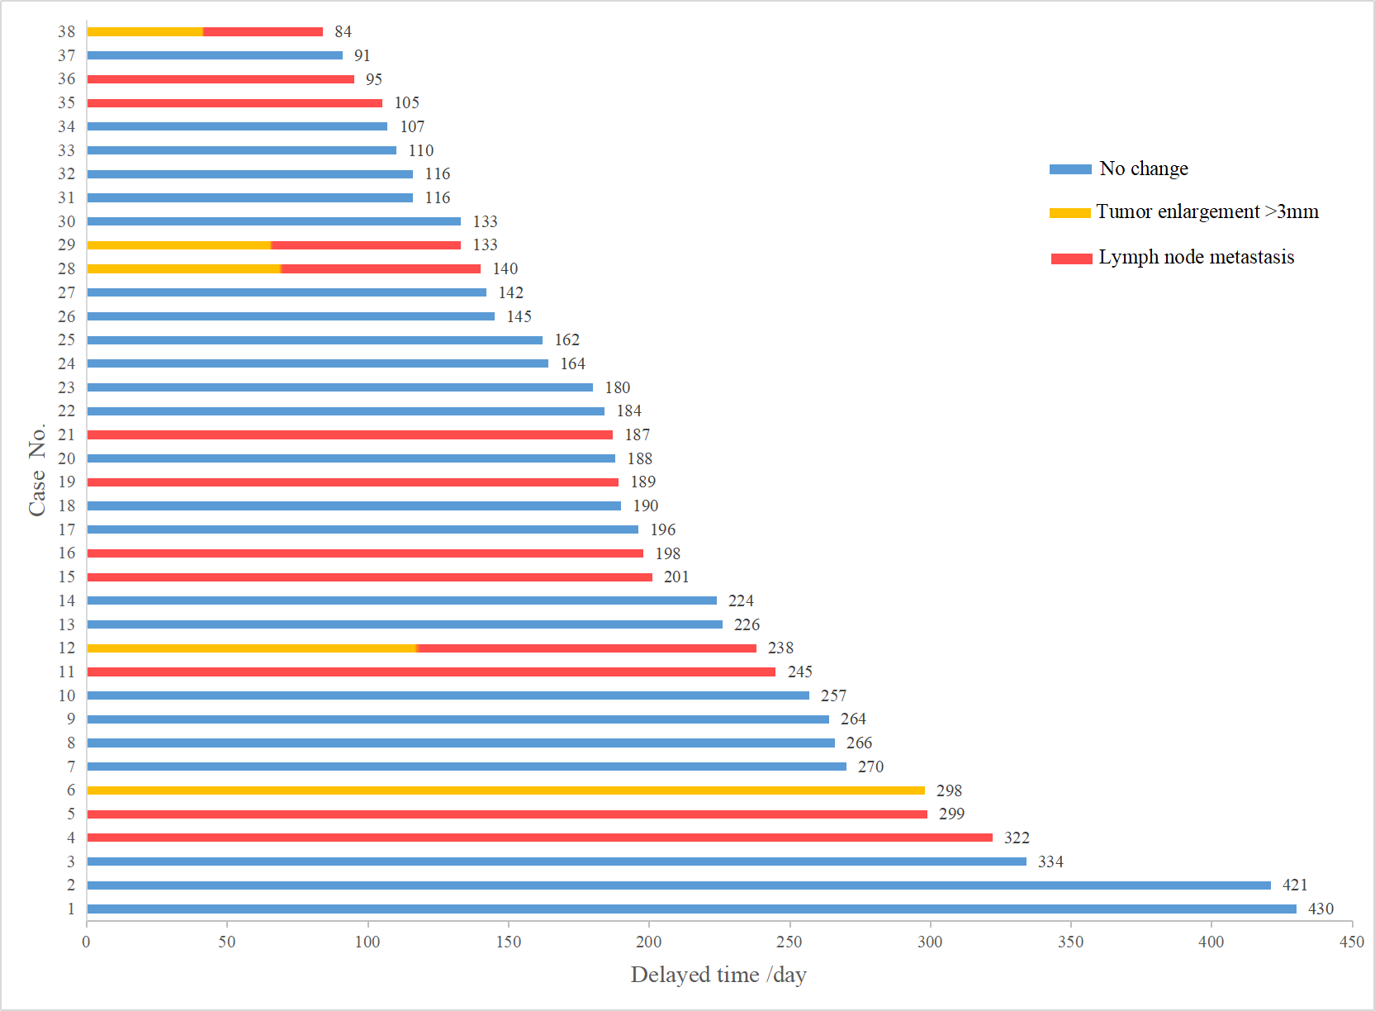
Supplementary Figure 4. The COVID-19-induced delayed treatment time of 38 patients and the relationships with tumor enlargement and lymph node metastasis.
An amount of 5 patients experienced tumor enlargement >3mm during the pandemic and 13 patients had abnormal lymph nodes under ultrasound.

STROBE Statement—Checklist of items that should be included in reports of cohort studies
 | Item No | Recommendation
Title and abstract | 1 | - A retrospective, cohort study
Title and abstract | 1 | - A single-center, retrospective study was conducted and thyroid cancer patients’ data from Feb. 1, 2017 to Sept 15, 2020 was pooled for analysis. The demographic characteristics, ultrasonic and pathological data were compared between the pre and post COVID-19 group. Lymph node metastases, tumor size, extrathyroidal extension, multifocal lesions were compared in each year to evaluate the annual change of patients’ characteristics. Regression analyses were first adopted in evaluating cancer behavior along with the admission date interval, and then were used to find risk factors for lymph node metastasis. Patients’ ultrasonic data were compared before and after the lockdown to assess the tumor progression. The outcomes of tumors ≤10mm and delayed time ≤180 days were then studied.  The post-lockdown patients were more likely to have multiple lesions (p=0.040), extrathyroidal extensions (p=0.011) and lymph node metastases (p=0.007). Lymph node metastasis rate increased by year (p<0.001). The tumor size correlated negatively with the admission date interval (p=0.002). No significant difference was observed in the main outcomes of patients with tumor ≤10mm or delayed time ≤180 days.
Introduction
Background/rationale | 2 | Many thyroid cancer patients have suffered from treatment delays caused by the Coronavirus Disease 2019 pandemic. Though there were many reviews, recommendations, or clinical experiences, clinical evidence was lacking in evaluating patients’ disease status.
Objectives | 3 | To evaluate the natural history of thyroid cancer and investigate the change of patients’ clinical condition between the lockdown and its potential reasons, including medical delay, annual change and rebound medical visits.
Methods
Study design | 4 | A retrospective, cohort study
Setting | 5 | The study was conducted in Renmin Hospital of Wuhan University. Data was collected from Feb. 1st, 2017 to Sept. 15th, 2020.
Participants | 6 | (a) All patients ≥ 18 years old, admitted to Renmin Hospital of Wuhan University with all histological types of thyroid cancer as evidenced by postsurgical pathological sections were included in the studies. Included patients should have complete pathological data.
Participants | 6 | (b) This is not a matched study.
Variables | 7 | Variables include demographic variables (age, sex, comorbidities, Hashimoto’s thyroidities, familial or personal history of cancer, histological type), postoperative pathological information (maximum size, multifocal lesion, extrathyroidal extension, lymph node metastasis) and ultrasound characteristics (tumor size, aspect ratio, irregular margin, peripheral location, site, microcalcification, multiple lesion, lymph node metastasis). Comorbidities include hypertension, diabetes mellitus, cerebrovascular diseases and other chronic diseases. Other concomitant thyroid diseases were excluded from comorbidities. The pre-COVID-19 ultrasound data were collected based on the last ultrasound before the pandemic. Lesions were evaluated in accordance with the Thyroid Imaging, Reporting and Data System (TI-RADS) of the American College of Radiology. The delayed time was defined as the time interval between the date of the last pre-pandemic ultrasound and the presurgical ones. The admission date interval (ADI) was defined as the time interval between the patient admission date and April 8th, 2020, which was the last day of lockdown.
Data sources/ measurement | 8* | The demographic variables were derived from hospital information system, pathological information from pathological reports, ultrasound variables from presurgical ultrasound reports. Data were extracted in the same way in different groups.
Bias | 9 | Since it was a retrospective cohort study, we didn’t address potential sources of bias
Study size | 10 | All patients who met the included criteria were included in the study.
Quantitative variables | 11 | The patients’ numbers and percentages were calculated for categorized data. Continuous data were presented as means (SDs) or medians (quantiles).
Statistical methods | 12 | (a) The comparisons of clinical characteristics between different cohorts were conducted using the Pearson chi-square test or McNemar test for categorized data, t-test or analysis of variance for continuous data, and Mann-Whitney U test or Wilcoxon's sign rank test for ordinal data. Logistic regression analysis was employed to analyze the risk factors of lymph node metastasis. Logistic and linear regression analyses were also adopted in evaluating the correlation between admission date interval and pathological characteristics.
Statistical methods | 12 | (b) There were no subgroup analyses.
Statistical methods | 12 | (c) Missing data were removed from analysis.
Statistical methods | 12 | (d) Not applicable.
Statistical methods | 12 | (e) There was no sensitivity analyses
Results
Participants | 13* | 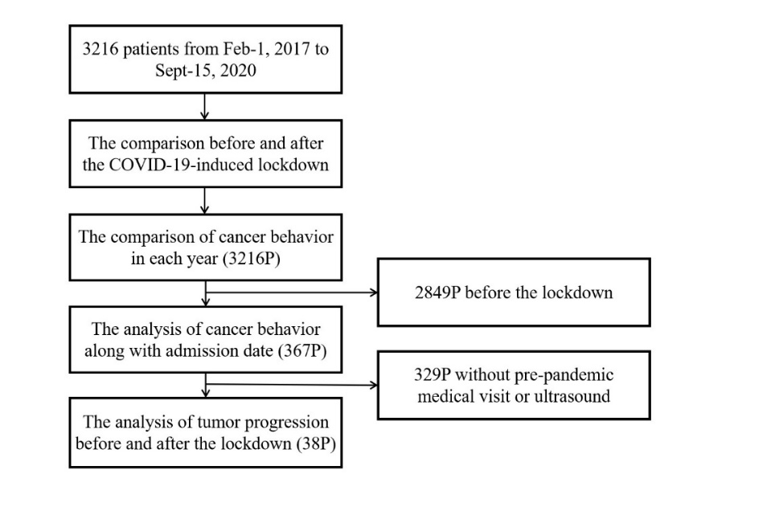
Descriptive data | 14* | (a) Female patients accounted for 75.5% of all in-hospital patients. The mean and median age were 45.9 and 47 respectively, with no significant difference between the pre- and post-lockdown groups. Comorbidities were more common before the pandemic (p=0.001). Hashimoto's thyroiditis was discovered in 10.0% patients with no statistical significance between the two groups (p=0.061). A percentage of 13.7% reported that at least one of their family members had had cancer or a personal history of other malignancy.
Descriptive data | 14* | (b) 2016 patients without central lymph node dissection and 2957 without lateral lymph node dissection.
Descriptive data | 14* | (c) Not applicable.
Outcome data | 15* | The average maximum size of tumor was 1.01 cm in the pre-lockdown group and 1.02 cm in the other group (p=0.758). Patients after the lockdown tended to have more multiple lesions than those before the pandemic (p=0.040). Of the post-lockdown patients, extrathyroidal extension (p=0.011), and lymph node metastases (p=0.007) were observed more commonly than the pre-pandemic group. In addition, central and lateral lymph node positive rate increased in the post-pandemic group respectively (36.4% vs 43.9%, p=0.006, 7.8% vs 10.9%, p=0.041).
Main results | 16 | The post-lockdown patients were more likely to have multiple lesions (p=0.040), extrathyroidal extensions (p=0.011) and lymph node metastases (p=0.007). Lymph node metastasis rate increased by year (p<0.001). The tumor size correlated negatively with the admission date interval (p=0.002).
Other analyses | 17 | No significant difference was observed in the main outcomes of patients with tumor ≤10mm or delayed time ≤180 days.
Discussion
Key results | 18 | Patients with the COVID-19-induced treatment delay had more aggressive cancer behavior. The rebound medical visit and annually growing aggressiveness may be the potential reason, while an individual patient’s tumor didn’t progress during the delay.
Limitations | 19 | First, the patient number in pre- and post-pandemic ultrasound comparison was short for a more solid conclusion. Besides, though the included 3253 patients had either pathological or ultrasound records (most patients had both), there were a minority of patients with missing items, which may lead to information bias. And this is a single-center retrospective study and the generalization of our theory was thus limited. Further prospective studies with larger sample sizes from multicenter are in need to evaluate our results.
Interpretation | 20 | Our study revealed more aggressive cancer behavior in thyroid cancer patients after a long period of COVID-19 induced treatment delay. As they were indolent, most tumors didn’t progress during the lockdown. The more hazardous signs in postoperative pathology could be interpreted with retaliatory medical visits due to patients’ anxiety, and the growing aggressiveness. Besides, our study revealed that thyroid cancer patients with tumors less than 10mm could tolerate a long treatment delay without any prominent progression, and a no more than 180 days delay is tolerable for most patients.
Generalisability | 21 | These findings will help clinicians to better evaluate thyroid cancer patients in the era of pandemics.
Other information
Funding | 22 | This work was supported by the National Natural Science Foundation of China [grant number 81471781], the Key Talent Training Program of Renmin Hospital and the Foundation for the Construction of National Medical and Health Service Center, and the Fundamental Research Funds for the Central Universities [grant number 2042019kf0229].

*Give information separately for exposed and unexposed groups.

Note: An Explanation and Elaboration article discusses each checklist item and gives methodological background and published examples of transparent reporting. The STROBE checklist is best used in conjunction with this article (freely available on the Web sites of PLoS Medicine at http://www.plosmedicine.org/, Annals of Internal Medicine at http://www.annals.org/, and Epidemiology at http://www.epidem.com/). Information on the STROBE Initiative is available at http://www.strobe-statement.org

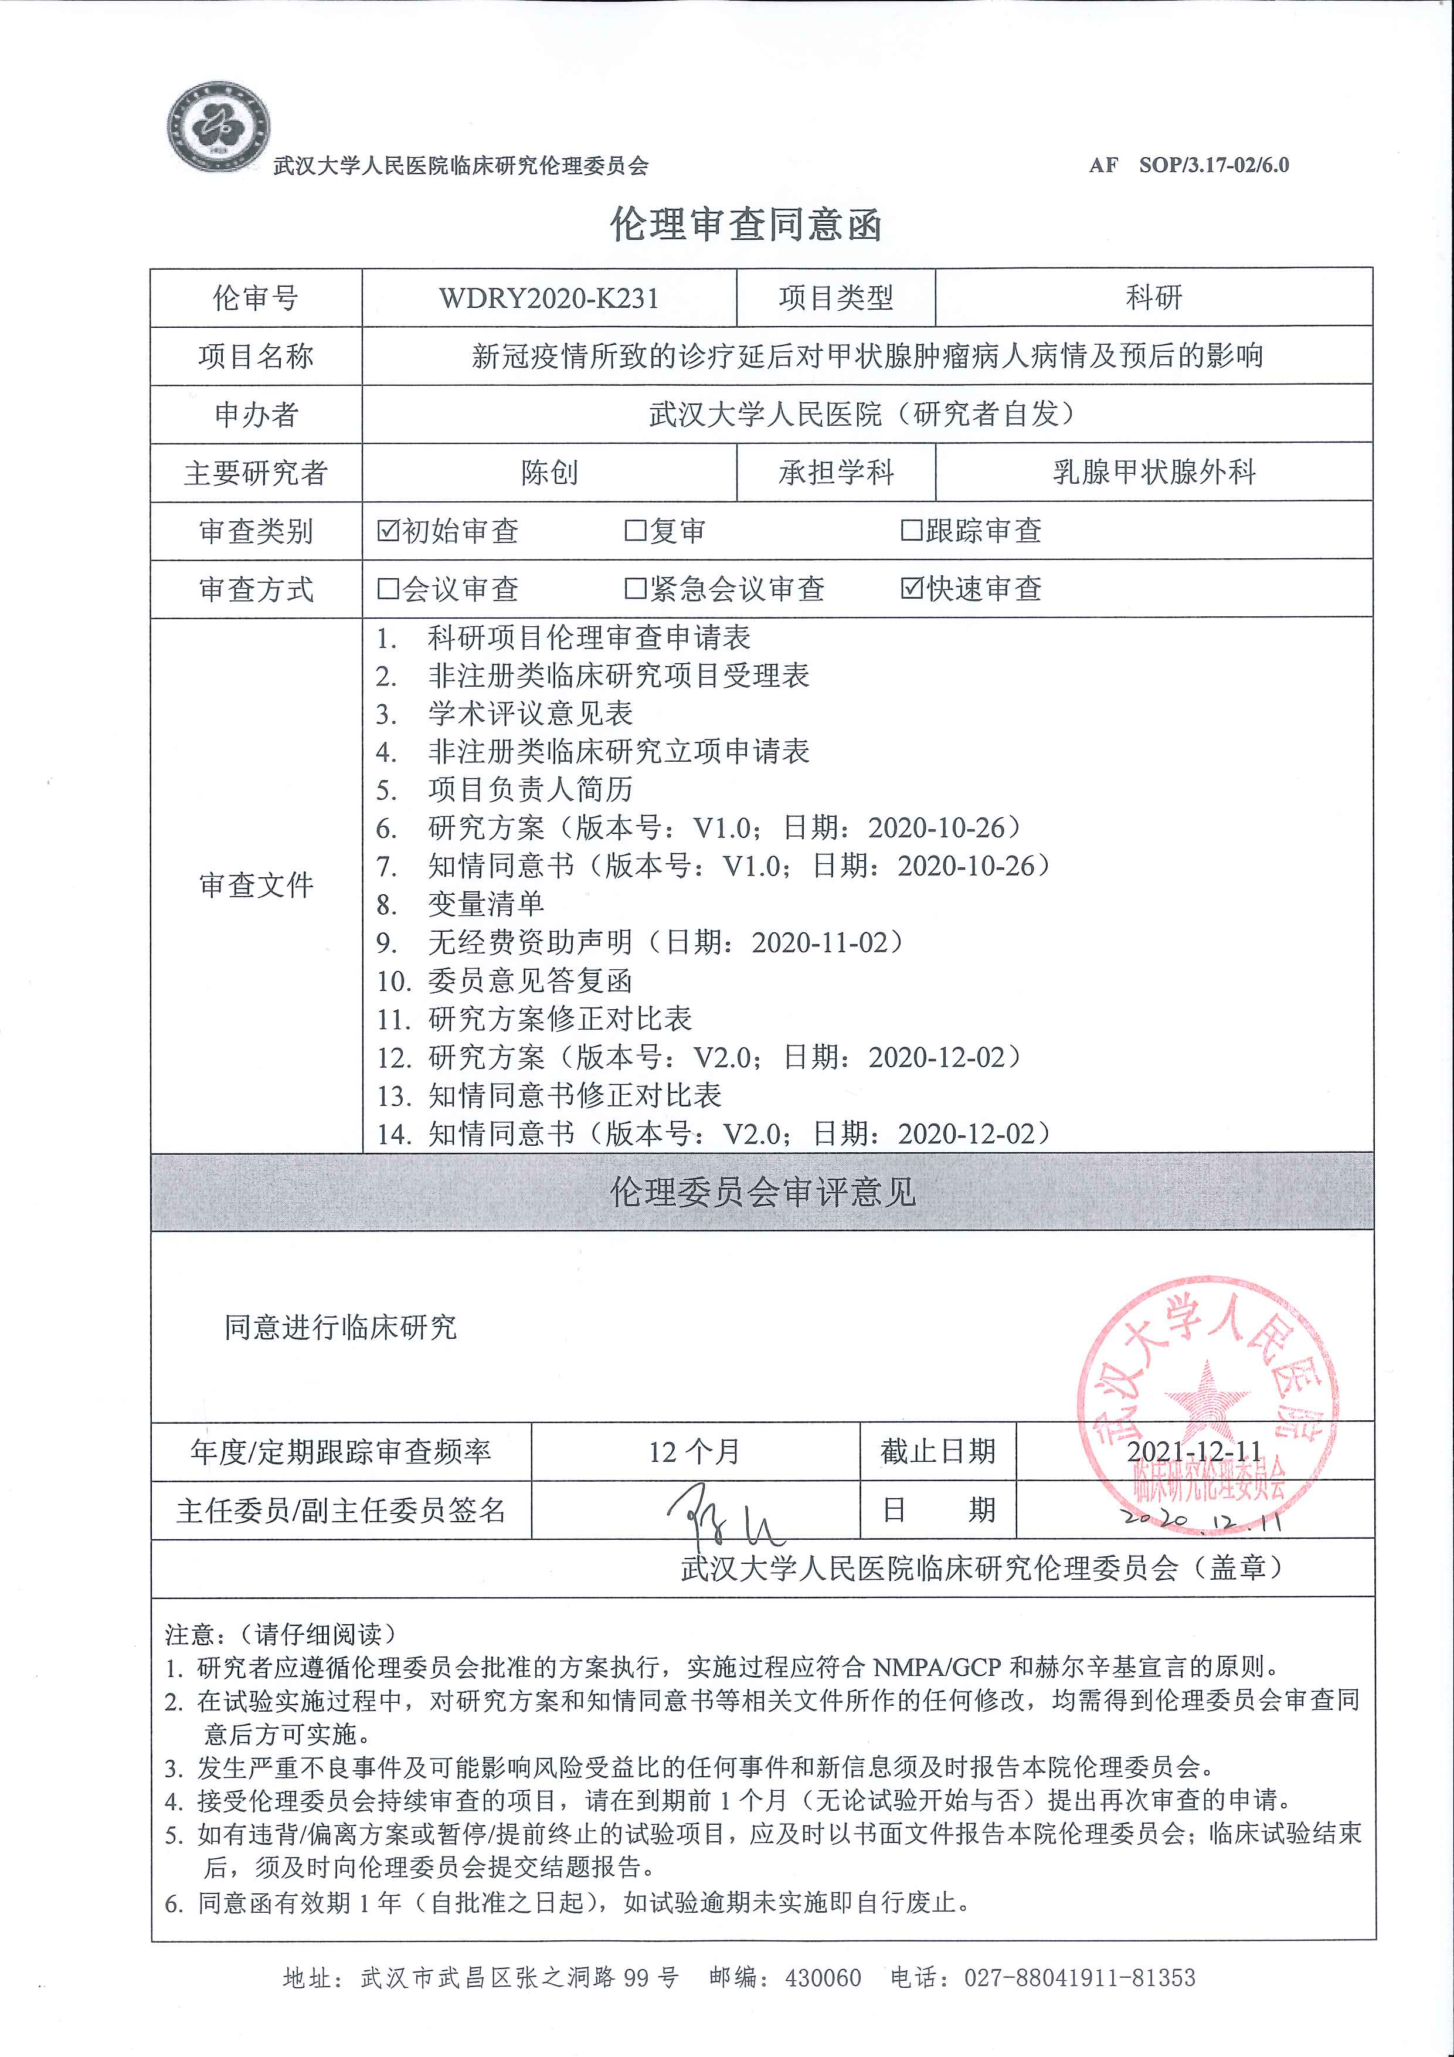
Approving letter from IEC of Renmin Hospital of Wuhan University

