Supplementary materials
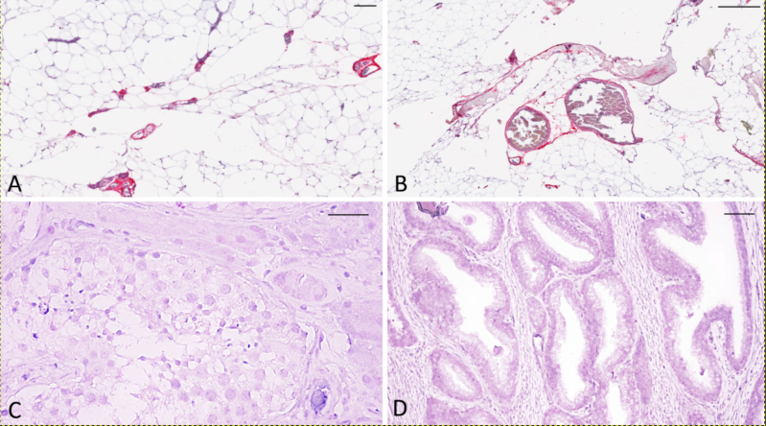
Supplementary Figure 1 (A and B) Immunolocalization of omentin-1/ITLN1 in the omental capillaries (Ultraview Universal Alkaline Phosphatase Red Detection Kit, Ventana). Bars: A: 20 µm; B: 10 µm. (C and D) Testis epithelium and prostate gland treated with anti omentin-1/ITLN1 antibody revealed with Ultraview Universal Alkaline Phosphatase Red Detection Kit (Ventana). In testicular (C) and prostate gland (D) tissues signal is absent. Bars: C: 50 µm; D: 100 µm.

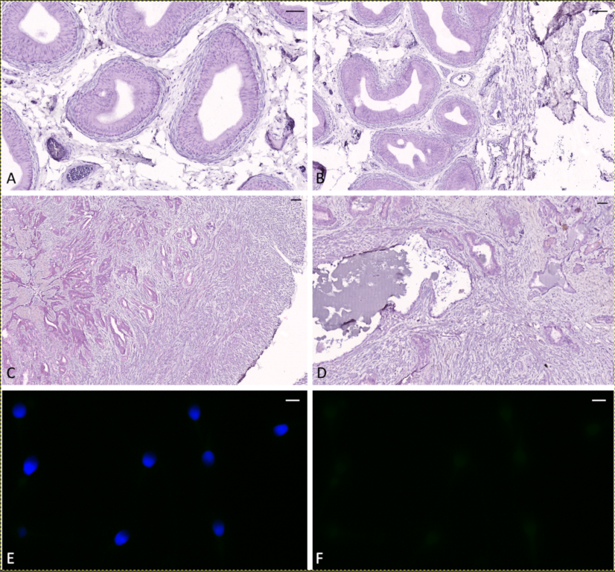

Supplementary Figure 2 (A-F) negative controls for omentin-1/ITLN1 antibody. Epididymis (A, B), seminal vesicles (C, D) and spermatozoa (E, F) treated with the immunocytochemical protocol omitting anti omentin-1/ITLN1 antibody. E shows a merged image acquired with DAPI and FITC filters, F the same image acquired with FITC filter. Bars: A, B: 50 µm; C: 300 µm; D: 200 µm; E, F: 6 µm.

