Supplementary files

Table S1. The primers used for real-time PCR analysis.
Genes | Primer sequences
Mouse Sox9 | forward 5’-GAGGAAGTCGGTGAAGAACG-3’
Mouse Sox9 | reverse 5’-CTGAGATTGCCCAGAGTGCT-3’
Mouse Acan | forward 5’-CCTGCTACTTCATCGACCCC-3’
Mouse Acan | reverse 5’-AGATGCTGTTGACTCGAACCT-3’
Mouse Col2 | forward 5’-GTGGAGCAGCAAGAGCAAG-3’
Mouse Col2 | reverse 5’-CGGAGGAAAGTCATCTGGAC-3’
Mouse Col10 | forward 5’-ATGCCGCTTGTCAGTGCTA-3’
Mouse Col10 | reverse 5’-TCTTGGGTCGTAATGCTGCT-3’
Mouse Cox-2 | forward 5’-GCAGGAAGTCTTTGGTCTGG-3’
Mouse Cox-2 | reverse 5’-AGTTGCTCATCACCCCACTC-3’
Mouse Adamts4 | forward 5’-ATGGCCTCAATCCATCCCAG-3’
Mouse Adamts4 | reverse 5’-AAGCAGGGTTGGAATCTTTGC-3’
Mouse Adamts5 | forward 5’-CGTAGACAAGGTAGCCCACTTT-3’
Mouse Adamts5 | reverse 5’-CGTAGACAAGGTAGCCCACTTT-3’
Mouse Mmp3 | forward 5’-ACATGGAGACTTTGTCCCTTTTG-3’
Mouse Mmp3 | reverse 5’-TTGGCTGAGTGGTAGAGTCCC-3’
Mouse Mmp9 | forward 5’-CTGGACAGCCAGACACTAAAG-3’
Mouse Mmp9 | reverse 5’-CTCGCGGCAAGTCTTCAGAG-3’
Mouse Mmp13 | forward 5’-CTTCTTCTTGTTGAGCTGGACTC-3’
Mouse Mmp13 | reverse 5’-CTGTGGAGGTCACTGTAGACT-3’
Mouse IL-1β | forward 5’- CCCAACTGGTACATCAGCACCTC-3’
Mouse IL-1β | reverse 5’- GACACGGATTCCATGGTGAAGTC-3’
Mouse IL-6 | forward 5’- ATAGTCCTTCCTACCCCAATTTCC-3’
Mouse IL-6 | reverse 5’- GATGAATTGGATGGTCTTGGTCC-3’
Mouse TNF-α | forward 5’- CTGAACTTCGGGGTGATCGG-3’
Mouse TNF-α | reverse 5’- GGCTTGTCACTCGAATTTTGAGA-3’
Mouse Kmt2a | forward 5’- GCAGATTGTAAGACGGCGAG-3’
Mouse Kmt2a | reverse 5’- GAGAGGGGGTGTTCCTTCCTT-3’
Mouse Kmt2b | forward 5’- CGTCACCACCCTTGACTCC-3’
Mouse Kmt2b | reverse 5’- CATGTAGCTGGGACAAGAGGA-3’
Mouse Kmt2c | forward 5’- TGTTCACAGTGTGGTCAATGTT-3’
Mouse Kmt2c | reverse 5’- GAGGGTCTAGGCAGTAGGTATG-3’
Mouse Kmt2d | forward 5’- GTGGCTGTTCCACACCCAG-3’
Mouse Kmt2d | reverse 5’- AGCTTGAGCTTCTCAGCATCG-3’
Mouse Kmt2e | forward 5’- TTCAGACCTCCTGTAGAGAGC-3’
Mouse Kmt2e | reverse 5’- AAAAGTCCTCGCATCAACACA-3’
Mouse Zbtb20 | forward 5’- GCGAGCCCAAAGGTGAAAG-3’
Mouse Zbtb20 | reverse 5’- GCTGTAGGACGCCCTTATCG-3’
Mouse Il13ra2 | forward 5’- ACCGAAATGTTGATAGCGACAG-3’
Mouse Il13ra2 | reverse 5’- ACAATGCTCTGACAAATGCGTA -3’
Mouse Capn12 | forward 5’- GGAGAGATTGGGCTTAGGACC-3’
Mouse Capn12 | reverse 5’- TAGCGGCTAGTGAGGGACTG-3’
Mouse Mex3b | forward 5’- GGGCTTTGATCTGCATCACG-3’
Mouse Mex3b | reverse 5’- AGCTGTCGTTGCGATAGCTG-3’
Mouse Nexn | forward 5’- ATGAATGACGTTTCGCAAAAGG-3’
Mouse Nexn | reverse 5’- GCTAATTCGCGCTGTATTTTCC-3’
Mouse Cldn1 | forward 5’- GGGGACAACATCGTGACCG-3’
Mouse Cldn1 | reverse 5’- AGGAGTCGAAGACTTTGCACT-3’
Mouse Tgif1 | forward 5’- GACAGTCCCCTGGACCTTTC-3’
Mouse Tgif1 | reverse 5’- ATACAGCCAGTCTCGCAGAAT-3’
Mouse Srek1 | forward 5’- GAGAGCGTTCTACCTCCACAA-3’
Mouse Srek1 | reverse 5’- TTACCTTCGTCCTCAGTCCTC-3’
Mouse Gpcpd1 | forward 5’- ATGACACCTTCTCAGGTCACT-3’
Mouse Gpcpd1 | reverse 5’- GCTTTCCACAACACACTGTCTC-3’
Mouse Slc20a1 | forward 5’- TCCTCCGTAAGGCAGATCCG-3’
Mouse Slc20a1 | reverse 5’- TTCCGATTGTGCAGGCATAAA-3’
Mouse GAPDH | forward 5’-TTCCAGGAGCGAGACCCCACTA-3’
Mouse GAPDH | reverse 5’-GGGCGGAGATGATGACCCTTTT-3’

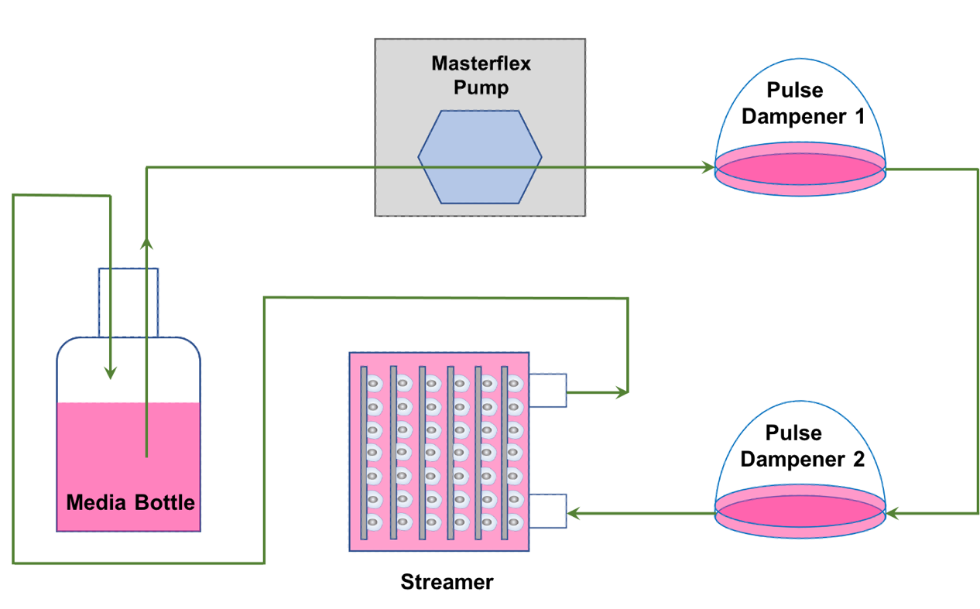

Figure S1. Schematic diagram of the Flexcell Streamer System.
A density of 2 × 10⁵ chondrocytes were seeded onto the culture slips and put into a parallel-plate flow system. The system is a six-chamber laminar flow device which includes a total of six 75 x 25 x 1 mm culture slips. After being exposed to 20 dyne/cm² FSS treatment for 2 h, the cells were collected for further experiments.

Figure S2. Quantitative statistical analysis of western blot of Figure 1D. **p < 0.01, ***p < 0.001.

Figure S3. Quantitative statistical analysis of western blot of Figure 2A. * p < 0.05, **p < 0.01, ns, not significant.

Figure S4. KEGG enrichment results of differentially expressed genes between TMJ chondrocytes with or without FSS treatment.

Figure S5. Wnt signaling pathway is closely involved in ZBTB20 or FSS-mediated biological process. (A) qPCR results indicated the inhibition of Wnt signaling by LF3 partially rescues the negative effect of ZBTB20 on chondrocytes. (B) qPCR results indicated the inhibition of Wnt signaling by LF3 partially rescues the negative effect of FSS on chondrocytes.
* p < 0.05, **p < 0.01, ***p < 0.001.

Figure S6. Quantitative statistical analysis of western blot of Figure 6D. * p < 0.05, **p < 0.01.

Figure S7. Quantitative statistical analysis of western blot of Figure 6H. * p < 0.05, **p < 0.01.

