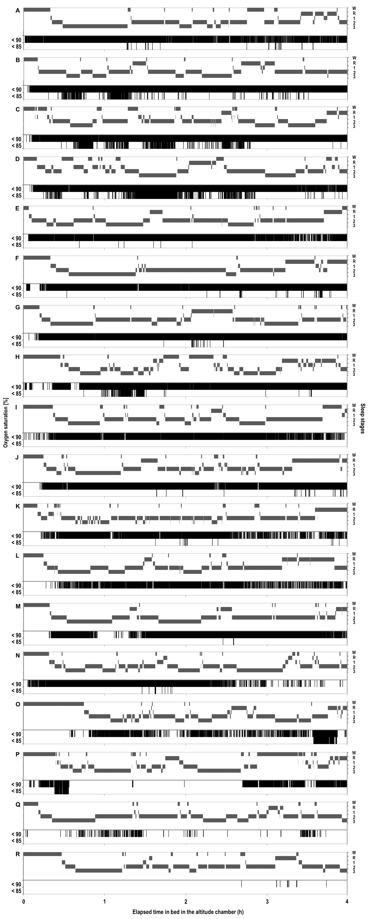
Supplemental Figure S1: Temporal distribution of oxygen desaturation events throughout the night. Panels A to R represent hypnograms and oxygen desaturation events per night for each of the 18 participants of study 1.

