Supplementary material

Silver nanoparticles as chlorhexidine and metronidazole drug delivery platforms potential use in periodontitis treatment
Karol P. Steckiewicz¹, Piotr, Cieciórski², Ewelina Barcińska¹, Maciej Jaśkiewicz³, Magdalena Narajczyk⁴, Marta Bauer³, Wojciech Kamysz³, Elżbieta Megiel², Iwona Inkielewicz – Stepniak^{1*}

¹ Department of Pharmaceutical Pathophysiology, Faculty of Pharmacy, Medical University of Gdansk, Gdansk, Poland
² Faculty of Chemistry, University of Warsaw, Warsaw, Poland
³ Department of Inorganic Chemistry, Faculty of Pharmacy, Medical University of Gdansk, Gdansk, Poland
⁴ Laboratory of Electron Microscopy, Faculty of Biology, University of Gdansk, Gdansk, Poland

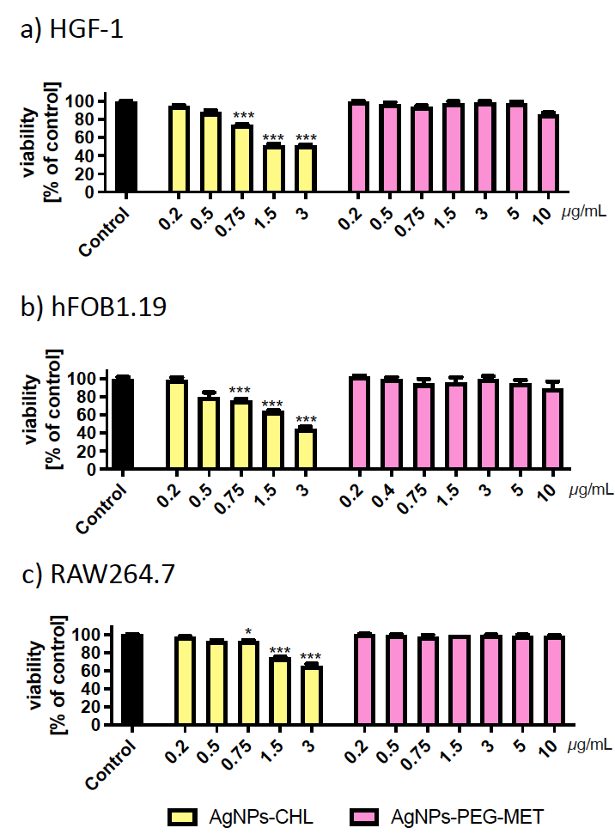
Supplementary figure 1 Effect of AgNPs-CHL and AgNPs-PEG-MET on viability of cells. Viability was measure by MTT assay after 24h of treatment. a) HGF-1 cells, b) hFOB1.19 cells, c) RAW264.7 cells. Data are presented as mean ± SD. * p<0.05, *** p<0.001

Supplementary figure 2 Intracellular production of cytokines by HGF-1 cells. Cells were treated with AgNPs for 24h and LPS was used to stimulate inflammation. Production of IL-1ß a), production of IL-6 b), production of TNFα c), production of IL-8 d). Data are presented as mean ± SD.
Supplementary figure 3 Metalloproteinase levels in HGF-1 cells. Cells were treated with AgNPs for 24h and LPS was used to stimulate inflammation representative western blots a), quantification of MMP3 levels b), quantification of MMP8 levels c), quantification of MMP9 levels d). Data are presented as mean ± SD. *p<0.05 (vs control treated with LPS).

