Supplementary Materials for Plasma endoglin is associated with favorable outcome for pemetrexed-based therapy in advanced non-small cell lung cancer
Che-Hsing Li; Jiunn-Liang Ko; Yu-Ping Hsiao; Ming-Hung Tsai; Yen-Chein Lai; I-Lun Hsin; Yu-Ting Kang; Gwo-Tarng Sheu; Wea-Lung Lin; Ming-Fang Wu

Figures
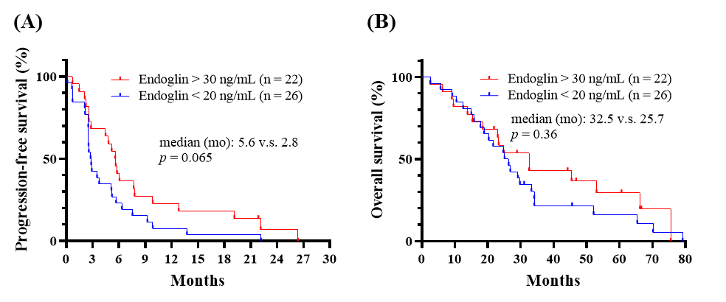
Supplementary Fig. 1 Effects of endoglin levels on pemetrexed-based therapy prognosis in the cohort. Endoglin concentration (ng/mL) in patients with non-small cell lung cancer before pemetrexed treatment was measured using enzyme-linked immunosorbent assay. (A) Progression-free survival and (B) overall survival of groups with very high (> 30 ng/mL) and very low endoglin (< 20 ng/mL) were analysed using the Kaplan–Meier method and the log rank test.

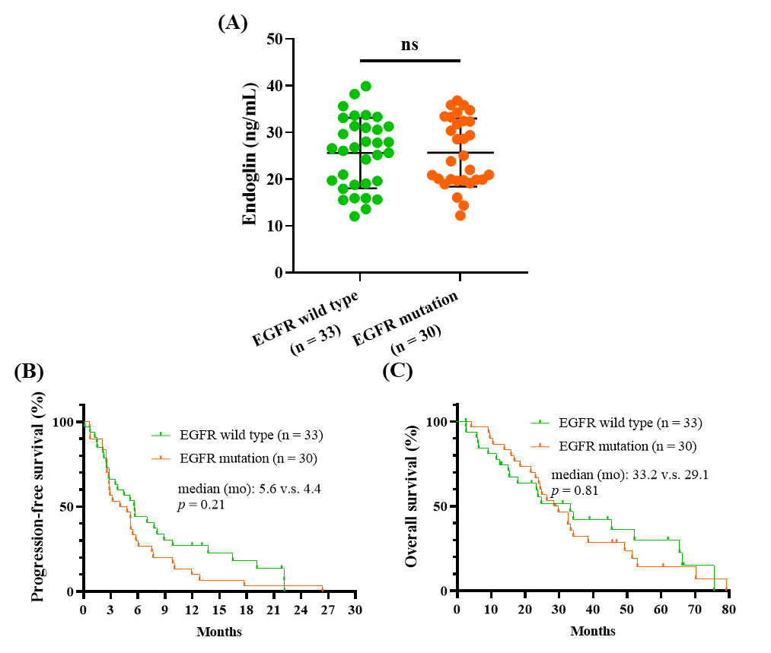
Supplementary Fig. 2 Effects of epidermal growth factor receptor (EGFR) mutation on endoglin levels and survival. (A) Endoglin concentration (ng/mL) in patients with non-small cell lung cancer before pemetrexed-based treatment was measured using enzyme-linked immunosorbent assay. The endoglin levels in the EGFR wild type and mutation group were compared through unpaired t test. (B) Progression-free survival and (C) overall survival of groups with EGFR wild type and mutation were analysed using the Kaplan–Meier method and the log rank test.

Tables
Supplementary Table 1 Demographic data of patients with non-small cell lung cancer and treated with pemetrexed-based treatment.
Factors |  | All patient  (n = 71)
Gender | Female | 38 (54%)
Gender | Male | 33 (46%)
Ageª | < 65 | 46 (65%)
Ageª | ≥ 65 | 25 (35%)
Pathological type | Adenocarcinoma | 69 (97%)
Pathological type | Others^{b} | 2 (3%)
Tumor stage | IIIB | 4 (6%)
Tumor stage | IV | 67 (94%)
Lymph node | N0 – N1 | 13 (18%)
Lymph node | N2 – N3 | 58 (82%)
ECOG PS | 0 – 1 | 56 (79%)
ECOG PS | 2 | 15 (21%)
Smoking | Never | 45 (63%)
Smoking | Active or quitted | 26 (37%)
Chemotherapy line | 1 | 54 (76%)
Chemotherapy line | > 1 | 17 (24%)
Pemetrexed | Alone | 12 (17%)
Pemetrexed | Combined^{c} | 59 (83%)
EGFR status | Wild type | 33 (46%)
EGFR status | Mutation | 30 (42%)
EGFR status | Unknown | 8 (11%)
ECOG PS, Eastern Cooperative Oncology Group Performance status. EGFR, epidermal growth factor receptor. a, age presents the patient’s age at baseline. b, other pathological types include squamous cell carcinoma and poorly differentiated carcinoma. c, pemetrexed is combined with platinum.

