Annual body weight change and prognosis in chronic obstructive pulmonary disease

Yuki Abeª, Masaru Suzukiª*, Hiroshi Shima^{b}, Yusuke Shiraishi^{b}, Naoya Tanabe^{b}, Susumu Sato^{b}, Kaoruko Shimizuª, Hirokazu Kimuraª, Hironi Makita^{a,c}, Toyohiro Hirai^{b}, Satoshi Konnoª, Masaharu Nishimura^{a,c}

* Corresponding author

ª. Department of Respiratory Medicine, Faculty of Medicine and Graduate School of Medicine, Hokkaido University, Kita 15, Nishi 7, Kita-ku, Sapporo 060-8638, Japan
^{b}. Department of Respiratory Medicine, Graduate School of Medicine, Kyoto University, 54 Kawahara-cho, Shogoin, Sakyo-ku, Kyoto, 606-8507, Japan
^{c}. Hokkaido Medical Research Institute for Respiratory Diseases, Minami 3, Nishi 2, Chuo-ku, Sapporo 060-0063, Japan

Online data supplement

Figure Legend
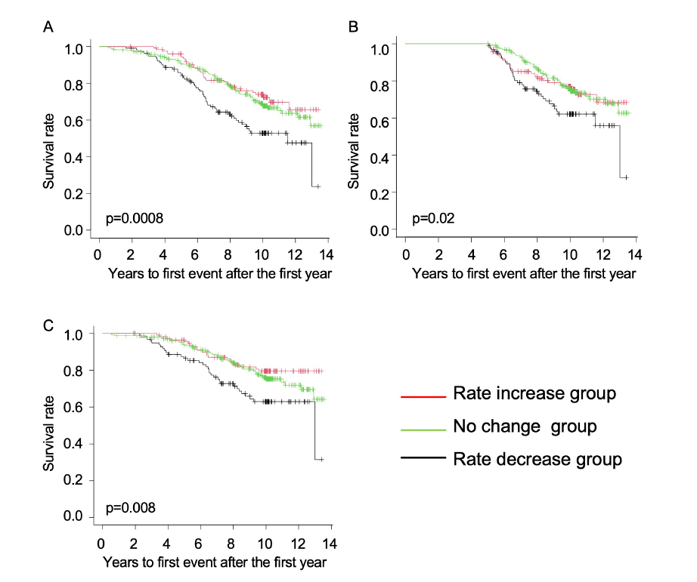
Supplementary Figure 1. Kaplan–Meier curves based on groups divided by annual change in the rate of body weight to baseline.
(A) All-cause mortality. (B) Patients who survived during the first 5 years. (C) Patients excluding death from malignancy.
Supplementary Table 1. Characteristics of groups divided by annual change in the rate of body weight to baseline
 | Rate decrease group | No change group | Rate increase group | P-value
 | (n = 116) | (n = 283) | (n = 127)
Age, years | 70.8 ± 7.8 | 69.8 ± 8.2 | 68.5 ± 8.1 | 0.09
Female, N (%) | 10 (8.6%) | 17 (6.0%) | 13 (10.2%) | 0.28
Height, cm | 162.6 ± 6.8 | 163.6 ± 7.1 | 163.1 ± 6.0 | 0.35
Body mass index, kg/m² | 21.9 ± 3.3 | 22.6 ± 2.8 | 21.6 ± 3.4 | 0.005
GOLD stage 1/2/3/4 | 26/48/37/5 | 64/136/71/12 | 33/57/29/8 | 0.66
Pack-years | 63.5 ± 30.3 | 64.9 ± 32.5 | 60.9 ± 32.6 | 0.51
FEV₁, % predicted | 60.8 ± 20.9 | 62.9 ± 20.7 | 64.0 ± 22.4 | 0.49
FVC, % predicted | 96.4 ± 19.1 | 98.8 ± 18.1 | 99.5 ± 17.7 | 0.38
FEV₁/FVC, % | 50.1 ± 12.5 | 50.9 ± 12.7 | 51.5 ± 14.5 | 0.71
DL_{CO}, % predicted | 75.7 ± 26.5 | 81.5 ± 27.9 | 80.4 ± 26.4 | 0.16
K_{CO}, % predicted | 62.0 ± 23.9 | 65.3 ± 23.8 | 64.1 ± 24.3 | 0.45
Annual decline in FEV₁, mL/yr | 29.7 ± 25.7 | 30.7 ± 24.6 | 34.8 ± 25.9 | 0.22
Annual decline in the rate*, %/yr | 2.0 ± 2.2 | 2.1 ± 1.8 | 2.2 ± 2.3 | 0.64
Exacerbation, events/yr | 0.3 ± 0.5 | 0.3 ± 0.6 | 0.3 ± 0.5 | 0.80

* Rate of FEV ₁ to baseline FEV₁ (%)
GOLD, Global Initiative for Chronic Obstructive Lung Disease; FEV₁, forced expiratory volume in 1 second; FVC, forced vital capacity; DL_{CO}, carbon monoxide diffusion capacity; K_{CO,} carbon monoxide transfer coefficient.
Data are shown as the mean ± standard deviation (SD), median (interquartile range), or number (%).
P-values were obtained using the Fisher’s exact test, one-way analysis of variance, or the Kruskal–Wallis test, as appropriate.

Supplementary Table 2. Multivariable Cox proportional hazards analysis of all-cause mortality using annual change in the rate of body weight to baseline
Variables | Hazard ratio (95% CI) | P-value
Model 1
Annual change in the rate*, %/yr | 0.82 (0.72-0.95) | 0.008
Age, years | 1.09 (1.06-1.11) | <0.001
Model 2
Annual change in the rate*, %/yr | 0.79 (0.69-0.91) | 0.001
Age, years | 1.07 (1.05-1.10) | <0.001
Sex, male | 2.94 (1.20-7.24) | 0.006
Body mass index, kg/m² | 0.93 (0.88-0.99) | 0.02
Pack-years | 1.00 (0.99-1.0005) | 0.08
FEV₁, L | 0.81 (0.60-1.07) | 0.14
K_{CO}, % predicted | 1.00 (0.98-0.99) | <0.001

* Rate of body weight to baseline body weight (%)
FEV₁, forced expiratory volume in 1 second; K_{CO,} carbon monoxide transfer coefficient.
The hazard ratio was derived from the multivariate Cox proportional hazards models.

