Supplementary Figure Legends
Supplementary Figure 1. A flow diagram representing the study design of this study.
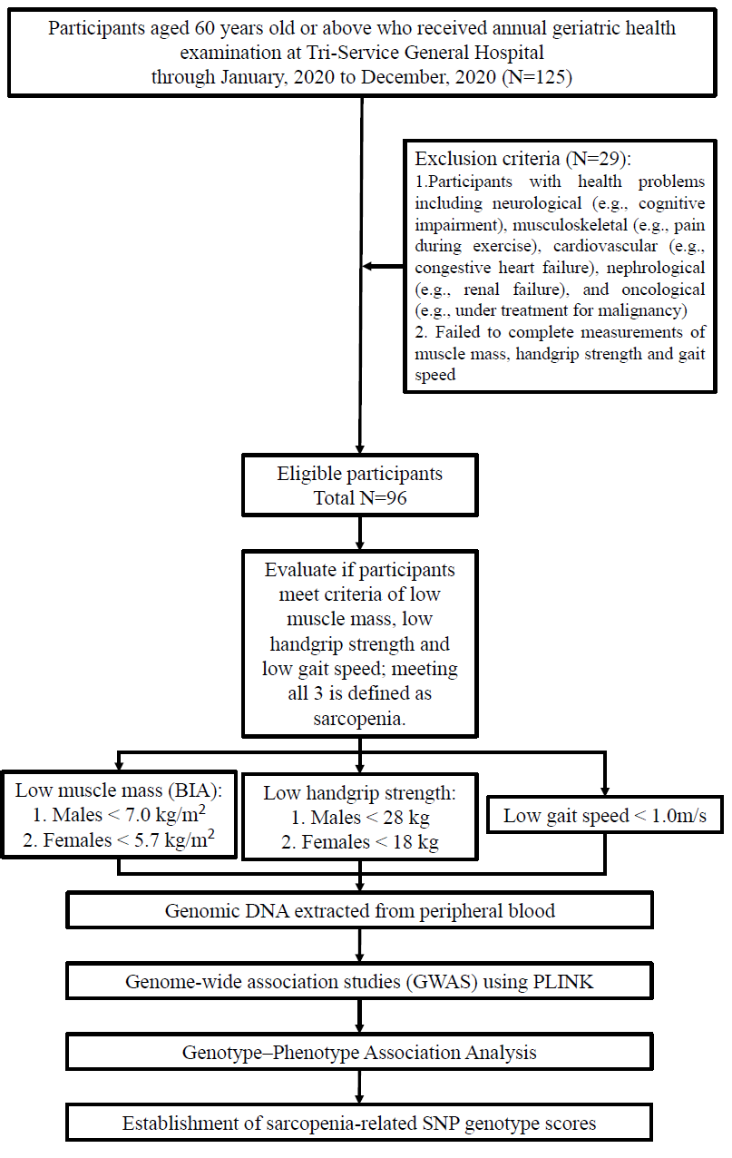

Supplementary Figure 2. Manhattan plots and related box plots for sarcopenic indices (muscle mass, muscle strength and gait speed) among different genotypes. Manhattan plot showing p values along the whole genome. The blue line indicates the suggestive threshold of 1 × 10–5. Boxplot showing the differences in sarcopenic indices among genotypes of twelve SNPs of interest. The horizontal line represents the median value, the bottom and top of the boxes represent the first and third quartiles, and the ends of the whiskers represent 1.5 IQRs of the data. Outliers are pointed by dots. (A) Low skeletal muscle mass index (B) Low gait speed (C) Low handgrip strength
