Supporting Information

Templated Three-dimensional Engineered Bone Matrix as a Model for Breast Cancer Osteolytic Bone Metastasis Process
Manman Sun¹, Ke Huang¹, Xueshi Luo^{2,3 *}, and Hong Li^{1, *}
1 Department of Materials Science and Engineering, College of Chemistry and Materials Science, Jinan University, Guangzhou, Guangdong, People’s Republic of China
2 The First Affiliated Hospital of Jinan University, Jinan University, Guangzhou, Guangdong, People’s Republic of China
3 Department of Chemistry, College of Chemistry and Materials Science, Jinan University, Guangzhou, Guangdong, People’s Republic of China
*Correspondence: Xueshi Luo; Hong Li
Jinan University, No. 601, West Huangpu Avenue, Guangzhou, Guangdong, 510632, People’s Republic of China
Tel.: +86 020 85223062
Fax: +86 020 85223271
E-mail: 1254914942@qq.com (Xueshi Luo); tlihong@jnu.edu.cn (Hong Li)

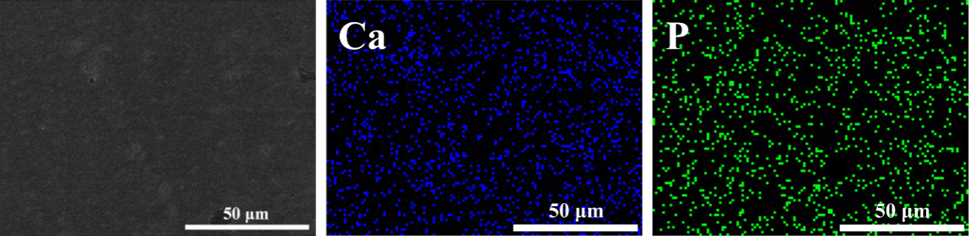
Figure S1 Energy Dispersive Spectrometer (EDS) analysis of Ca and P elements in the bone-like matrix.
Energy Dispersive Spectrometer (EDS), the accessory for microanalysis of components of scanning electron microscope (SEM, PXL30, Philips, Netherlands) was used to scan the microarea of the bone-like matrix and analyze the distribution of Ca and P elements. The result proved the existence of inorganic minerals and their uniform distribution among the formed matrix.

Figure S2. Characterization of the engineered bone matrix with/without breast cancer cells co-culturing for 7 days. (a, b) 2D section morphologies of mineralized bone matrix without breast cancer cells on Day 7 (Col I immunofluorescence staining in red) via LCSM; (c) The thickness of the matrix co-cultured with/without breast cancer cells for 7 days. Data are expressed as means ± standard deviation (n = 3). ns=p>0.05/*p<0.05/**p<0.01/*** p<0.001.

