Table S1. Clinical characteristic of rCDI patients and donors.
Sample Number |  | Age | Sex | CRP (mg/dL) | Weight (kg) | Height (cm) | BMI (kg/m2) | Underlying Disease | Hospitalization | Antibiotic therapy in rCDI treatment | Concomitant therapy before FMT | Stool Consistency | CDI Severity | FMT Repeat | Donors Relation to Recipient
1 | Patient 1, Pre- FMT | 23 | Male | 17 | 108 | 190 | 29.6 | IBD (UC) | No | Vancomycin 125 mg given 4 times daily for 10 days | Anti-TNF alpha (infliximab) 40 mg/fortnight, Asacol tablets 3200 mg/day, one Asacol suppository every night, one Asacol enema every night | Watery-Bloody | Mild-to-moderate | 1 | Mother
2 | Patient 1, Post- FMT, Second week |  | Male | 2 | 107 |  | 29.6 |  | No | Vancomycin 500 mg given 4 times daily for 10 days
3 | Patient 1, Post- FMT, Eighth week |  | Male | 2 | 107 |  | 29.6 |  | No | Vancomycin 500 mg given 4 times daily for 10 days
4 | Donor for patient 1 | 58 | Female
5 | Patient 2, Pre- FMT | 52 | Male | 20.5 | 65 | 178 | 20.5 | IBD (UC) | No | Vancomycin 125 mg given 4 times daily for 10 days | Anti-TNF alpha (infliximab) 40 mg/fortnight, Asacol tablets 3200 mg/day, one Asacol suppository every night, one Asacol enema every night | Watery-Bloody | Mild-to-moderate | 1 | Cousin
6 | Patient 2, Post- FMT, Second week |  | Male | 21.4 | 65 |  | 20.5 |  | No | Vancomycin 500 mg given 4 times daily for 10 days
7 | Patient 2, Post- FMT, Eighth week |  | Male | 21 | 66 |  | 20.8 |  | No | Vancomycin 500 mg given 4 times daily for 10 days
8 | Donor for patient 2 | 38 | Female
9 | Patient 3, Pre- FMT | 45 | Male | 12 | 55 | 162 | 20.5 | IBD (UC) | No | Vancomycin 125 mg given 4 times daily for 10 days | Anti-TNF alpha (infliximab) 40 mg/fortnight, Asacol tablets 3200 mg/day, one Asacol suppository every night, one Asacol enema every night, Azathioprine tablet 200 mg/day | Watery | Mild-to-moderate | 2 | Brother
10 | Patient 3, Post- FMT, Second week |  | Male | 10 | 64 |  | 21.4 |  | No | Vancomycin 500 mg given 4 times daily for 10 days
11 | Patient 3, Post- FMT, Eighth week |  | Male | 10 | 64 |  | 21.4 |  | No | Vancomycin 500 mg given 4 times daily for 10 days
12 | Donor for patient 3 | 40 | Female
13 | Patient 3, Post- FMT, Four months later |  | Male | 8 | 64 |  | 21.4 |  | No
14 | Donor for patient 3, Four months later |  | Female
15 | Patient 4, Pre- FMT | 37 | Male | 14 | 63 | 178 | 19.8 | IBD (UC) | Yes | Vancomycin 125 mg given 4 times daily for 10 days | Anti-TNF alpha (infliximab) 40 mg/ fortnight, Azathioprine tablet 200 mg/day, Sulfasalazine 2000 mg/day | Watery-Bloody | Mild-to-moderate | 1 | Friend
16 | Patient 4, Post- FMT, Second week |  | Male | 1 | 75 |  | 23.6 |  | Yes | Vancomycin 500 mg given 4 times daily for 10 days
17 | Patient 4, Post- FMT, Eighth week |  | Male | 1 | 75 |  | 23.6 |  | Yes | Vancomycin 500 mg given 4 times daily for 10 days
18 | Donor for patient 4 | 35 | Female
19 | Patient 5, Pre- FMT | 33 | Male | 13 | 54 | 165 | 19.8 | IBD (UC) | No | Vancomycin 125 mg given 4 times daily for 10 days | Anti-TNF alpha (infliximab) 40 mg/fortnight, Asacol tablets 3200 mg/day, one Asacol suppository every night, one Asacol enema every night | Watery-Bloody | Mild-to-moderate | 1 | Brother
20 | Patient 5, Post- FMT, Second week |  | Male | 7 | 56 |  | 20.5 |  | No | Vancomycin 500 mg given 4 times daily for 10 days
21 | Patient 5, Post- FMT, Eighth week |  | Male | 7 | 56 |  | 20.5 |  | No | Vancomycin 500 mg given 4 times daily for 10 days
22 | Donor for patient 5 | 37 | Male
23 | Patient 6, Pre- FMT | 60 | Female | 12 | 68 | 168 | 24 | IBD (UC) | No | Vancomycin 125 mg given 4 times daily for 10 days | Anti-TNF alpha (infliximab) 40 mg/fortnight, Azathioprine tablet 200 | Watery | Mild-to-moderate | 1 | Son-in-law
24 | Patient 6, Post- FMT, Second week |  | Female | 3 | 70 |  | 24.8 |  | No | Vancomycin 500 mg given 4 times daily for 10 days
25 | Patient 6, Post- FMT, Eighth week |  | Female | 3 | 70 |  | 24.8 |  | No | Vancomycin 500 mg given 4 times daily for 10 days
26 | Donor for patient 6 | 38 | Male
27 | Patient 7, Pre- FMT | 24 | Male | 16 | 78 | 185 | 22.7 | IBD (UC) | No | Vancomycin 125 mg given 4 times daily for 10 days | Anti-TNF alpha (infliximab) 40 mg/fortnight, Asacol tablets 3200 mg/day, one Asacol suppository every night, one Asacol enema every night, Azathioprine tablet 200 mg/day | Watery | Mild-to-moderate | 2 | Father
28 | Patient 7, Post- FMT, Second week |  | Male | 12 | 79 |  | 23 |  | No | Vancomycin 500 mg given 4 times daily for 10 days
29 | Patient 7, Post- FMT, Eighth week |  | Male | 12 | 79 |  | 23 |  | No | Vancomycin 500 mg given 4 times daily for 10 days
30 | Donor for patient 7 | 57 | Male
31 | Donor for patient 7, Four months later |  | Male
32 | Patient 8, Pre- FMT | 22 | Female | 11 | 50 | 165 | 18.3 | IBD (CD) | No | Vancomycin 125 mg given 4 times daily for 10 days | Anti-TNF alpha (infliximab) 40 mg/fortnight, Azathioprine tablet 200 mg/day | Watery | Mild-to-moderate | 1 | Sister
33 | Patient 8, Post- FMT, Second week |  | Female | 3 | 50 |  | 18.7 |  | No | Vancomycin 500 mg given 4 times daily for 10 days
34 | Patient 8, Post- FMT, Eighth week |  | Female | 3 | 50 |  | 18.7 |  | No | Vancomycin 500 mg given 4 times daily for 10 days
35 | Donor for patient 8 | 25 | Female

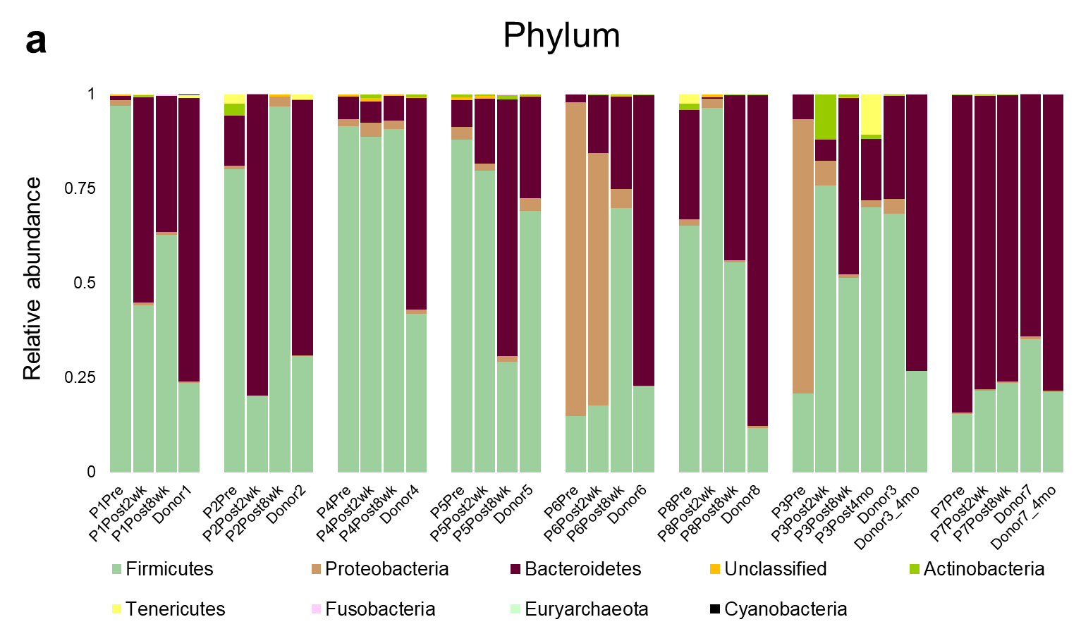
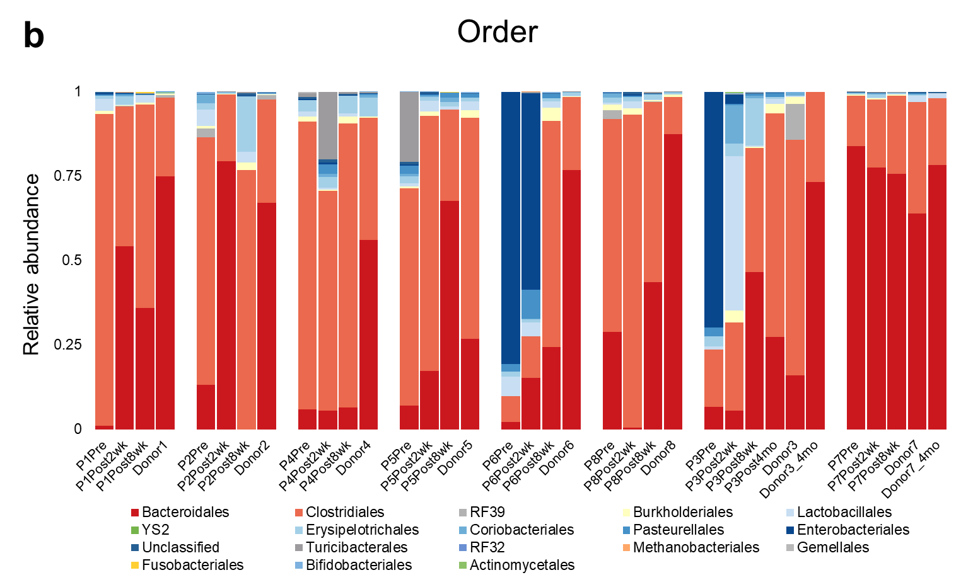
Figure S1. a Taxonomic classifications of individual rCDI patients at phylum level. b Taxonomic classifications of individual rCDI patients at order level. All of individual donor samples were described in order of the donor number (Donor'n'), and all the numbers of rCDI patients (P'n') were designated as those of donors.

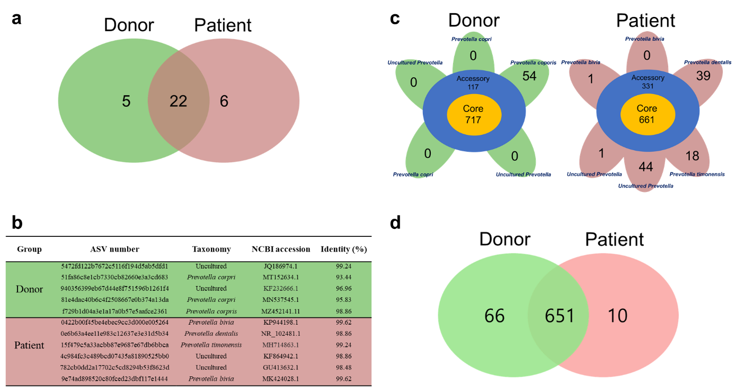
Figure S2. Comparison of functional genes in Prevotella in FMT donors and rCDI patients. a Classification of Prevotella ASVs into three groups by their sources: guts in donors, patients, and both of donor and patients respectively. The numbers of each ASV are represented on Venn diagram. b Table that comprises the information such as ASV number, Taxonomy, NCBI accession, and identity value of NCBI blast. The table was grouped by donor and patients group. c Result of pan-genome analysis among the Prevotella detectable in donors or patients. Left represents donor-specific detectable Prevotella, and right does patient-specific detectable Prevotella. Seven hundred seventeen(717) and 661 core genes are confirmed respectively. d Distribution of core genes in Prevotella. 651 core genes are observed in both donors and patients, 66 genes are detectable only in donors, and 10 genes are monitored in patients alone.

Table S2. List of core genes detected in donors alone. A total of 66 genes are descried with KEGG number, name, and description.
KEGG | Gene | Description
K00176 | korD, oorD | 2-oxoglutarate ferredoxin oxidoreductase subunit delta [EC:1.2.7.3]
K00177 | korC, oorC | 2-oxoglutarate ferredoxin oxidoreductase subunit gamma [EC:1.2.7.3]
K00278 | nadB | L-aspartate oxidase [EC:1.4.3.16]
K00558 | DNMT1, dcm | DNA (cytosine-5)-methyltransferase 1 [EC:2.1.1.37]
K00571 | E2.1.1.72 | site-specific DNA-methyltransferase (adenine-specific) [EC:2.1.1.72]
K00606 | panB | 3-methyl-2-oxobutanoate hydroxymethyltransferase [EC:2.1.2.11]
K00640 | cysE | serine O-acetyltransferase [EC:2.3.1.30]
K00656 | E2.3.1.54, pflD | formate C-acetyltransferase [EC:2.3.1.54]
K00661 | maa | maltose O-acetyltransferase [EC:2.3.1.79]
K00767 | nadC, QPRT | nicotinate-nucleotide pyrophosphorylase (carboxylating) [EC:2.4.2.19]
K00782 | lldG | L-lactate dehydrogenase complex protein LldG
K00820 | glmS, GFPT | glucosamine---fructose-6-phosphate aminotransferase (isomerizing) [EC:2.6.1.16]
K00826 | E2.6.1.42, ilvE | branched-chain amino acid aminotransferase [EC:2.6.1.42]
K00847 | E2.7.1.4, scrK | fructokinase [EC:2.7.1.4]
K00865 | glxK, garK | glycerate 2-kinase [EC:2.7.1.165]
K00868 | pdxK, pdxY | pyridoxine kinase [EC:2.7.1.35]
K00949 | thiN, TPK1, THI80 | thiamine pyrophosphokinase [EC:2.7.6.2]
K01079 | serB, PSPH | phosphoserine phosphatase [EC:3.1.3.3]
K01153 | hsdR | type I restriction enzyme, R subunit [EC:3.1.21.3]
K01154 | hsdS | type I restriction enzyme, S subunit [EC:3.1.21.3]
K01246 | tag | DNA-3-methyladenine glycosylase I [EC:3.2.2.20]
K01322 | PREP | prolyl oligopeptidase [EC:3.4.21.26]
K01579 | panD | aspartate 1-decarboxylase [EC:4.1.1.11]
K01609 | trpC | indole-3-glycerol phosphate synthase [EC:4.1.1.48]
K01658 | trpG | anthranilate synthase component II [EC:4.1.3.27]
K01665 | pabB | para-aminobenzoate synthetase component I [EC:2.6.1.85]
K01744 | aspA | aspartate ammonia-lyase [EC:4.3.1.1]
K01858 | INO1, ISYNA1 | myo-inositol-1-phosphate synthase [EC:5.5.1.4]
K01918 | panC | pantoate--beta-alanine ligase [EC:6.3.2.1]
K02217 | ftnA, ftn | ferritin [EC:1.16.3.2]
K02346 | dinB | DNA polymerase IV [EC:2.7.7.7]
K02477 | K02477 | two-component system, LytTR family, response regulator
K02619 | pabC | 4-amino-4-deoxychorismate lyase [EC:4.1.3.38]
K03147 | thiC | phosphomethylpyrimidine synthase [EC:4.1.99.17]
K03332 | fruA | fructan beta-fructosidase [EC:3.2.1.80]
K03427 | hsdM | type I restriction enzyme M protein [EC:2.1.1.72]
K03455 | TC.KEF | monovalent cation:H+ antiporter-2, CPA2 family
K03517 | nadA | quinolinate synthase [EC:2.5.1.72]
K03612 | rnfG | electron transport complex protein RnfG
K03768 | PPIB, ppiB | peptidyl-prolyl cis-trans isomerase B (cyclophilin B) [EC:5.2.1.8]
K03885 | ndh | NADH dehydrogenase [EC:1.6.99.3]
K04069 | pflA, pflC, pflE | pyruvate formate lyase activating enzyme [EC:1.97.1.4]
K04764 | ihfA, himA | integration host factor subunit alpha
K05516 | cbpA | curved DNA-binding protein
K05601 | hcp | hydroxylamine reductase [EC:1.7.99.1]
K06872 | K06872 | uncharacterized protein
K06889 | K06889 | uncharacterized protein
K06926 | K06926 | uncharacterized protein
K06959 | tex | protein Tex
K07005 | K07005 | uncharacterized protein
K07024 | SPP | sucrose-6-phosphatase [EC:3.1.3.24]
K07139 | K07139 | uncharacterized protein
K07154 | hipA | serine/threonine-protein kinase HipA [EC:2.7.11.1]
K07213 | ATOX1, ATX1, copZ, golB | copper chaperone
K07240 | chrA | chromate transporter
K07316 | mod | adenine-specific DNA-methyltransferase [EC:2.1.1.72]
K08307 | mltD, dniR | membrane-bound lytic murein transglycosylase D [EC:4.2.2.-]
K08641 | vanX | zinc D-Ala-D-Ala dipeptidase [EC:3.4.13.22]
K08998 | K08998 | uncharacterized protein
K09607 | ina | immune inhibitor A [EC:3.4.24.-]
K11921 | cynR | LysR family transcriptional regulator, cyn operon transcriptional activator
K13038 | coaBC, dfp | phosphopantothenoylcysteine decarboxylase / [EC:4.1.1.36 6.3.2.5]
K13993 | HSP20 | HSP20 family protein
K16053 | ybdG, mscM | miniconductance mechanosensitive channel
K18928 | lldE | L-lactate dehydrogenase complex protein LldE
K18929 | lldF | L-lactate dehydrogenase complex protein LldF

