Supplementary Table 1 The sequences of eEF2K siRNA
eEF2K siRNA | Primer direction | sequence
eEF2K siRNA1 | sense | 5′-GUCAAUUCCAAGGUUAAUATT-3′
 | antisense | 5′-UAUUAACCUUGGAAUUGACTT-3′
eEF2K siRNA2 | sense | 5′-AAGCUCGAACCAGAAUGUCTT-3′
 | antisense | 5′-GACAUUCUGGUUCGAGCUUTT-3′
eEF2K siRNA3 | sense | 5′-GAGGAAGGUUACUUCAUCUTT-3′
 | antisense | 5′-AGAUGAAGUAACCUUCCUCTT-3′

Supplementary Table 2 The sequences of RT-qPCR primers
Gene | Primer direction | Primer sequence (5' to 3')
CCL-2 | Forward | CAGCCAGATGCAATCAATGCC
 | Reverse | TGGAATCCTGAACCCACTTCT
IL-6 | Forward | ACTCACCTCTTCAGAACGAATTG
 | Reverse | CCATCTTTGGAAGGTTCAGGTTG
IL-8 | Forward | ACTGAGAGTGATTGAGAGTGGAC
 | Reverse | AACCCTCTGCACCCAGTTTTC
CXCL-10 | Forward | GTGGCATTCAAGGAGTACCTC
 | Reverse | TGATGGCCTTCGATTCTGGATT
GAPDH | Forward | GCACCGTCAAGGCTGAGAAC
 | Reverse | TGGTGAAGACGCCAGTGGA
TNFR1 | Forward | ATGATGAGCGGCAGTGTTCAG
 | Reverse | GCAGGGGCACAGATCAGTTG
TNFR2 | Forward | ACCGTCATCATGTCTGACCA
 | Reverse | TGGAACACCCTGTCTTTGAC

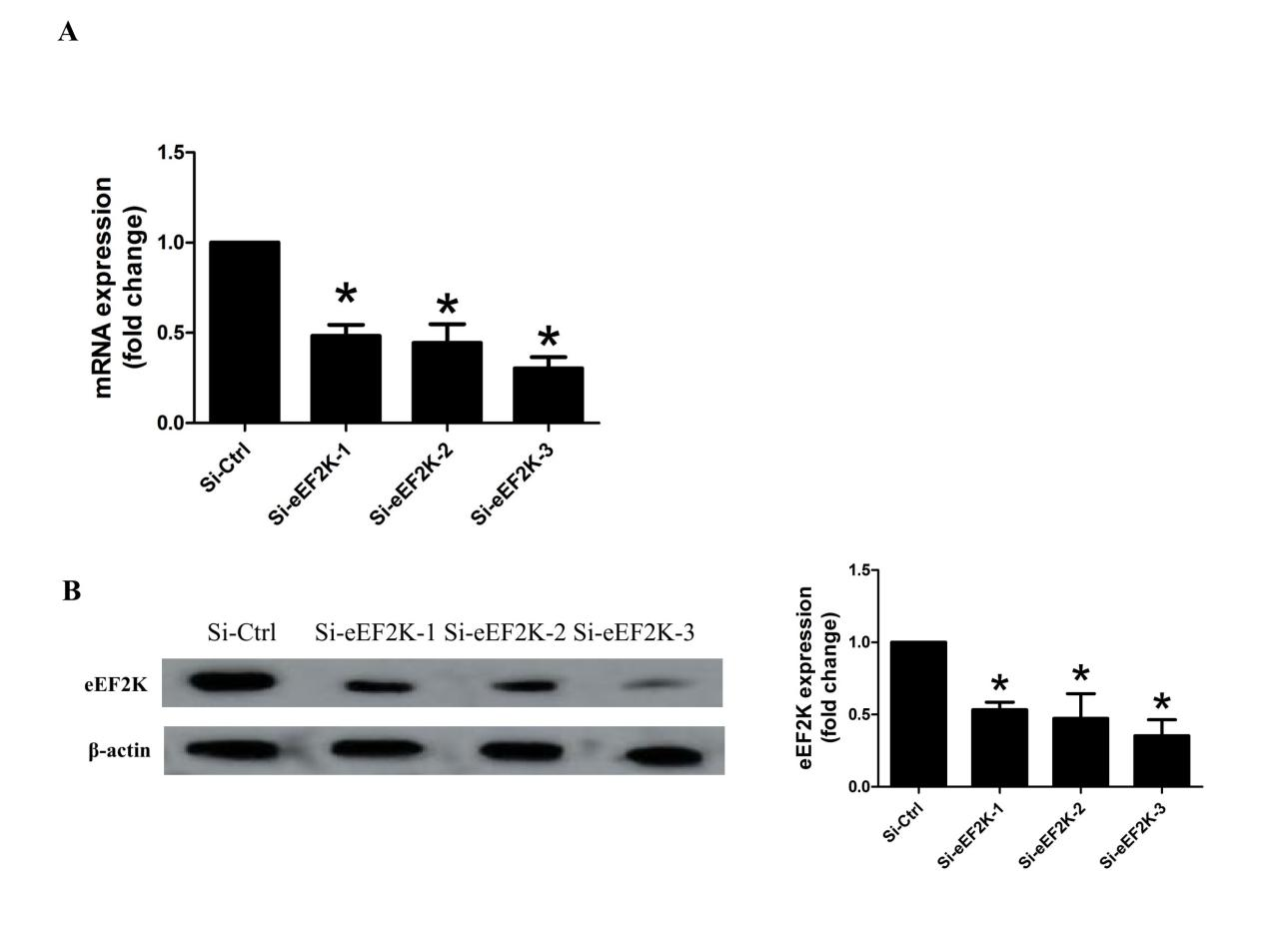Supplementary Figure 1 Efficiency of eEF2K knockdown
RA FLSs were transfected with eEF2K siRNA 1-3 for 48 h and subjected to (A) RT-qPCR analysis and (B) Western blotting assays. Data shown are the mean ± SD from 3 independent experiments. *P < 0.05 vs. si-C, by 1-way ANOVA.

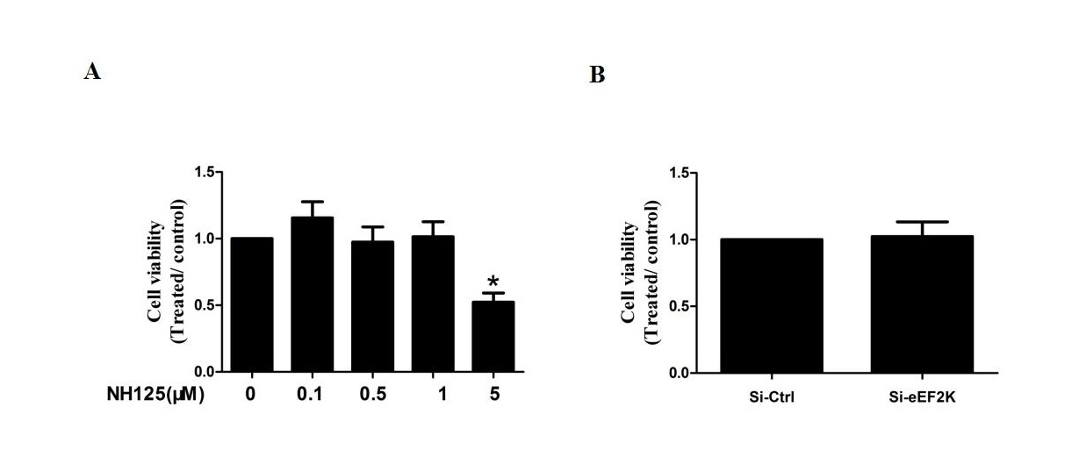Supplementary Figure 2 Effects of eEF2K inhibition on cell viability in RA FLSs
Cell viability was tested by MTT assays. RA FLSs were pretreated with DMSO or NH125 for 24 h (A) or transfected with eEF2K-siRNA or control siRNA (si-C) (B). Data are means of three separated experiments±SEM. *P < 0.05, vs. control. RA, rheumatoid arthritis; FLSs, fibroblast-like synoviocytes; MTT, Methyl-thiazol tetrazolium cytotoxicity.

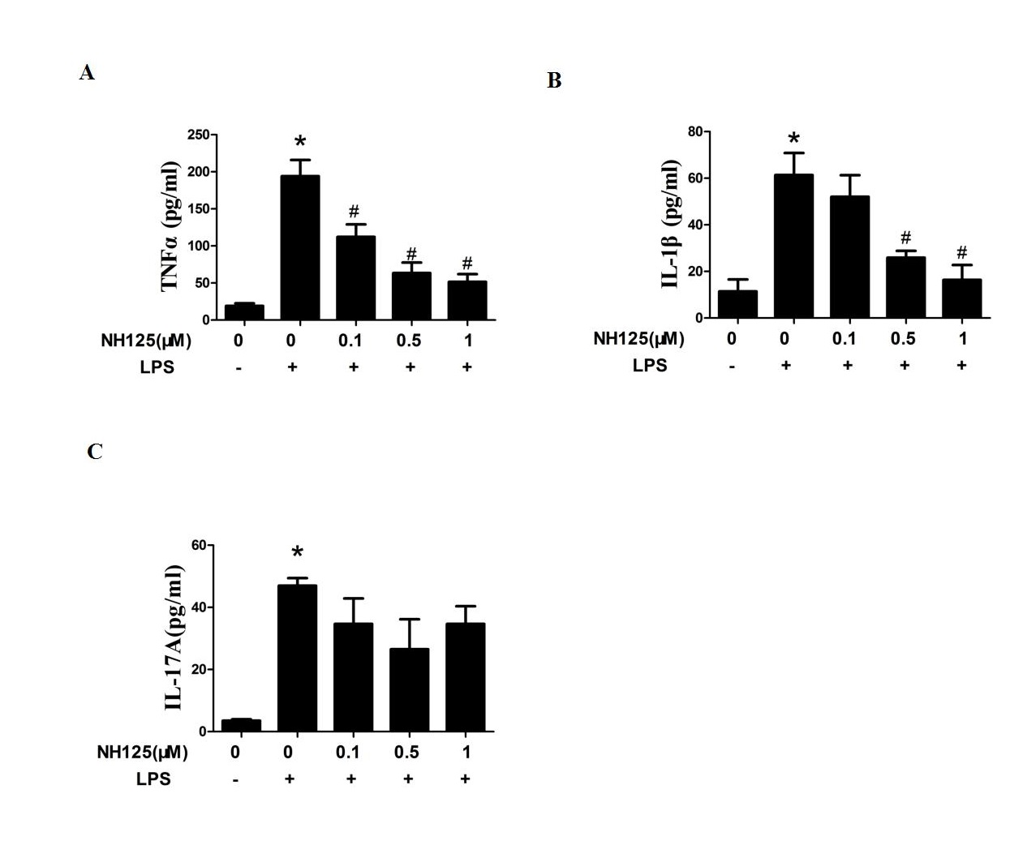Supplementary Figure 3 NH125 suppressed LPS-induced cytokines in RA FLSs
RA FLSs were pretreated with dimethyl sulfoxide (DMSO, as the control) or NH125 (at the different concentration 0.1, 0.5, and 1.0μM) for 24 hours. Then RA FLSs were stimulated with or without LPS (10 ng/ml) for 24h. The levels of TNF-α (A), IL-1β (B), and IL-17A (C) in culture supernatant were detected by ELISA assays . Data were representative as means ± SD *P < 0.05 vs. DMSO control, #P < 0.05 vs. treatment with LPS alone.

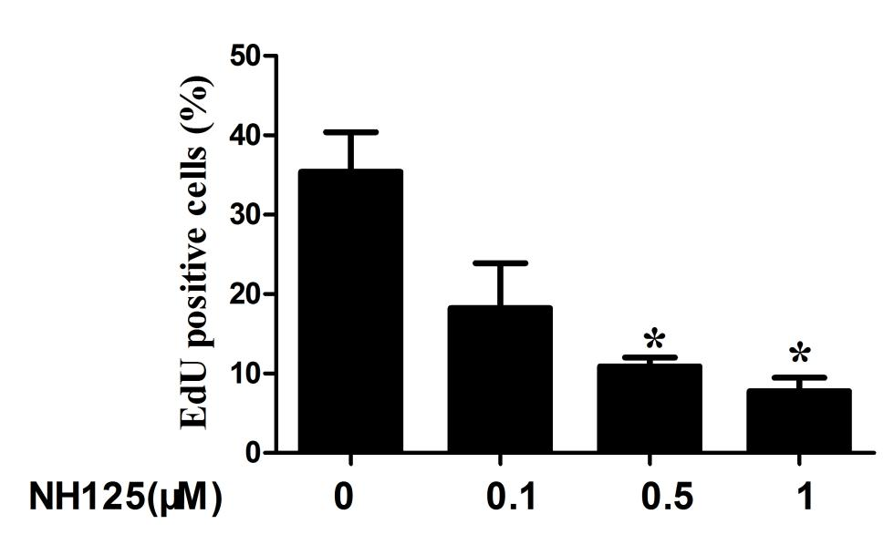
Supplementary Figure 4 NH125 inhibited the cell proliferation of RA FLSs
Cell proliferation was tested by EdU incorporation assays. The bar represents the relative proliferation rate of RA FLSs. *P < 0.05 vs. control. RA, rheumatoid arthritis; FLSs, fibroblast-like synoviocytes.

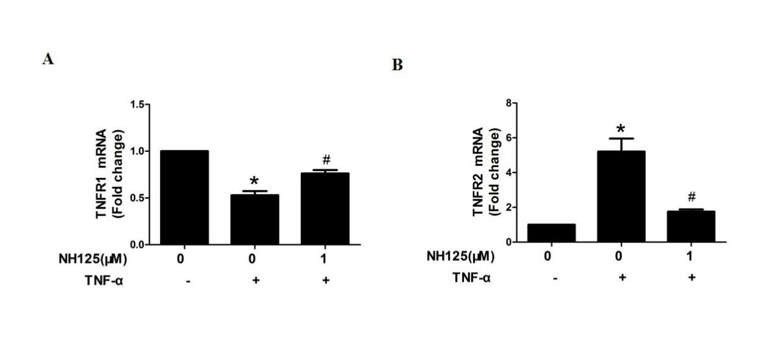Supplementary Figure 5 NH125 regulated the expression of TNFR in RA FLSs
RA FLSs were pretreated with DMSO or NH125 for 24 h. Then RA FLSs were stimulated with or without TNF-α (10 ng/ml) for 24h. The expression of TNFRI (A) and TNFRII (B) was measured by RT-qPCR analysis. Data show the mean ± SD for samples from 5 different RA patients. *P < 0.05 vs. DMSO control, #P < 0.05 vs. treatment with TNF-α alone. TNFRI, Tumor necrosis factors receptor I; TNFRII, Tumor necrosis factors receptor II.

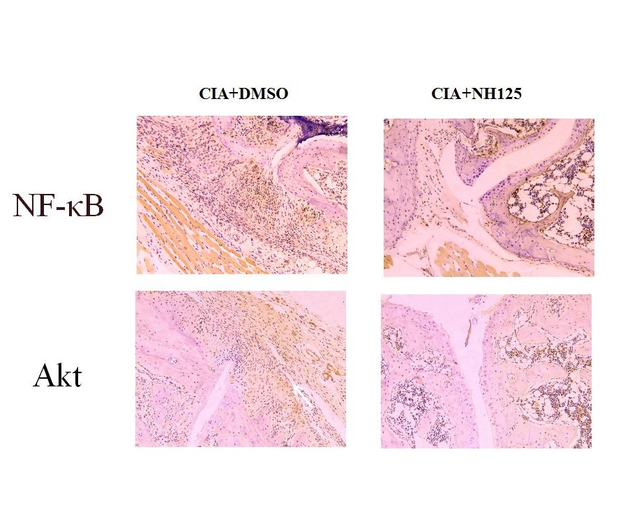
Supplementary Figure 6 NH125 regulated NF-κB and AKT pathway in synovial tissue from CIA mice.
Expression of NF-κB and AKT, measured by immunohistochemical staining, in synovial tissue from CIA mice. Representative images.

Supplementary Figure 7 Effect of eEF2K inhibition on glucose uptake, lactate and intracellular levels of F2,6B in RA FLSs
RA FLSs were pretreated with DMSO or NH125 (1.0 μM) for 4 h or transfected with eEF2K-siRNA or control siRNA (si-C), and then stimulated with TNF-α (10ng/mL) for 24 h. (A) Glucose uptake was measured by a glucose uptake assay kit (colorimetric). (B) The intracellular levels of F2,6BP were measured by a coupled enzyme assay. (C) The concentrations of lactate in the supernatants of RA FLSs were measured by a lactate oxidase-based assay. *P < 0.05 vs. DMSO control or si-C, #P < 0.05 vs. treatment with TNF-α. Data were representative as means ± SD. F2,6BP: fructose-2,6-bisphosphate.

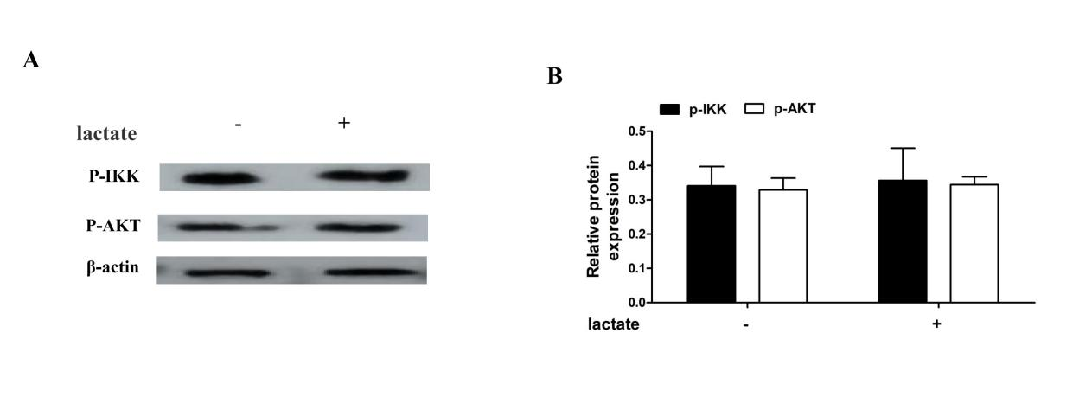Supplementary Figure 8 The effect of lactate on the activition of NF-κB and AKT pathway in RA FLSs
RA FLSs were pretreated with or without lactate (Lac, 10 mM) for 6 h. The expression of p-IKK and p-AKT was measured by Western blot. (A) Representative laser confocal microcopy images. (B) The right panel shows a densitometric analysis of western blots. Data were representative as means ± SD.

