Supplementary data

Chitosan-coated-PLGA nanoparticles enhance the antitumor and antimetastatic activity of Stattic, a STAT3 dimerization blocker

Stephanie Sally Fong^{1#}, Yiing Yee Foo^{1#}, Wen Shang Saw², Bey Fen Leo³, Yin Yin Teo⁴, Ivy Chung¹, Boon Tong Goh⁵, Misni Misran⁴, Toyoko Imae⁶, Chia-Ching Chang^{7,8,9,10, 11*}, Lip Yong Chung², Lik Voon Kiew^{1,7 *}
¹ Department of Pharmacology, Faculty of Medicine, University of Malaya, Kuala Lumpur 50603, Malaysia
² Department of Pharmaceutical Chemistry, Faculty of Pharmacy, University of Malaya, Kuala Lumpur 50603, Malaysia
³ Faculty of Medicine, University of Malaya, Kuala Lumpur 50603, Malaysia
⁴ Department of Chemistry, Faculty of Science, University of Malaya, Kuala Lumpur 50603, Malaysia
⁵ Low Dimensional Materials Research Center, Department of Physics, Faculty of Science, University of Malaya, Kuala Lumpur 50603, Malaysia
⁶ Graduate Institute of Applied Science and Technology, National Taiwan University of Science and Technology, Taipei 10607, Taiwan
⁷ Department of Biological Science and Technology, College of Biological Science and Technology, National Yang Ming Chiao Tung University, Hsinchu 30068, Taiwan
⁸ Center for Intelligent Drug Systems and Smart Bio-devices (IDS²B), National Yang Ming Chiao Tung University, Hsinchu 30050, Taiwan
⁹ Department of Electrophysics, National Yang Ming Chiao Tung University, Hsinchu 30010, Taiwan
¹⁰ Institute of Physics, Academia Sinica, Nankang, Taipei, Taiwan
¹¹ Taiwan-Malaysia Semiconductor and Biomedical Oversea Science and Technology Innovation Center, National Yang Ming Chiao Tung University, Hsinchu 30010, Taiwan

#These authors contributed equally to this work
Correspondences: Lik Voon Kiew; Chia-Ching Chang
Email lvkiew@um.edu.my; ccchang01@ nycu.edu.tw

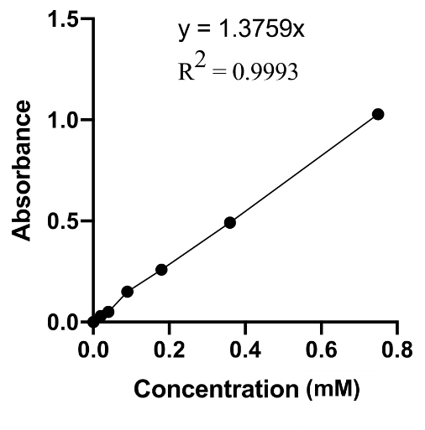
Figure S1 Calibration curve for drug loading and entrapment efficiency determination
Notes: The concentration of Stattic was then determined by using a standard curve derived from the absorbance of solution with a known concentration of Stattic.

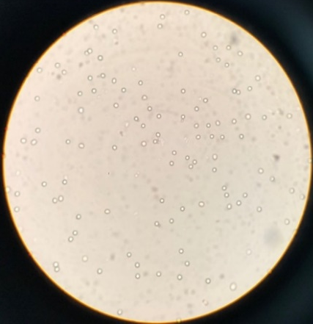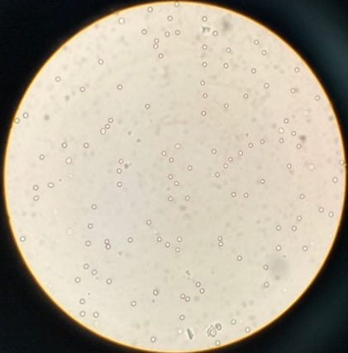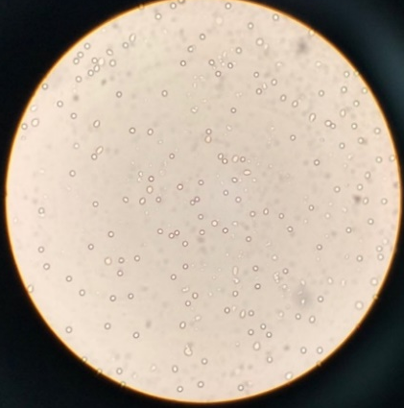
B
A
C
Figure S2 Red blood cell aggregation test.
Notes: Microscopic images of red blood cells (RBC) at 100 × magnification. No RBC aggregation was observed after treatment with (A) Blank PLGA, (B) S@PLGA, and (C) S@C-PLGA NPs for 2 h, at 37°C and 97% humidity.
Abbreviations: RBC, red blood cells; NPS, nanoparticles

Figure S3 Percentage of hemolysis after the incubation of different concentrations of nanoparticles in 2% red blood cells.
Notes: 37°C and 97% humidity for 5 h. Triton X-100 (1% v/v) and blank PBS (100 µl) were used as positive and negative controls, respectively.
Abbreviations: PBS, phosphate buffer saline

Figure S4 The percentage of cell viability for 4T1 after treated 24 h.
Notes: Data represent mean ± SEM from three independent experiments.

Figure S5 The normalized migration rate of MDA-MB-231 and 4T1 cells after treated with Stattic of different concentrations for 24 h.
Notes: Data represent mean ± SEM from three independent experiments.

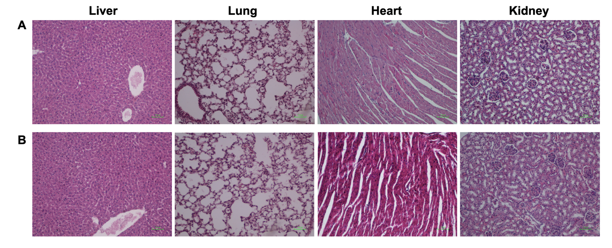
Figure S6 In vivo antimetastatic effects of Stattic and S@C-PLGA NPs.
Notes: Representative liver, lung, heart and kidney of healthy mice injected with 24 mg/kg Stattic (A) and S@C-PLGA NPs (24 mg Stattic eqv./kg) (B) No signs of toxicity were seen in the both groups mice.

