Supporting Information

Glyco-nanoparticles with activatable near-infrared probes for tumor cell imaging and targeted drug delivery
Guanyu Chi^{1,}, Yinghua Lv^{1,} , Shuang Chao^{1,} , Chenxi Hou¹, Yuxin Pei¹ and Zhichao Pei¹
¹Shaanxi Key Laboratory of Natural Products & Chemical Biology, College of Chemistry and Pharmacy, Northwest A&F University, Yangling, Shaanxi 712100, People’s Republic of China
These authors contributed equally to this work.

Correspondence: Zhichao Pei
Shaanxi Key Laboratory of Natural Products & Chemical Biology, College of Chemistry and Pharmacy, Northwest A&F University, Yangling, Shaanxi 712100, People’s Republic of China
Tel: +86 29 87092769
Fax: +86 29 87092769
E-mail address: peizc@nwafu.edu.cn

1 Syntheses and characterization
1.1 Synthesis of Lac-NH₂ (5).

Scheme S1. Synthesis of Lac-NH₂ (5). Reagents: (i) Sodium acetate, acetate anhydride, 89%; (ii) BE₃·OEt₂, HO[CH₂CH₂O]₂CH₂CH₂Cl, 43.1%; (iii) NaN₃, DMF, 90%; (iv) H₂, Pd, 98%; (v) NaOMe, MeOH, 81%.
Compound 1 was synthesized according to a published procedure¹. A suspension of sodium acetate (1.32 g, 16.1 mmol) in acetic anhydride (25 mL) was heated to reflux at 140°C. D-Lactose (5.0 g, 14.6 mmol) was then added into the mixture in small portions. After addition of D-Lactose, the mixture became a clean solution that was stirred under reflux for 20 minutes. The hot solution was then poured into ice-water (200 mL) under vigorous stirring until ice melted. CH₂Cl₂ (150 mL) was added to the stirred solution and the aqueous layer was then removed. The organic layer was washed with ice-cold water (3 × 100 mL), saturated aqueous NaHCO₃ solution (100 mL). The organic solution was then dried over Na₂SO₄, filtered and finally concentrated under reduced pressure to give a crude yellow oil to give Compound 1 (8.8 g, 89%).¹H NMR (500 MHz, CDCl₃), δ (ppm): 6.25 (d, J = 3.65 Hz, 1H), 5.45 (t, J = 9.6 Hz, 1H), 5.35 (d, J = 3.5 Hz, 1H), 5.14-5.10 (m, 1H), 5.00 (dd, J = 6.55, 10.3 Hz, 1H), 4.97-4.94 (m, 1H), 4.49-4.43 (m, 2H), 4.17-4.07 (m, 4H), 3.89-3.74 (m, 2H), 2.18 (s, 3H), 2.16 (s, 3H), 2.12 (s, 3H), 2.08-2.04 (t, 9H), 2.01 (s, 3H), 1.96 (s, 3H). The data was consistent with literature values.
Compound 2 was synthesized according to a published procedure². The Compound 1 (2.00 g, 2.95 mmol) and 2-chloroethoxy-2-ethoxydiethanol (0.64 mL, 19.13 mmol) were dissolved in dry dichloromethane (20 mL) in a 50 mL round bottom flask. Furthermore, BF₃·Et₂O (1.5 mL, 12 mmol) was added dropwise under ice-cooling. Then the reaction system was stirred at room temperature for 24 h. At the end of the reaction, additional dichloromethane (30 mL) was added to the system and washed three times with saturated NaHCO₃. The organic phase was collected and dried over anhydrous Na₂SO₄ to get the crude product. Compound 2 (1.00 g, 43.1%) was separated via column chromatography. ¹H NMR (500 MHz, CDCl₃), δ (ppm): 5.34 (d, J = 3.3 Hz, 1H), 5.19 (t, J = 9.35 Hz, 1H), 5.10 (m, 1H), 4.95 (dd, J = 3.4, 10.4 Hz, 1H), 4.89 (m, 1H), 4.57 (d, J = 7.95 Hz, 1H), 4.49-4.46 (m, 2H), 4.13-4.06 (m, 3H), 3.93-3.84 (m, 2H), 3.81-3.77 (m, 1H), 3.76-3.61 (m, 12H), 2.14 (s, 3H), 2.11 (s, 3H), 2.06-2.03 (m, 12H), 1.96 (s, 3H). The data was consistent with literature values.
Compound 3 was synthesized according to a published procedure². Compound 2 (1.20 g, 1.53 mmol) was added to a suspension of NaN₃ (0.49 g, 7.6 mmol) in dry DMF (15 mL) at 80°C. After reacting for 16 h, the mixture was concentrated in vacuum and diluted with CHCl₃ (30 mL). The organic layer was washed with H₂O and brine then dried over MgSO₄. The concentrated residue was purified by chromatography to give 3 (1.09 g, 90%) as a colorless syrup. ¹H NMR (500 MHz, CDCl₃), δ (ppm): 5.19 (t, J = 7.95 Hz, 1H), 5.09 (t, J = 10.2 Hz, 1H), 4.95 (dd, J = 3.3, 10.4 Hz, 1H), 4.89 (t, J = 9.05 Hz, 1H), 4.56 (d, J = 7.95 Hz, 1H), 4.50-4.45 (m, 2H), 4.24 (t, J = 6.25 Hz, 1H), 4.13-4.07 (m, 3H), 3.92-3.84 (m, 2H), 3.78 (t, J = 9.6 Hz, 1H), 3.68-3.56 (m, 12H), 2.14 (s, 3H), 2.11 (s, 3H), 2.06-2.03 (m, 12H), 1.95 (s, 3H). The data was consistent with literature values.
Compound 4 was synthesized according to a published procedure². A solution of 3 (200 mg, 0.40 mmol) and Pd-on-carbon (catalytic amount) in MeOH (20 mL) was hydrogenated at rt under atmospheric pressure for 8 h. The reaction mixture was filtered over a celite bed. Concentration of the filtrates gave 4 (190 mg, 98%). ¹H NMR (500 MHz, CDCl₃), δ (ppm): 5.34 (d, J = 3.2 Hz, 1H), 5.18 (t, J = 9.35 Hz, 1H), 5.1 (dd, J = 8.15, 10.2 Hz, 1H), 4.95 (dd, J = 3.3, 10.4 Hz, 1H), 4.89 (t, J = 9.05 Hz, 1H), 4.56 (d, J = 7.95 Hz, 1H), 4.47 (t, J = 7.9 Hz, 2H), 4.24 (t, J = 6.3 Hz, 1H), 4.13-4.06 (m, 3H), 3.92-3.84 (m, 2H), 3.78 (t, J = 9.3 Hz, 1H), 3.68-3.56 (m, 11H), 3.38 (t, J = 5.05 Hz, 2H), 2.14 (s, 3H), 2.11 (s, 3H), 2.03 (t, J = 8.75 Hz, 12H), 1.95 (s, 3H). The data was consistent with literature values.
Compound 5 was synthesized according to a published procedure². Compound 4 (2.0 g, 2.5 mmol) was deacetylated with a catalytic amount of sodium methoxide in MeOH (20 mL) to give 5 (1.1 g, 81%) as a colorless solid. ¹H NMR (500 MHz, D₂O), δ (ppm): 4.51 (d, J = 7.85 Hz, 1H), 4.43 (d, J = 7.7 Hz, 1H), 4.06 (d, J = 11.45 Hz, 1H), 3.96 (d, J = 12.2 Hz, 1H), 3.89 (d, J = 13.05 Hz, 2H), 3.84 (t, J = 4.0 Hz, 1H), 3.83-3.79 (m, 2H), 3.78 (s, 1H), 3.75 (s, 4H), 3.73-3.68 (m, 8H), 3.66-3.56 (m, 9H), 3.53 (t, J = 7.9 Hz, 2H), 2.92 (s, 2H). The data was consistent with literature values.
Fig. S1 ¹H NMR spectrum of Compound 5 in D₂O.
1.2 Synthesis of DCM (9).
Scheme S2. Synthesis of DCM (9). Reagents: (i) Na, 50.4%; (ii) CH₃COOH, H₂SO₄ ,68%; (iii) malononitriler, CH₃COOH, 21%; (iv) N-(4-formyl-phenyl) acetamide, HCl, EtOH, 33%.
Compound 6 was synthesized according to a published procedure³. 1-(2-hydroxyphenyl) ethanone (10.0 g, 73.5 mmol) was dissolved in 200 mL ethyl acetate and then react with sodium (8.00 g, 34 mmol). The grayish-green solid was filtered after violently stirring for 4 h in ambient temperature. The solid was dissolved in 100 mL methanol to consume the remained sodium. The solvent was evaporated under vacuum and the residue was dissolved in 100 mL deionized water. The pH of solution was adjusted to neutral. The aqueous solution was extracted with 200 mL ethyl acetate. Then organic layers were combined and dried over Na₂SO₄. The filtrate was concentrated to yield the crude product of 6 as a brown solid (6.70 g, 50.4 %), which was directly used in the next reaction without further purification.
Compound 7 was synthesized according to a published procedure³. Sulfuric acid (4.6 mL) was slowly added to acetic acid solution (70 mL) containing compound 6 (6.70 g, 37.5 mmol). The mixture was refluxed for about 30 min and poured into 800 mL of ice water, followed by adjusting its pH to neutral with Na₂CO₃. The aqueous solution was extracted with dichloromethane twice. The organic layers were combined and dried over Na₂SO₄. The filtrate was concentrated to yield the crude product of 7 as an acicular gray solid (4.54 g, 68 %). The crude product was directly used in the next reaction without further purification.
Compound 8 was synthesized according to a published procedure³. Compound 7 (2.30 g, 14.4 mmol) and malononitrile (1.20 g, 18.1 mmol) were dissolved in 15 mL of acetic anhydride. The solution was refluxed for 14 h and then the solvent was evaporated in vacuum. Deionized water (40 mL) was added to the residue and the mixture was refluxed for another 0.5 h, followed by extraction with methylene dichloride after cooling down to room temperature. The organic layers were combined and dried over Na₂SO₄. The filtrate was concentrated to yield the crude product, which was purified by silica column chromatography to yield Compound 8 as a yellow solid (0.63 g, 21 %). ¹H NMR (500 MHz, CDCl₃), δ (ppm): 8.92 (d, J = 8.6 Hz, 1H), 7.72 (t, J = 8.65 Hz, 1H), 7.48-7.43 (m, 2H), 6.72 (s, 1H). The data was consistent with literature values.
Compound 9 was synthesized according to a published procedure³. Compound 8 (400 mg, 1.90 mmol) and N-(4-formyl-phenyl) acetamide (284 mg, 1.76 mmol) were dissolved in toluene (20 mL) with piperidine (1.0 mL) and acetic acid (1.0 mL) under nitrogen protection at room temperature. Then the mixture was refluxed for 12 h to give an orange precipitate. After filtration, the orange solid was refluxed in a solution of HCl and ethanol (2:1, v/v, 200 mL) for another 16 h before the pH of the solution was adjusted to neutral. The aqueous solution was extracted with ethyl acetate. The organic layers were combined and dried over Na₂SO₄. The filtrate was concentrated to yield the crude product, which was purified by silica column chromatography to yield 9 as a crimson solid (192 mg, 33 %). ¹H NMR (500 MHz, DMSO-d₆), δ (ppm): 7.87 (t, J = 8.0 Hz, 1H), 7.75 (d, J = 8.3 Hz, 1H), 7.63 (d, J = 15.75 Hz, 1H), 7.57 (t, J = 7.85 Hz, 1H), 7.48 (d, J = 8.45 Hz, 2H), 7.07 (d, J = 15.75 Hz, 1H), 6.85 (s, 1H), 6.60 (d, J = 8.45 Hz, 2H), 6.01 (s, 2H). The data was consistent with literature values.

Fig. S2 ¹H NMR spectrum of Compound 8 in CDCl₃.

Fig. S3 ¹H NMR spectrum of Compound 9 in DMSO-d₆.

1.3 Synthesis of DCM-SS-NH₂ (13).
Scheme S3. Synthesis of DCM-SS-NH₂ (13). Reagents: (i) (Boc)₂O, 55%; (ii) NHS, EDC, 28.4%; (iii) N, N'-Carbonyldiimidazole (CDI), 19%; (iv) TFA, CH₂Cl₂, 31%.
Compound 10 was synthesized according to a published procedure⁴. Ethylenediamine (1.0 g, 16 mmol) was dissolved in CH₂Cl₂ (20 mL) and ditertbutyldicarbonate (1.82 g, 8.3 mmol) dissolved in CH₂Cl₂ (20 mL) was added dropwise over 2 h at 0°C. After stirring the solution overnight at rt, the solvent was removed and the residue dissolved in water then extracted with CH₂Cl₂. Afterwards the combined organic layer was dried over MgSO₄ and the solvent was removed to yield 10 as a colorless oil (0.88 g, 55%). ¹H NMR (500 MHz, CDCl₃), δ (ppm): 4.91 (s, 1H), 3.16 (d, J = 5.55 Hz, 2H), 2.77 (t, J = 6.0 Hz, 2H), 1.43 (s, 9H). The data was consistent with literature values.
Compound 11 was synthesized according to the previous procedure⁵. NHS (1.15 g, 0.01 mol), EDC (1.91g, 0.01 mol) and 3,3'-Thiodipropionic acid (2.1 g, 0.01 mol) were mixed in 20 mL of anhydrous THF and stirred for 2 h at room temperature to activate one end carboxyl group of 3,3'-thiodipropionic acid. Compound 10 (1.6 g, 0.01 mol) was dissolved in 10 mL of anhydrous THF and then added into the above mixture. After stirring for 8 h, the solvent was removed under reduced pressure and 20 mL of CH₂Cl₂ was added. The organic layer was washed with water and then dried over Na₂SO₄. The filtrate was concentrated to yield the crude product, which was purified by silica column chromatography to yield 11 as yellow oil (1.0 g, 28.4%). ¹H NMR (500 MHz, CDCl₃), δ (ppm): 7.85 (s, 1H), 6.94 (s, 1H), 5.3 (s, 1H), 3.33 (d, J = 5.6 Hz, 2H), 3.25 (m, 2H), 2.93 (s, 4H), 2.71 (d, J = 11.8 Hz, 2H), 2.6 (d, J = 6.15 Hz, 2H), 1.41 (s, 9H). ¹³C NMR (125 MHz, CDCl₃), δ (ppm): 151.2, 148.5, 133.4, 56.3, 16.7, 16.2, 12.2, 10.1, 9.6, 4.6, 1.7. HRMS: m/z calculated for [M + Na]⁺, C₁₃H₂₄N₂O₅S₂Na⁺, 375.1025, found 375.1025.
Compound 12 was synthesized according to the previous procedure⁶. To a stirred solution containing compound 11 (250 mg, 0.72 mmol) and 5 mL of anhydrous THF, 5 mL of N, N’-carbonyl diimidazole (230 mg, 1.44 mmol) in anhydrous THF was added slowly. The reaction was stirred for 15 minutes at room temperature and then 9 (150 mg, 0.48 mmol) in 5 mL of anhydrous THF were added. The reaction mixture was refluxed at 50°C for additional 12 hours, and then the solvent was removed under reduced pressure and 25 mL of CH₂Cl₂ was added. The organic layer was washed with water and then dried over Na₂SO₄. The filtrate was concentrated to yield the crude product, which was purified by silica column chromatography to yield 12 as a yellow-brown solid (58 mg, 19%)⁵. ¹H NMR (500 MHz, DMSO) δ (ppm): 10.29 (s, 1H), 8.72 (d, J = 8.35 Hz, 1H), 7.96 (t, J = 5.3 Hz, 1H), 7.91 (t, J = 7.4 Hz, 1H), 7.78 (d, J = 10.0 Hz, 1H), 7.69 (m, 6H), 7.6 (t, J = 7.7 Hz, 1H), 7.37 (d, J = 15.95 Hz, 1H), 6.97 (s, 1H), 3.06 (m, 2H), 2.98 (m, 4H), 2.91 (t, J = 7.2 Hz, 2H), 2.77 (t, J = 6.95 Hz, 2H), 2.47 (t, J = 7.2 Hz, 2H), 1.36 (s, 9H). ¹³C NMR (125 MHz, DMSO), δ (ppm): 170.6, 169.9, 158.9, 156.1, 153.3, 152.5, 141.5, 138.9, 135.8, 131.9, 130.2, 129.6, 129.1, 126.6, 125.1, 119.6, 119.5, 118.3, 117.6, 116.3, 106.8, 78.1, 60.3, 40.0, 39.2, 36.6, 35.5, 34.3, 33.8, 28.7, 19.1. HRMS: m/z calculated for [M + Na]⁺, C₃₃H₃₅N₅O₅S₂Na⁺, 668.1978, found 668.1973.
Compound 13 was synthesized according to the previous procedure⁴. Compound 12 (50 mg, 0.09 mmol) was dissolved in 4 mL DCM/TFA (v/v=1:1) and stirred for 0.5 h at room temperature. The residue was dissolved in CH₂Cl₂ after removing the solvent, and then dried over Na₂SO₄. The filtrate was concentrated to yield the crude product, which was purified by silica column chromatography to yield 13 as a yellow solid (14.7 mg, 31%). ¹H NMR (500 MHz, DMSO) δ (ppm): 10.43 (s, 1H), 8.77 (d, J = 8.3 Hz, 1H), 8.25 (s, 1H), 7.96 (t, J = 7.4 Hz, 1H), 7.83 (d, J = 8.35 Hz, 1H), 7.75 (m, 5H), 7.65 (t, J = 7.45 Hz, 1H), 7.42 (d, J = 15.9 Hz, 1H), 7.04 (s, 1H), 3.32 (m, 2H), 3.19 (d, J = 4.95 Hz, 2H), 3.04 (t, J = 7.15 Hz, 2H), 2.98 (t, J = 7.1 Hz, 2H), 2.87 (t, J = 5.95 Hz, 2H), 2.82 (t, J = 6.9 Hz, 2H), 2.56 (t, J = 7.05 Hz, 2H). ¹³C NMR (125 MHz, DMSO), δ (ppm): 171.4, 170.0, 167.1, 158.9, 153.4, 152.5, 138.9, 135.9, 130.3, 129.6, 128.5, 126.6, 125.1, 119.7, 119.5, 118.4, 117.7, 117.6, 116.4, 106.8, 85.9, 40.6, 39.2, 36.6, 35.5, 34.0, 33.9, 29.4. HRMS: m/z calculated for [M + H]⁺, C₂₈H₂₈N₅O₃S₂⁺, 546.1555, found 546.1638.
Fig. S4 ¹H NMR spectrum of Compound 10 in CDCl₃.

Fig. S5 ¹H NMR spectrum of Compound 11 in CDCl₃.

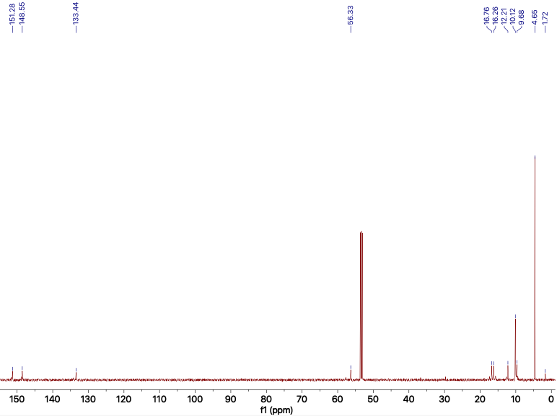
Fig. S6. ¹³C NMR spectrum of Compound 11 in CDCl₃.

Fig. S7. HRMS spectrum of Compound 11.
Fig. S8 ¹H NMR spectrum of Compound 12 in DMSO-d₆.

Fig. S9. ¹³C NMR spectrum of Compound 12 in DMSO-d₆.

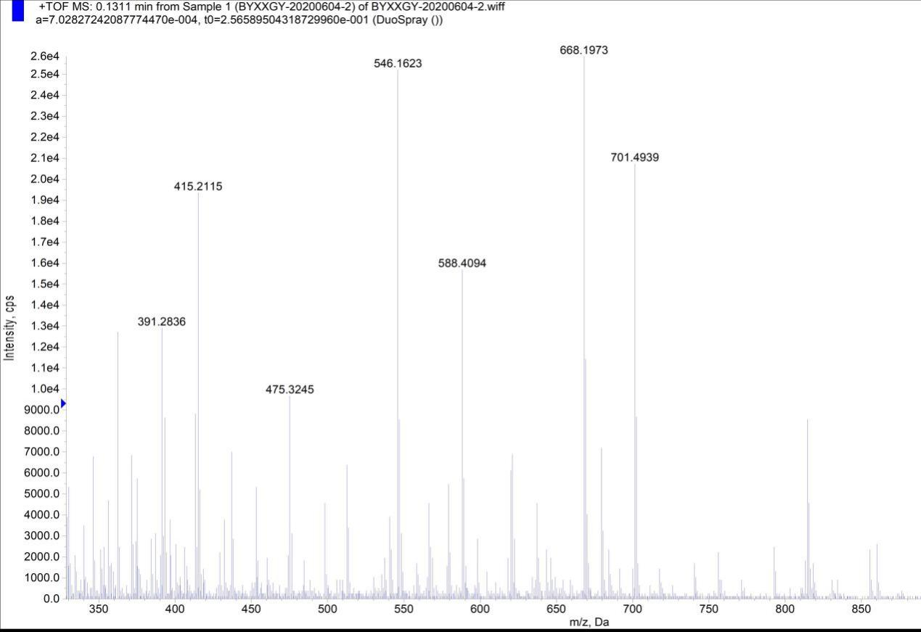
Fig. S10. HRMS spectrum of Compound 12.

Fig. S11 ¹H NMR spectrum of Compound 13 in DMSO-d₆.
Fig. S12. ¹³C NMR spectrum of Compound 13 in DMSO-d₆.

Fig. S13. HRMS spectrum of Compound 13.

1.4 Synthesis of PDA.
Scheme S4. Synthesis of PDA.
Polydopamine nanoparticles (PDA NPs) were synthesized according to a previously reported method (Scheme S4)⁷. 50 mg dopamine hydrochloride was added to the mixture of 0.33 mL ammonia, 4 mL ethanol and 9 mL deionized water, stirring at 40°C for 8 h and the product was washed with deionized water several times then centrifuged (16000 rpm, 10 min) to yield PDA as black solid.
2 The characterization of the PLDD NPs
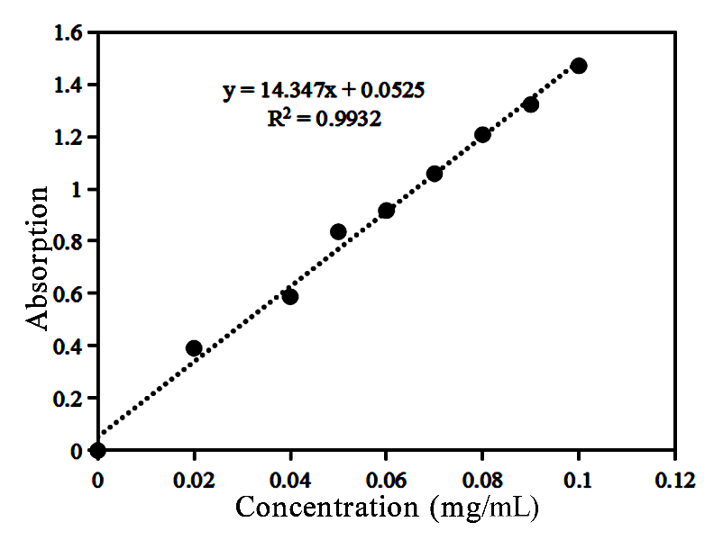
Fig. S14 The standard curve of DCM-SS-NH₂ (λabs = 460 nm).

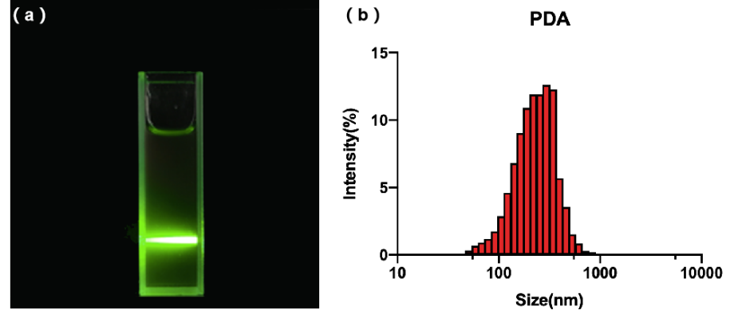
Fig. S15 (a) Tyndall effect of PLDD NPs; (b) The size distribution of PDA NPs by DLS.
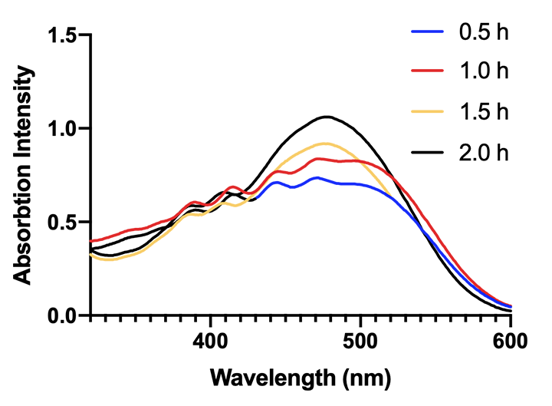
Fig. S16 The absorption spectra of DCM-SS-NH₂ incubated with GSH (5 mM) for different duration.
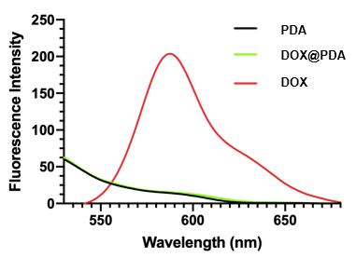
Fig. S17 The fluorescence emission spectra of PDA, DOX@PDA and DOX.
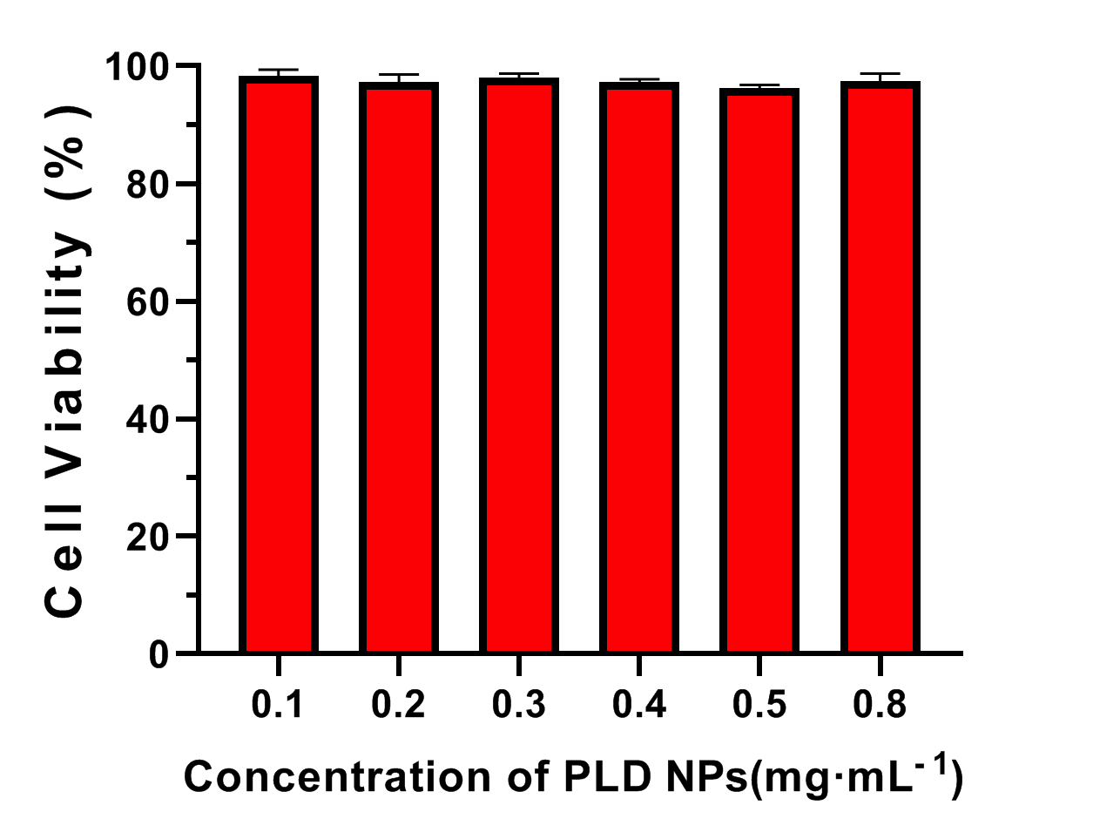
Fig. S18 HL7702 cells incubated with different concentration of PLD NPs.

- P. Vargil, L. Pawaret, H. Sun, K. Oleg, D, N. Christopher, M. T. Tam, B. Annabelle, A. W. Daniela, P. Mihai, S. Zhang, P. K. Neha, V. Kevin, M. Diana, D. J. Eric, A. H. Daniel, J. P. Darrin, Y. Chen, M, C. Yoann, T. Shiao, B. Milan, A. Sabine, R. Rene, J. G. Hans and A. H. Paul, J. Am. Chem. Soc., 2013, 135, 9055-9077.
- H. Kato, H. Uzawa, T. Nagatsuka, S. Kondo, K. Sato, I. Ohsawa, M. Kanamori-Kataoka, Y. Takei, S. Ota and M. Furuno, Carbohydr. Res. 2011, 346, 1820-1826.
- S. Cao, Z. Pei, Y. Xu and Y. Pei, Chem. Mat., 2016, 28, 4501-4506.
- H. Chan, L. Lyu, A. W. Linna, J. Zhang, W. Li, J. Yang and B. Xing, ACS Chem. Biol., 2018, 13, 1890-1896.
- S. Shi, L. Zhang, M. Zhu, G. Wan, C. Li, J. Zhang, Y. Wang and Y. Wang, ACS Appl. Mater. Interfaces., 2018, 10, 29260-29272.
- J. Gao, O. Zhang, J. Ren, C. Wu and Y. Zhao, Langmuir., 2016, 32, 1601-1610.
- X. Wang, C. Wang, Y. Wang, Q. Zhang, Y. Cheng, Chem. Mat., 2017, 29, 1370-1376.

