Online Supplemental Material

Reference equations for assessing the physical activity of chronic obstructive pulmonary disease
Yoshiaki Minakata, Seigo Sasaki, Yuichiro Azuma, Kazumi Kawabe, Hideya Ono

Table S1. Simple regression analysis results with transformed PA values.
 | Duration at  ≥2.0 METs |  | Duration at  ≥3.0 METs |  | Total activity  at ≥3.0 METs |  | Step count
 | r | p | r | p | r | p | r | p
Age (years) | -0.106 | 0.112 | -0.157 | 0.018 | -0.160 | 0.016 | -0.184 | 0.005
Gender [M/F] | -0.145 | 0.029 | -0.083 | 0.214 | -0.080 | 0.232 | -0.018 | 0.788
Height (cm) | -0.142 | 0.033 | -0.037 | 0.582 | -0.031 | 0.644 | 0.068 | 0.305
Weight (kg) | 0.019 | 0.774 | 0.114 | 0.087 | 0.117 | 0.078 | 0.063 | 0.344
BMI (kg/m²) | 0.111 | 0.096 | 0.158 | 0.017 | 0.158 | 0.017 | 0.048 | 0.476
Smoking [non/ex/curr] | -0.099 | 0.137 | -0.062 | 0.351 | -0.061 | 0.358 | -0.029 | 0.667
Smoking (Pack·Year) | -0.080 | 0.233 | -0.024 | 0.725 | -0.020 | 0.764 | 0.046 | 0.492
IC (L) | 0.154 | 0.020 | 0.241 | <0.001 | 0.246 | <0.001 | 0.207 | 0.002
FVC %pred (%) | 0.216 | 0.001 | 0.281 | <0.001 | 0.282 | <0.001 | 0.260 | <0.001
FEV1/FVC | 0.319 | <0.001 | 0.359 | <0.001 | 0.360 | <0.001 | 0.289 | <0.001
FEV1 %pred (%) | 0.360 | <0.001 | 0.425 | <0.001 | 0.425 | <0.001 | 0.360 | <0.001
6MWD (m) | 0.288 | <0.001 | 0.432 | <0.001 | 0.433 | <0.001 | 0.423 | <0.001
Lowest SpO₂ during 6-minute walk test (%) | 0.160 | 0.016 | 0.199 | 0.003 | 0.201 | 0.002 | 0.172 | 0.010
Upper arm circumference (cm) | 0.138 | 0.037 | 0.170 | 0.010 | 0.170 | 0.011 | 0.105 | 0.116
Subcutaneous fat thickness of triceps brachii (cm) | -0.008 | 0.908 | -0.043 | 0.516 | -0.042 | 0.531 | -0.141 | 0.034
Grip strength (kgf) | 0.113 | 0.091 | 0.142 | 0.032 | 0.141 | 0.034 | 0.143 | 0.031
Fasting plasma glucose (mg/dL) | -0.028 | 0.672 | 0.060 | 0.369 | 0.076 | 0.257 | -0.027 | 0.684
Hemoglobin A1c (%) | -0.025 | 0.705 | 0.021 | 0.756 | 0.034 | 0.606 | -0.029 | 0.663
Red blood cells (×10⁴/mL) | -0.033 | 0.624 | -0.040 | 0.551 | -0.037 | 0.577 | -0.058 | 0.386
Hemoglobin (g/dL) | -0.090 | 0.177 | -0.049 | 0.467 | -0.046 | 0.491 | -0.052 | 0.436
Brain Natriuretic Peptide (pg/mL) | -0.054 | 0.415 | -0.131 | 0.049 | -0.138 | 0.038 | -0.034 | 0.612
Albumin (g/dL) | 0.117 | 0.080 | 0.123 | 0.065 | 0.123 | 0.064 | 0.107 | 0.109
Anxiety score of HADS | 0.172 | 0.009 | 0.145 | 0.029 | 0.146 | 0.028 | 0.129 | 0.053
Depression score of HADS | -0.053 | 0.430 | -0.079 | 0.237 | -0.082 | 0.219 | -0.056 | 0.400
mMRC | -0.334 | <0.001 | -0.446 | <0.001 | -0.442 | <0.001 | -0.377 | <0.001
Treatment [yes/no] | -0.166 | 0.012 | -0.217 | 0.001 | -0.216 | 0.001 | -0.206 | 0.002
Rehabilitation [yes/no] | -0.112 | 0.094 | -0.080 | 0.232 | -0.087 | 0.193 | 0.035 | 0.602
Comorbidity [yes/no] | -0.006 | 0.931 | -0.004 | 0.952 | -0.001 | 0.990 | -0.029 | 0.660
BMI, body mass index; LAMA, long-acting muscarinic antagonist; LABA, long-acting beta 2 adrenergic agonist; ICS, inhaled corticosteroid; Theo, theophylline; Muco, mucolytic agent; IC, inspiratory capacity; FVC, forced vital capacity; FEV1, forced expiratory volume in 1 second; %pred, % of predicted value; 6MWD, 6-minute walk distance; HADS, Hospital Anxiety and Depression Scale; mMRC, modified Medical Research Council, METs, metabolic equivalents.
Figure legends
Figure S1. Histograms of PA. A: duration at ≥2.0 METs, B: duration at ≥3.0 METs, C: total activity at ≥3.0 METs, D: Step count. METs, metabolic equivalents
Figure S2. Histograms of transformed PA values. A: duration at ≥2.0 METs, B: duration at ≥3.0 METs, C: total activity at ≥3.0 METs, D: Step count. METs, metabolic equivalents

Figure S1
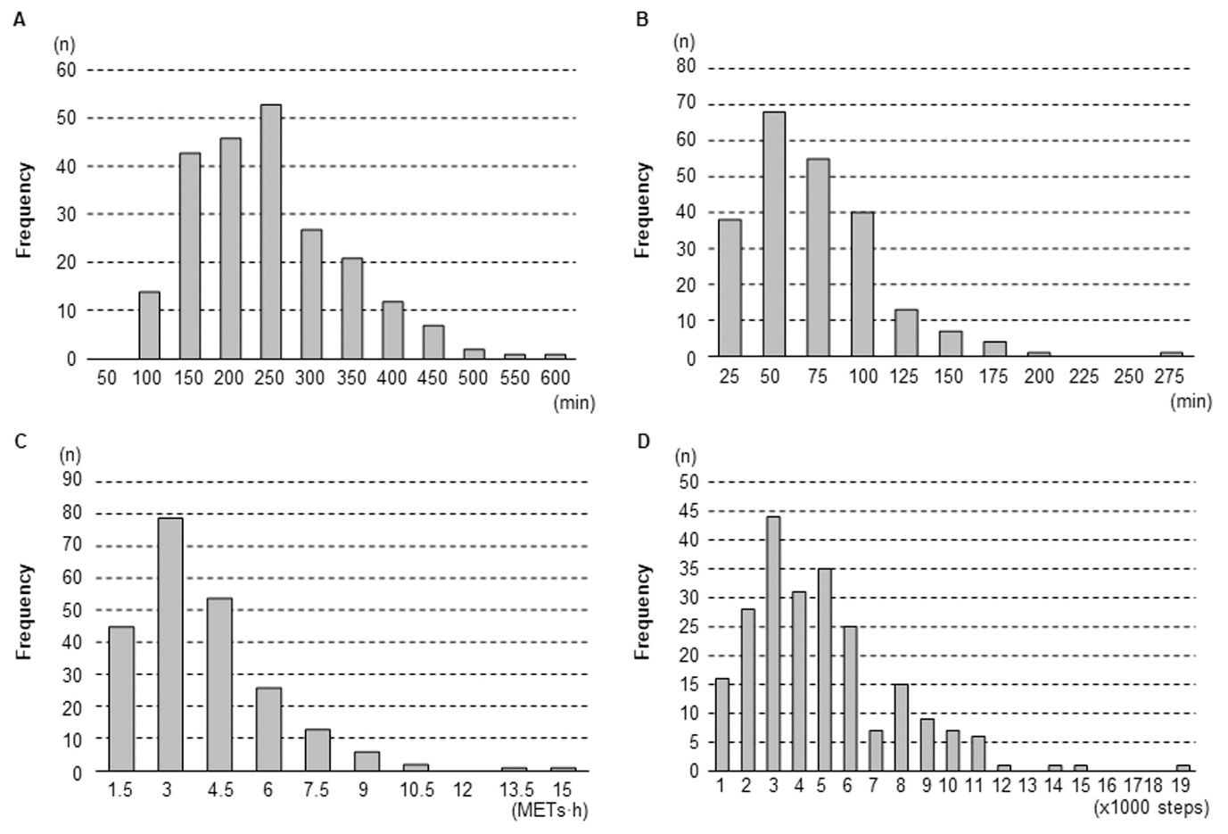
Figure S2
