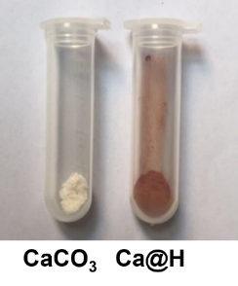
Figure S1 Photographes of CaCO₃ and Ca@H.

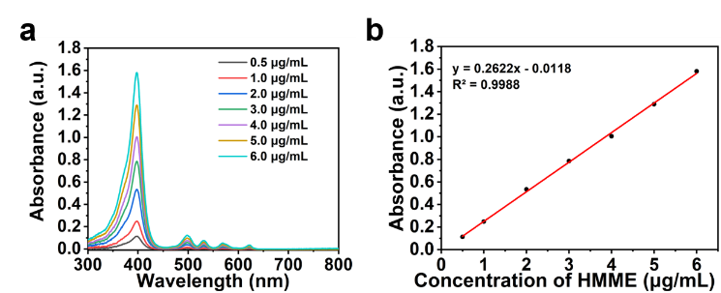
Figure S2 (a) UV-vis spectra of HMME at elevated concentrations. (b) The standard UV-vis absorbance spectra curve of HMME at 398 nm.
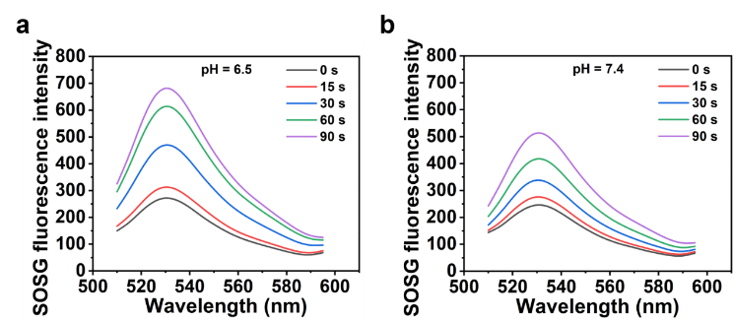
Figure S3 (a) Time-dependent ROS generation of Ca@H (pH = 6.5). (b) Time-dependent ROS generation of Ca@H (pH = 7.4).

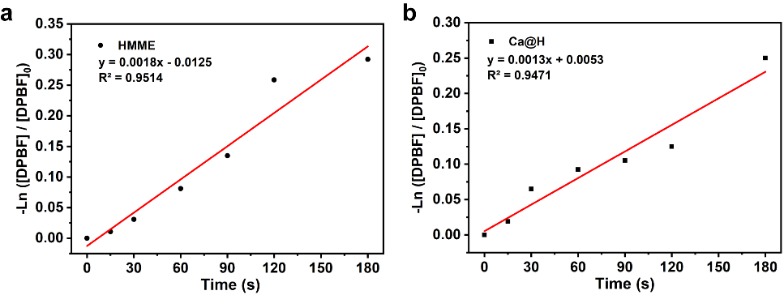
Figure S4. Rate constants of DPBF decomposition in presence of HMME and Ca@H after US irradiation (a-b).

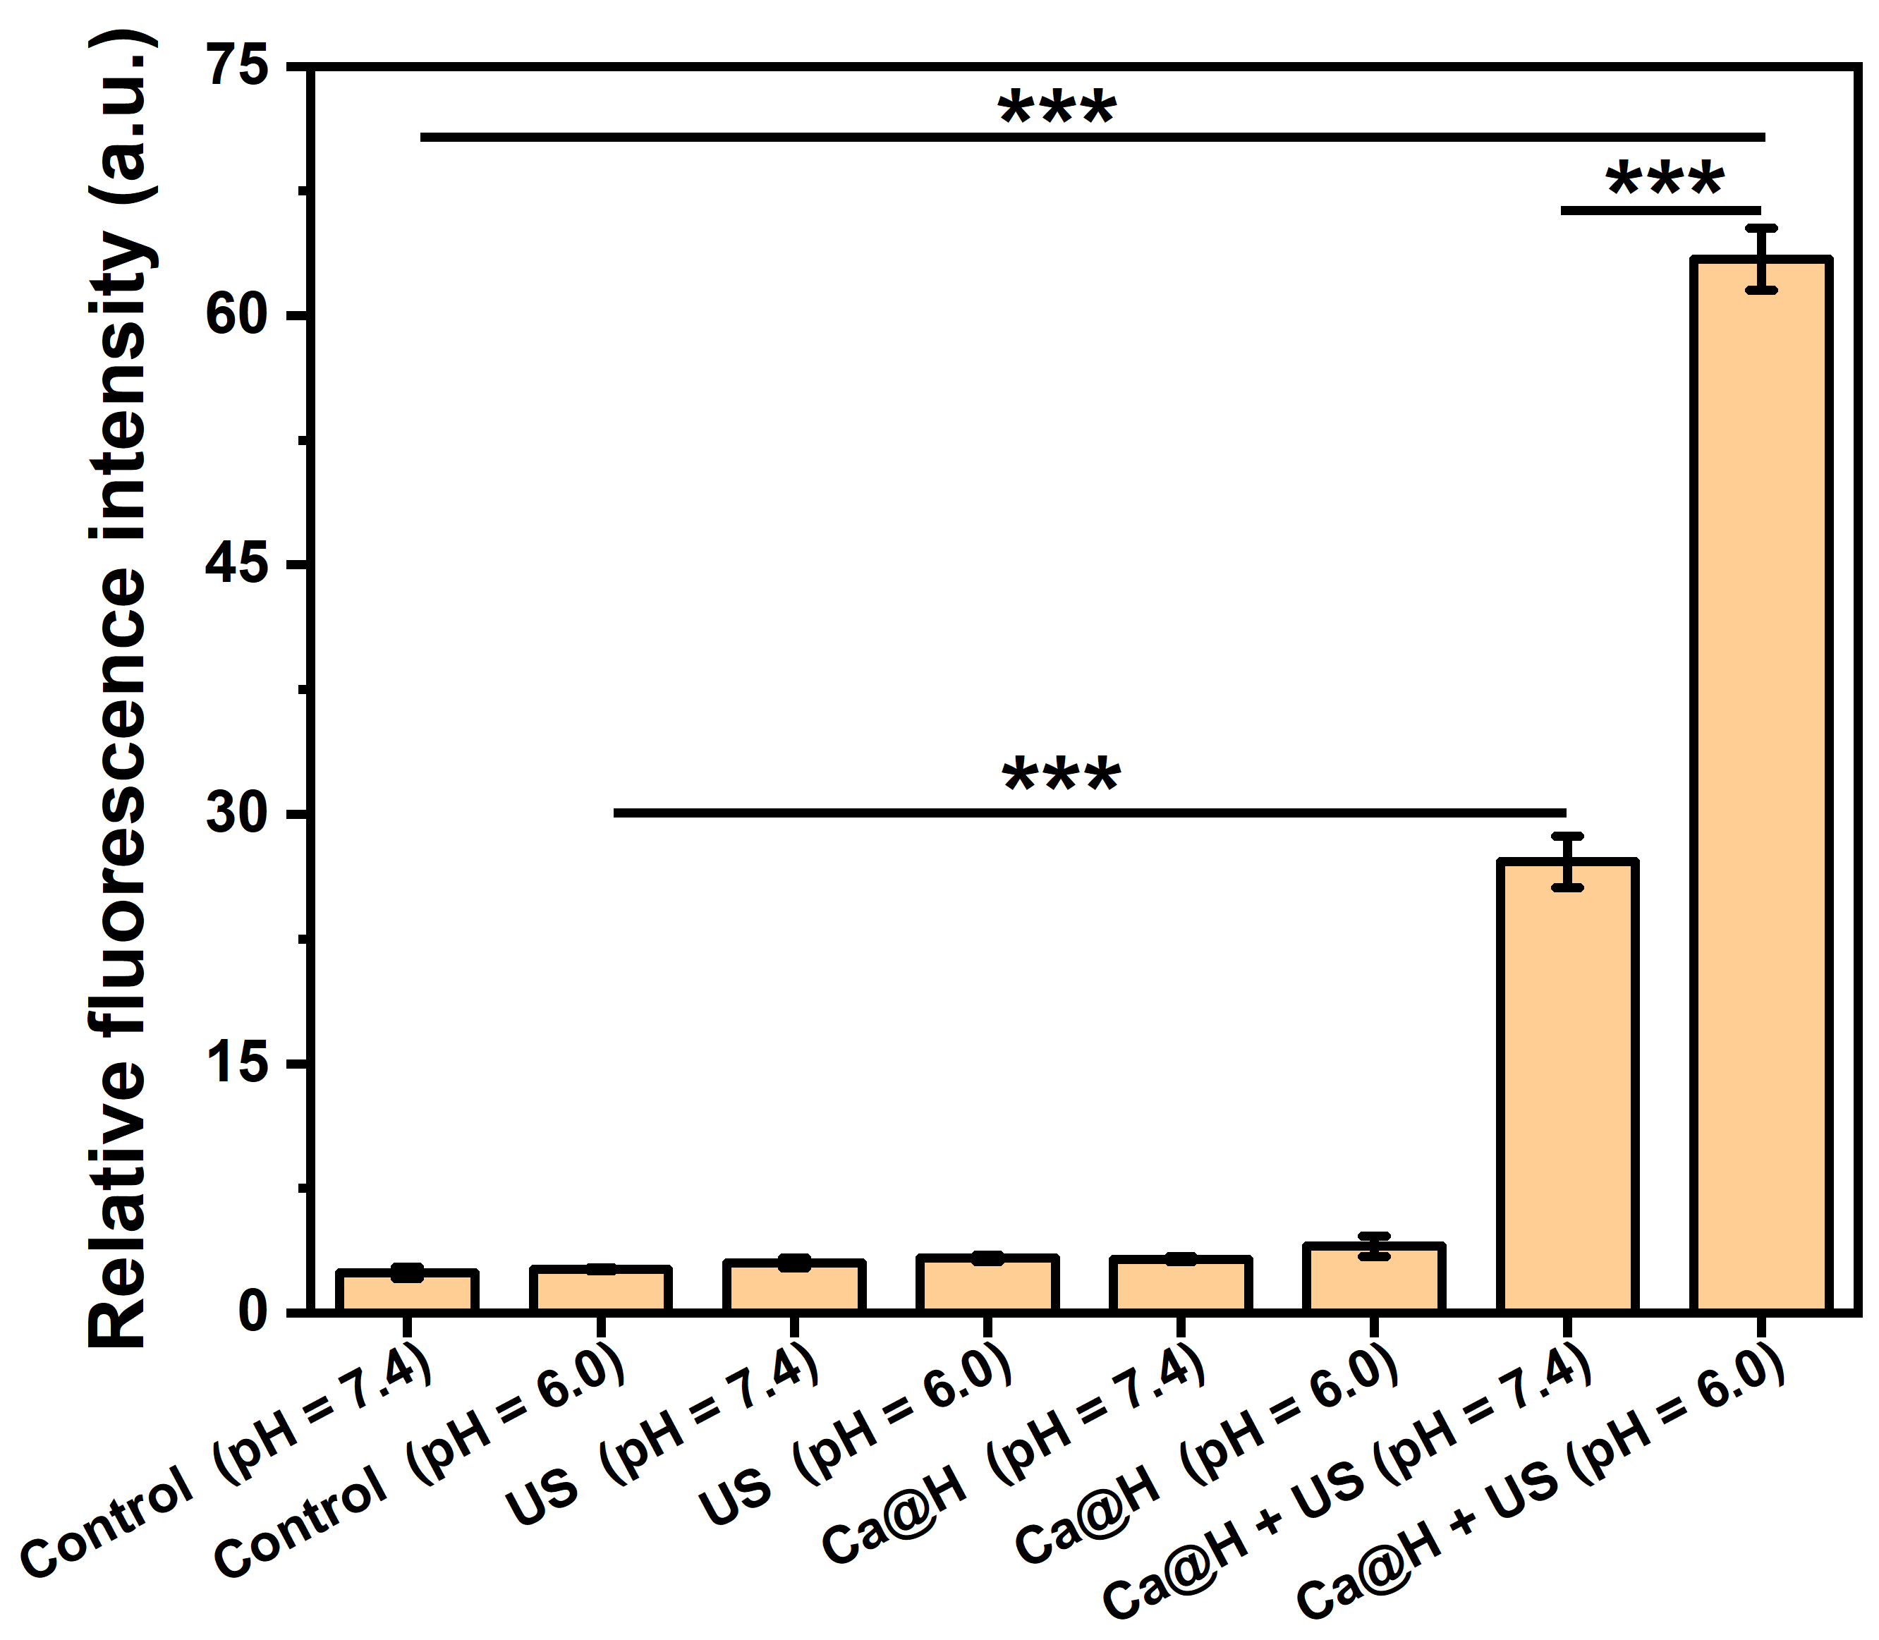
Figure S5 Relative fluorescence intensities measured by Image J for Figure 3c (n = 3, t test, ***p < 0.001).

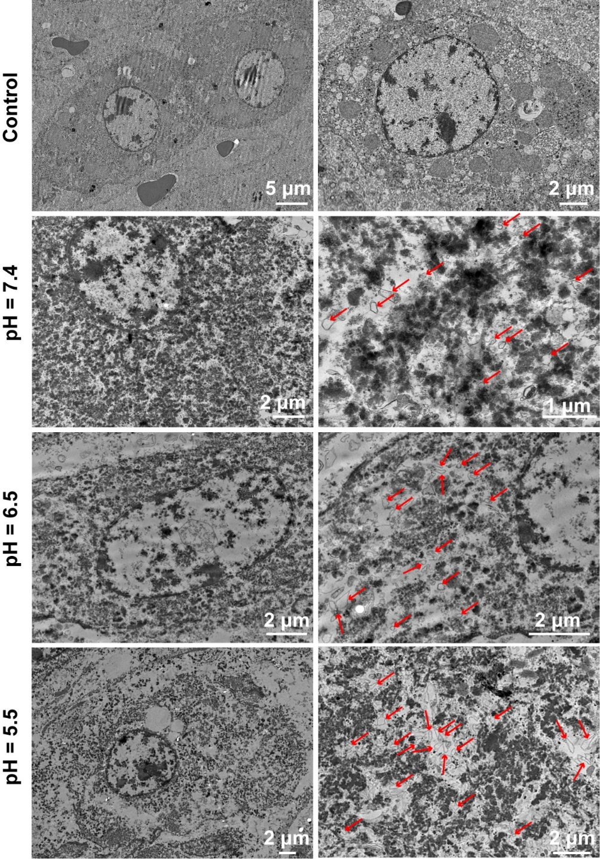
Figure S6 TEM images of bovine liver tissue after HIFU ablation (the red arrows indicate cell vacuolization).

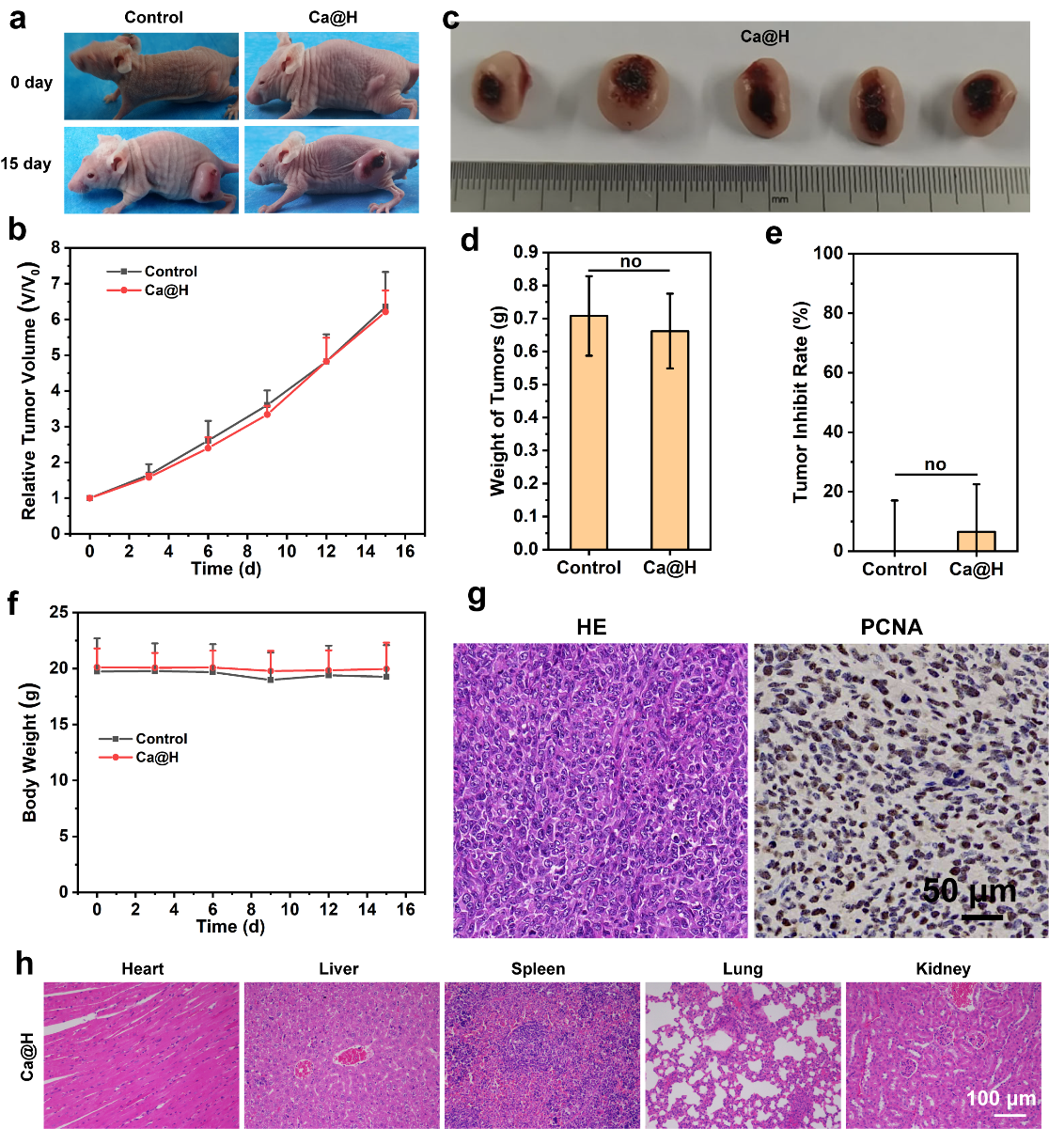
Figure S7 (a) Digital photos of 4T1 tumor bearing mice before and post Ca@H NPs treatment. (b) Tumor growth curve of 4T1 tumor-bearing mice after Ca@H NPs treatment. (c) Digital photo of tumors after Ca@H NPs treatment (n = 5). (d) Weight of tumor tissues excised from the Ca@H NPs-treated group (n = 5, t test, no: Not statistically significant). (e) Tumor inhibition rate after Ca@H NPs treatment (n = 5, t test, no: Not statistically significant). (f) Body weight of mice during the therapeutic period (n = 5). (g) H&E and PCNA stanning of tumor tissues after Ca@H NPs treatment. (h) H&E staining of major organs of mice after Ca@H NPs treatment.
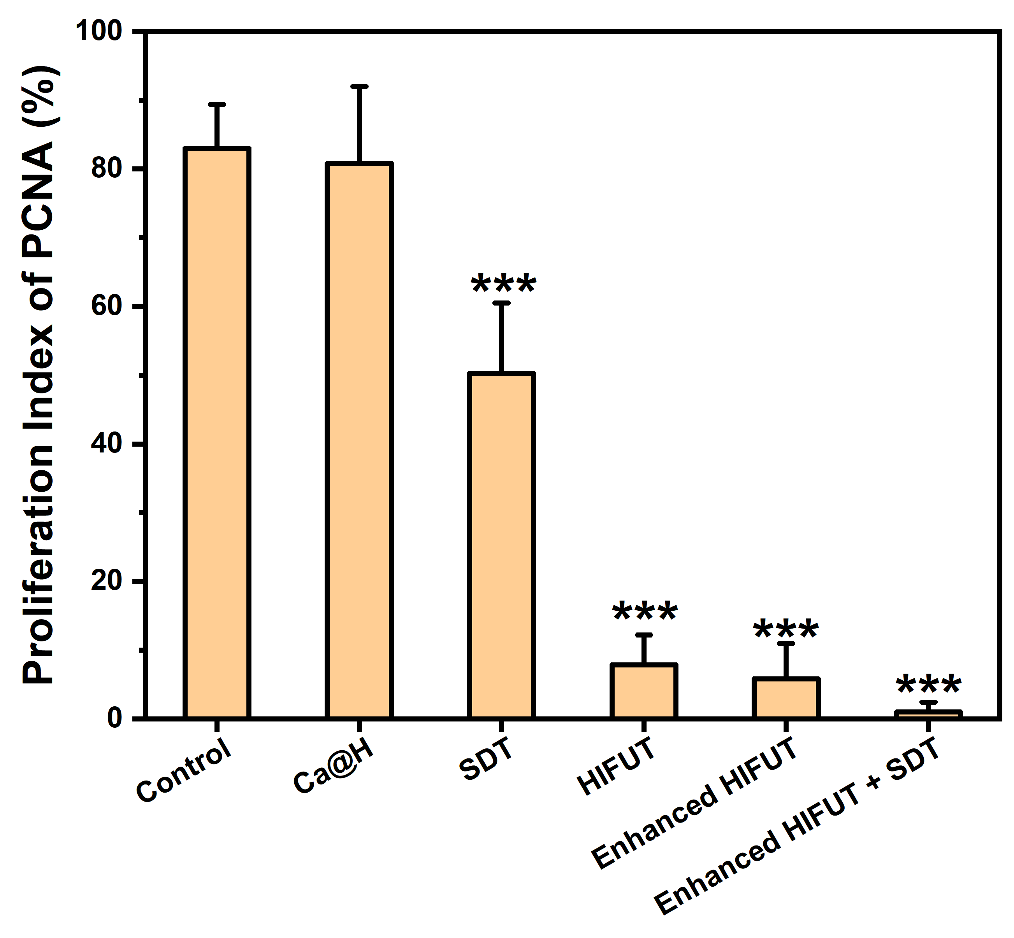
Figure S8 Proliferation index of PCNA after various treatments (n = 5, t test, ***p < 0.001).

