Supplemental Table 1. The bioinformatics tools applied to analyze the roles of TEAD family in OSC biological processes.
Databases | URL | Refs
GEPIA | http://gepia.cancer-pku.cn/ | [14]
GE-mini | http://gemini.cancer-pku.cn/ | [15]
Oncomine3.0 | https://www.oncomine.org/resource/login.html | [16]
Kaplan-Meier plotter | http://kmplot.com/analysis/ | [17]
cBioPortal | http://www.cbioportal.org/ | [18]
STRING | https://string-db.org/cgi/input.pl | [19]
WebGestalt | http://www.webgestalt.org/ | [20]
TIMER2.0 | https://cistrome.shinyapps.io/timer/ | [21]
References
14. Tang Z, Li C, Kang B, Gao G, Li C, Zhang Z. GEPIA: a web server for cancer and normal gene expression profiling and interactive analyses. Nucleic acids research. Jul 3 2017;45(W1):W98-W102.
15. Tang Z, Li C, Zhang K, Yang M, Hu X. GE-mini: a mobile APP for large-scale gene expression visualization. Bioinformatics. Mar 15 2017;33(6):941-943.
16. Rhodes DR, Yu J, Shanker K, et al. ONCOMINE: a cancer microarray database and integrated data-mining platform. Neoplasia. Jan-Feb 2004;6(1):1-6.
17. Gyorffy B, Gyorffy A, Tulassay Z. [The problem of multiple testing and solutions for genome-wide studies]. Orvosi hetilap. Mar 20 2005;146(12):559-563.
18. Cerami E, Gao J, Dogrusoz U, et al. The cBio cancer genomics portal: an open platform for exploring multidimensional cancer genomics data. Cancer discovery. May 2012;2(5):401-404.
19. Szklarczyk D, Morris JH, Cook H, et al. The STRING database in 2017: quality-controlled protein-protein association networks, made broadly accessible. Nucleic acids research. Jan 4 2017;45(D1):D362-D368.
20. Wang J, Vasaikar S, Shi Z, Greer M, Zhang B. WebGestalt 2017: a more comprehensive, powerful, flexible and interactive gene set enrichment analysis toolkit. Nucleic acids research. Jul 3 2017;45(W1):W130-W137.
21. Li T, Fu J, Zeng Z, et al. TIMER2.0 for analysis of tumor-infiltrating immune cells. Nucleic acids research. Jul 2 2020;48(W1):W509-W514.

Supplemental Table 2. TEAD family-associated coexpression genes in OSC patients.
Correlated Gene | Cytoband | Spearman's Correlation | p-Value | q-Value
NUP98 | 11p15.4 | 0.532639084 | 9.99E-15 | 1.04E-10
CELF1 | 11p11.2 | 0.530459397 | 1.34E-14 | 1.04E-10
FAR1 | 11p15.3 | 0.529284953 | 1.57E-14 | 1.04E-10
TOMM6 | 6p21.1 | -0.515390687 | 9.72E-14 | 3.83E-10
USP47 | 11p15.3 | 0.514060238 | 1.15E-13 | 3.83E-10
STRN | 2p22.2 | 0.514043062 | 1.15E-13 | 3.83E-10
TRAPPC4 | 11q23.3 | -0.497477434 | 9.04E-13 | 2.39E-09
DENND5A | 11p15.4 | 0.496987751 | 9.60E-13 | 2.39E-09
PARVA | 11p15.3 | 0.492717951 | 1.60E-12 | 3.23E-09
SBF2 | 11p15.4 | 0.492608469 | 1.62E-12 | 3.23E-09
RPL26L1 | 5q35.1 | -0.488392415 | 2.67E-12 | 4.83E-09
DCXR | 17q25.3 | -0.487186122 | 3.08E-12 | 5.10E-09
CUTA | 6p21.32 | -0.477426296 | 9.46E-12 | 1.45E-08
SSH2 | 17q11.2 | 0.475873642 | 1.13E-11 | 1.54E-08
MRPL55 | 1q42.13 | -0.475632781 | 1.16E-11 | 1.54E-08
RPP21 | 6p22.1 | -0.474440422 | 1.32E-11 | 1.65E-08
MEA1 | 6p21.1 | -0.473029099 | 1.55E-11 | 1.71E-08
KRTCAP2 | 1q22 | -0.472384151 | 1.67E-11 | 1.71E-08
TAOK1 | 17q11.2 | 0.471884514 | 1.76E-11 | 1.71E-08
CENPX | 17q25.3 | -0.471854656 | 1.77E-11 | 1.71E-08
SNRPC | 6p21.31 | -0.471687447 | 1.80E-11 | 1.71E-08
NCOA3 | 20q13.12 | 0.470704099 | 2.01E-11 | 1.78E-08
GARRE1 | 19q13.11 | 0.470495322 | 2.06E-11 | 1.78E-08
PRELID1 | 5q35.3 | -0.469722742 | 2.24E-11 | 1.86E-08
C15ORF61 | 15q23 | -0.468184021 | 2.65E-11 | 2.11E-08
RPS10 | 6p21.31 | -0.467419638 | 2.89E-11 | 2.20E-08
KIF1B | 1p36.22 | 0.467125031 | 2.98E-11 | 2.20E-08
MPC2 | 1q24.2 | -0.46503492 | 3.75E-11 | 2.66E-08
PPFIBP1 | 12p11.23-p11.22 | 0.463271264 | 4.54E-11 | 3.11E-08
SCAND1 | 20q11.23 | -0.462602428 | 4.88E-11 | 3.24E-08
MRPL2 | 6p21.1 | -0.461786289 | 5.33E-11 | 3.42E-08
RASA2 | 3q23 | 0.460932329 | 5.84E-11 | 3.63E-08
POLR1H | 6p22.1 | -0.45864515 | 7.46E-11 | 4.50E-08
DNPH1 | 6p21.1 | -0.457954418 | 8.03E-11 | 4.64E-08
RPL32 | 3p25.2 | -0.457809105 | 8.15E-11 | 4.64E-08
SMIM29 | 6p21.31 | -0.456537123 | 9.33E-11 | 5.16E-08
COA6 | 1q42.2 | -0.456057392 | 9.81E-11 | 5.26E-08
KIAA1109 | 4q27 | 0.455846391 | 1.00E-10 | 5.26E-08
SWAP70 | 11p15.4 | 0.454811288 | 1.12E-10 | 5.71E-08
MRPL14 | 6p21.1 | -0.45430568 | 1.18E-10 | 5.88E-08
LSM3 | 3p25.1 | -0.452265333 | 1.46E-10 | 7.10E-08
PRELID1P6 | 2p15 | -0.45167413 | 1.55E-10 | 7.37E-08
NOTCH2 | 1p12 | 0.450296647 | 1.79E-10 | 8.31E-08
EIF4G3 | 1p36.12 | 0.449096325 | 2.03E-10 | 9.20E-08
HIPK3 | 11p13 | 0.44856683 | 2.15E-10 | 9.24E-08
COX7A2 | 6q14.1 | -0.448562849 | 2.15E-10 | 9.24E-08
PHRF1 | 11p15.5 | 0.448415546 | 2.18E-10 | 9.24E-08
EXOSC4 | 8q24.3 | -0.447563577 | 2.38E-10 | 9.87E-08
MYCBP2 | 13q22.3 | 0.447181385 | 2.48E-10 | 1.01E-07
LUZP1 | 1p36.12 | 0.446373208 | 2.69E-10 | 1.07E-07
MYL12B | 18p11.31 | -0.444207455 | 3.36E-10 | 1.31E-07
SPEN | 1p36.21-p36.13 | 0.442849877 | 3.85E-10 | 1.47E-07
HP1BP3 | 1p36.12 | 0.440560707 | 4.85E-10 | 1.82E-07
RPUSD3 | 3p25.3 | -0.438259594 | 6.11E-10 | 2.25E-07
ERCC6L2 | 9q22.32 | 0.437540994 | 6.56E-10 | 2.38E-07
ANAPC11 | 17q25.3 | -0.436565608 | 7.23E-10 | 2.57E-07
AAK1 | 2p13.3 | 0.435904735 | 7.72E-10 | 2.66E-07
CCDC107 | 9p13.3 | -0.435878857 | 7.74E-10 | 2.66E-07
FRY | 13q13.1 | 0.435653921 | 7.92E-10 | 2.67E-07
SLK | 10q24.33-q25.1 | 0.435150304 | 8.32E-10 | 2.76E-07
ARHGAP21 | 10p12.1 | 0.434204777 | 9.13E-10 | 2.98E-07
GUK1 | 1q42.13 | -0.434039559 | 9.28E-10 | 2.98E-07
RPS18 | 6p21.32 | -0.432528707 | 1.08E-09 | 3.40E-07
SPTY2D1 | 11p15.1 | 0.431905654 | 1.14E-09 | 3.56E-07
CDKL5 | Xp22.13 | 0.43144583 | 1.20E-09 | 3.61E-07
HPS5 | 11p15.1 | 0.431435877 | 1.20E-09 | 3.61E-07
METTL5 | 2q31.1 | -0.431183073 | 1.23E-09 | 3.65E-07
MRPS18A | 6p21.1 | -0.430872542 | 1.27E-09 | 3.70E-07
POLR1C | 6p21.1 | -0.430739173 | 1.28E-09 | 3.70E-07
TIMM8B | 11q23.1 | -0.430380868 | 1.33E-09 | 3.78E-07
BOLA1 | 1q21.2 | -0.428903856 | 1.53E-09 | 4.30E-07
EYA3 | 1p35.3 | 0.428105632 | 1.66E-09 | 4.52E-07
MIDEAS | 14q24.3 | 0.428095679 | 1.66E-09 | 4.52E-07
RPL14 | 3p22.1 | -0.427349211 | 1.78E-09 | 4.79E-07
SCN8A | 12q13.13 | 0.427118303 | 1.82E-09 | 4.83E-07
BTBD10 | 11p15.3 | 0.426998868 | 1.84E-09 | 4.83E-07
C16ORF91 | 16p13.3 | -0.426825688 | 1.87E-09 | 4.84E-07
PLEKHA7 | 11p15 | 0.426212588 | 1.99E-09 | 5.07E-07
DUSP23 | 1q23.2 | -0.424890841 | 2.25E-09 | 5.58E-07
NAXE | 1q22 | -0.424878898 | 2.26E-09 | 5.58E-07
MED1 | 17q12 | 0.424811218 | 2.27E-09 | 5.58E-07
GLRX2 | 1q31.2 | -0.424243902 | 2.40E-09 | 5.82E-07
CTR9 | 11p15.4 | 0.42399906 | 2.45E-09 | 5.89E-07
USP48 | 1p36.12 | 0.423803983 | 2.50E-09 | 5.90E-07
MARCHF8 | 10q11.21-q11.22 | 0.423734313 | 2.52E-09 | 5.90E-07
IMP3 | 15q24.2 | -0.423545208 | 2.56E-09 | 5.93E-07
MRPS23 | 17q22 | -0.423115242 | 2.67E-09 | 6.11E-07
MICAL2 | 11p15.3 | 0.421534719 | 3.10E-09 | 7.02E-07
SBNO1 | 12q24.31 | 0.421335661 | 3.16E-09 | 7.07E-07
CZIB | 1p32.3 | -0.420587202 | 3.39E-09 | 7.50E-07
CASS4 | 20q13.31 | 0.420292596 | 3.49E-09 | 7.57E-07
NDUFA2 | 5q31.3 | -0.420266718 | 3.50E-09 | 7.57E-07
DNAJC13 | 3q22.1 | 0.420095528 | 3.55E-09 | 7.61E-07
DIP2B | 12q13.12 | 0.419480438 | 3.76E-09 | 7.97E-07
C6ORF226 | 6p21.1 | -0.419295314 | 3.83E-09 | 8.03E-07
CLCN6 | 1p36.22 | 0.419024595 | 3.93E-09 | 8.15E-07
SVIL | 10p11.23 | 0.418642403 | 4.07E-09 | 8.36E-07
NDUFB1 | 14q31.3 | -0.41818855 | 4.25E-09 | 8.61E-07
MICALCL | 11p15.3 | 0.418104946 | 4.28E-09 | 8.61E-07
TMCO1 | 1q24.1 | -0.417975558 | 4.33E-09 | 8.63E-07
MED13L | 12q24.21 | 0.417579432 | 4.50E-09 | 8.86E-07
SOGA1 | 20q11.23 | 0.417414213 | 4.57E-09 | 8.91E-07
REL | 2p16.1 | 0.417296769 | 4.62E-09 | 8.92E-07
TTBK2 | 15q15.2 | 0.417171362 | 4.67E-09 | 8.94E-07
ROCK2 | 2p25.1 | 0.416852869 | 4.81E-09 | 9.12E-07
CSNK2B | 6p21.33 | -0.416106401 | 5.16E-09 | 9.69E-07
OXLD1 | 17q25.3 | -0.41565852 | 5.38E-09 | 9.95E-07
TRIM44 | 11p13 | 0.415612736 | 5.40E-09 | 9.95E-07
EPG5 | 18q12.3-q21.1 | 0.414695078 | 5.88E-09 | 1.07367E-06
NDUFB10 | 16p13.3 | -0.413741589 | 6.42E-09 | 1.16176E-06
NTPCR | 1q42.2 | -0.413600257 | 6.50E-09 | 1.16638E-06
ABHD14A | 3p21.2 | -0.413174273 | 6.76E-09 | 1.20218E-06
MAD2L1BP | 6p21.1 | -0.412885638 | 6.94E-09 | 1.22358E-06
DDI2 | 1p36.21 | 0.412706486 | 7.06E-09 | 1.23296E-06
ZNF507 | 19q13.11 | 0.412401926 | 7.26E-09 | 1.25689E-06
HSPE1 | 2q33.1 | -0.412204859 | 7.39E-09 | 1.26668E-06
NUFIP2 | 17q11.2 | 0.412129217 | 7.44E-09 | 1.26668E-06
CNIH4 | 1q42.11 | -0.412029688 | 7.51E-09 | 1.26746E-06
JTB | 1q21.3 | -0.411794799 | 7.67E-09 | 1.28413E-06
BRK1 | 3p25.3 | -0.411092123 | 8.18E-09 | 1.3501E-06
PER3 | 1p36.23 | 0.41090899 | 8.32E-09 | 1.3501E-06
RPS29 | 14q21.3 | -0.410895055 | 8.33E-09 | 1.3501E-06
WDR61 | 15q25.1 | -0.410885103 | 8.34E-09 | 1.3501E-06
PIK3C2A | 11p15.1 | 0.410361579 | 8.75E-09 | 1.4047E-06
TGFBRAP1 | 2q12.1-q12.2 | 0.410220248 | 8.86E-09 | 1.41152E-06
MTX1 | 1q22 | -0.409979388 | 9.06E-09 | 1.43137E-06
MAP3K2 | 2q14.3 | 0.409790282 | 9.22E-09 | 1.44474E-06
HYPK | 15q15.3 | -0.409025898 | 9.88E-09 | 1.52984E-06
BYSL | 6p21.1 | -0.408988077 | 9.91E-09 | 1.52984E-06
TRAPPC2L | 16q24.3 | -0.408639725 | 1.02E-08 | 1.56678E-06
EIF4G2 | 11p15.4 | 0.408424743 | 1.04E-08 | 1.57707E-06
ITSN1 | 21q22.11 | 0.408398865 | 1.05E-08 | 1.57707E-06
NDUFAF3 | 3p21.31 | -0.408022645 | 1.08E-08 | 1.61941E-06
TRIM66 | 11p15.4 | 0.407102996 | 1.18E-08 | 1.74648E-06
BAZ2A | 12q13.3 | 0.406609331 | 1.23E-08 | 1.80582E-06
NDUFB6 | 9p21.1 | -0.406567529 | 1.23E-08 | 1.80582E-06
NPRL2 | 3p21.31 | -0.406404301 | 1.25E-08 | 1.81916E-06
LATS1 | 6q25.1 | 0.406020119 | 1.30E-08 | 1.86943E-06
MAIP1 | 2q33.1 | -0.405309481 | 1.38E-08 | 1.97074E-06
SEC13 | 3p25.3 | -0.40520398 | 1.39E-08 | 1.97074E-06
TNS1 | 2q35 | 0.405192036 | 1.40E-08 | 1.97074E-06
INCENP | 11q12.3 | 0.405104451 | 1.41E-08 | 1.97228E-06
SH3PXD2A | 10q24.33 | 0.404953167 | 1.43E-08 | 1.9848E-06
SNRPE | 1q32.1 | -0.404877524 | 1.44E-08 | 1.9848E-06
SPCS1 | 3p21.1 | -0.402785422 | 1.73E-08 | 2.34836E-06
RPP25L | 9p13.3 | -0.402747601 | 1.74E-08 | 2.34836E-06
OR52W1 | 11p15.4 | 0.402686901 | 1.75E-08 | 2.34836E-06
NDUFAF8 | 17q25.3 | -0.402683902 | 1.75E-08 | 2.34836E-06
NHP2 | 5q35.3 | -0.40250475 | 1.77E-08 | 2.37002E-06
USP12 | 13q12.13 | 0.402188247 | 1.82E-08 | 2.42128E-06
C1ORF53 | 1q31.3 | -0.401575148 | 1.93E-08 | 2.53754E-06
NDUFAF4 | 6q16.1 | -0.401509459 | 1.94E-08 | 2.53754E-06
C1ORF35 | 1q42.13 | -0.401276561 | 1.98E-08 | 2.57343E-06
CMC1 | 3p24.1 | -0.400916265 | 2.04E-08 | 2.63945E-06
STARD10 | 11q13.4 | -0.400675405 | 2.09E-08 | 2.67878E-06
ELOB | 16p13.3 | -0.40055796 | 2.11E-08 | 2.68934E-06
JAGN1 | 3p25.3 | -0.400225533 | 2.17E-08 | 2.7517E-06
OCIAD2 | 4p11 | -0.400036428 | 2.21E-08 | 2.78022E-06
ZNF688 | 16p11.2 | -0.399067014 | 2.40E-08 | 3.00857E-06
TOMM5 | 9p13.2 | -0.398607189 | 2.50E-08 | 3.11283E-06
DCTN3 | 9p13.3 | -0.398119497 | 2.61E-08 | 3.22744E-06
BMP2K | 4q21.21 | 0.397990109 | 2.64E-08 | 3.22744E-06
DPM3 | 1q22 | -0.397982146 | 2.64E-08 | 3.22744E-06
NDUFAB1 | 16p12.2 | -0.397607917 | 2.73E-08 | 3.31445E-06
TOPBP1 | 3q22.1 | 0.397428765 | 2.77E-08 | 3.34631E-06
P2RX7 | 12q24.31 | 0.39700477 | 2.88E-08 | 3.45152E-06
PTPRJ | 11p11.2 | 0.396726089 | 2.95E-08 | 3.5152E-06
RPL24 | 3q12.3 | -0.396570823 | 2.99E-08 | 3.54185E-06
MYO5A | 15q21.2 | 0.396451388 | 3.02E-08 | 3.55088E-06
COA4 | 11q13.4 | -0.396405605 | 3.03E-08 | 3.55088E-06
MRPL36 | 5p15.33 | -0.395955733 | 3.15E-08 | 3.67095E-06
DPY19L3 | 19q13.11 | 0.395846251 | 3.18E-08 | 3.68449E-06
UQCC2 | 6p21.31 | -0.395442163 | 3.30E-08 | 3.79396E-06
PCNX1 | 14q24.2 | 0.395326709 | 3.33E-08 | 3.81012E-06
KMT2D | 12q13.12 | 0.395071915 | 3.40E-08 | 3.86357E-06
TSTD1 | 1q23.3 | -0.395034094 | 3.42E-08 | 3.86357E-06
FAU | 11q13.1 | -0.39474944 | 3.50E-08 | 3.92797E-06
SLC38A1 | 12q13.11 | 0.394695695 | 3.52E-08 | 3.92797E-06
HINT2 | 9p13.3 | -0.394647921 | 3.53E-08 | 3.92797E-06
RPL35 | 9q33.3 | -0.394361277 | 3.62E-08 | 4.00419E-06
CCDC85B | 11q13.1 | -0.393909415 | 3.76E-08 | 4.14055E-06
SMIM26 | 20p11.23 | -0.393561063 | 3.88E-08 | 4.24341E-06
POP7 | 7q22.1 | -0.393266456 | 3.98E-08 | 4.32872E-06
NDUFS8 | 11q13.2 | -0.393087304 | 4.04E-08 | 4.37212E-06
MRPS34 | 16p13.3 | -0.392967869 | 4.08E-08 | 4.39341E-06
REST | 4q12 | 0.392728999 | 4.17E-08 | 4.46049E-06
RPS27A | 2p16.1 | -0.392533922 | 4.24E-08 | 4.51164E-06
METTL23 | 17q25.2 | -0.392392591 | 4.29E-08 | 4.54245E-06
CHCHD2 | 7p11.2 | -0.391240043 | 4.73E-08 | 4.98756E-06
FER | 5q21.3 | 0.390971315 | 4.84E-08 | 5.07664E-06
ARID1A | 1p36.11 | 0.390835955 | 4.90E-08 | 5.10881E-06
ASXL1 | 20q11.21 | 0.390601066 | 5.00E-08 | 5.18517E-06
MRPL24 | 1q23.1 | -0.389552029 | 5.47E-08 | 5.60745E-06
FKBPL | 6p21.32 | -0.389532124 | 5.48E-08 | 5.60745E-06
PTRH2 | 17q23.1 | -0.389500274 | 5.49E-08 | 5.60745E-06
LMTK2 | 7q21.3 | 0.389114101 | 5.67E-08 | 5.765E-06
APRT | 16q24.3 | -0.388851344 | 5.80E-08 | 5.84736E-06
KMT2B | 19q13.12 | 0.388827457 | 5.81E-08 | 5.84736E-06
C11ORF1 | 11q23.1 | -0.387864015 | 6.31E-08 | 6.31282E-06
EMC4 | 15q14 | -0.387459927 | 6.53E-08 | 6.44601E-06

Supplemental Table 3. The raw data of RT-PCR in figure 1D.
Sample | Internal control | Cq | Target gene 1 | Cq | Target gene 2 | Cq | Target gene 3 | Cq | Target gene 4 | Cq
IOSE80 | 18S | 10.22 | TEAD1 | 23.18 | TEAD2 | 28.58 | TEAD3 | 25.80 | TEAD4 | 23.54
IOSE80 | 18S | 10.16 | TEAD1 | 23.28 | TEAD2 | 28.65 | TEAD3 | 25.74 | TEAD4 | 23.22
IOSE80 | 18S | 9.90 | TEAD1 | 23.43 | TEAD2 | 28.20 | TEAD3 | 25.54 | TEAD4 | 23.13
A2780 | 18S | 11.04 | TEAD1 | 22.98 | TEAD2 | 25.14 | TEAD3 | 26.32 | TEAD4 | 22.64
A2780 | 18S | 11.04 | TEAD1 | 23.10 | TEAD2 | 24.93 | TEAD3 | 26.79 | TEAD4 | 22.53
A2780 | 18S | 11.36 | TEAD1 | 23.13 | TEAD2 | 25.23 | TEAD3 | 26.92 | TEAD4 | 23.03
TOV112D | 18S | 12.81 | TEAD1 | 24.37 | TEAD2 | 26.18 | TEAD3 | 27.29 | TEAD4 | 24.21
TOV112D | 18S | 12.60 | TEAD1 | 24.23 | TEAD2 | 26.28 | TEAD3 | 27.54 | TEAD4 | 24.05
TOV112D | 18S | 12.49 | TEAD1 | 23.98 | TEAD2 | 26.16 | TEAD3 | 27.30 | TEAD4 | 23.99

Supplemental Table 4. The raw data of RT-PCR in figure 1E.
Sample | Internal control | Cq | Target gene 1 | Cq | Target gene 2 | Cq | Target gene 3 | Cq | Target gene 4 | Cq
N1 | 18S | 12.60 | TEAD1 | 29.80 | TEAD2 | 28.76 | TEAD3 | 29.43 | TEAD4 | 29.01
N1 | 18S | 12.72 | TEAD1 | 29.69 | TEAD2 | 28.53 | TEAD3 | 28.62 | TEAD4 | 28.43
N1 | 18S | 12.59 | TEAD1 | 30.18 | TEAD2 | 28.48 | TEAD3 | 27.54 | TEAD4 | 29.45
N2 | 18S | 10.13 | TEAD1 | 27.43 | TEAD2 | 27.83 | TEAD3 | 27.93 | TEAD4 | 27.59
N2 | 18S | 9.89 | TEAD1 | 28.89 | TEAD2 | 29.48 | TEAD3 | 26.90 | TEAD4 | 26.94
N2 | 18S | 10.34 | TEAD1 | 29.95 | TEAD2 | 28.78 | TEAD3 | 28.95 | TEAD4 | 27.95
N3 | 18S | 11.12 | TEAD1 | 28.33 | TEAD2 | 27.11 | TEAD3 | 27.53 | TEAD4 | 27.93
N3 | 18S | 11.27 | TEAD1 | 27.73 | TEAD2 | 28.46 | TEAD3 | 29.03 | TEAD4 | 28.35
N3 | 18S | 10.96 | TEAD1 | 28.31 | TEAD2 | 28.66 | TEAD3 | 28.48 | TEAD4 | 28.18
N4 | 18S | 10.17 | TEAD1 | 28.13 | TEAD2 | 29.26 | TEAD3 | 29.02 | TEAD4 | 28.69
N4 | 18S | 9.57 | TEAD1 | 29.04 | TEAD2 | 28.97 | TEAD3 | 29.47 | TEAD4 | 29.13
N4 | 18S | 10.06 | TEAD1 | 29.79 | TEAD2 | 29.57 | TEAD3 | 29.34 | TEAD4 | 28.48
N5 | 18S | 11.21 | TEAD1 | 26.59 | TEAD2 | 26.12 | TEAD3 | 28.63 | TEAD4 | 26.98
N5 | 18S | 11.07 | TEAD1 | 26.36 | TEAD2 | 26.55 | TEAD3 | 27.43 | TEAD4 | 26.77
N5 | 18S | 10.85 | TEAD1 | 27.16 | TEAD2 | 25.16 | TEAD3 | 27.58 | TEAD4 | 27.03
N6 | 18S | 11.15 | TEAD1 | 26.87 | TEAD2 | 27.52 | TEAD3 | 25.66 | TEAD4 | 28.46
N6 | 18S | 10.73 | TEAD1 | 27.90 | TEAD2 | 27.77 | TEAD3 | 25.99 | TEAD4 | 27.58
N6 | 18S | 10.56 | TEAD1 | 28.65 | TEAD2 | 28.04 | TEAD3 | 25.41 | TEAD4 | 26.99
N7 | 18S | 10.55 | TEAD1 | 25.38 | TEAD2 | 24.87 | TEAD3 | 25.09 | TEAD4 | 25.56
N7 | 18S | 10.25 | TEAD1 | 24.98 | TEAD2 | 24.66 | TEAD3 | 25.23 | TEAD4 | 25.15
N7 | 18S | 9.88 | TEAD1 | 24.82 | TEAD2 | 25.43 | TEAD3 | 25.34 | TEAD4 | 24.88
N8 | 18S | 10.33 | TEAD1 | 26.41 | TEAD2 | 26.79 | TEAD3 | 26.85 | TEAD4 | 27.30
N8 | 18S | 9.95 | TEAD1 | 26.26 | TEAD2 | 26.65 | TEAD3 | 27.18 | TEAD4 | 26.94
N8 | 18S | 9.80 | TEAD1 | 27.80 | TEAD2 | 26.95 | TEAD3 | 27.23 | TEAD4 | 27.05
T1 | 18S | 10.15 | TEAD1 | 24.62 | TEAD2 | 23.23 | TEAD3 | 23.47 | TEAD4 | 23.52
T1 | 18S | 10.27 | TEAD1 | 24.13 | TEAD2 | 23.87 | TEAD3 | 24.11 | TEAD4 | 24.26
T1 | 18S | 10.18 | TEAD1 | 24.52 | TEAD2 | 24.01 | TEAD3 | 23.68 | TEAD4 | 24.89
T2 | 18S | 10.53 | TEAD1 | 24.16 | TEAD2 | 24.23 | TEAD3 | 24.36 | TEAD4 | 23.59
T2 | 18S | 10.21 | TEAD1 | 25.38 | TEAD2 | 24.77 | TEAD3 | 25.69 | TEAD4 | 24.36
T2 | 18S | 10.07 | TEAD1 | 24.02 | TEAD2 | 24.56 | TEAD3 | 24.03 | TEAD4 | 24.66
T3 | 18S | 11.13 | TEAD1 | 24.14 | TEAD2 | 24.53 | TEAD3 | 26.74 | TEAD4 | 26.24
T3 | 18S | 11.02 | TEAD1 | 25.06 | TEAD2 | 24.28 | TEAD3 | 25.36 | TEAD4 | 27.96
T3 | 18S | 10.76 | TEAD1 | 26.43 | TEAD2 | 25.05 | TEAD3 | 26.49 | TEAD4 | 26.89
T4 | 18S | 9.87 | TEAD1 | 26.44 | TEAD2 | 25.36 | TEAD3 | 24.68 | TEAD4 | 25.77
T4 | 18S | 10.14 | TEAD1 | 27.12 | TEAD2 | 24.69 | TEAD3 | 23.55 | TEAD4 | 26.43
T4 | 18S | 10.03 | TEAD1 | 27.34 | TEAD2 | 25.95 | TEAD3 | 24.98 | TEAD4 | 26.33
T5 | 18S | 10.01 | TEAD1 | 25.68 | TEAD2 | 26.77 | TEAD3 | 25.25 | TEAD4 | 24.32
T5 | 18S | 9.97 | TEAD1 | 24.55 | TEAD2 | 25.83 | TEAD3 | 25.37 | TEAD4 | 25.69
T5 | 18S | 10.31 | TEAD1 | 25.31 | TEAD2 | 25.91 | TEAD3 | 24.96 | TEAD4 | 24.82
T6 | 18S | 11.33 | TEAD1 | 27.55 | TEAD2 | 28.03 | TEAD3 | 26.75 | TEAD4 | 25.64
T6 | 18S | 11.69 | TEAD1 | 26.21 | TEAD2 | 27.44 | TEAD3 | 27.11 | TEAD4 | 26.32
T6 | 18S | 11.29 | TEAD1 | 26.60 | TEAD2 | 27.80 | TEAD3 | 27.28 | TEAD4 | 25.80
T7 | 18S | 10.25 | TEAD1 | 24.66 | TEAD2 | 23.81 | TEAD3 | 26.35 | TEAD4 | 25.47
T7 | 18S | 10.88 | TEAD1 | 25.09 | TEAD2 | 24.55 | TEAD3 | 25.23 | TEAD4 | 25.65
T7 | 18S | 10.53 | TEAD1 | 24.80 | TEAD2 | 24.66 | TEAD3 | 25.79 | TEAD4 | 26.24
T8 | 18S | 11.22 | TEAD1 | 25.38 | TEAD2 | 24.76 | TEAD3 | 25.44 | TEAD4 | 26.34
T8 | 18S | 10.93 | TEAD1 | 25.86 | TEAD2 | 25.19 | TEAD3 | 25.28 | TEAD4 | 26.18
T8 | 18S | 11.06 | TEAD1 | 26.22 | TEAD2 | 24.43 | TEAD3 | 24.96 | TEAD4 | 24.88
T9 | 18S | 10.42 | TEAD1 | 28.01 | TEAD2 | 26.52 | TEAD3 | 27.12 | TEAD4 | 26.82
T9 | 18S | 10.71 | TEAD1 | 27.85 | TEAD2 | 25.25 | TEAD3 | 27.37 | TEAD4 | 27.21
T9 | 18S | 10.15 | TEAD1 | 27.56 | TEAD2 | 25.39 | TEAD3 | 26.42 | TEAD4 | 27.04
T10 | 18S | 10.73 | TEAD1 | 26.42 | TEAD2 | 25.12 | TEAD3 | 23.46 | TEAD4 | 25.21
T10 | 18S | 10.23 | TEAD1 | 27.37 | TEAD2 | 24.29 | TEAD3 | 24.25 | TEAD4 | 24.84
T10 | 18S | 10.54 | TEAD1 | 27.58 | TEAD2 | 25.47 | TEAD3 | 24.64 | TEAD4 | 24.52
T11 | 18S | 10.00 | TEAD1 | 24.53 | TEAD2 | 23.31 | TEAD3 | 23.57 | TEAD4 | 24.33
T11 | 18S | 10.04 | TEAD1 | 24.60 | TEAD2 | 24.23 | TEAD3 | 23.79 | TEAD4 | 25.03
T11 | 18S | 9.96 | TEAD1 | 24.46 | TEAD2 | 23.58 | TEAD3 | 24.22 | TEAD4 | 24.59
T12 | 18S | 10.17 | TEAD1 | 23.72 | TEAD2 | 22.53 | TEAD3 | 21.42 | TEAD4 | 22.35
T12 | 18S | 10.20 | TEAD1 | 23.66 | TEAD2 | 22.79 | TEAD3 | 22.15 | TEAD4 | 22.52
T12 | 18S | 10.10 | TEAD1 | 24.01 | TEAD2 | 23.03 | TEAD3 | 21.68 | TEAD4 | 22.69
T13 | 18S | 11.32 | TEAD1 | 23.60 | TEAD2 | 21.36 | TEAD3 | 22.16 | TEAD4 | 22.44
T13 | 18S | 11.41 | TEAD1 | 23.46 | TEAD2 | 22.13 | TEAD3 | 22.35 | TEAD4 | 21.80
T13 | 18S | 11.56 | TEAD1 | 23.15 | TEAD2 | 21.58 | TEAD3 | 22.57 | TEAD4 | 22.21
T14 | 18S | 9.99 | TEAD1 | 25.77 | TEAD2 | 23.56 | TEAD3 | 25.41 | TEAD4 | 24.52
T14 | 18S | 10.13 | TEAD1 | 25.37 | TEAD2 | 24.04 | TEAD3 | 24.88 | TEAD4 | 24.39
T14 | 18S | 10.18 | TEAD1 | 25.27 | TEAD2 | 23.80 | TEAD3 | 24.94 | TEAD4 | 24.03
T15 | 18S | 11.24 | TEAD1 | 22.52 | TEAD2 | 21.26 | TEAD3 | 22.34 | TEAD4 | 23.03
T15 | 18S | 10.93 | TEAD1 | 22.31 | TEAD2 | 22.17 | TEAD3 | 22.48 | TEAD4 | 22.78
T15 | 18S | 11.14 | TEAD1 | 22.20 | TEAD2 | 21.65 | TEAD3 | 22.63 | TEAD4 | 22.84
T16 | 18S | 11.73 | TEAD1 | 23.63 | TEAD2 | 21.35 | TEAD3 | 20.80 | TEAD4 | 23.97
T16 | 18S | 11.78 | TEAD1 | 23.35 | TEAD2 | 21.52 | TEAD3 | 21.26 | TEAD4 | 24.63
T16 | 18S | 11.66 | TEAD1 | 22.94 | TEAD2 | 21.67 | TEAD3 | 21.38 | TEAD4 | 24.55
T17 | 18S | 11.60 | TEAD1 | 22.05 | TEAD2 | 23.46 | TEAD3 | 24.66 | TEAD4 | 26.32
T17 | 18S | 11.85 | TEAD1 | 22.02 | TEAD2 | 23.04 | TEAD3 | 23.80 | TEAD4 | 25.47
T17 | 18S | 11.87 | TEAD1 | 21.74 | TEAD2 | 22.83 | TEAD3 | 24.26 | TEAD4 | 25.84
T18 | 18S | 11.86 | TEAD1 | 26.25 | TEAD2 | 27.09 | TEAD3 | 25.33 | TEAD4 | 24.68
T18 | 18S | 11.68 | TEAD1 | 26.04 | TEAD2 | 26.64 | TEAD3 | 26.05 | TEAD4 | 24.99
T18 | 18S | 11.72 | TEAD1 | 26.37 | TEAD2 | 26.83 | TEAD3 | 25.64 | TEAD4 | 25.14
T19 | 18S | 11.89 | TEAD1 | 23.15 | TEAD2 | 22.37 | TEAD3 | 23.59 | TEAD4 | 24.12
T19 | 18S | 11.46 | TEAD1 | 23.37 | TEAD2 | 22.15 | TEAD3 | 24.05 | TEAD4 | 24.53
T19 | 18S | 11.22 | TEAD1 | 23.42 | TEAD2 | 21.53 | TEAD3 | 23.80 | TEAD4 | 24.69
T20 | 18S | 9.35 | TEAD1 | 23.47 | TEAD2 | 22.32 | TEAD3 | 24.01 | TEAD4 | 24.43
T20 | 18S | 9.49 | TEAD1 | 23.50 | TEAD2 | 22.58 | TEAD3 | 23.23 | TEAD4 | 23.77
T20 | 18S | 10.16 | TEAD1 | 23.27 | TEAD2 | 22.65 | TEAD3 | 23.74 | TEAD4 | 23.49
N represented “Normal ovary”, T represented “OSC”.

Supplemental Figure 1. The protein levels of TEAD2 in normal ovary cell line IOSE80 and OSC cell lines A2780, TOV112D, SKOV-3 and OVCAR3.
TEAD2:
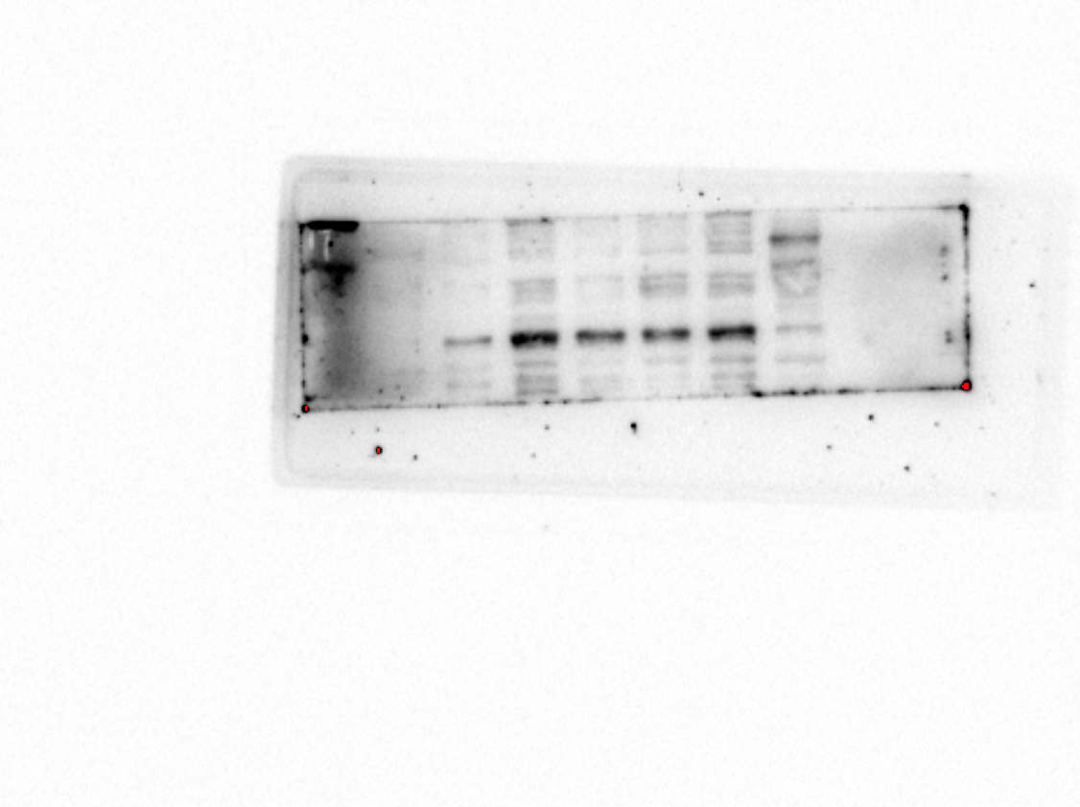
Actin:
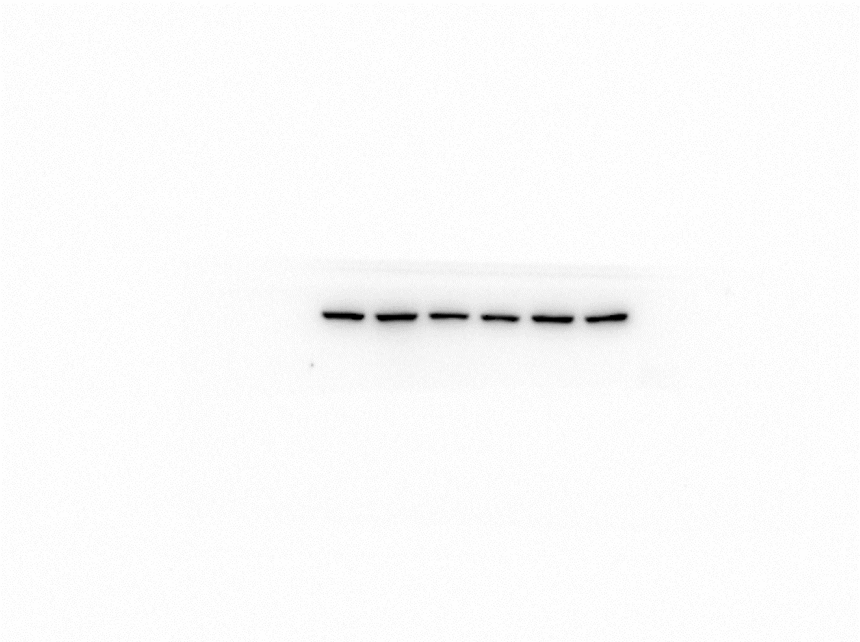

Supplemental Figure 2. Knockout of TEAD2 in A2780 cells was confirmed by Western blot.
siTEAD2:
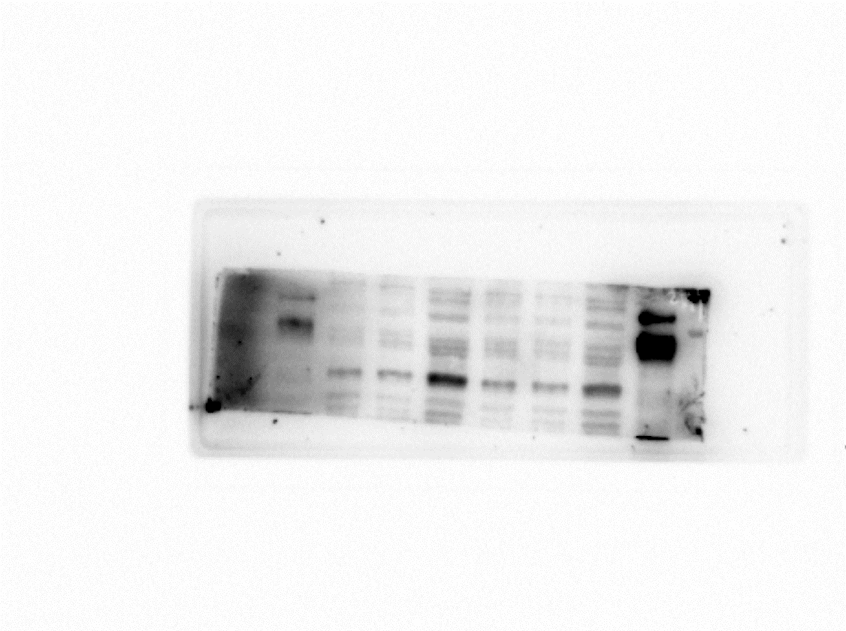
Actin:
