Supporting Information
Antibacterial, Docking, DFT and ADMET properties Evaluation of some hybrid Chalcone-Sulfonamide derivatives prepared using ZnO Nanoparticle Catalysis
Abdanne Weyessa¹, Rajalakshmanan Eswaramoorthy^{1*}, Yadessa Melaku^{1*} and Endale Mulugeta^{1*}
¹Department of Applied Chemistry, School of Applied Natural Science, Adama Science and Technology University, P.O.Box 1888, Adama, Ethiopia
*Email: rajalakshmanan.e@gmail.com, yadessamelaku2010@gmail.com and endexindex05@gmail.com
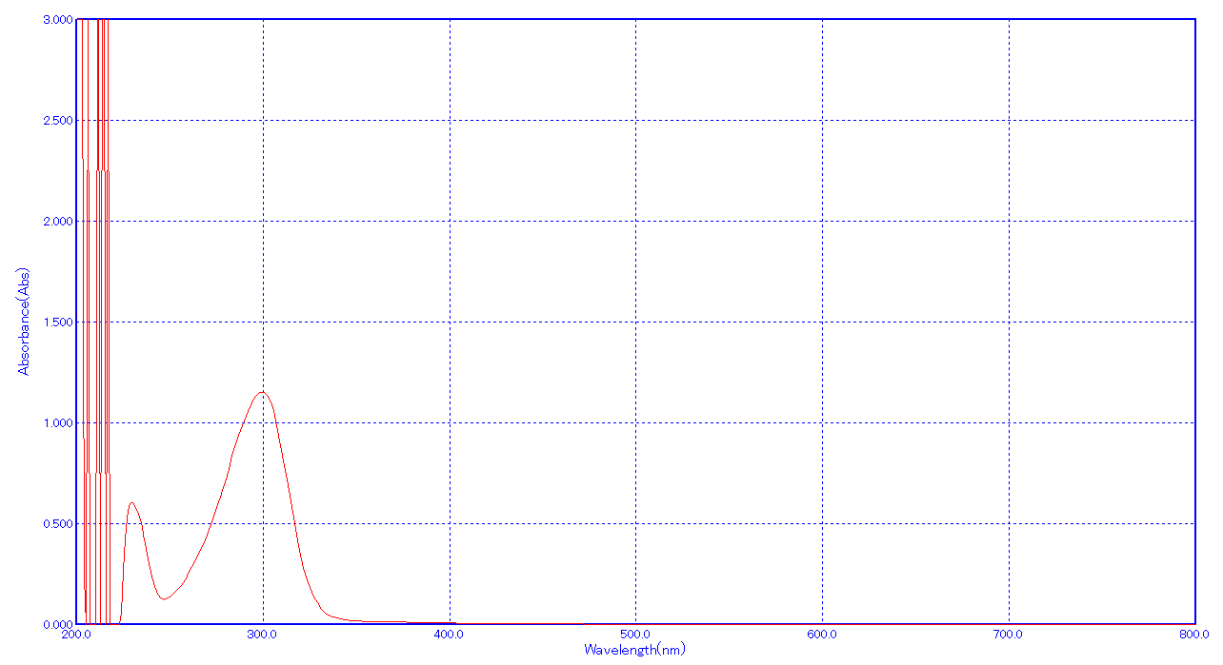
Fig. S1: UV-Vis of p-aminoacetophenone (4)
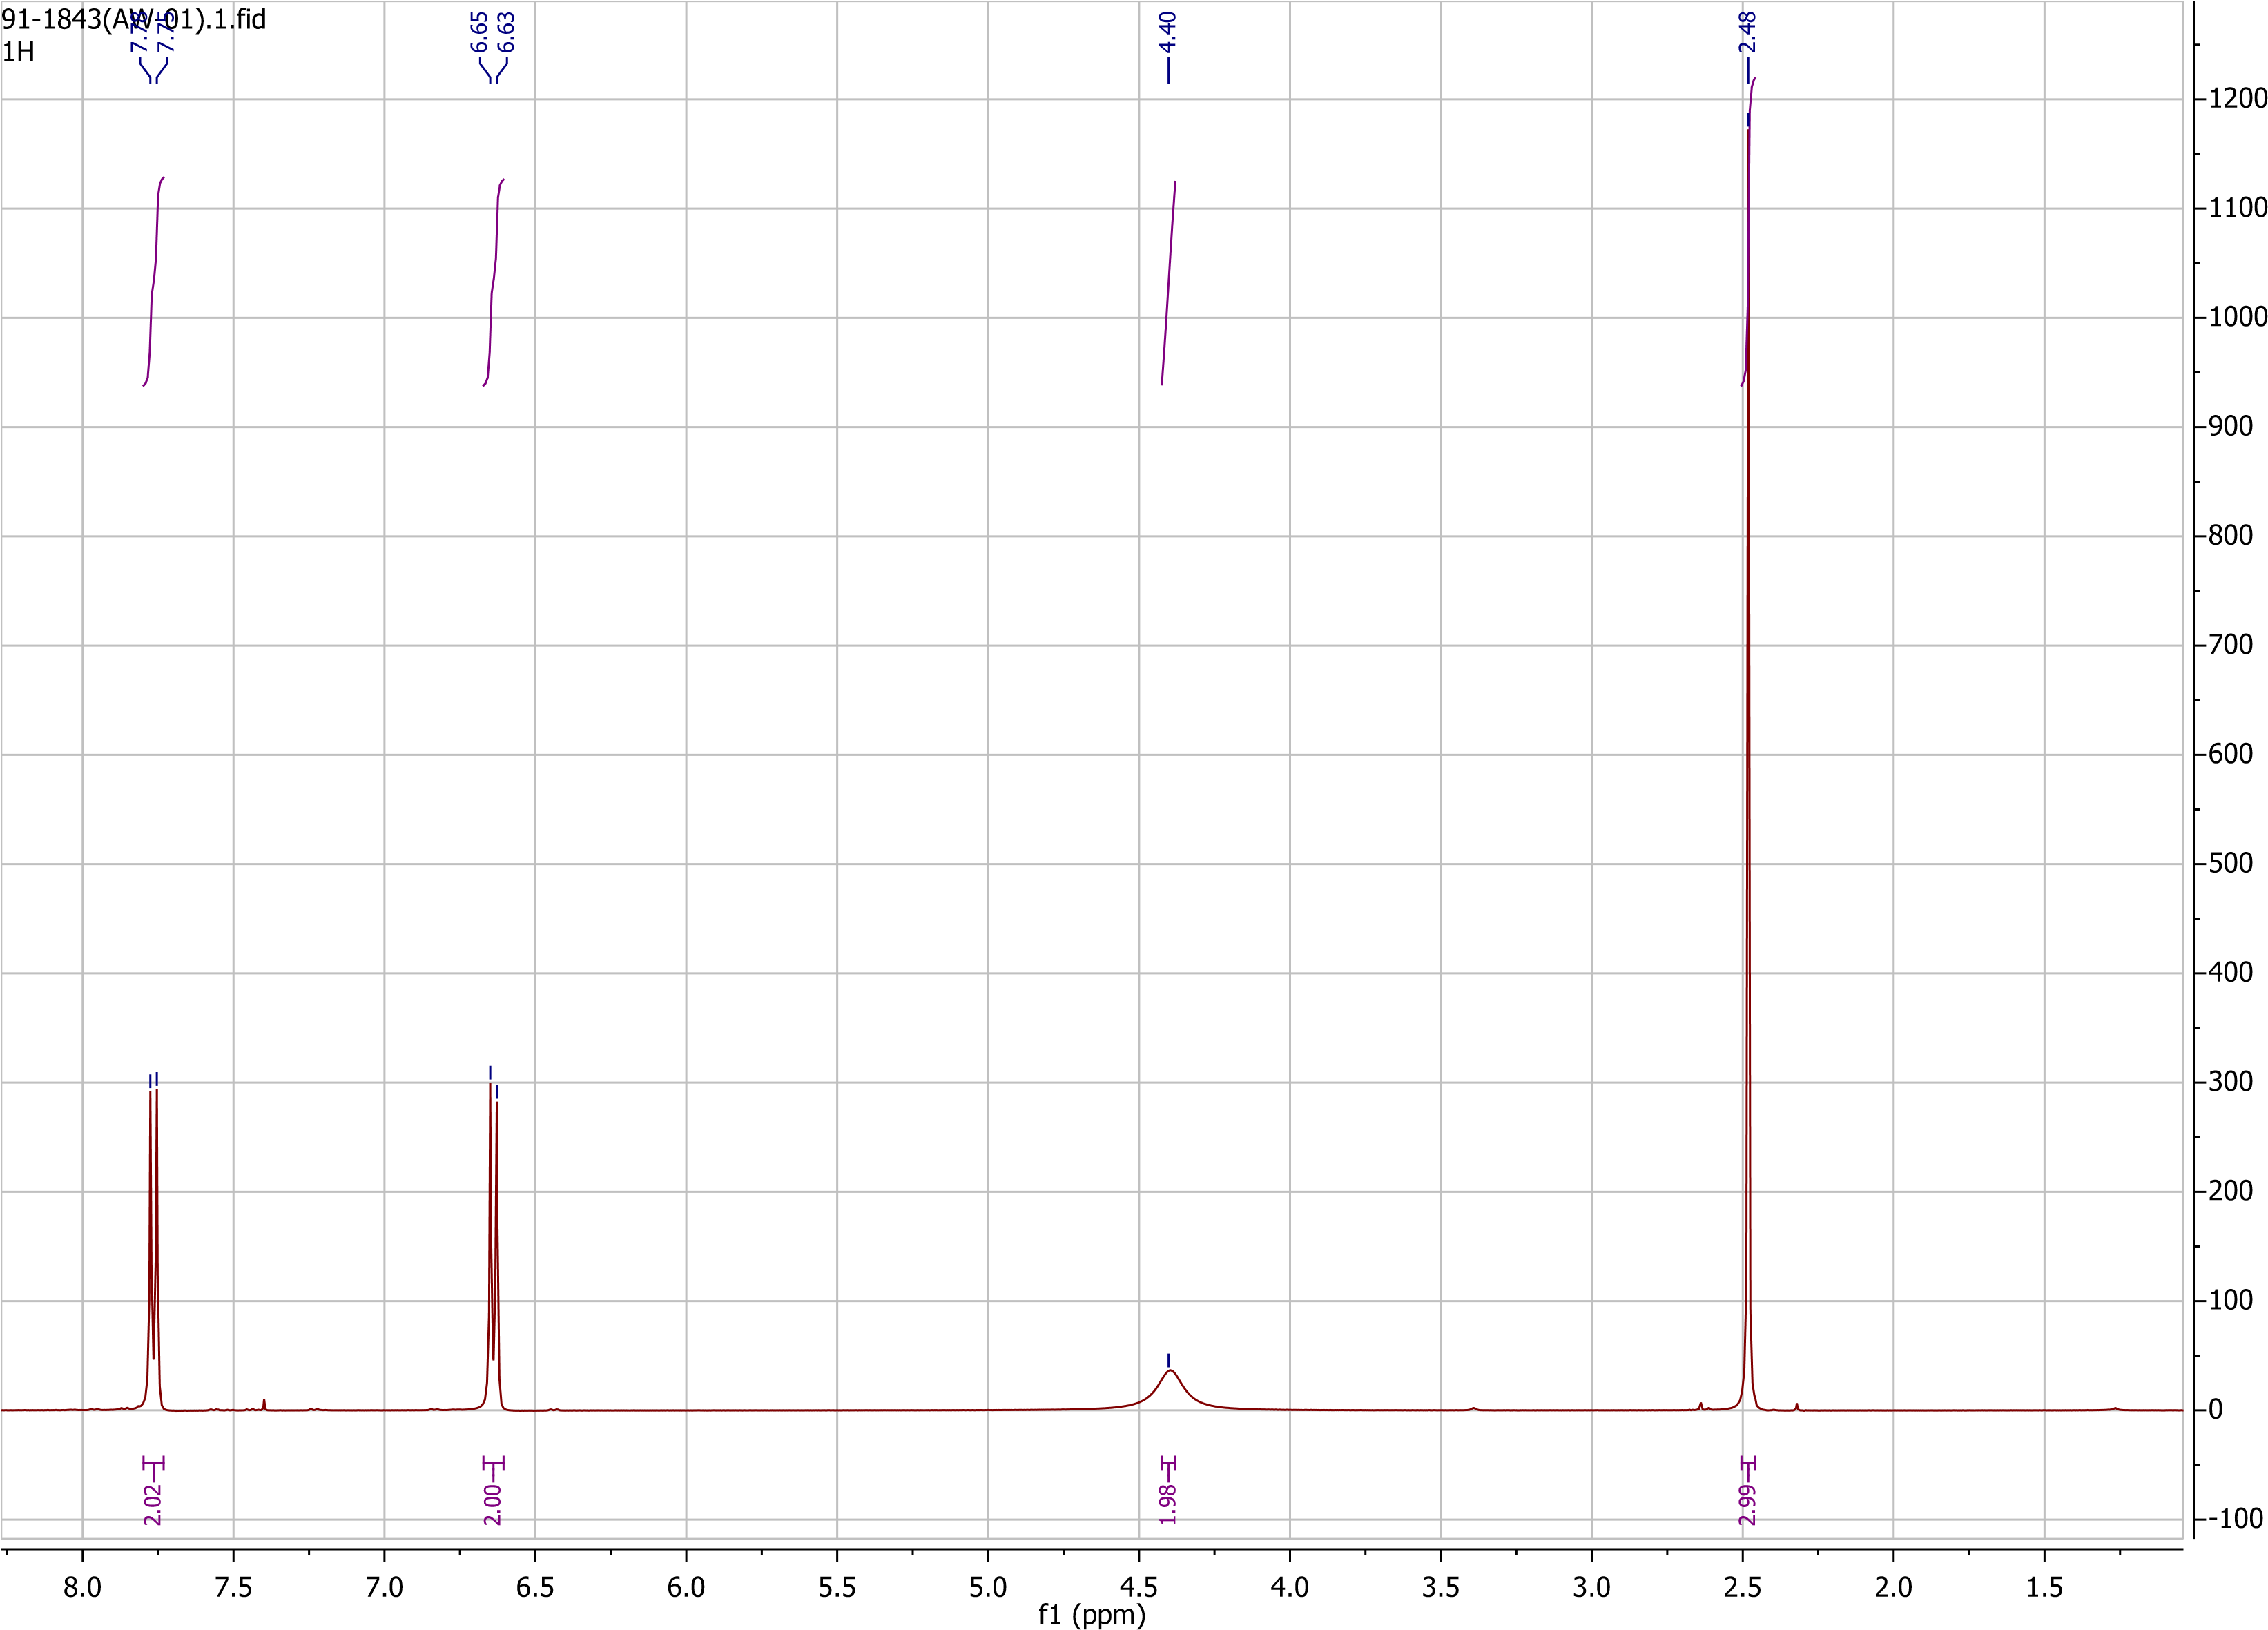
Fig. S2: ¹H NMR of p-aminoacetophenone (4).
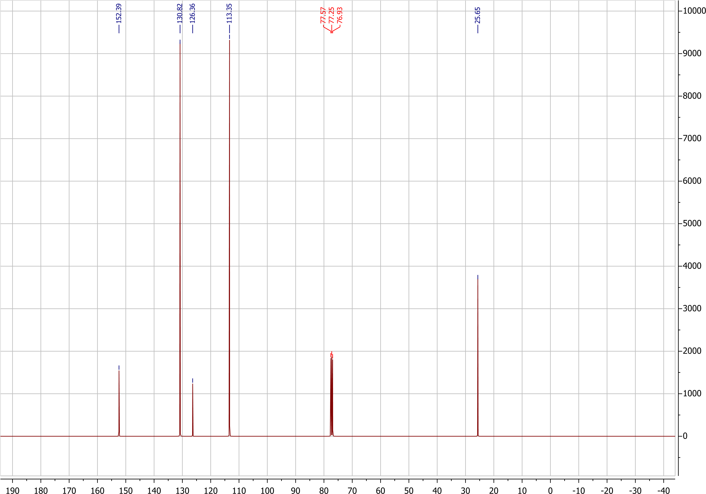
Fig. S3: ¹³C of p-aminoacetophenone (4).
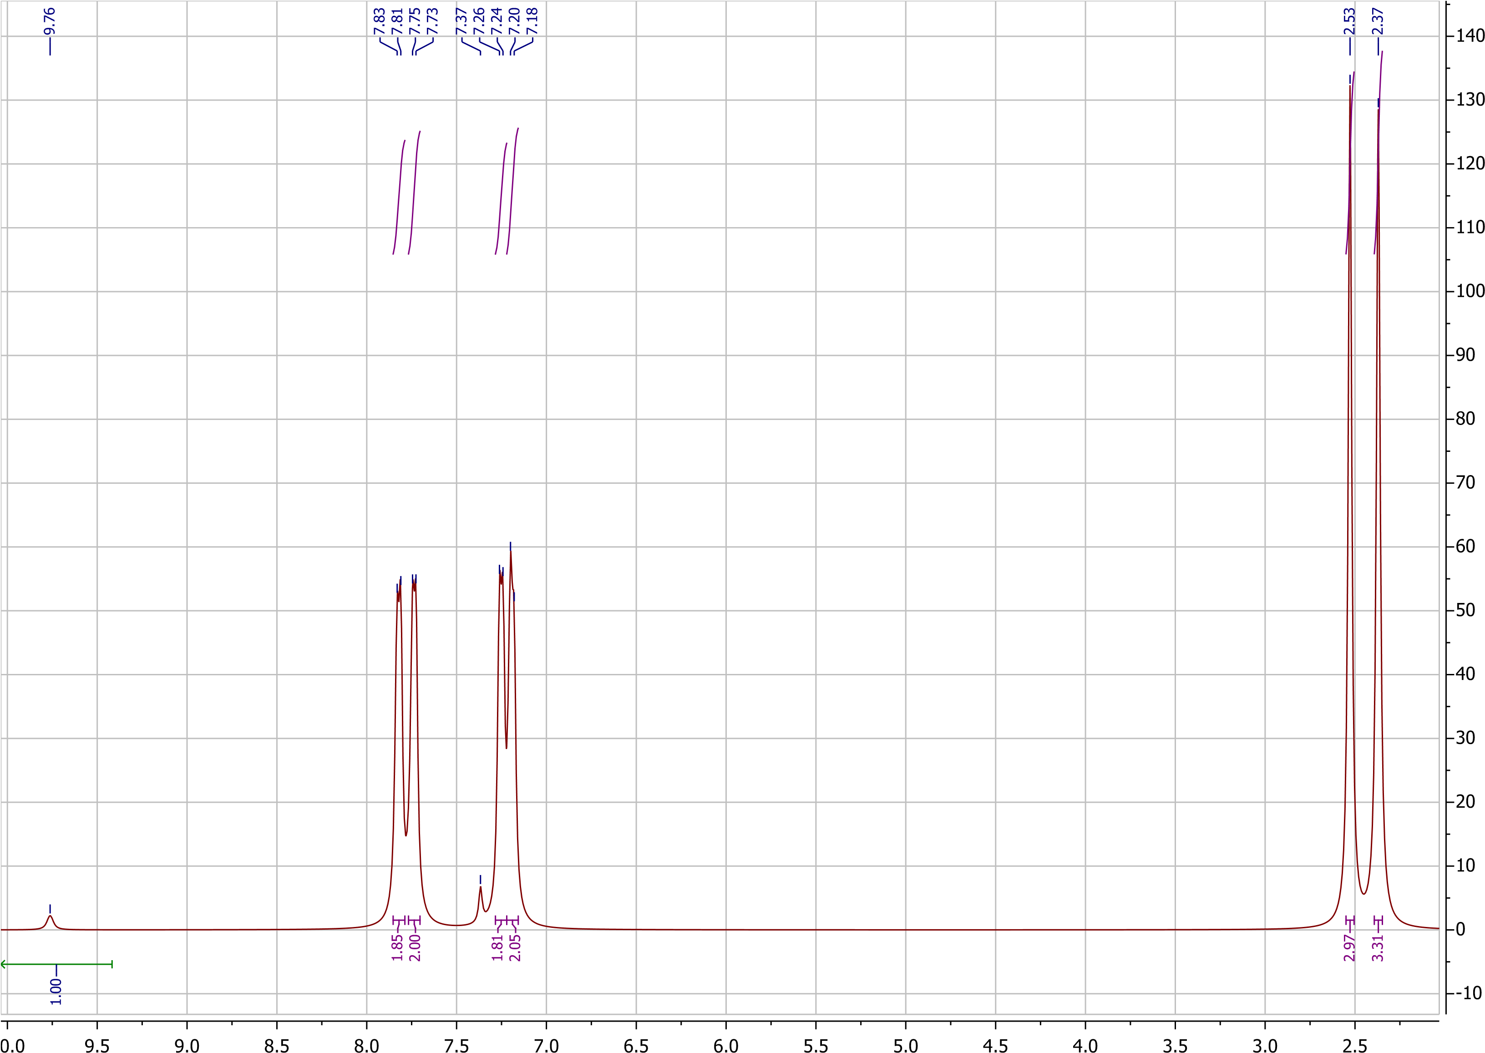
Fig. S4: ¹H NMR of ketone sulfonamide (5b)

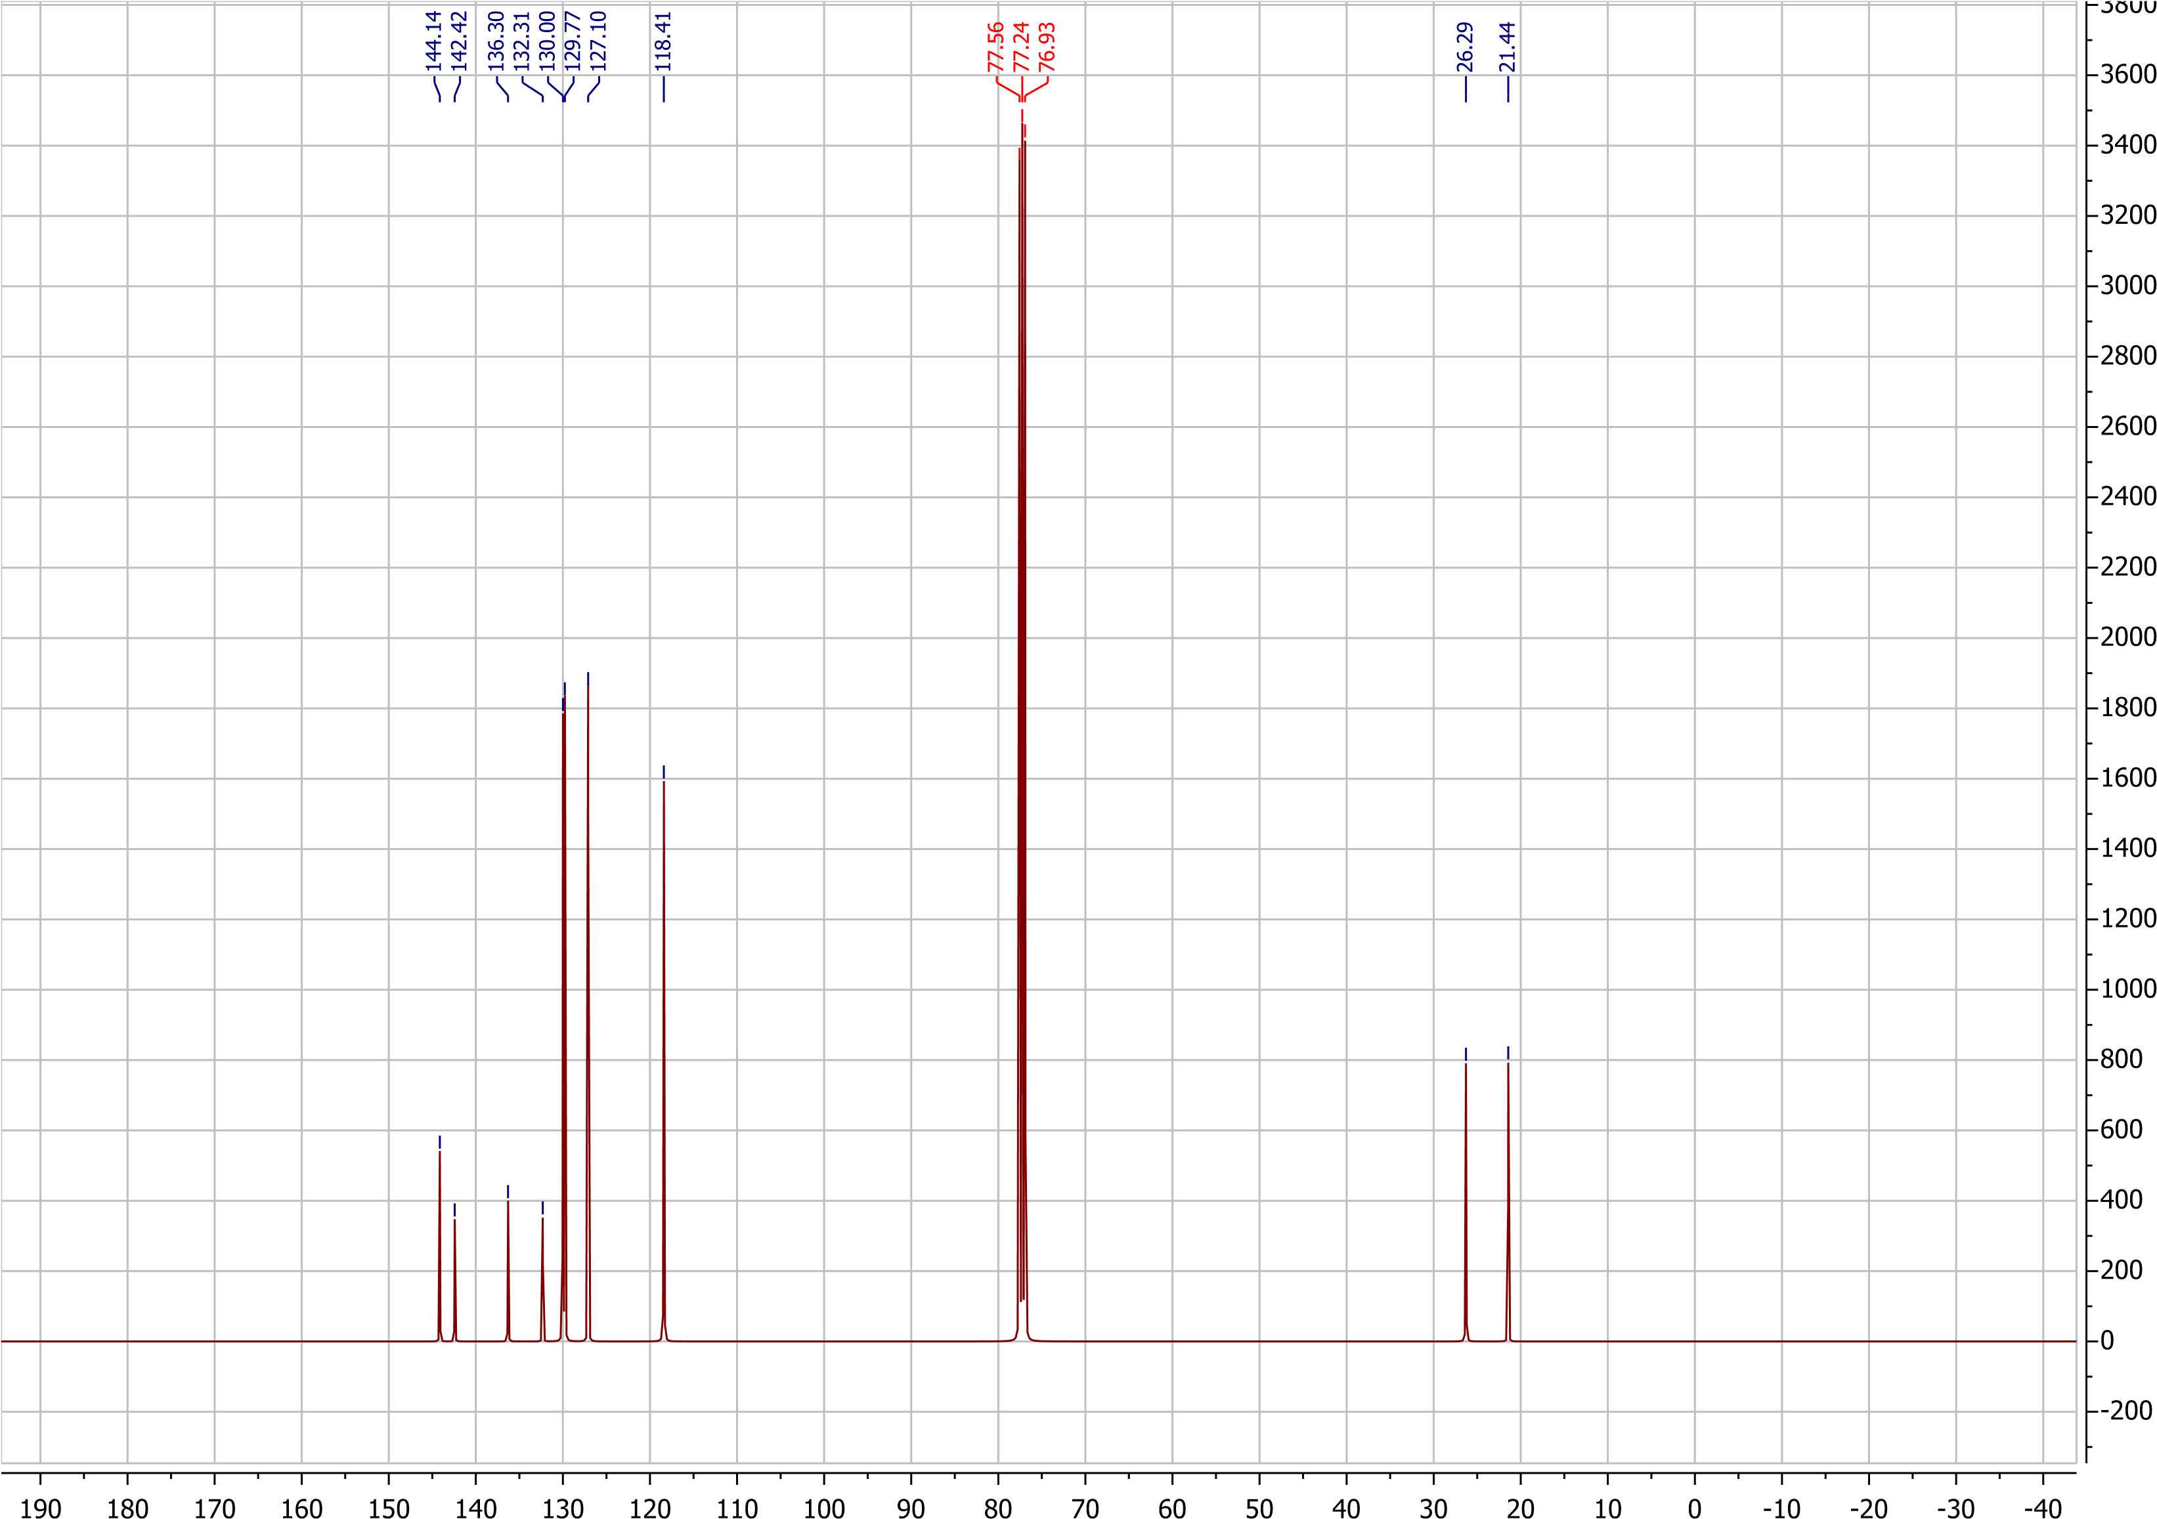
Fig. S5: ¹³C NMR of ketone sulfonamide (5b)
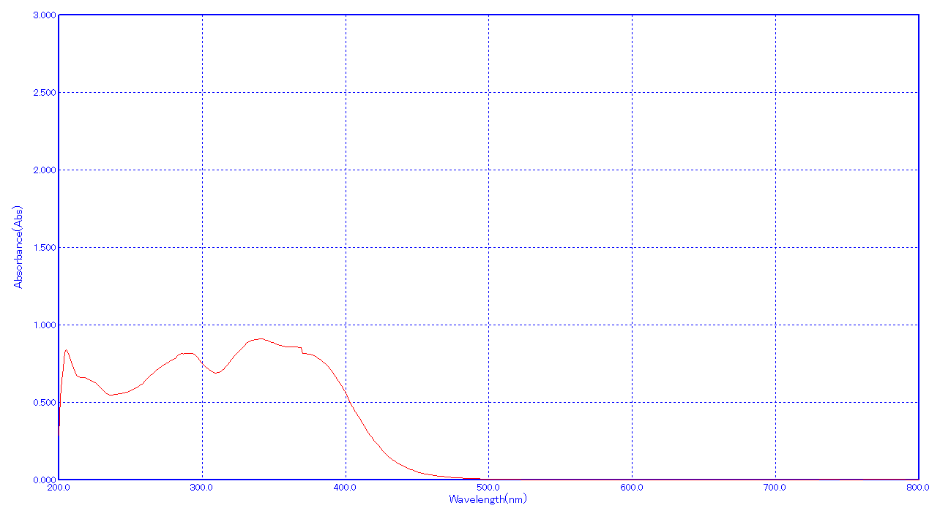
Fig. S6: UV-Vis of compound 6
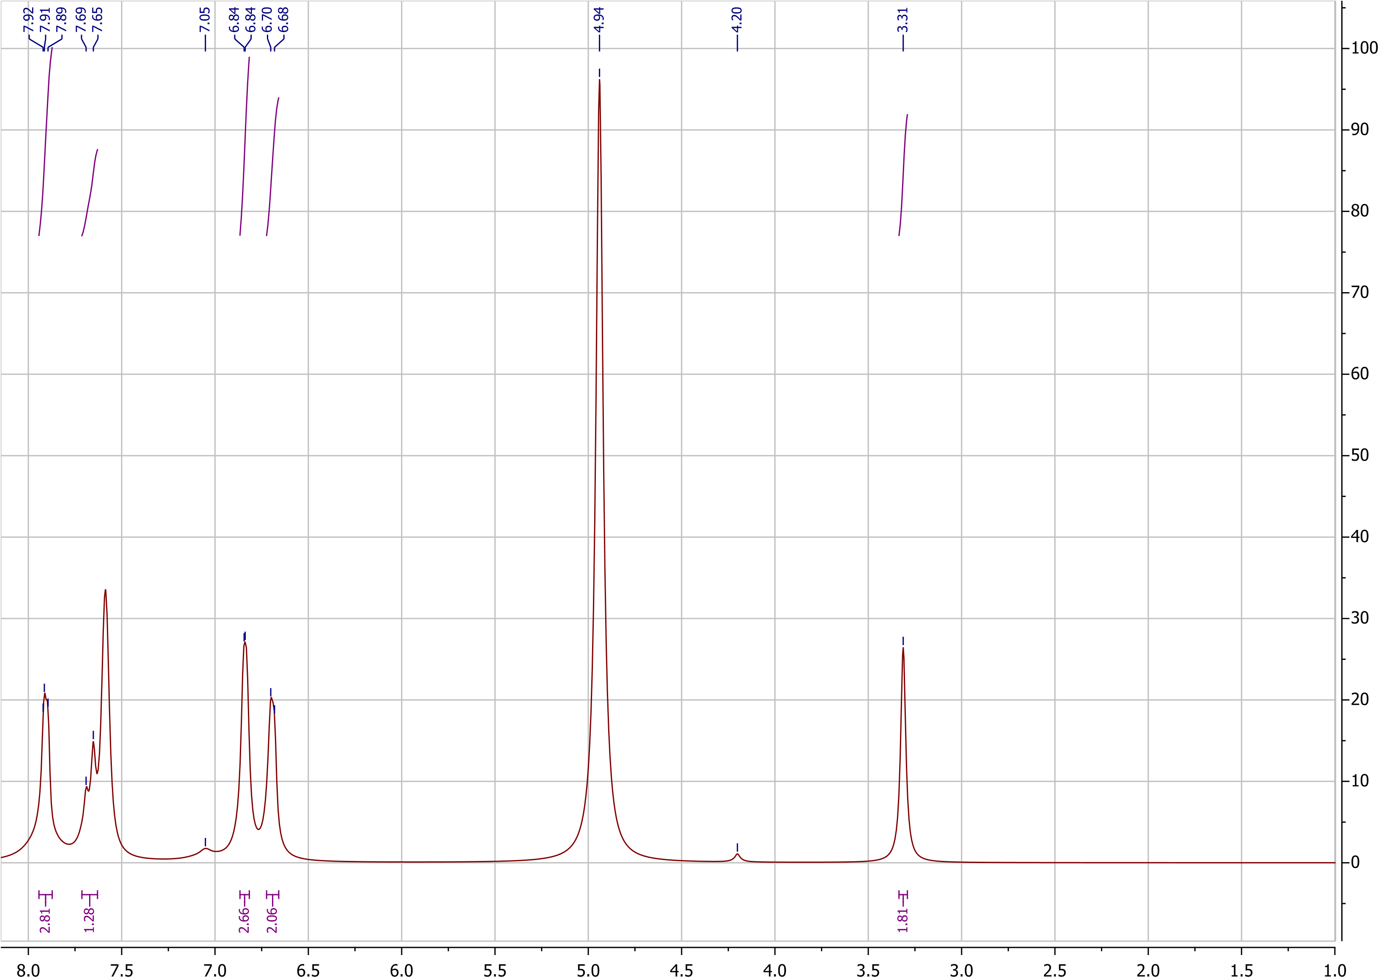
Fig. S7: ¹H- NMR of compound 6.
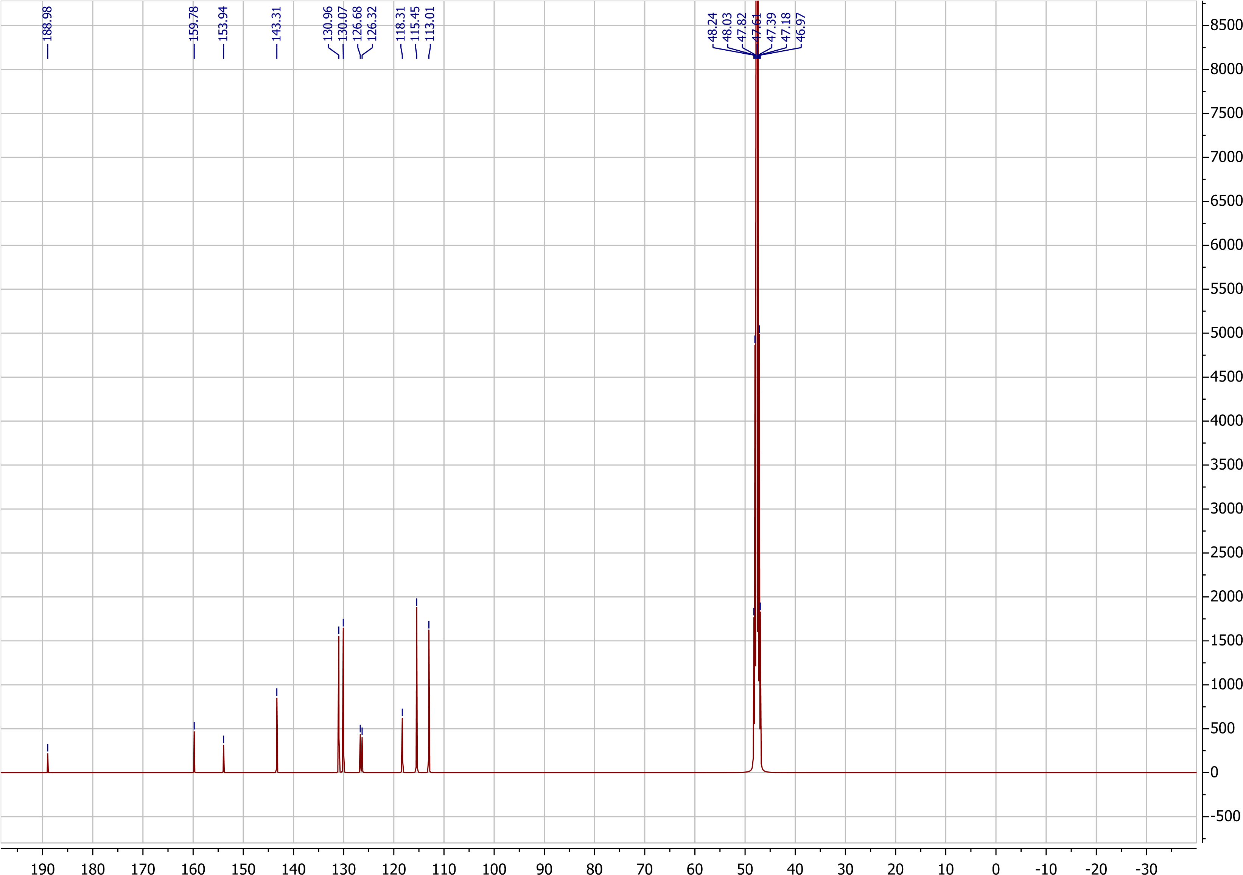
Fig. S8: ¹³C-NMR of compound 6.
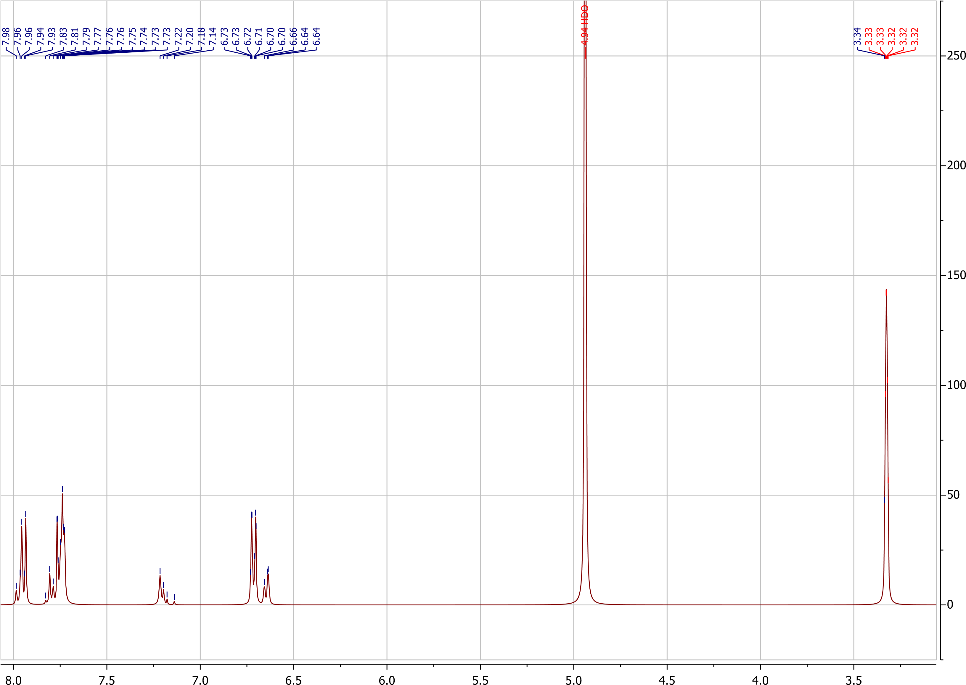
Fig. S9: ¹H-NMR of compound 7.

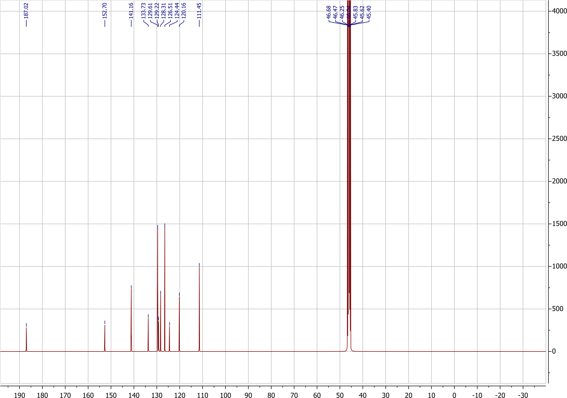
Fig. S10: ¹³C-NMR of compound 7.
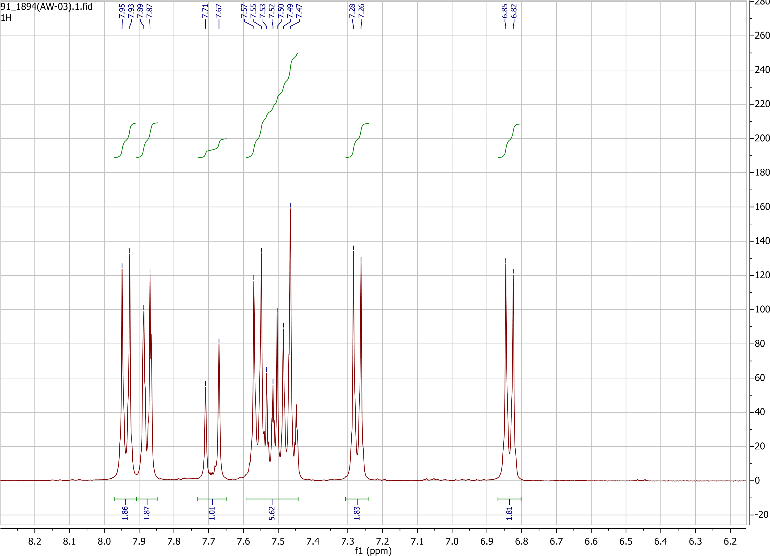
Fig. S11: ¹H-NMR of compound 8.
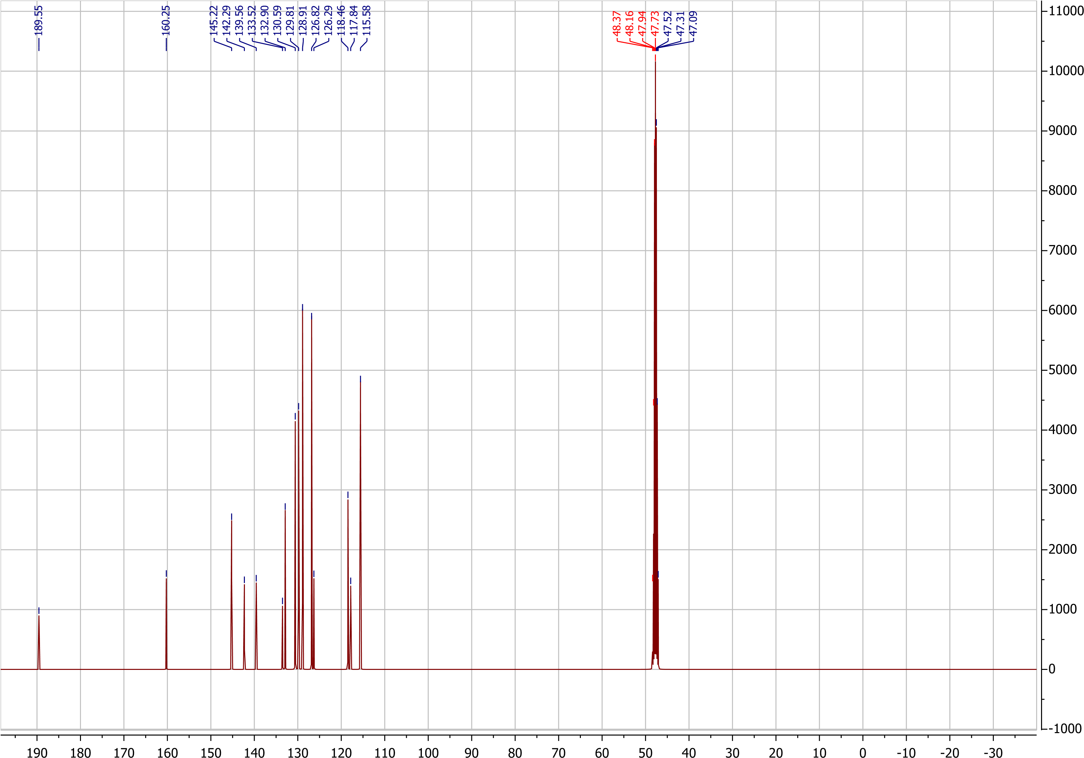
Fig. S12: ¹³C-NMR of compound 8.
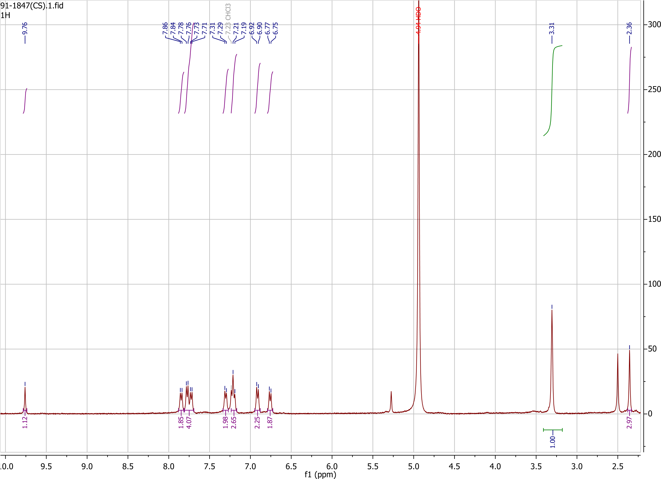
Fig. S13: ¹H-NMR of compound 9.
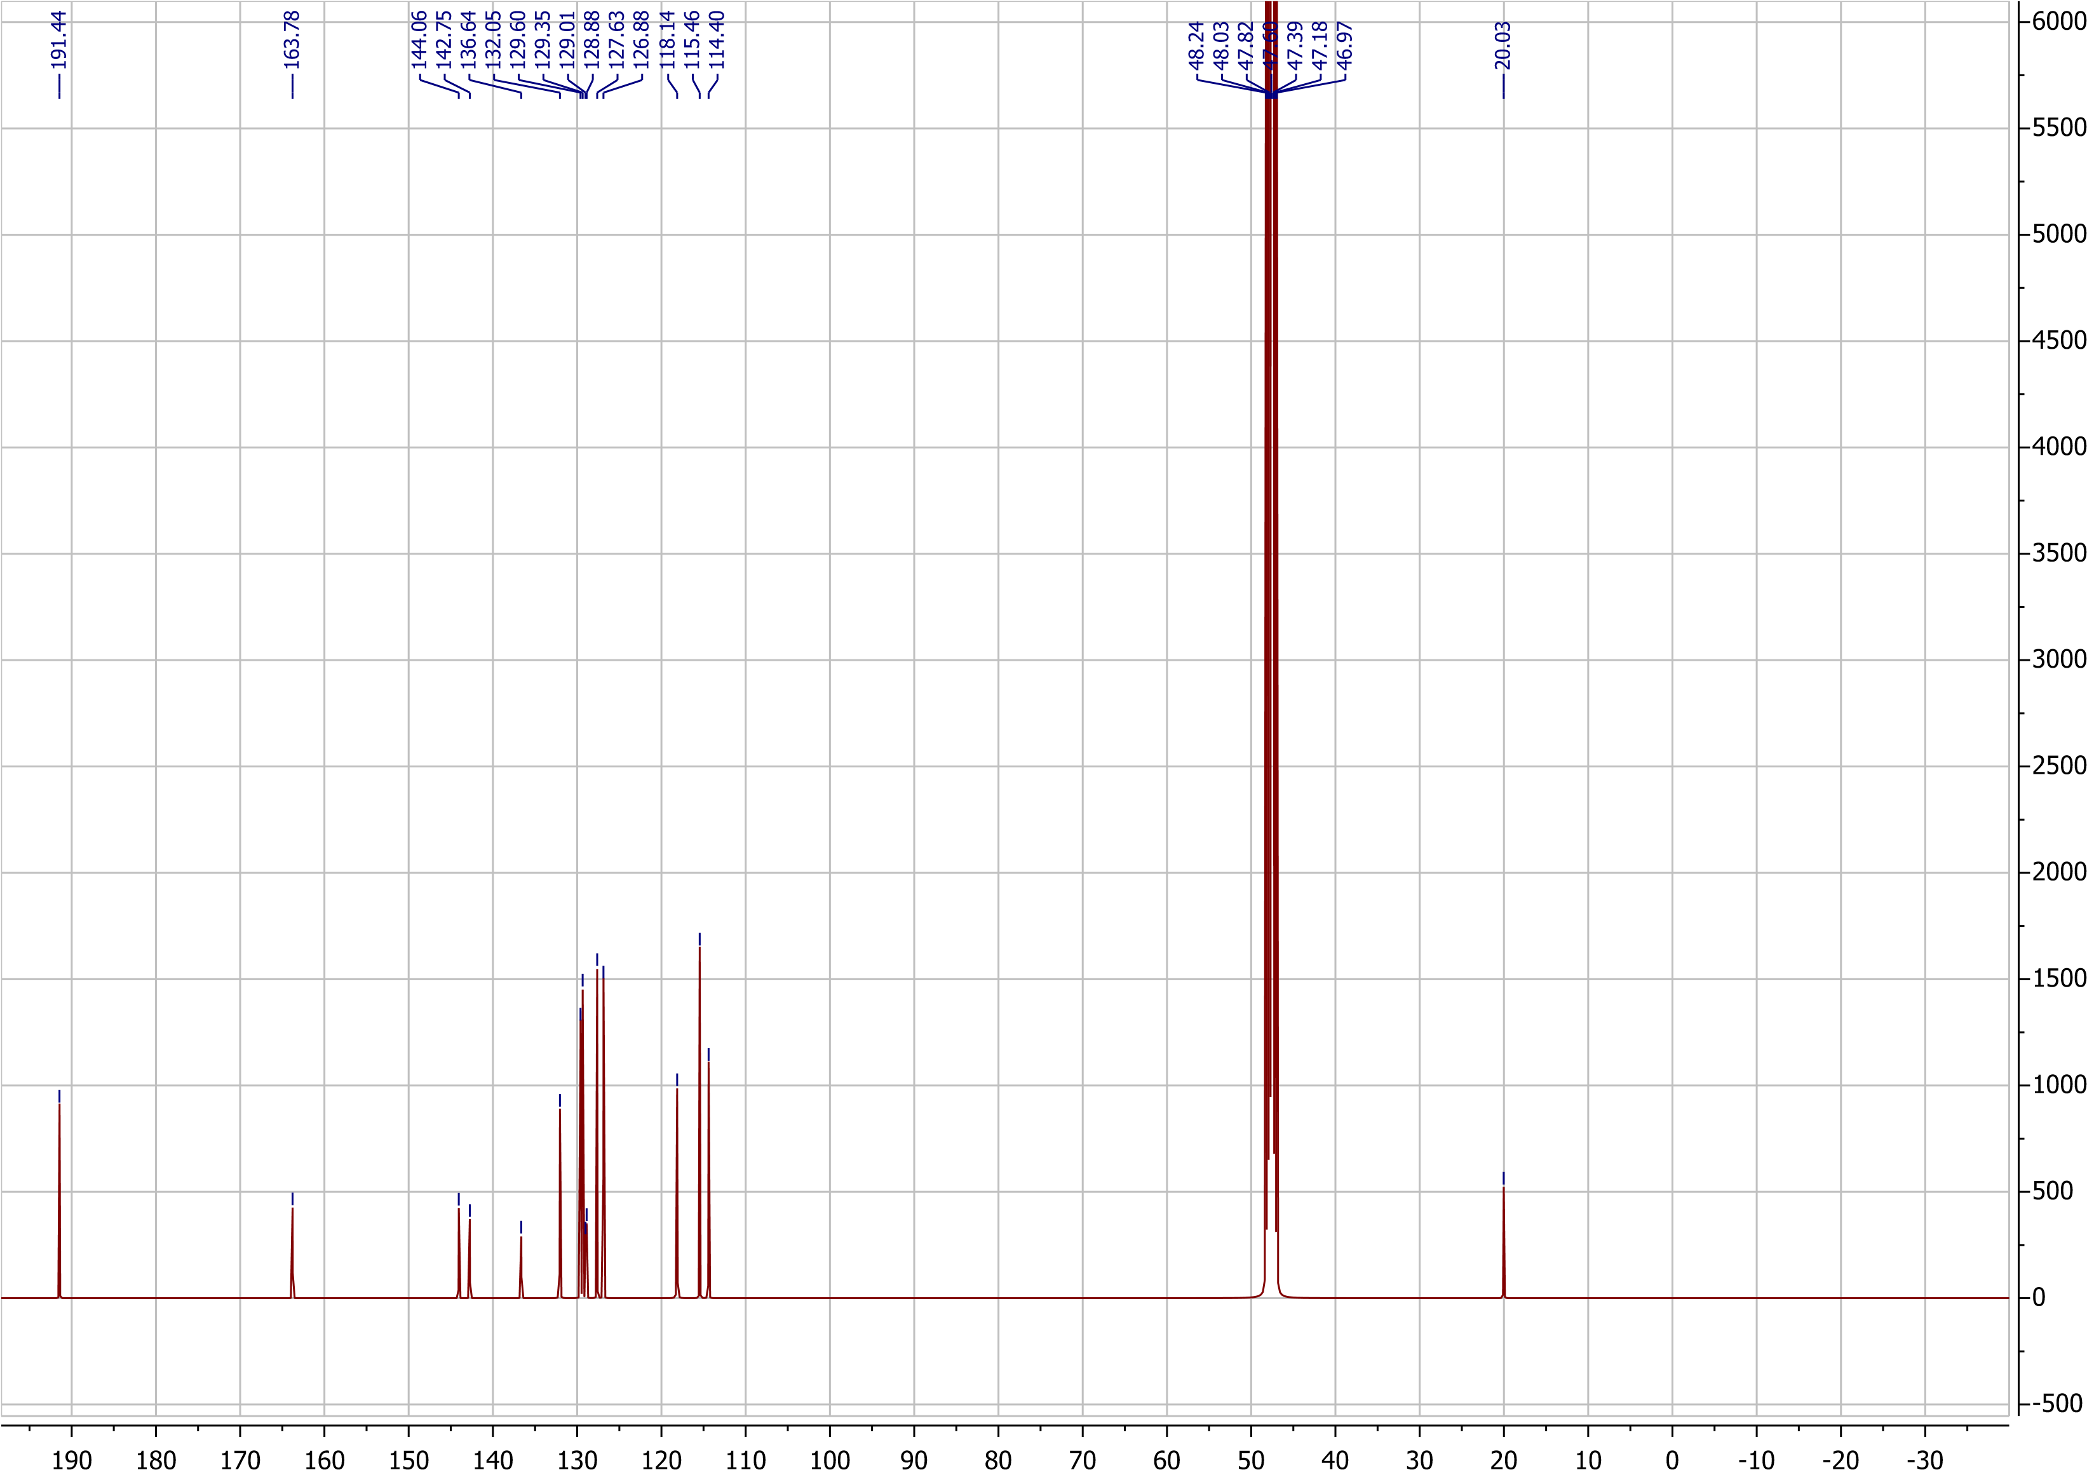
Fig. S14: ¹³C-NMR of compound 9.

Fig. S15: The Optimized structures of compounds (6-9) [26].
Compound 6
Compound 7

Compound 8
Compound 9

Sulfamethoxazole

Fig. S16. The 2D and 3D binding interactions of compounds (6-9) against E. Coli dihydropteroate synthase (PDB ID: 1AJ0). Ribbon model shows the binding pocket structure of E. Coli dihydropteroate synthase with compounds (6-9). Hydrogen bond between compounds and amino acids are shown as green dash lines, hydrophobic interaction are shown as pink lines [30].
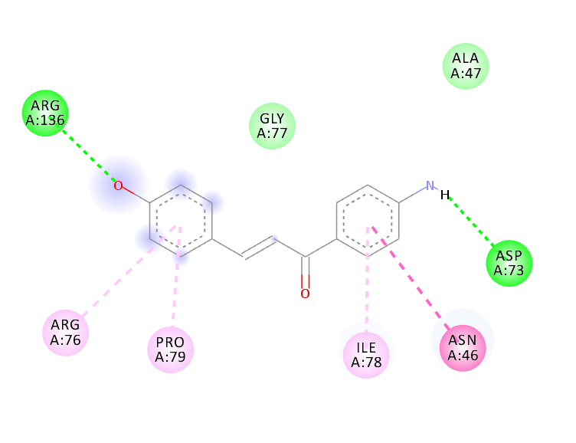
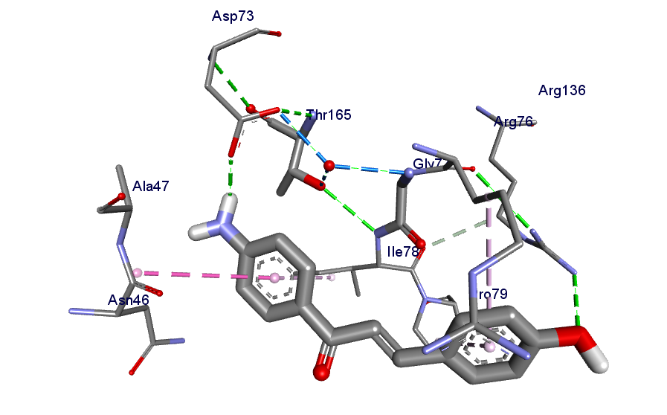

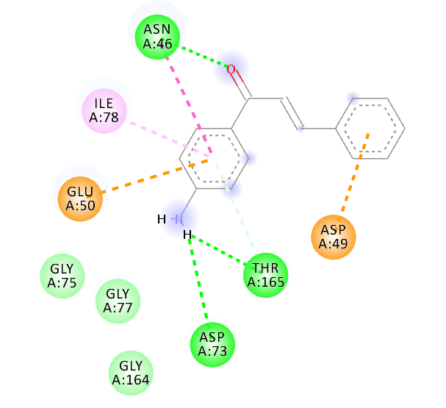
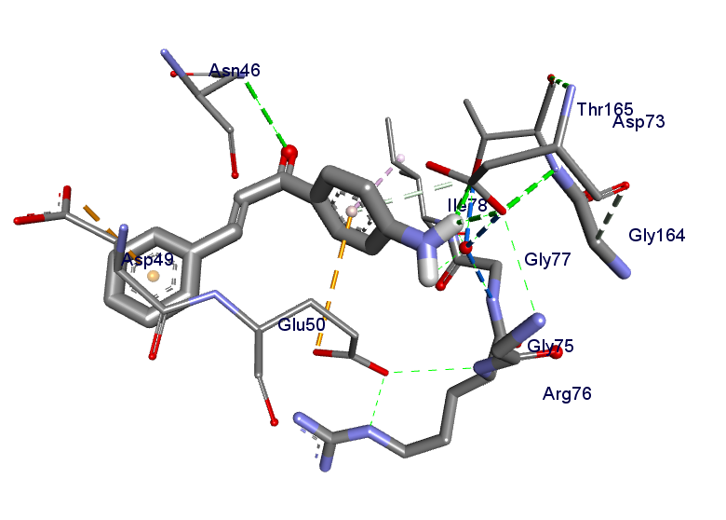

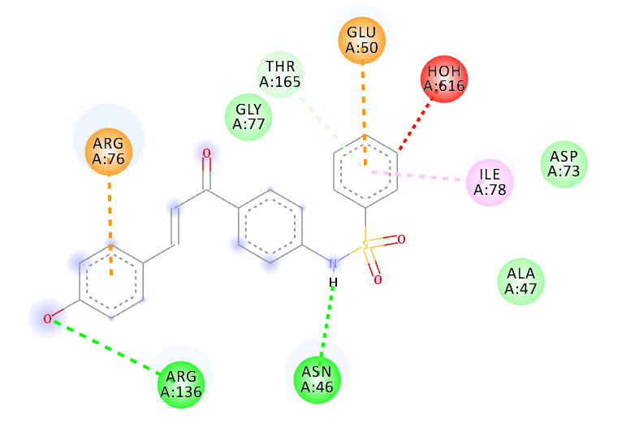
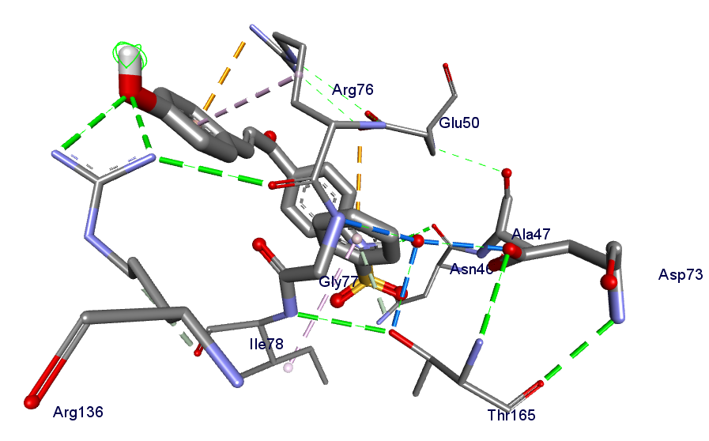

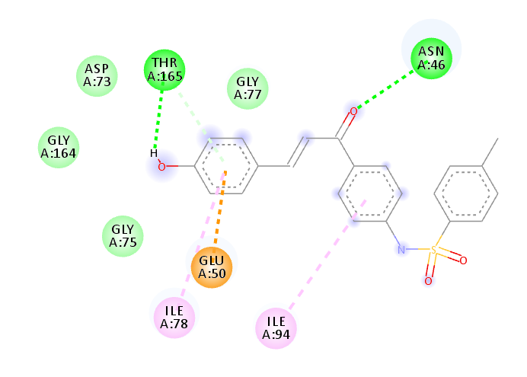
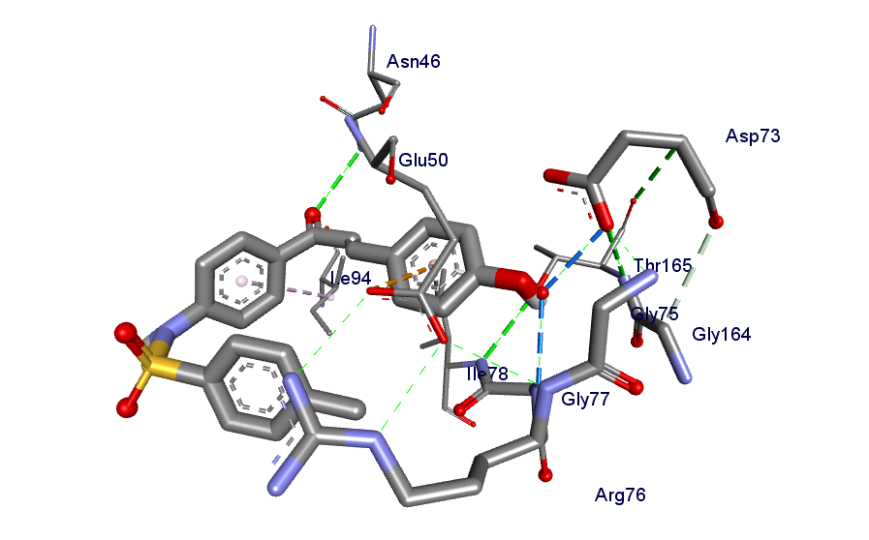

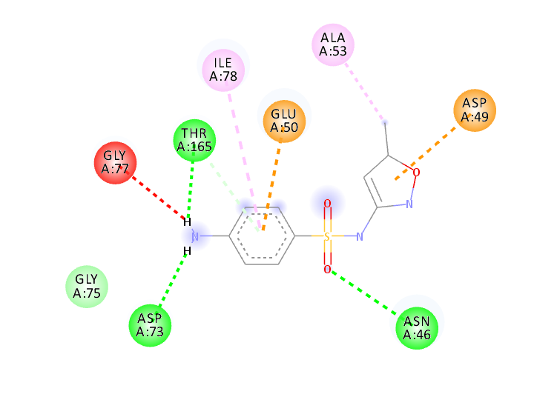
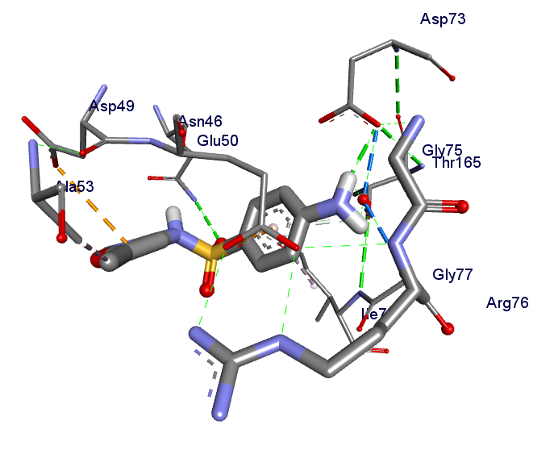

Fig. S17. The 2D and 3D binding interactions of Compound 6-9 against DNA gyrase B (PDB ID: 6F86). Ribbon model shows the binding pocket structure of DNA gyrase B with Compound 6-9. Hydrogen bond between compounds and amino acids are shown as green dash lines, hydrophobic interaction are shown as pink lines [30].

Table S1 ADME predictions of isolated compounds, computed by SwissADME and PreADMET

S. No. | Compound | log Kp cm/s | GI Absorption | BBB Permeability | Inhibitor Interaction (SwissADME/PreADMET)
 |  |  |  |  | P-gp substrate | CYP1A2 inhibitor | CYP2C19 inhibitor | CYP2C9 inhibitor | CYP2D6 inhibitor | CYP3A4 inhibitor
1 | 6 | -5.9 | High | Yes | Yes | Yes | Yes | Yes | Yes | Yes
2 | 7 | -5.61 | High | Yes | Yes | Yes | Yes | Yes | Yes | Yes
3 | 8 | -6.47 | High | Yes | No | Yes | No | No | Yes | No
4 | 9 | -6.05 | High | Yes | No | No | Yes | Yes | Yes | Yes
5 | Sulfamethoxazole | -7.21 | High | No | No | No | No | No | No | No
Notes: Data from these studies.²³⁻²⁵
LogKp = Skin permeation value, GI = Gastro-Intestinal, BBB = Blood Brain Barrier, P-gp = P-glycoprotein, CYP = Cytochrome-P
Table S2 Predication of Toxicity of synthesized compound computed by Pre-ADMET and OSIRIS Property Explorer
S. No. | Compound | LD ₅₀ (mg/kg) | Toxicity Class | Organ Toxicity
 |  |  |  | Hepatotoxicity | Carcinogenicity | Cytotoxicity | Mutagenicity | Reproductive Effective | Irritant
1 | 6 | 1048 | 4 | Yes | No | No | No | No | No
2 | 7 | 3000 | 5 | Yes | Yes | No | No | No | No
3 | 8 | 6000 | 6 | Yes | Yes | No | No | No | No
4 | 9 | 6000 | 6 | Yes | Yes | No | No | No | No
5 | Sulfamethoxazole | 2300 | 5 | Yes | No | No | No | No | No

Table S3 The various quantum chemical parameters of compounds (6-9)

S.NO | Compounds | E_{HUMO} (eV) | E_{LUMO} (eV) | Energy Gap  ΔE (eV) | Electronegativity  χ (eV) | Global Hardness  η (eV) | Global Softness  σ (eV⁻¹) | Global Electrophilicity  ω (eV)
1 | 6 | -5.39872 | -1.55104 | 3.847678 | 3.474883 | 1.923839 | 0.519794 | 3.138208
2 | 7 | -5.48308 | -1.70343 | 3.77965 | 3.593252 | 1.889825 | 0.52915 | 3.416047
3 | 8 | -5.98104 | -2.01364 | 3.967408 | 3.99734 | 1.983704 | 0.504108 | 4.027498
4 | 9 | -5.87492 | -1.86942 | 4.005503 | 3.872168 | 2.002752 | 0.499313 | 3.743271

Note: Data from Abu-Melha S.²⁸

Table S4 The values of the Mullikan's atomic charges of the compounds
Ligand 6 Ligand 7 Ligand 8 Ligand 9
1 | C | -0.07646 | 1 | C | -0.0211 | 1 | C | 0.278505 | 1 | C | 0.326313
2 | C | -0.20137 | 2 | C | -0.18749 | 2 | C | -0.20657 | 2 | C | -0.18033
3 | C | -0.15779 | 3 | C | -0.12251 | 3 | C | -0.18716 | 3 | C | -0.21192
4 | C | -0.19109 | 4 | C | -0.2569 | 4 | C | -0.06451 | 4 | C | -0.20164
5 | C | -0.19505 | 5 | C | -0.18123 | 5 | C | -0.18827 | 5 | C | 0.295038
6 | C | 0.391204 | 6 | C | 0.391785 | 6 | C | 0.296431 | 6 | C | -0.0679
7 | C | 0.351142 | 7 | C | -0.18083 | 7 | C | -0.16046 | 7 | C | -0.2151
8 | C | -0.2615 | 8 | C | -0.184 | 8 | C | -0.21464 | 8 | C | -0.17806
9 | C | 0.292569 | 9 | C | -0.19069 | 9 | C | -0.17766 | 9 | C | -0.16014
10 | C | -0.2156 | 10 | C | -0.18207 | 10 | C | -0.17887 | 10 | C | -0.45799
11 | C | -0.17885 | 11 | C | -0.07658 | 11 | C | 0.402253 | 11 | C | -0.17957
12 | C | -0.12249 | 12 | C | -0.19457 | 12 | C | -0.47758 | 12 | C | -0.59978
13 | C | -0.18075 | 13 | C | 0.352016 | 13 | C | -0.1755 | 13 | C | 0.396733
14 | C | -0.18794 | 14 | C | -0.20104 | 14 | C | -0.1861 | 14 | C | -0.18719
15 | C | -0.02767 | 15 | C | -0.15707 | 15 | C | -0.17704 | 15 | C | -0.14922
16 | H | 0.172563 | 16 | H | 0.189285 | 16 | C | -0.26303 | 16 | C | 0.020513
17 | H | 0.310663 | 17 | H | 0.190721 | 17 | C | -0.17638 | 17 | C | -0.02854
18 | H | 0.182152 | 18 | H | 0.193147 | 18 | C | -0.15472 | 18 | C | -0.26281
19 | H | 0.170223 | 19 | H | 0.185721 | 19 | C | -0.11667 | 19 | C | -0.17585
20 | H | 0.311732 | 20 | H | 0.216786 | 20 | C | -0.02849 | 20 | C | -0.15166
21 | H | 0.214088 | 21 | H | 0.186422 | 21 | C | -0.1561 | 21 | C | -0.11881
22 | H | 0.180394 | 22 | H | 0.214252 | 22 | H | 0.209332 | 22 | C | -0.17411
23 | H | 0.205732 | 23 | H | 0.186784 | 23 | H | 0.184261 | 23 | H | 0.191899
24 | H | 0.213299 | 24 | H | 0.173766 | 24 | H | 0.208524 | 24 | H | 0.18282
25 | H | 0.186328 | 25 | O | -0.50071 | 25 | H | 0.327126 | 25 | H | 0.224554
26 | H | 0.190902 | 26 | H | 0.190216 | 26 | H | 0.184112 | 26 | H | 0.22075
27 | H | 0.196535 | 27 | N | -0.82923 | 27 | H | 0.198412 | 27 | H | 0.184023
28 | H | 0.357845 | 28 | H | 0.31254 | 28 | H | 0.215929 | 28 | H | 0.220739
29 | N | -0.82955 | 29 | H | 0.311407 | 29 | H | 0.218374 | 29 | H | 0.24292
30 | O | -0.50426 | 30 | H | 0.171174 | 30 | H | 0.239045 | 30 | H | 0.208054
31 | O | -0.59701 |  |  |  | 31 | H | 0.247341 | 31 | H | 0.346841
 |  |  |  |  |  | 32 | H | 0.240474 | 32 | H | 0.216599
 |  |  |  |  |  | 33 | H | 0.360375 | 33 | H | 0.198716
 |  |  |  |  |  | 34 | H | 0.207168 | 34 | H | 0.200695
 |  |  |  |  |  | 35 | H | 0.208911 | 35 | H | 0.359464
 |  |  |  |  |  | 36 | H | 0.179634 | 36 | H | 0.21248
 |  |  |  |  |  | 37 | H | 0.199713 | 37 | H | 0.18296
 |  |  |  |  |  | 38 | H | 0.190516 | 38 | H | 0.198316
 |  |  |  |  |  | 39 | N | -0.8736 | 39 | H | 0.224211
 |  |  |  |  |  | 40 | O | -0.59529 | 40 | H | 0.208821
 |  |  |  |  |  | 41 | O | -0.54445 | 41 | H | 0.191701
 |  |  |  |  |  | 42 | O | -0.48847 | 42 | N | -0.94112
 |  |  |  |  |  | 43 | O | -0.5381 | 43 | O | -0.59574
 |  |  |  |  |  | 44 | S | 1.533205 | 44 | O | -0.55851
 |  |  |  |  |  |  |  |  | 45 | O | -0.55609
 |  |  |  |  |  |  |  |  | 46 | O | -0.49526
 |  |  |  |  |  |  |  |  | 47 | S | 1.59217

Note: Data from Abu-Melha S.²⁸

