S1

S2
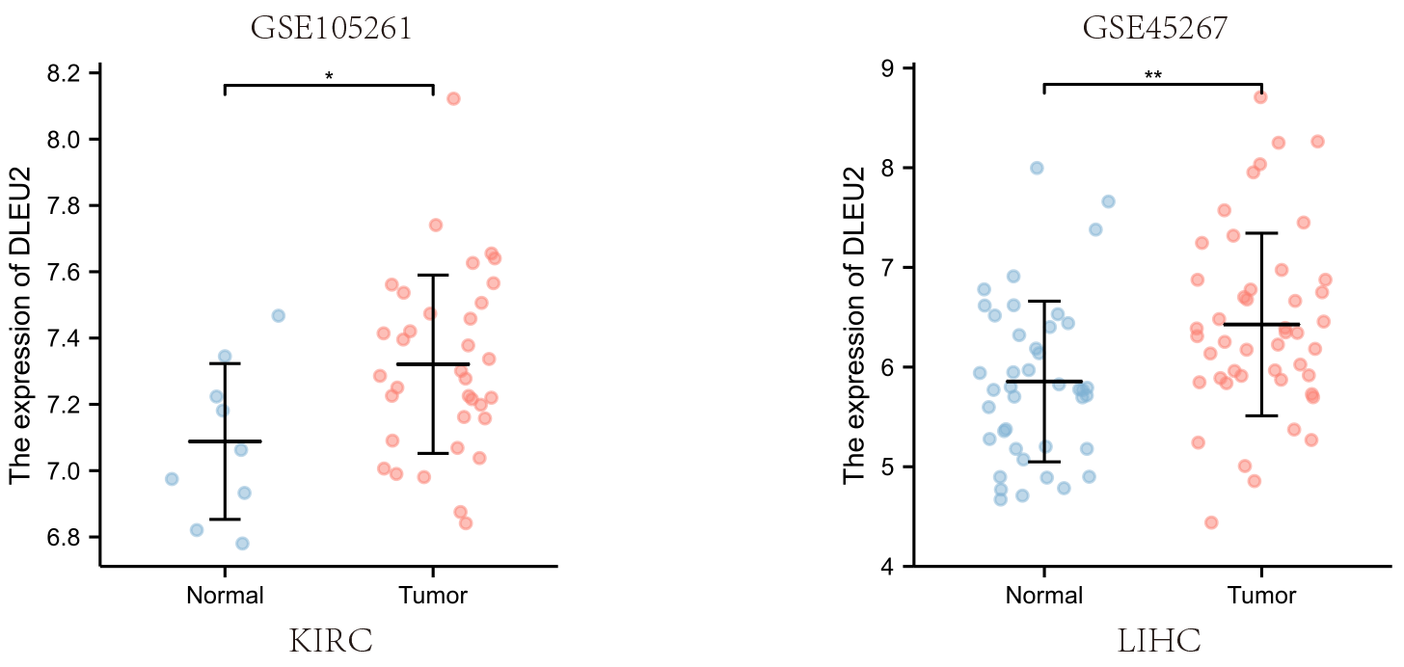
S3
Figure S1 Differential expression of DLEU2 between cancerous tissue samples and normal tissue samples in human carcinomas. ns, not significant; **p<0.01; ***p<0.001.

Figure S2 Expression of DLEU2 in KIRC and LIHC tissues. (A) Expression of DLEU2 in KIRC from the GSE105261 dataset. (B) Expression of DLEU2 in LIHC from the GSE45267 dataset. *p<0.05; **p<0.01; KIRC, Kidney renal clear cell carcinoma; LIHC, Liver hepatocellular carcinoma.

Figure S3 Methylation difference in DLEU2 in KIRC (A) and LIHC (B) compared to that in normal samples. *p<0.05; KIRC, Kidney renal clear cell carcinoma; LIHC, Liver hepatocellular carcinoma.

