Supplementary Table 1. Serum CEA levels according to clinicopathological parameters
 | No. of patients (%) | CEA level (ng/mL)* | p-value
All | 77 (100.0) | 3.3 (2.0-5.1)
Age |  |  | 0.0493
<70 | 48 (62.3) | 2.9 (1.7-4.7)
≥70 | 29 (37.7) | 4.2 (2.6-5.5)
Sex |  |  | 0.1577
Male | 31 (40.3) | 2.8 (1.5-4.6)
Female | 46 (59.7) | 3.8 (2.3-5.5)
Smoking history |  |  | 0.2171
Never | 67 (87.0) | 3.1 (1.5-4.4)
Ever | 10 (13.0) | 4.3 (2.5-5.7)
ECOG PS |  |  | 0.5672
0,1 | 68 (88.3) | 3.3 (1.8-5.2)
≥2 | 9 (11.7) | 4.1 (3.5-5.6)
Stage |  |  | 0.0003
I, II | 55 (71.4) | 2.8 (1.6-4.3)
IIIA | 22 (28.6) | 5.2 (3.6-7.9)
T stage |  |  | 0.1672
T1–2 | 67 (87.0) | 3.0 (1.7-4.6)
T3–4 | 10 (13.0) | 4.1 (3.4-5.2)
N stage |  |  | 0.3412
N0 | 57 (70.0) | 2.9 (1.7-5.0)
≥N1 | 20 (30.0) | 3.9 (3.4-5.2)
Differentiation |  |  | 0.0433
Well/moderate | 67 (87.0) | 3.0 (1.9-5.1)
Poor | 10 (13.0) | 4.4 (4.1-5.8)
EGFR mutation† |  |  | 0.1137
Negative | 40 (53.3) | 4.2 (2.6-5.5)
Positive | 35 (46.7) | 3.0 (1.6-4.7)
ALK translocation‡ |  |  | 0.1324
Negative | 40 (95.2) | 3.6 (2.1-5.4)
Positive | 2 (4.8) | 1.7 (0.7-2.6)
Surgical technique |  |  | 0.0966
Lobectomy | 67 (87.0) | 3.6 (2.0-5.4)
Segmentectomy | 10 (13.0) | 2.3 (1.8-3.0)
*presented as the median (interquartile range). †Analysis after excluding two ALK-positive patients
‡Analysis after excluding 35 EGFR-positive patients
Romo1, reactive oxygen species modulator 1; ECOG PS, Eastern Cooperative Oncology Group performance status; T, tumor; N, lymph node; EGFR, epidermal growth factor receptor; ALK, anaplastic lymphoma kinase

Supplementary Table 2. Distribution of patients according to different serum CEA levels
 | No. of patients (%) | CEA level (ng/mL) |  | p-value
 | No. of patients (%) | Low (<2.9) | High (≥2.9) | p-value
All | 77 (100.0) | 34 (44.2) | 43 (55.8)
Age |  |  |  | 0.0715
<70 | 48 (62.3) | 25 (52.1) | 23 (47.9)
≥70 | 29 (37.7) | 9 (31.0) | 20 (69.0)
Sex |  |  |  | 0.1212
Male | 31 (40.3) | 17 (54.8) | 14 (45.2)
Female | 46 (59.7) | 17 (37.0) | 29 (63.0)
Smoking history |  |  |  | 0.4125
Never | 67 (87.0) | 29 (43.2) | 38 (56.8)
Ever | 10 (13.0) | 5 (50.0) | 5 (50.0)
ECOG PS |  |  |  | 0.9862
0,1 | 68 (88.3) | 30 (44.1) | 38 (55.9)
≥2 | 9 (11.7) | 4 (44.4) | 5 (55.6)
Stage |  |  |  | 0.0006
I, II | 55 (71.4) | 31 (56.3) | 24 (43.7)
III | 22 (28.6) | 3 (13.6) | 19 (86.4)
T stage |  |  |  | 0.1587
T1–2 | 67 (87.0) | 31 (46.2) | 36 (53.8)
T3–4 | 10 (13.0) | 3 (30.0) | 7 (70.0)
N stage |  |  |  | 0.2138
N0 | 57 (70.0) | 28 (49.1) | 29 (50.9)
≥N1 | 20 (30.0) | 6 (30.0) | 14 (70.0)
Differentiation |  |  |  | 0.0197
Well/moderate | 67 (87.0) | 33 (49.3) | 34 (50.7)
Poor | 10 (13.0) | 1 (10.0) | 9 (90.0)
EGFR mutation† |  |  |  | 0.1317
Negative | 40 (53.3) | 8 (29.6) | 19 (70.4)
Positive | 35 (46.7) | 17 (48.6) | 18 (51.4)
ALK translocation‡ |  |  |  | 0.0824
Negative | 40 (95.2) | 24 (38.7) | 38 (61.3)
Positive | 2 (4.8) | 2 (100.0) | 0 (0.0)
Surgical technique |  |  |  | 0.0969
Lobectomy | 67 (87.0) | 27 (40.3) | 40 (59.7)
Segmentectomy | 10 (13.0) | 7 (70.0) | 3 (30.0)
†Analysis after excluding two ALK-positive patients
‡Analysis after excluding 35 EGFR-positive patients
Romo1, reactive oxygen species modulator 1; ECOG PS, Eastern Cooperative Oncology Group performance status; T, tumor; N, lymph node; EGFR, epidermal growth factor receptor; ALK, anaplastic lymphoma kinase

Supplementary Table 3. Hazard ratios for DFS of high serum Romo1 stratified by different clinicopathological parameters
 | No. of patients (%) | HR (95% CI) | p-value
All | 77 (100) | 2.30 (1.21-5.98) | 0.0105
Age
<70 | 48 (62.3) | 4.25 (1.08-12.44) | 0.0491
≥70 | 29 (37.7) | 1.18 (0.32-4.39) | 0.8103
Sex
Male | 31 (40.3) | 2.52 (0.62-10.3) | 0.1975
Female | 46 (59.7) | 2.62 (1.01-7.08) | 0.0475
Smoking history
Never | 67 (87.0) | 1.82 (0.67-4.93) | 0.2364
Ever | 10 (13.0) | 2.40 (0.31-18.31) | 0.3995
ECOG PS
0,1 | 68 (88.3) | 2.70 (1.27-10.49) | 0.0228
≥2 | 9 (11.7) | NA
Stage
I, II | 55 (71.4) | 4.04 (1.09-18.26) | 0.0394
IIIA | 22 (28.6) | 1.90 (0.71-5.10) | 0.2015
T stage
T1–2 | 67 (87.0) | 2.59 (0.81-8.58) | 0.0539
T3–4 | 10 (13.0) | NA
N stage
N0 | 57 (70.0) | 2.35 (0.60-9.11) | 0.2178
≥N1 | 20 (30.0) | 2.67 (0.95-8.39) | 0.0531
Differentiation
Well/moderate | 67 (87.0) | 2.85 (1.08-8.29) | 0.0444
Poor | 10 (13.0) | NA
EGFR mutation*
Negative | 40 (53.3) | 2.15 (0.74-6.25) | 0.1584
Positive | 35 (46.7) | 3.54 (1.00-13.40) | 0.0427
Surgical technique
Lobectomy | 67 (87.0) | 2.91 (1.17-7.23) | 0.0215
Segmentectomy | 10 (13.0) | NA
*Analysis after excluding two ALK-positive patients HR, hazard ratio; CI, confidence interval; ECOG PS, Eastern Cooperative Oncology Group performance status; T, tumor; N, lymph node; EGFR, epidermal growth factor receptor; Romo1, reactive oxygen species modulator 1; NA, not applicable
Supplementary Table 4. OS analysis results according to clinicopathological parameters of all study subjects
 | No. of patients (%) | 4-YSR (%) | Univariate |  | Multivariate
 | No. of patients (%) | 4-YSR (%) | HR (95% CI) | p-value* | HR (95% CI) | p-value†
All |  | 78.4
Age |  |  |  | 0.0498 |  | 0.2012
<70 | 48 (62.3) | 84.5 | reference |  | reference
≥70 | 29 (37.7) | 68.2 | 3.05 (1.01-9.29) |  | 2.71 (0.59-12.55)
Sex |  |  |  | 0.1794 |  | 0.7699
Male | 31 (40.3) | 92.9 | reference |  | reference
Female | 46 (59.7) | 69.5 | 2.43 (0.66-8.92) |  | 1.33 (0.20-9.06)
Smoking history |  |  |  | 0.7487 | NA
Never | 67 (87.0) | 84.1 | reference
Ever | 10 (13.0) | 77.0 | 1.20 (0.15-5.21)
ECOG PS |  |  |  | 0.8118 | NA
0,1 | 68 (88.3) | 82.3 | 1.18 (0.14-3.89)
≥2 | 9 (11.7) | 79.2 | reference
Stage |  |  |  | 0.0060 |  | 0.0304
I, II | 55 (71.4) | 90.5 | reference |  | reference
IIIA | 22 (28.6) | 52.5 | 4.96 (1.58-15.55) |  | 3.69 (1.18-15.10)
T stage |  |  |  | 0.5414 | NA
T1–2 | 67 (87.0) | 79.3 | reference
T3–4 | 10 (13.0) | 72.7 | 1.16 (0.12-5.43)
N stage |  |  |  | 0.3418 | NA
N0 | 57 (70.0) | 81.8 | reference
≥N1 | 20 (30.0) | 74.1 | 1.25 (0.54-4.57)
Differentiation |  |  |  | 0.3217 |  | 0.3442
Well/moderate | 67 (87.0) | 79.6 | reference |  | reference
Poor | 10 (13.0) | 67.5 | 2.05 (0.58-6.19) |  | 2.62 (0.36-19.22)
EGFR mutation† |  |  |  | 0.0391 | reference | 0.4292
Negative | 40 (53.3) | 63.2 | 7.09 (1.10-45.62) |  | 2.13 (0.33-13.83)
Positive | 35 (46.7) | 97.1 | reference
Surgical technique |  |  |  | 0.9997 | NA
Lobectomy | 67 (87.0) | 77.4 | reference
Segmentectomy | 10 (13.0) | 88.9 | 1.21 (0.19-5.26)
Romo1 |  |  |  | 0.0617 |  | 0.0886
Low | 42 (54.6) | 85.0 | reference |  | reference
High | 35 (45.4) | 71.4 | 3.09 (0.95-10.12) |  | 2.47 (0.89-11.71)
CEA |  |  |  | 0.0584 |  | 0.07451
Low | 34 (44.2) | 87.4 | reference |  | reference
High | 43 (55.8) | 71.1 | 2.88 (0.93-8.14) |  | 2.39 (0.91-8.25)
* Univariate analysis p-value by log-rank test.
† Multivariate analysis p-value by Cox proportional hazard regression.
HR, hazard ratio; CI, confidence interval; ECOG PS, Eastern Cooperative Oncology Group performance status; T, tumor; N, lymph node; EGFR, epidermal growth factor receptor; ALK, anaplastic lymphoma kinase; Romo1, reactive oxygen species modulator 1; CEA, carcinoembryonic antigen; NA, not applicable

- (B)
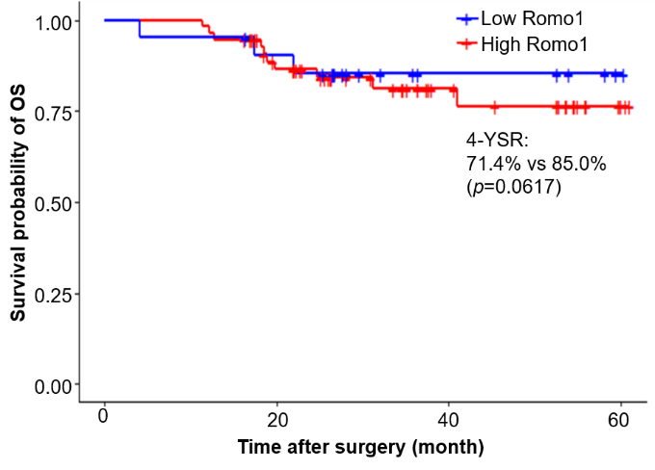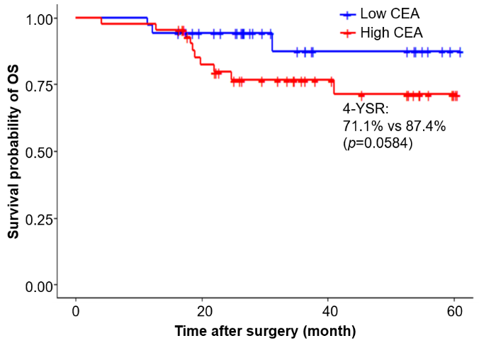
Supplementary Figure 1. Kaplan–Meier curves for cumulative overall survival according to Romo1 (A) and CEA (B) levels. p values were determined by the log-rank test. Romo1, reactive oxygen species modulator 1; CEA, carcinoembryonic antigen.

